School of Electronics and Computer Science
ELEC6050 MEng Group Design Project
_______________________________________________________
Project Specification and Plan

Title: Unmanned Aircraft Camera Module (GDP Group 18)

Supervisor: Rob Maunder (rm@ecs.soton.ac.uk)

Team Members: John Charlesworth (jgac1g08@ecs.soton.ac.uk)
Paramithi Svastisinha (ps6g08@ecs.soton.ac.uk)
Piyabhum Sornpaisarn (ps26g08@ecs.soton.ac.uk)
Andrew Busse (ajb2g08@ecs.soton.ac.uk)
Michael Hodgson (mh23g08@ecs.soton.ac.uk)

Customer: Dr. Matt Bennett, SkyCircuits (m.bennett@skycircuits.com)

Project Specification:

To design, build and test an electronic module capable of capturing still images from an unmanned aerial vehicle (UAV) and transmitting the images to a base station. The module must use the UAV autopilot’s low-bandwidth RS485 serial link (38.4 kBaud). A program must be written to interface with the base station software over a TCP/IP link, allowing image data to be received and displayed to the user. The electronic module will be constructed using strip-boards and will later be implemented on PCB if time is available.

The aim of the project will be to achieve the following criteria:

- The image will be encoded in such a way that a low quality image will be available quickly, the quality of which will improve as more information is downloaded. [high priority]
- Minimise the time needed to download the images from the UAV to the base station. The time from the user’s prompt until the image has been fully downloaded will be measured against the theoretical 3 minutes necessary to transmit a full image without using any compression. The goal will be to obtain a full image in less than 3 minutes. [high priority]
- The module weight will be less than 250g. [medium priority]
- Image resolution of 640x480. [medium priority]
- Allow the user to perform the following actions on the UAV’s camera from the base station:
  - Prompt the UAV to capture and download an image. [high priority]
  - Cancel the downloading of any image while the image is being downloaded.
[medium priority]
  - Resend an image in case the current preview is corrupted. [low priority]
  - Interrupt the download of an incomplete image and allow the user to save the incomplete image. [low priority]
  - Select the resolution settings of the image. [low priority]
  - Display a progress indicator which will show the percentage of the image data received, as well as a time estimate for the rest of the image to be downloaded. [low priority]
  - The image capture will be triggered automatically by the UAV using triggers built into the autopilot. [low priority]
  - Allow the user to command the image capture to trigger periodically over a user-specified time interval will be added if time permits. [low priority]
- Images will be transmitted in colour as opposed to black and white. [low priority]
- The user can select between a colour image and a black and white. [low priority]

Deliverables to the customer include:
- Hardware: Camera module, constructed on PCB (if time permits, otherwise on strip-board), including layout designs.
- Software: all firmware for the electronic module, and software on the base station for viewing images. The full source code and all executable files will be included.
- Documentation: Technical and User Documentation. This includes all schematics related to hardware as well as all other documents concerning both the software and hardware delivered.
- Public repository: The full source code, all schematics, and all documents concerning both the software and hardware will be included on a public repository so that the client may share this information with his clients.

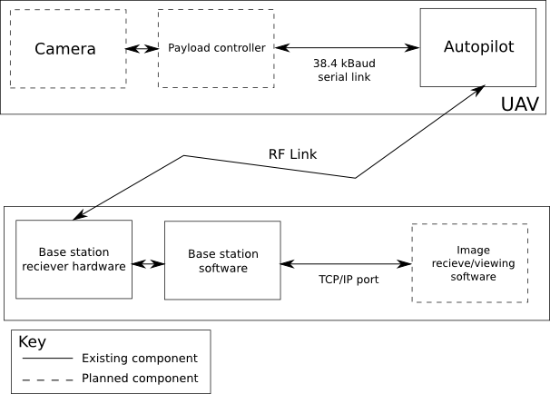
Complete Block Diagram of the System

