Rationale

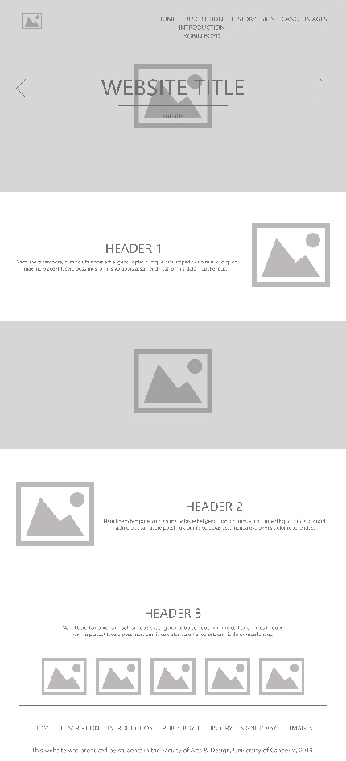For this project, we were tasked with creating a responsive website, purely using semantic HTML5 and CSS. I have used these two languages many times over the years, but never have I been quite as stumped as I was with this assignment. To make a website which is responsive takes a considerable amount of thought, forcing me develop the website for a platform I have never really considered or developed for before: mobile.

Making this website came easy to begin with by pulling from my website design background, however, when organising the navigation, there were some troubles. As time went on, I found the navigation would be inline with the title of the website in the top left of the page, however when implementing a new set of code gathered from [Mark Caron](https://medium.com/@heyoka/responsive-pure-css-off-canvas-hamburger-menu-aebc8d11d793) about making the hamburger icon work, this would be changed. It took me over a week to try and sort the problem, though after deliberation with Ben the issue was fixed within minutes, allowing me to continue with the website’s development.

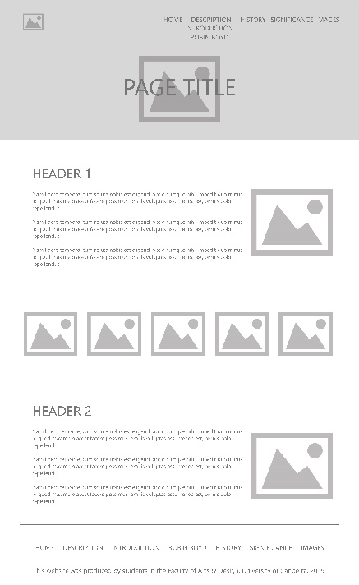Comparing the website to my original design, the main structure has been used, and has opted to for a better use of mobile development. Where it differs was the use of a small drop down menu when used on a desktop device, no hero slider on the homepage, the navigation does not float over the hero content instead having its own container, not using as many pages as originally thought, and the layout of information changing, as needed to suit the source content. Other than these, the website has become what I originally envisioned, and I believe this to be a success.

This project has been a great learning experience and challenged me in new ways than I have been with web development before. Having answered the project brief, and matched the design to how I imagined, my variation of the Churchill House website uses a clean interface and one which is aesthetically pleasing to the eye.