**Case1_ExceOnline**

**Andy Chen**

Questions:

1. What percentage of respondents have applied program experiences and learnings to their role? [agree and

strongly agree]

Answer: 87.56%

I imported the csv file into my Access Database and created the table: ***execprod.stg_sk_survey_1.*** Then I wrote the following query in Question2 and got the above result: 87.56%.

2. Please write a SQL statement to pull only the relevant data fields from the data set provided for the previous

question (Assume the provided data set is a data table named ***execprod.stg_sk_survey_1***)

Answer: The SQL query is as below and I run the query in my Access Database.

SELECT Format ( ( SELECT Count(*) FROM ***execprod.stg_sk_survey_1*** WHERE *How much do you agree with the following?I have applied my program experiences and learnings to my professional role.* IN ( 'Agree', 'Strongly agree' ) ) **/** Count(*) , 'Percent' ) AS Percentage FROM ***execprod.stg_sk_survey_1***

3. Please find 2 or 3 key insights from the provided data set and present them visually.

Answer: I manipulated the dataset in Jupyter Notebook using Python. And I attached my Jupyter Notebook including my code and visualizations. I reorganized the data, renamed the columns and restored the data when I manipulated. And my insights is as following:

**Insight I: Bar charts**

(1). Reflecting on your participation in the program, how would you rate the value of your experience?

***The majority of respondent rate the value of them experience as very good.***

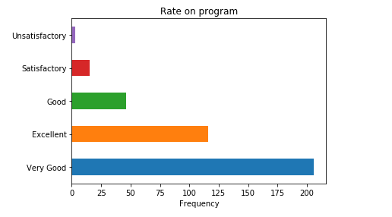

(2). What is the primary business impact your project has had on the organization?

***Increased Efficiency is the primary business impact the respondents’ projects has had on the organization.***

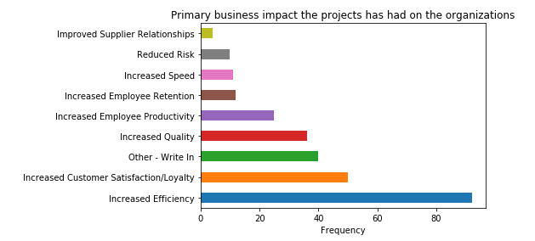

(3). How much do you agree that the following were barriers to the successful implementation of your project?

**The most barrier to the successful implementation of the projects is Conflicting Priorities, so our product should focus on solving this problem.**

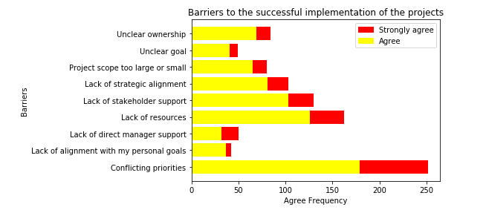

(4). ***The majority of the respondents understood why they are selected, the purpose and the benefit of the course before taking the program.***

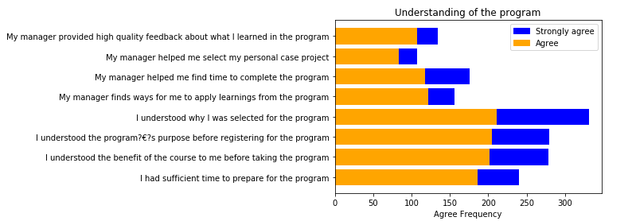

(5). How much better or worse was your digital learning experience compared to in person learning courses you may have had on the following characteristics?

***The biggest shortage of Digital Learning compare to In Person Learning is Networking Opportunities based on the survey. So our product should find a way to make up this shortage.***

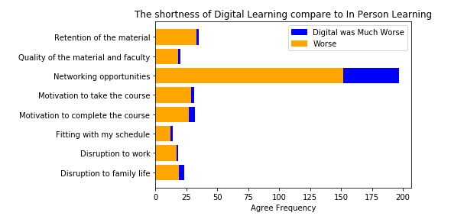

(6). Which of the following time management strategies did you use to try to complete the course?

***Most of the respondents would like to schedule weekend time to work on the course. So the time of our course should be scheduled during weekend.***

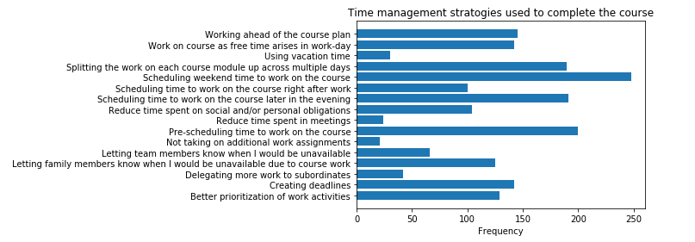

(7). How much time have you spent with your direct manager talking about what you learned in the course?

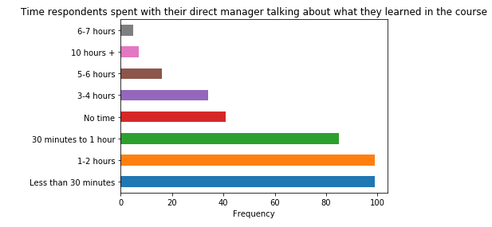

**Insights II: Correlations**

I want to find out the correlation between ‘Rate of the program’ and ‘Respondents received a promotion or not’, and the correlation between ‘Rate of the program’ and ‘Respondents expanded their responsibilities or not’. The following is the code and the result.

*#I converted non numeric variables to 1/0 values. Yes has been converted to 1, No has been converted to 0*

**x = df['Yes:Now we?€?d like to know a little bit more about your career accomplishments since you took the program.?? ?? Have you received a promotion since you took the program? ??'].apply(lambda x: 1 if x == 'Yes' else 0)**

**y = df['Yes:Have you expanded your responsibilities???'].apply(lambda y: 1 if y == 'Yes' else 0)**

*#If rate is ‘Very good’, ‘Excellent’, ‘Good’ ,’Satisfactory’ then I converted them to 1, which means positive. And if rate is ‘Unsatisfactory’ then I converted them to o, which means negative.*

**z = df['Reflecting on your participation in the program, how would you rate the value of your experience?'].apply(lambda z: 1 if (z=='Very Good' or z == 'Excellent' or z=='Good' or z == ‘Satisfactory’)else 0)**

**stats.pearsonr(z, x)**

*#The result is (-0.14348516865858352, 0.0047351064040425245), which means corr=-0.14348516865858352 and p-value = 0.0047351064040425245*

**stats.pearsonr(z, y)**

*#The result is (-0.040823725992295036, 0.4238317834148647), which means corr=-0.040823725992295036 and p-value = 0.4238317834148647*

Conclusion: There is no obvious relationship between them. Which means respondents who rate our program ‘Unsatisfactory’ not mainly because they didn’t receive a promotion or they didn’t expand their responsibilities.