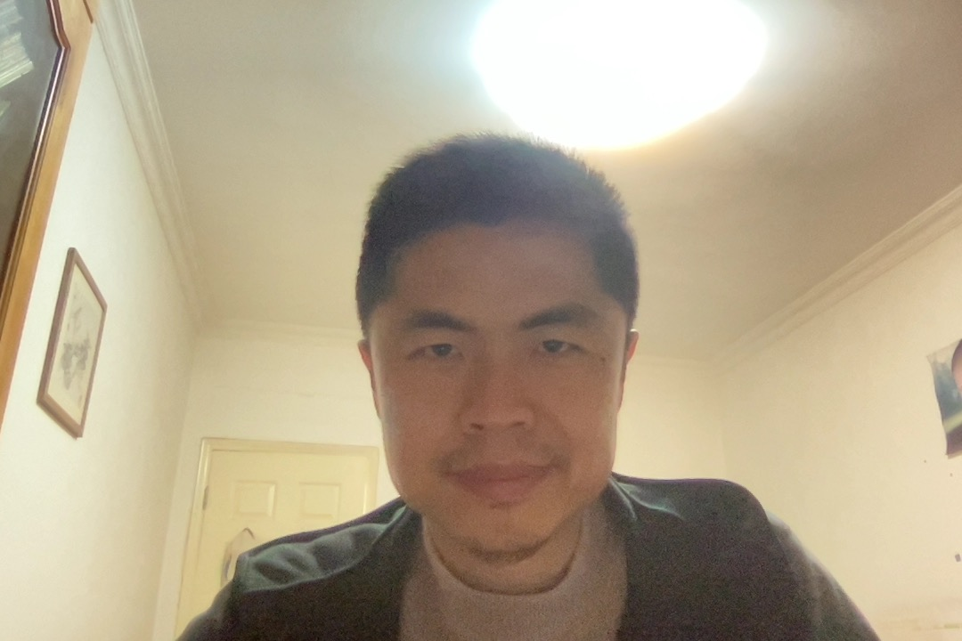

Joe Chen |12315823345643 |1593779@qq.com

# About me

I am a senior software tester and QA manager

# Working Experience

**AAAAA** *2011 -- 2019*Testing and Coding

**DDDDD** *2019 -- 2021*QA Manager

# Skills

* Writing
* Testing
* Coding