Assignment 5 - Perceptron Report

Data Description
The dataset has 100 points with two features (x1, x2) and a binary label (0 or 1). The first 50 are class 1 (blue) and the last 50 are class 0 (red). From the plot, class 1 mostly clusters in the lower-left area and class 0 is in the upper-right area. There is some overlap in the middle which makes perfect linear separation hard.

Part 1 - Heuristic Perceptron

How it works
The heuristic perceptron uses the sigmoid function to output a continuous value (y_hat) instead of just 0 or 1. The error is (y - y_hat), and the weights and bias get updated by that error times the learning rate. This repeats over all data points for many epochs.

Result Plots
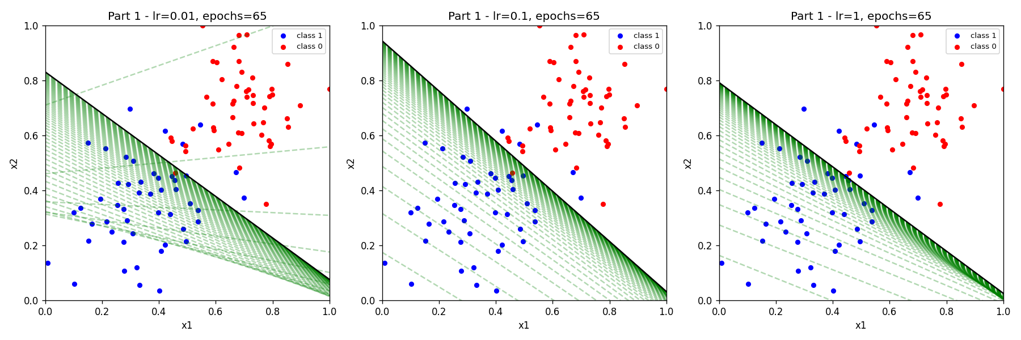

Figure 1: Part 1 decision boundaries for learning_rate = 0.01, 0.1, and 1 (left to right). Red = initial line, dashed green = intermediate lines, black = final line.

Analysis
With learning_rate = 0.01, the boundary lines are very close together and move very slowly. After 65 epochs the model is still converging but the steps are tiny so the final line may not fully separate the data yet.
With learning_rate = 0.1, the lines spread out a bit more but still converge to a reasonable position. The final boundary separates most of the points correctly.
With learning_rate = 1, the green dashed lines are spread out a lot and some go far outside the visible area. The model takes big steps so it jumps around more before settling. But it can also get to a good answer faster.
In general, small learning rate = stable but slow. Large learning rate = fast but unstable and might overshoot.

Part 2 - Gradient Descent Perceptron

How it works
This version uses hard classification (0 or 1, threshold at 0.5) and only updates weights when the model gets a point wrong. If the prediction is 0 but the label is 1, the learning rate is added to the bias and weights. If prediction is 1 but label is 0, we subtract. Log loss (cross-entropy) is computed every 10 epochs to track error.

Result Plots - lr = 0.01
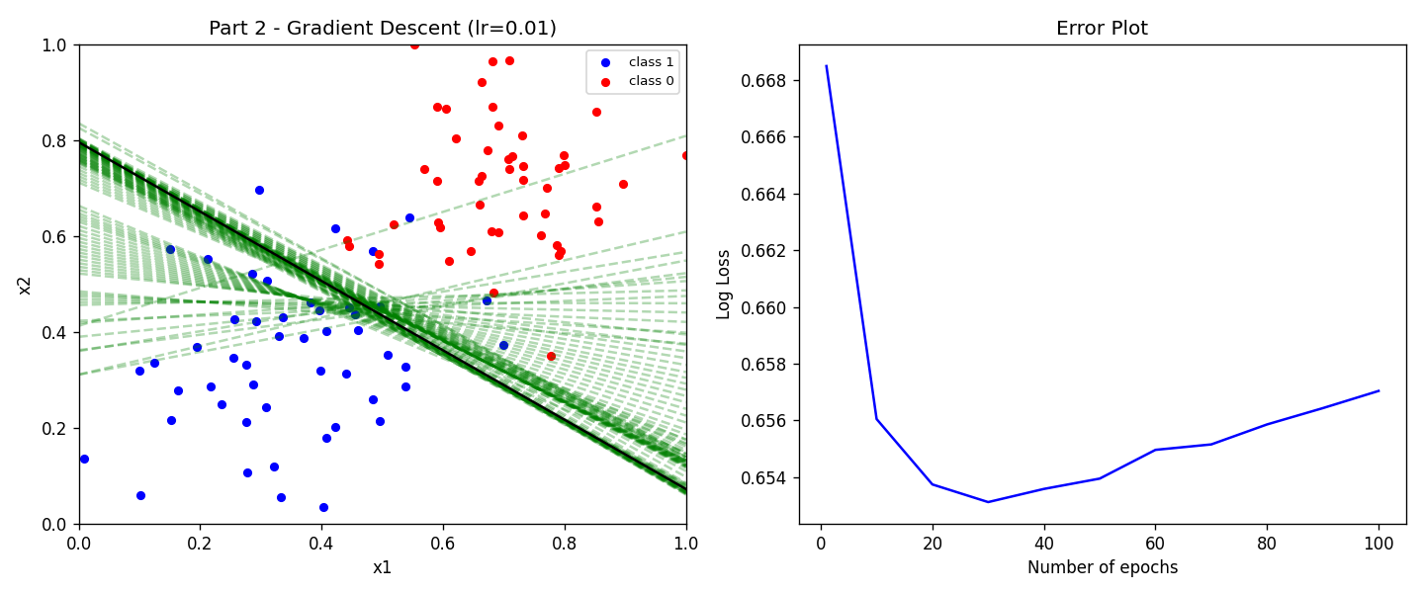
Figure 2: learning_rate = 0.01, 100 epochs. The error drops slowly and final log loss is around 0.657.

Result Plots - lr = 0.1
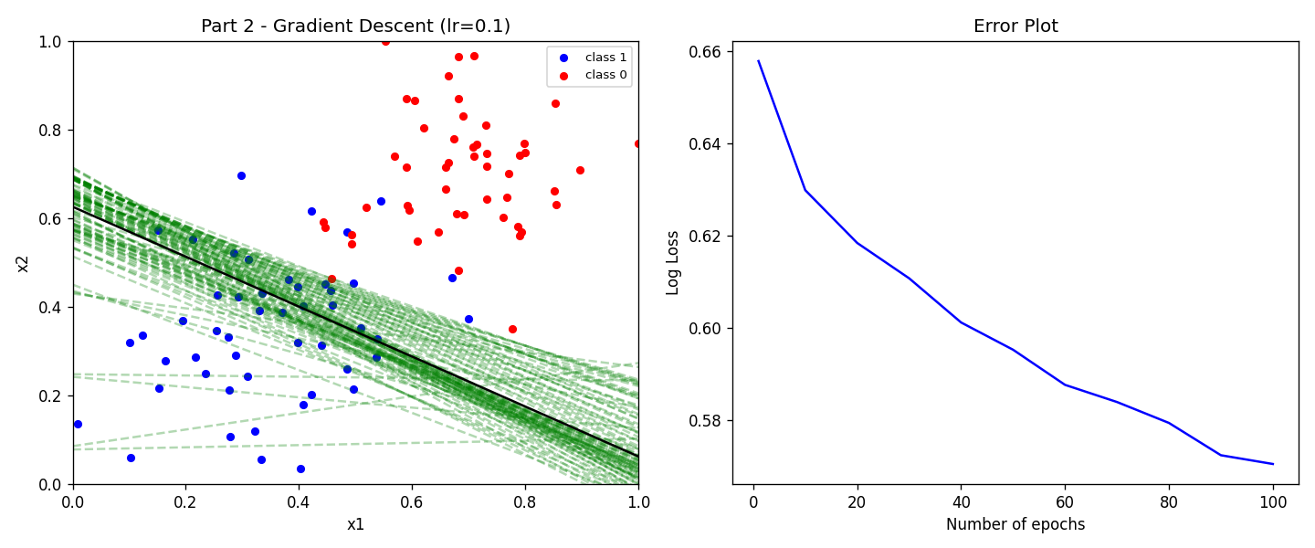
Figure 3: learning_rate = 0.1, 100 epochs. Error drops faster, final log loss around 0.571.

Result Plots - lr = 1
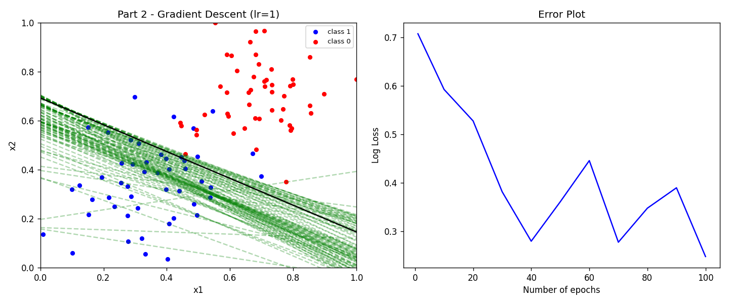
Figure 4: learning_rate = 1, 100 epochs. Boundary lines jump around more, but final log loss reaches around 0.248 which is the lowest.

Analysis
With lr = 0.01, the error curve barely moves and the model is learning very slowly. The final boundary is still not great after 100 epochs.
With lr = 0.1, the error drops faster. The boundary does a better job separating both classes and the log loss is lower.
With lr = 1, the model takes large correction steps every time it misclassifies a point. The green lines are more spread out because of this. But it ends up with the best final result since it can make bigger corrections.
The error plots in all three cases show a curve that drops quickly at first and then flattens. This is what we expect from gradient descent. Higher learning rate means a faster drop but also more noise in the early stages.

Part 1 vs Part 2 Comparison
Part 1 updates weights on every single point every pass using a soft error (y minus sigmoid output). Part 2 only updates when a point is actually misclassified. Part 1 is smoother because the error signal is continuous. Part 2 can be more aggressive since it only reacts to mistakes.
Both methods find a decent boundary on this dataset. The data is mostly linearly separable so even a single-layer perceptron handles it well. With more epochs or better tuning, both can produce a clean final boundary.

