Footstool Measurement Sheet

Customer Name ____________________
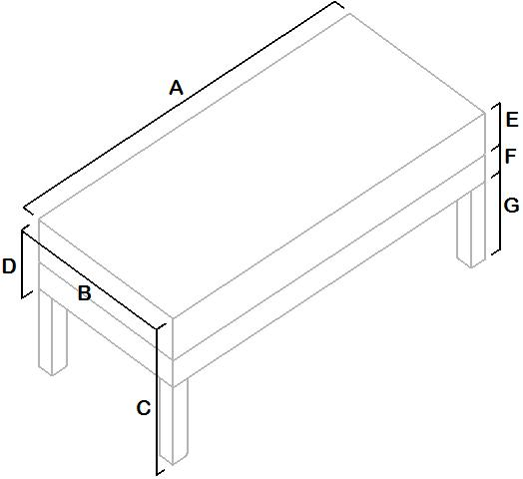
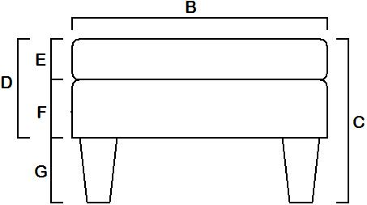
Footstool Length A = __________
Footstool Width B = __________
Overall Footstool Height C = __________
Overall Top Thickness D = __________
Foam Thickness E = __________
Base Thickness F = __________
Leg Height G = __________
Type of Legs __________ Castors YES / NO

If you would like a specific button pattern please indicate on top diagram

