Customer Name _________________________
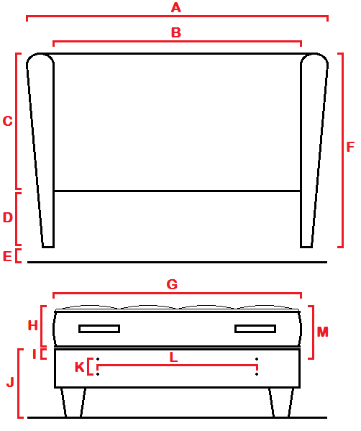
A Overall width = __________
B Headboard width (W/O wings) = __________
C Headboard height (W/O wings) = __________
D Distance between bottom of wing and headboard = __________
E Height of wing above floor = __________
F Overall height of headboard = __________

G Width of bed = __________
H Thickness of mattress = __________
I Distance between top bolt and top of base = __________
J Height of base above floor = __________
K Vertical bolt spacings = __________
L Horizontal bolt spacings = __________
M Distance between top bolt and top of mattress = __________

Please Make Any Further Notes Overleaf

