Headboard Sizing Sheet

Customer Name ____________________
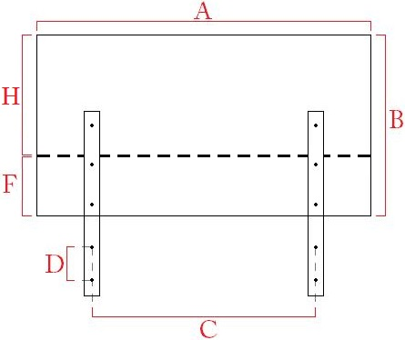
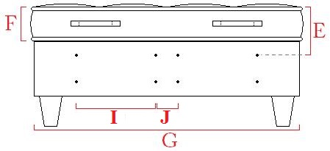
Headboard Width A = __________
Headboard Height B = __________
Horizontal Bolt Spacing C = __________
Vertical Bolt Spacing D = __________
Top Bolt To Mattress Top E = __________
Mattress Height F = __________
Bed Width G = __________
Headboard Height Above Mattress H = __________
(If Applicable) Single bed bolt spacing I = __________
(If Applicable) Centre Bolt Spacing J = __________

If you would like a specific buttoning pattern please indicate on top diagram

