Valance/Bed Spread Measurement Sheet

Customer Name ____________________
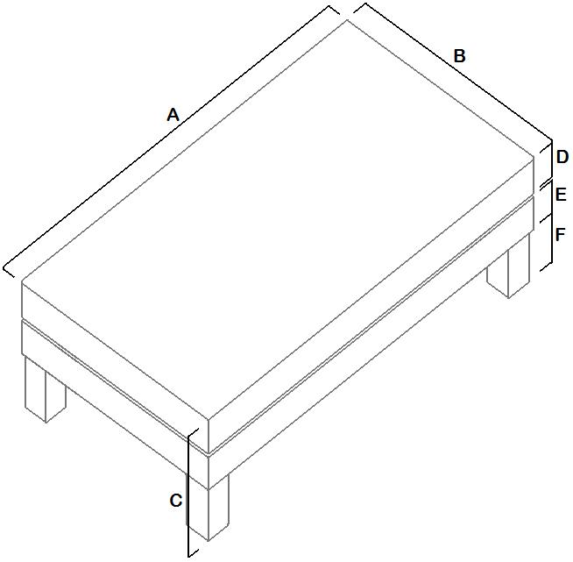
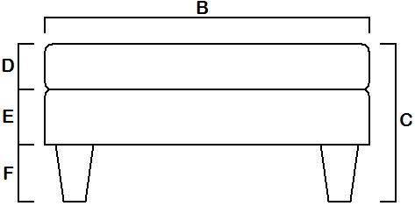
Bed Length A = __________
Bed Width B = __________
Overall Bed Height C = __________
Mattress Thickness D = __________
Base Thickness E = __________
Leg/Castor Height F = __________

