**Heart Health**

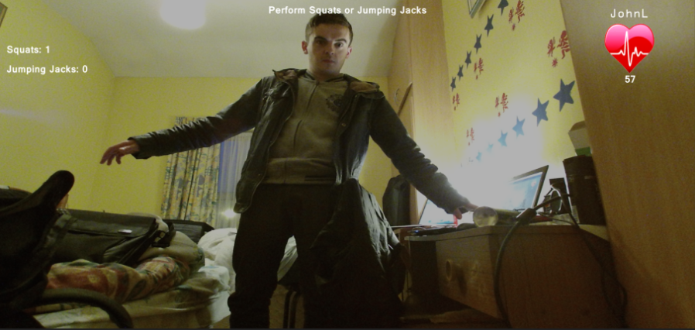

Heart Health utilizes the Kinect V2, patients must perform exercises in front of the Kinect and results are sent straight to the patient's Doctor/Physiotherapist. Heart Health also utilizes serious games as a means to maintain motivation for people undergoing therapy and engaging for this type of physical rehabilitation. Heart Health also uses heart rate estimation to determine the patient’s heart rate through exercise.

Heart Health is home-based rehabilitation system for patients in rehabilitation of cardio-vascular diseases with a user-friendly interface and also a doctor-patient interaction system for doctors/physiotherapists to diagnose and examine patients without face-to-face interaction.

Andrew Daly (DT211/4)