

***Heart Health***

***Home-based rehabilitation system using motion capture with Serious Games***

**DT211**

**BSc in Computing**

**Andrew Daly**

**C11710699**

**Supervisor: Bryan Duggan**

Summary

Home based rehabilitation system using the Xbox Kinect 2.

Exercises suited for patients with Cardio-Vascular Diseases

User must perform exercises in front of the Kinect, Exercises are played out on the form of a game, different exercises are provided and patient’s heart rate is monitored.

System is also connected online to the cloud for patient’s doctor to view, Doctor views how well exercises are performed and also keeps up to date with the patient without the need of continuous doctor visits.

Serious games can be thought of as any game based interfaces that have been designed for any purpose other than entertainment.

Rehabilitation in areas of Cardio-Vascular Diseases and Monitoring Heart-rate

Exercises may include: Squats, Jumping Jacks, Various Stretches and Basic Body Movements, etc.

End Deliverables

Patient’s System; Computer with Game/Rehabilitation Application and Kinect 2 attached.

Admin/Doctor’s System; Computer with Admin Application

Patient’s System; System will have the game and rehabilitation workout routines, Patient logs into their user-account (which is set up by Doctor) and application commences. Patient has ability to commence normal workouts, perform workouts in Gamified environment or view records from pervious workouts as well as comments from Doctor.

Admin/Doctor’s System; System will be a Doctor check-up system, Doctor logs into system, can view patients, create account for patient, can view specific patient records and send comment to patient on record to give progress, there may also be an ability to view exact patient workout.

Rough Prototype

System Overview:

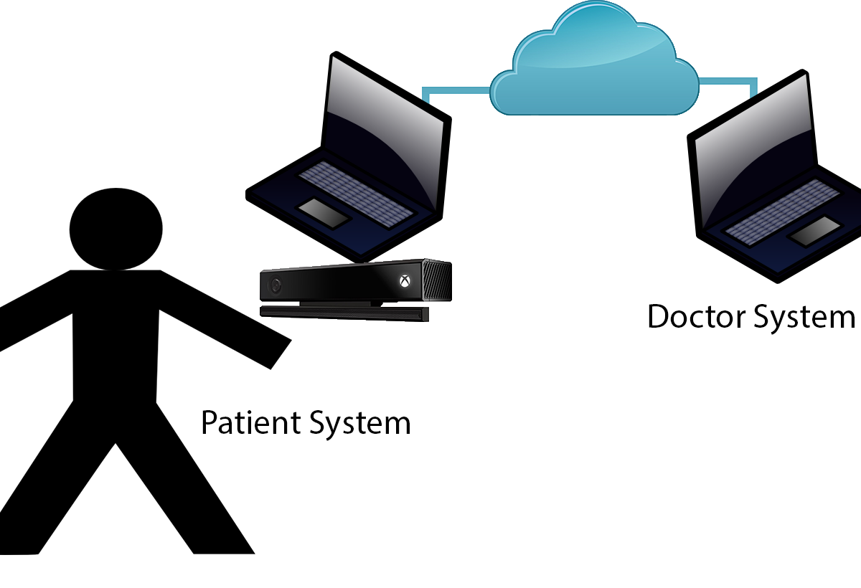

Patient System:

Login Screen;

Menu Screen; Select Options: Normal Workout, Gamified Workout, View Records

Normal Workout; Perform Normal workouts without gamified environment

Gamified Workout; Play Game, workouts performed along with game

View Records; View Records of Previous Workouts and view comments from Doctor

Doctor System:

Login Screen;

Patients Overview Screen; Displays all patients as well as option to create new patient

Specific Patient Overview Screen; View Details of Specific Patient Viewed, can also select specific workout performed, can comment or view progress