paleo-RF: the non-interp (March) pipeline run
Run on 2026-09-16, report written 2026-09-17. Branch run-nointerp (code changes), merged into chris-dev; legacy holds the code as received. Repository: github.com/andydawson/paleo-RF.
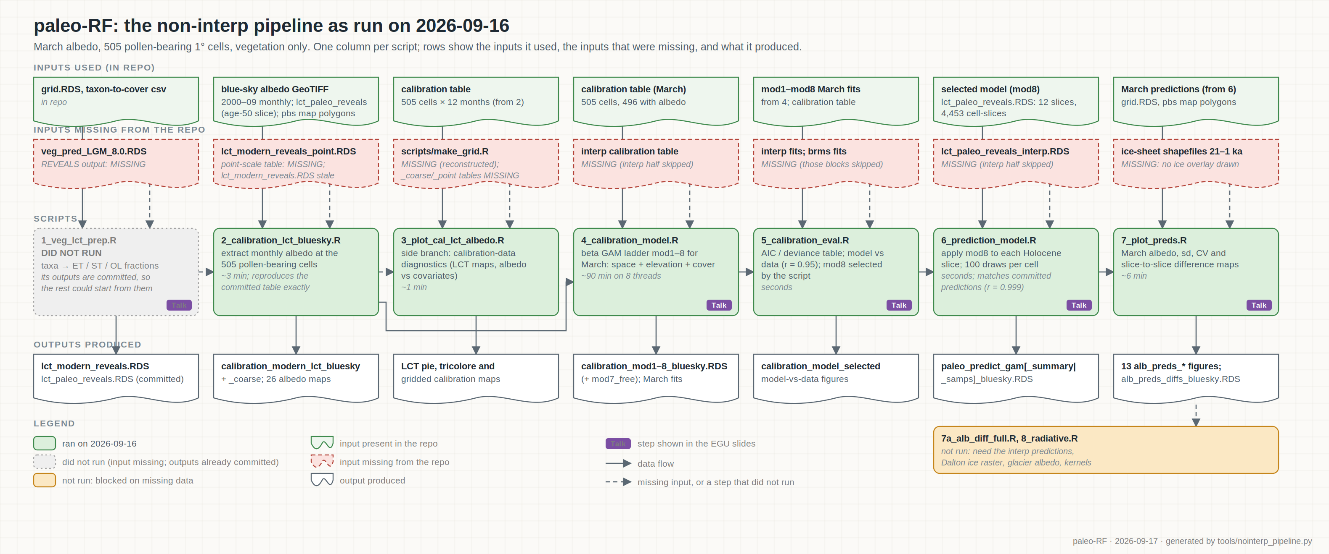
Figure 1. The non-interp pipeline as run: one column per script, with the inputs it used, the inputs missing from the repository, and what it produced. Purple badges mark steps shown in the EGU slides.

1. What we ran
The repository holds two flavours of the analysis. The "non-interp" flavour uses land cover at the 505 one-degree cells that contain pollen records and fits the calibration for March only; the "interp" flavour uses land cover interpolated over the full grid with an ice mask and fits all twelve months, but every interp input is missing from the repository. We therefore ran the non-interp flavour. Scripts 2 to 7 ran end to end. Script 1 did not run because its REVEALS input is not in the repository; its two outputs (the modern and paleo land-cover tables) are committed, so the pipeline could start from them. Scripts 7a (albedo differences split into vegetation and ice) and 8 (radiative forcing) could not run: they read only the interp predictions and need the Dalton ice raster, the glacier albedo table and the radiative-kernel files, none of which are in the repository. Runtimes: script 4 (eight model fits) about 90 minutes on 8 threads; script 7 about 6 minutes; the rest seconds to a few minutes.

2. Changes needed to make it run
All edits are marked "# [run-nointerp]" in the scripts and are described in the commit messages on branch run-nointerp. The interp code is untouched.
Where | Change and reason
All scripts | output/ and figures/ directories are never created; added dir.create().
Scripts 2-7 | A run_interp flag (file.exists on the interp input) wraps every interp block in if (run_interp) { ... }.
Script 2 | Point-scale albedo extraction commented out (its input lct_modern_reveals_point.RDS is missing).
Script 2 | lct_modern_reveals.RDS in the repo is stale: 1029 pollen-site coordinates with cover in percent, while every other file uses 505 grid cells with proportions. Fitting on it produced albedo of zero for every paleo cell. The age-50 slice of lct_paleo_reveals.RDS is exactly the committed calibration site set, so the script now falls back to it. With this, the regenerated calibration table is identical to the committed one.
Script 3 | scripts/make_grid.R is missing; a minimal reconstruction was written. rgeos and rgdal (retired from CRAN, not called) removed; dplyr loaded explicitly.
Script 4 | The commented-out March model ladder (mod1 to mod8) restored. Fixed saveRDS(mod7, "...mod7_free...") which saved the wrong object. An unused, unsaved ninth model (select = TRUE) commented out; it cost 45 minutes for nothing.
Script 5 | mod7_free read restored (script 4 now writes it); brms comparison skipped unless the brms fits exist.
Script 6 | library(SemiPar) removed (archived on CRAN, never used).
Script 7 | Empty ice overlay when the ice-sheet shapefiles are missing.
Environment | No system R on the machine and no sudo; a user-space micromamba environment with R 4.4 and all packages except rgeos, rgdal, SemiPar, pwiser and ClimClass (all gone from CRAN).

3. Results produced
Script 4 fits a ladder of beta-regression GAMs of March albedo on spatial location, elevation and land cover. By AIC, model 2 (location and elevation, no land cover) scored best in March and models 3 to 8 sit within a few points of each other; the script nonetheless assigns model 8 (the joint land-cover smooth) as the selected model, which is the only choice that lets albedo change through time, since only land cover varies between slices.
Model | Terms added | AIC (March)
mod1 | space | -1078
mod2 | + elevation | -1206
mod3 | + open land | -1204
mod4 | + evergreen | -1201
mod5 | + summergreen | -1201
mod6 | joint cover smooth | -1201
mod7 | joint cover, GP basis | -1203
mod7_free | as mod7, larger k | -1203
mod8 (selected) | joint cover, thin-plate basis | -1201

Selected model: adjusted R-squared 0.886 on 496 cells with March albedo; correlation between fitted and observed albedo 0.95. The paleo predictions regenerated by script 6 match the files committed in the repository (correlation 0.999, mean absolute difference 0.007), so the run reproduces the earlier March results.
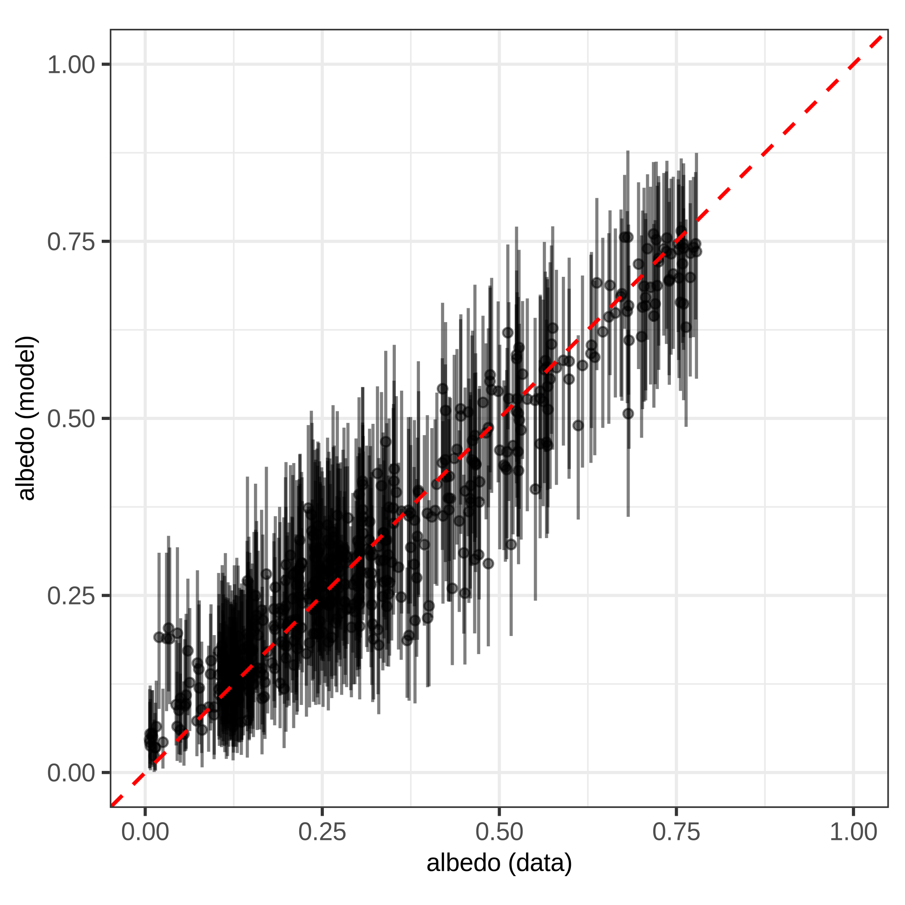
Figure 2. March calibration: modelled versus observed albedo at the 505 cells, with 95% intervals from 100 simulated draws (script 5).
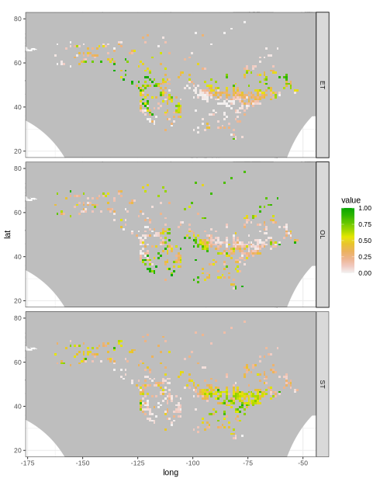
Figure 3. Modern land cover at the calibration cells: fractions of evergreen trees (ET), open land (OL) and summergreen trees (ST) (script 3). Cropped to North America: the repository version of every map is dominated by a grey world-wide boundary layer, a plotting problem noted in KNOWN_ISSUES.md.
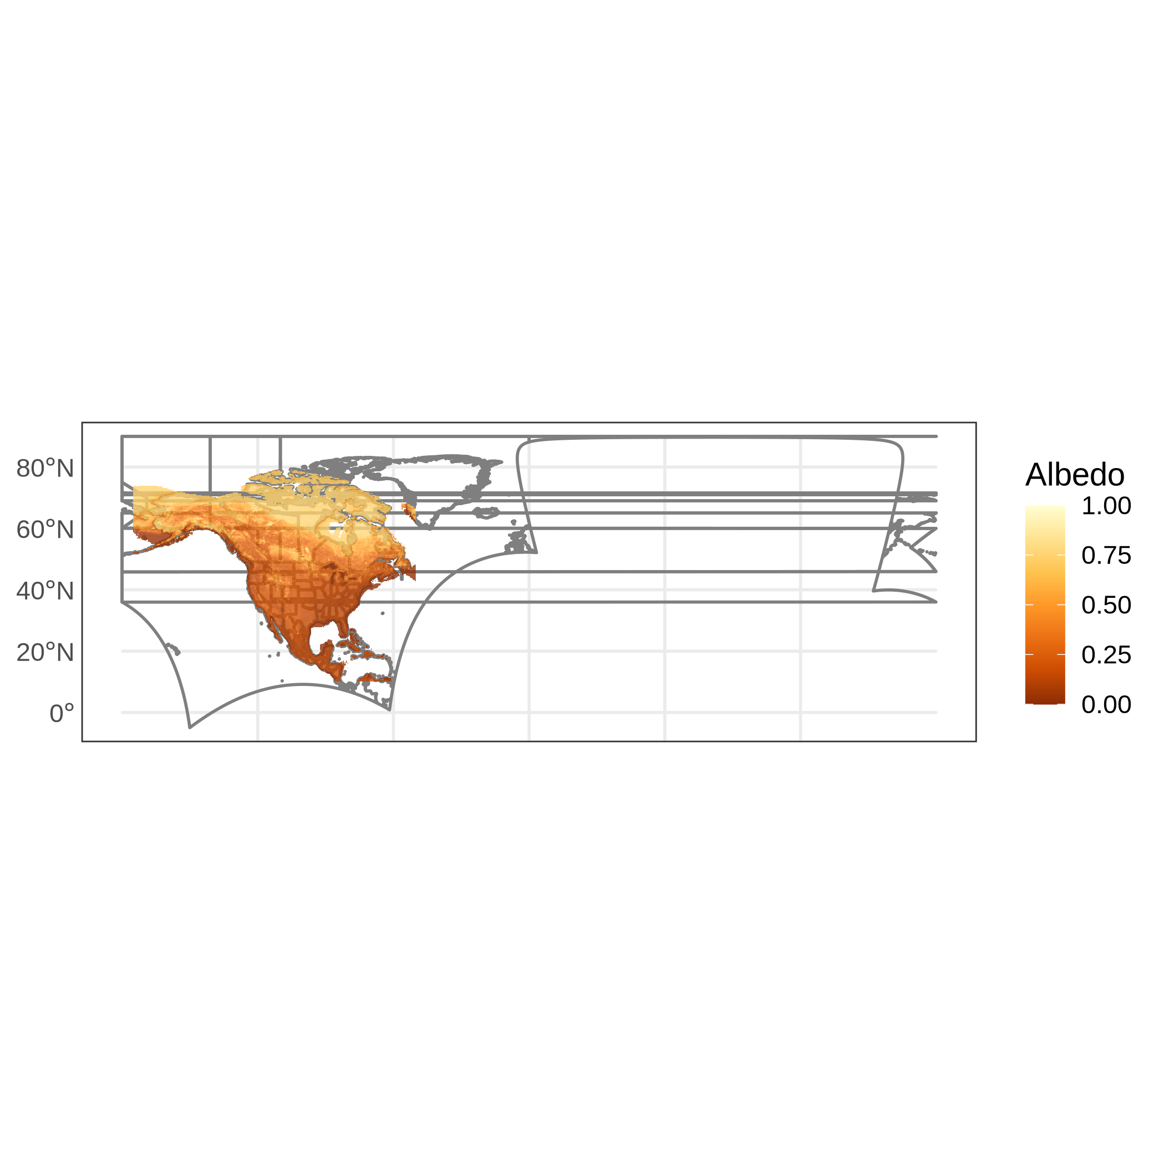
Figure 4. March blue-sky albedo (2000-2009 climatology) at native 0.25-degree resolution, the response variable (script 2).
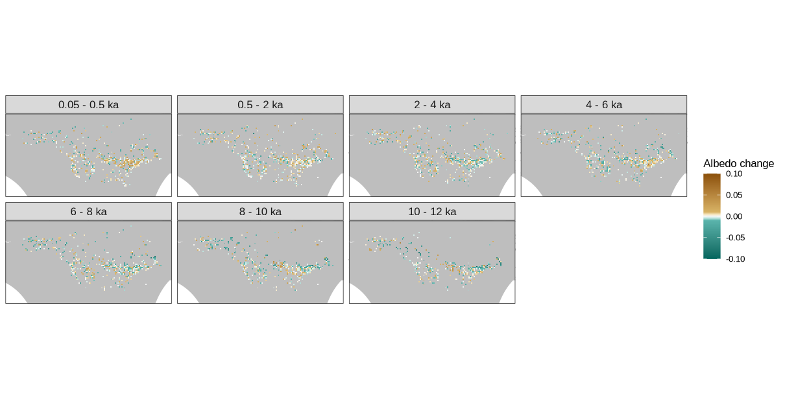
Figure 5. Change in predicted March albedo between consecutive time slices (younger minus older; brown = albedo increased = cooling, green = albedo decreased = warming), at the 505 cells, vegetation only, no ice. Cropped for legibility (script 7 data).

4. Comparison with the EGU talk
The results in the talk come from the interp, all-months path: the calibration was fitted on the interpolated full grid, predictions were made for every month, ice sheets were added with a prescribed glacier albedo, and forcing was computed with the HadGEM3 kernel. Ours are March only, on the 505 pollen cells, vegetation only, with no forcing because the kernels are not in the repository. The draft manuscript has no results figures yet, so the talk is the only comparison available.
(i) Calibration skill. Slide 13 shows May modelled versus observed albedo with several thousand points (the interpolated grid). Our March scatter has 505 points with a correlation of 0.95. The shape and skill are the same: points cluster on the one-to-one line with intervals of similar width.
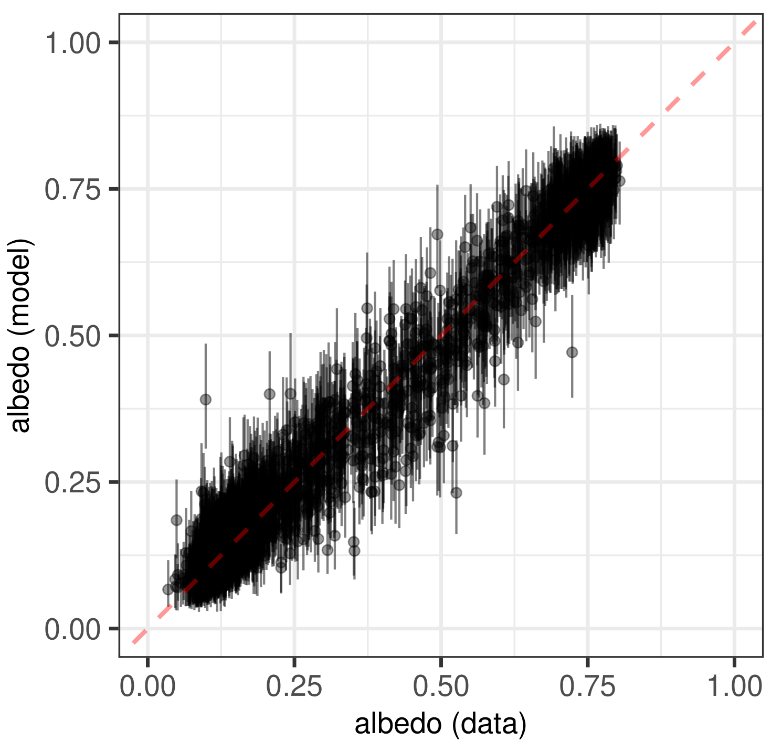
Figure 6. Left: talk slide 13, May, interpolated grid. Right: this run, March, 505 cells.
(ii) Direction of change through the Holocene. Slide 17 gives continental mean forcing per period for four months; its May bars show warming from 12 to 6 ka, cooling from 6 to 4 ka, slight warming 4 to 2 ka, and cooling over the last 2 ka. Albedo change has the opposite sign to forcing (albedo down = warming), so we can compare signs using the mean March albedo change per period over our cells. Forcing itself cannot be computed without the kernels.
Period | Mean March albedo change | Implies | Talk, May bar | Sign
10 - 12 ka | -0.0045 | warming | warming (largest bar) | agree
8 - 10 ka | -0.0038 | warming | warming | agree
6 - 8 ka | -0.0032 | warming | warming | agree
4 - 6 ka | -0.0012 | warming (weak) | cooling | differ
2 - 4 ka | -0.0002 | about zero | warming (small) | neutral
0.5 - 2 ka | +0.0013 | cooling | cooling | agree
0.05 - 0.5 ka | +0.0024 | cooling | cooling | agree

Five of seven periods agree in sign, including the early-Holocene warming and the recent cooling that carry the talk's story. The 4 to 6 ka period differs: the talk shows a clear cooling in May (the hemlock-decline signal), our March vegetation-only run shows a weak warming. Our changes are also small (mean magnitudes below 0.005), which is expected without ice and on pollen cells only. A May run with the same code is in progress so that a like-for-like month comparison will follow.
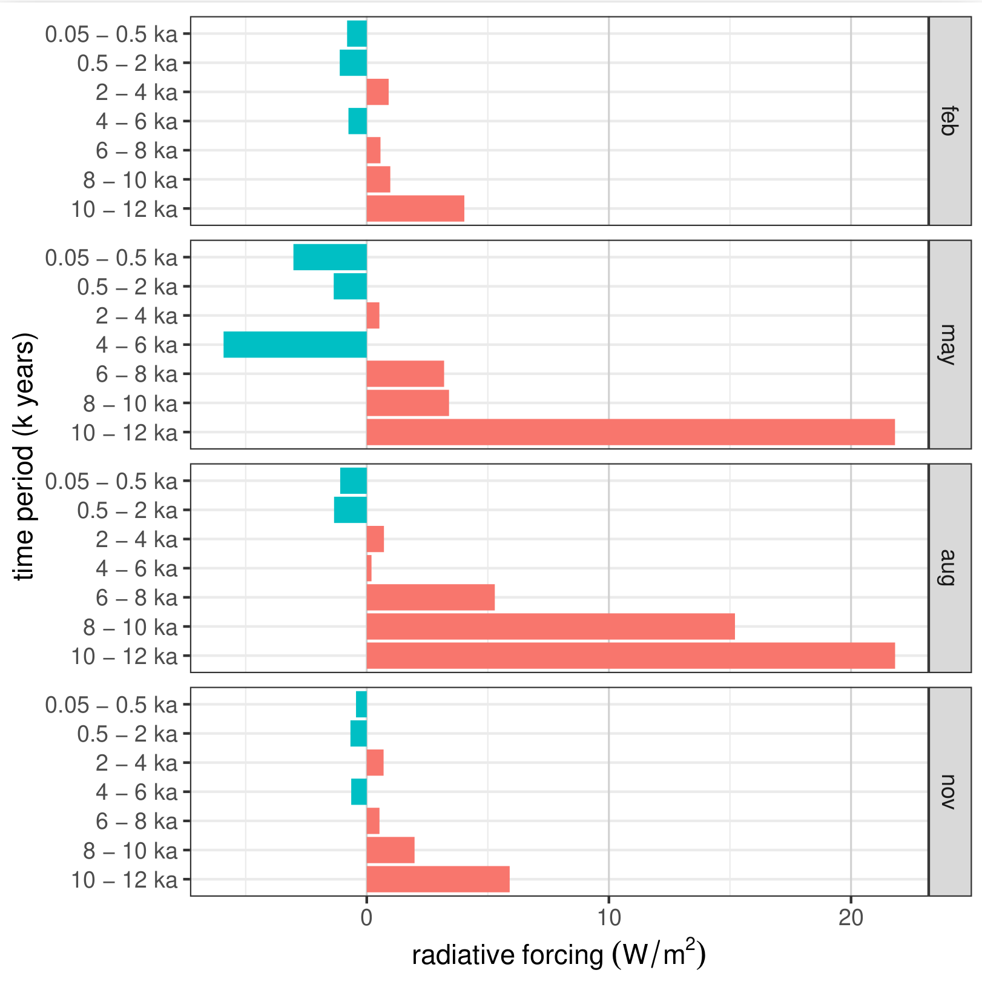
Figure 7. Left: talk slide 17, continental mean forcing per period and month (interp path, with ice). Right: this run, March albedo change per period.

5. Open points for Andria
- The interpolated REVEALS posteriors (veg_posts_interp_ice.RDS) and the code that produced them: without these the interp path, which is the one the talk reports, cannot run.
- Which modern land-cover file is the intended one: the site-level lct_modern_reveals.RDS in the repository, or the age-50 slice of the paleo table that matches every other file.
- Model 8 is assigned by hand in script 5; by AIC other models score better in March. What was the selection criterion, and does model 8 win in all months on the interp data?
- Snow is not modelled: the 2000-2009 snow climatology is held fixed through the spatial and elevation terms for every slice. Is that the intended interpretation, and should it be stated?
- The code draws 100 posterior samples per cell; the draft says 1,000. Which was used for the reported results?
- The ice-sheet shapefiles, the Dalton ice raster, the glacier albedo table and the three radiative-kernel files are needed to run scripts 7a and 8.

6. Top five questions to ask Andria
From the 58 questions in METHODOLOGY_QUESTIONS.md, these five go to the foundations of the method.
- Does uncertainty propagate at all? The REVEALS posterior draws are averaged to a single land-cover value per cell before anything else happens. The "posterior samples" in script 6 are new observations drawn from the fitted beta distribution, not draws of the model parameters, and the slice-to-slice differences use only the mean. So the forcing carries no land-cover uncertainty and possibly no model uncertainty. What do the credible ribbons in the talk represent?
- Why calibrate on the interpolated field? The all-months calibration is fitted to the interpolated modern land cover, so most of its "observations" are outputs of the interpolation model rather than pollen cells. That inflates the apparent sample size and smooths the very heterogeneity the model should learn from. Why not calibrate on pollen cells and predict on the interpolated grid?
- What is held fixed by space-for-time? Snow, clouds, atmosphere, soils, lakes, modern land use and the taxon-to-class mapping are all frozen at 2000-2009 values. Since the vegetation-albedo effect at these latitudes is mostly snow masking, what does a Holocene albedo forcing mean when the snow regime cannot change?
- How was model 8 chosen? Script 5 assigns model 8 regardless of the AIC and deviance tables that script 4 prints; in March the AIC prefers a model with no land cover, and models 3 to 8 are nearly tied. Which criterion was used, and does the same model win in every month on the interp data?
- Is the kernel comparison fair? The kernels are pre-industrial and clear-sky, applied to the early Holocene when summer insolation was much higher; clear-sky kernels also run larger than all-sky. And a local, land-only, per-interval forcing over North America is compared with the global-mean cumulative greenhouse-gas forcing. What is the Holocene vegetation forcing expressed as a global mean?

7. Missing artefacts we need
Drawn from KNOWN_ISSUES.md. Highest priority first within each group.

(a) Data files that cannot be rebuilt from the repository
Item | Why it matters / what it unblocks
veg_posts_interp_ice.RDS [HIGHEST PRIORITY] | The interpolated, ice-masked REVEALS posteriors: root input of the interp path. With this file alone, scripts 1 to 6 of the interp path (the talk's results) can be run.
veg_pred_LGM_8.0.RDS | Raw REVEALS output; lets script 1 be rerun from source instead of trusting the committed land-cover tables.
data/map-data/ice/glacier_shapefiles_21-1k.RDS | Ice-sheet outlines; map overlays and ICE/no-ICE status in script 7.
data/Dalton_QSR_2020_Ice/dalton_interpolated_LC6k.tif | Ice fraction per cell and slice; the vegetation-versus-ice split in 7a and the dominant 12-8 ka forcing.
data/albedo_glacier_monthly.csv | Prescribed glacier albedo per month; sets the ice contribution. Source unknown.
Radiative kernels: HadGEM3-GA7.1 TOA, CAM5 alb.kernel.nc, CACKv1.0.nc | Script 8; without them no forcing can be computed.
data/GCM/ccsm3_22-0k_*.nc | CCSM3 paleoclimate; only if the abandoned climate/snow branch is to be revived.

(b) Code
Item | Why it matters / what it unblocks
The REVEALS run and its inputs (pollen dataset version, site and taxon lists, productivity estimates, fall speeds, number of simulations) | Root of every result; the coauthors who ran it should add it or point to its repository and commit.
The Bayesian spatial interpolation and ice mask (Pirzamanbein et al. 2018) | Produces veg_posts_interp_ice.RDS; the current analysis depends on it and nothing in the repo documents it.
Blue-sky albedo construction from MODIS MCD43A3 and ERA5 | The response variable; described in the methods but the repo starts from the finished GeoTIFF.
Original scripts/make_grid.R | Sourced by script 3; reconstructed here, the original may differ.
Whatever produced the site-level lct_modern_reveals.RDS and lct_modern_reveals_point.RDS | Decides which modern land-cover file is canonical and whether point-scale calibration is part of the analysis.
brms model fits (calibration_brms_m1-8) | Script 5 compares against them; either add the fitting script or drop the comparison.
Kernel download and preprocessing | Reproducibility of script 8, including units and TOA-versus-surface conventions.

(c) Environment and provenance
Item | Why it matters / what it unblocks
R and package versions used for the reported results (renv.lock or sessionInfo()) | rgeos, rgdal, SemiPar and ClimClass are already gone from CRAN; without a lockfile the original environment cannot be rebuilt.
Which flavour and which months the paper reports, with a run order and expected runtimes | Tells us what to reproduce; the interp path is 12 months x 8 models x 2 fits, many hours.

