## A tree-ring based reconstruction of early summer precipitation in southwestern Virginia (1750-1981)

Andria Dawson, David Austin, David Walker, and Valerie Trouet

March 20, 2013

### Abstract

In a closed-canopy forest, stand dynamics play an important role in shaping the forest, and it has been hypothesized that dense forests are not sufficiently limited by climate to warrant climate reconstruction. We sampled Quercus prinus ring-widths from a dense forest in the Appalachians, and after removal of stand dynamics and age trends we find strong correlations between the developed chronology and early summer precipitation. To strengthen the climate signal, we include additional southeastern US Quercus prinus chronologies in a nested principal component analysis (PCA). Correlation between the growth proxy and early summer precipitation was increased through PCA, and assessment of reconstruction skill was favorable. The reconstruction was modeled using a Bayesian regression model, which allowed uncertainty to be quantified. The reconstruction covered the period 1750-1981, and extended the instrumental record by 150 years. The reconstruction showed key drought years identified by others, as well as 11-year periodicity.

### 1 Introduction

One of the most important centers of forest diversity in North America is the southern Appalachian region. This region has supported continuous forest communities longer than any other area on the continent and hosts many rare, endemic species. Additionally, it harbors many disjunct species populations, all of which make it one of the most important centers of forest diversity on the continent. [1]. The southern Appalachians also provide ecosystem services such as carbon storage, watershed and water quality protection, and serve as a timber source [2]. In order to protect these valuable resources, it is crucial that we thoroughly understand the past climate of this area and how it has influenced the many ecosystems within the region. A sound understanding of the past relationship between climate and southern Appalachian ecosystems will enable scientists and landowners to better manage the natural resources in the future.

Global circulation models project an increase in average global surface temperatures of 1.0 - 3.5∘ by the end of this century due to continued increases in greenhouse-gas emissions [3, 4]. However the influence of increased radiative forcing on precipitation regimes is not well understood, and this is particularly the case for the southeastern United States (US). The 24 models used to make predictions about climate change in the Intergovernmental Panel on Climate Change Fourth Assessment Report were not in consensus with respect to drought frequency [3, 5]. Uncertainty in climate projections makes it difficult to predict water and power usage. The ability to do so is crucial because the southeastern US has experienced substantial increases in population and energy consumption, over the last decade [5, 6]. It is important that the public and planners in the Southeast have access to information regarding climate change projections and mitigation. Through the use of tree-ring based climate reconstructions, scientists may better understand past precipitation regimes at decadal- to centennial time-scales in order to better project future precipitation patterns in a changing climate.

In order to reduce uncertainty in climate model projections and to extend meteorological records further back in time, tree-ring data are commonly used as regional proxies, particularly in regions where drought (e.g. the American Southwest, [7]) or summer temperature (e.g. the European Alps, [8]) is the limiting tree growth factor. However, tree-ring data have also successfully been used for climate reconstructions in the eastern US [9–11]. Traditionally it has been understood that trees in a closed-canopy forest are not limited by climate to the same extent as trees growing on the forest border [12]. Within a dense forest, stand dynamics play an important role in shaping the forest structure through their influence on radial tree growth. As these interactions between individuals increase in strength, the climatic influence on tree growth becomes less dominant.

Trees growing in temperate regions characterized by high humidity, such as those in the Southeast US, are typically thought to be less sensitive to climate than trees in semiarid regions [13]. This belief supports the idea that the degree to which an environmental factor is limiting affects the amount of variability in that factor that is seen in tree-ring time series. Although water access may not be limiting in southeastern US sites, increasing sample size may be sufficient to help identify common climate signal from site and individual variability. In regions that are subject to site heterogeneity, where significant climatic variance cannot be identified for a standard sample size, principal component analysis can be an effective means to overcome the lack of strength of climate signal [14–16]. Through the application of principal component analysis (PCA), tree-ring data collected from a network of regional sites can be combined to reduce-site level noise through the identification of a common climate signal across sites.

Despite the challenges of finding a climate signal in tree-ring time series from southeastern US forests, numerous studies have identified climate-growth correlations [17–19]. For example, Pan et al. showed that after tree-ring standardization, both annual ring-width and basal area increments of four deciduous species in Virginia were positively correlated with precipitation from both the prior summer, autumn, and current summer, while being negatively correlated with air temperature of the current growing season [17]. Speer et al. found similar correlations between precipitation and temperature and annual tree growth for oak chronologies from closed canopy forest in the Southern Appalachian Mountains [18].

In this study, we determined the presence of a significant relationship between chestnut oak growth-series in the eastern US and early summer precipitation and ascertained the viability of a climatic reconstruction based on the chestnut oak growth series as proxy data. The annual growth proxy data was subsequently used to reconstruct early summer precipitation using Bayesian methods. Finally, we evaluated the reliability of the reconstruction by comparing it to other verified regional reconstructions.

### 2 Materials and Methods

#### 2.1 Tree ring data

The study site was an Upland Oak-Pine forest located on the North facing slope of Brush Mountain in South-West Virginia (37∘ 22.2’ N, 80∘ 14.8’ W), with a site elevation of 558 m (Figure 1). This region is classified as either humid continental or mountain temperate, and characterized by warm, humid summers and winters that are predominantly cool with intermittent warm spells. The mean annual precipitation 1901-2010 at Blacksburg weather station was 1073 mm and the mean annual temperature was 10.9∘C.

The study site supported older chestnut oak trees amongst a canopy of many species, including scarlet oak (*Quercus coccinea*), northern red oak (*Quercus rubra*), red maple (*Acer rubrum*), Virginia pine (*Pinus virginiana*), pitch pine (*Pinus pungens*), and eastern white pine (*Pinus strobus*). Site access was adjacent to the Appalachian trail, but the site was selected to minimize human interference. The steepness of this slope suggested that climate may be a limiting growth factor, although the closed canopy and stand density suggested that stand dynamics may also play a significant role in shaping the forest structure.

We collected two cores from each of the 56 chestnut oak trees sampled. Samples were dried, mounted, and sanded according to standard guidelines (Stokes and Smiley [20]). Crossdating was performed using reflected light microscopy and the list method, which facilitates the identification of marker years that signify relatively favorable or unfavorable growth years in a stand (Yamaguchi 1991). All samples were measured using a LINTAB measurement stage with 0.01mm precision, and visual crossdating was checked using COFECHA [21]. COFECHA uses segmented time series correlation techniques that make use of common variability present in samples from a given site to identify potential crossdating errors [22]. COFECHA computes inter-series correlation, which is a measure of stand-level signal, and mean sensitivity, which measures the year-to-year variability in a time series. Based on inter-series correlation coefficients, a total of 76 tree-ring series from 53 trees contained enough common growth signal to be used for further analysis.

Non-climatic age-dependent and stand-dynamics related trends were removed from the individual tree-ring series using smoothing splines with a 50 % cutoff at 50 years (ARSTAN software, [23]). This method allowed us the flexibility to remove the episodic-like interaction effects from the time series, while retaining the high-frequency climatic variability. Note that as with any filtering technique, inevitably some portion of the climatic signal will be lost through the removal of these non-climatic trends [24]. We here assume that the loss of climatic signal was negligible, and comparison of the detrended time series with climatic data ultimately determined if the strength of the remaining signal was sufficient to perform further analyses. Furthermore, serial correlation is common in tree-ring time series, typically due to the change in availability of stored water or photosynthates. This autocorrelation effectively reduces the number of independent observations, and therefore must be taken into account through either reduction of the effective sample size to ensure that observation independence, or through autoregressive and/or moving average (ARMA) modeling [25, 26]. All series were checked for autocorrelation to determine if prewhitening via ARMA modeling was necessary, and applied when deemed necessary. The Brush Mountain site chronology was then developed based on the individually detrended tree-ring width time series, and will hereafter be referred to as BM.

We also computed the expressed population signal (EPS) to measure the common variability in our chronology at an annual resolution. EPS depends on both signal coherence and annual sample-depth. When an EPS values which fall below a predetermined cutoff (0.85) the chronology is no longer dominated by a coherent signal, and is therefore deemed less than ideal for climatic reconstructions.

#### 2.2 Principal component analysis

Principal component analysis (PCA) can be a useful tool to identify common patterns in climate-modulated tree growth between sites. A total of 8 Quercus prinus chronologies from the eastern US from the ITRDB were considered for inclusion in a PCA analysis. Chronology reliability for each of the 8 chronologies was assessed based on the mean sensitivity, inter-series correlation, the EPS, and the first-order autocorrelation. For each considered site, raw ring-width time series were detrended using a smoothing spline with 50% cutoff at 50 years, and subsequently used to build chronologies for each of the respective sites. These chronologies were then considered for use in our PCA with the goal of developing a stronger climatic signal. Only chronologies which extended back to at least 1845 and significantly correlated with precipitation anomalies were retained for further analysis. A set of 4 nearby Quercus tree-ring chronologies met these conditions (Table 1,Fig. 2), and were combined with the BM chronology in a nested singular value decomposition PCA [27]. The first PCA (5 contributing chronologies) was performed on the 1845-1981 time interval, and the second PCA (4 contributing chronologies) on the 1750-1981 interval. The PCA components with eigenvalues larger than one were retained for further analysis and the components explaining the largest amount of common variance in the tree-ring chronologies were in included in a climate correlation analysis.

#### 2.3 Climate data

Monthly precipitation, mean temperature, and mean Palmer Drought Severity Index (PDSI, Palmer 1965) were computed from daily measurements at the Blacksburg climate station (37∘ 12’ N, 80∘ 24’ W; elevation 634 m; 1901-2006) and were used in a correlation function analysis with the PCA time series. Pearson’s correlation coefficients were calculated for all months starting in April of the year previous to the growing season through current December, as well as for the seasons (Apr-June, July-Sep, Oct-Dec, Jan-Mar) and annual means.

The Blacksburg station monthly/seasonal climate variable with the strongest correlation with the BM chronology was then used as guidance for a spatial correlation analysis using a gridded (0.5∘× 0.5∘) monthly climate data set for the period 1901-2006 (Mitchell and Jones 2005). The grid point with the strongest correlation coefficient was then used as a target reconstruction.

#### 2.4 Reconstruction methods

To perform the reconstruction of computed climate variable anomalies, we use Bayesian linear regression with the selected principal components as proxies. We assume that the precipitation anomalies (y) satisfy yt ~ Normal(μt, σ2), where μt = β0 + β1xt where xt is the first principal component value at year t. In a Bayesian regression formulation we make the assumption that the true parameter values β0, β1, and σ2 are distributed according to a probability distribution function (PDF), and that these distributions express the degree of belief about where the true values lies. In a Bayesian framework, the PDFs are approximated by the posterior distribution, which is proportional to the likelihood multiplied by a prior. Posterior distributions can either be sampled directly if a closed-form solution exists, or can be indirectly sampled using a Markov Chain Monte Carlo (MCMC) algorithm. Due to the absence of prior information, parameters are assigned uninformative priors which take the form βi ~ Normal(⃗0, 1000) and σ2 ~ Uniform(0, 100). These uninformative priors indicate that we assign approximately equal weight to all possible parameters values because we saw no reason to assume any specific value is more likely than another. Model parameter distributions were determined using an MCMC algorithm with a Metropolis step method, and was run for 100,000 iterations with a burn-in of 50,000. For the sense of practicality, parameter estimates were thinned so that only every tenth estimate was saved to memory. The output from the MCMC algorithm generates a chain of parameter values sampled from the posterior distribution, and computing the 0.025, 0.5 and 0.975 quantiles of these chains allows us to define an upper and lower bound for a 95% credible interval as well as the median for that parameter (which allows us to say that the true parameter has a 0.95 probability of falling within that credible interval). For each set of sampled parameters, we generate predicted precipitation values for the years 1745 though 1981 according our model using our growth proxy principal component values (xt), and similarly define a 95% predictive interval using quantiles. This method allows us to estimate the uncertainty associated with our predictions based on our model.

#### 2.5 Model calibration and verification

To assess the accuracy of the modeled precipitation anomalies, we split the data into two periods: 1901-1940, and 1941-1981. Both the 1901-1940 and 1941-1981 periods of data were used in turn as the calibration period, to determine if the accuracy of the reconstruction was sufficient to warrant further analysis. Data from the period not used for calibration served as verification data, and for both calibration/verification pairs we computed the mean squared error (MSE), reduction of error (RE), coefficient of efficiency (CE), the squared correlation (r2), and the sign test (GLK) [12, 28]. Lastly, we computed the Gleichläufigkeit (GLK) score which measures the similarity of the relative annual change in value between two time series [29].

#### 2.6 Reconstruction assessment

To identify any dominant cyclical behavior in the reconstruction, we use a periodogram to calculate the significance of different frequencies in our time series. In the periodogram, peaks in the estimated spectrum are tested to determine if they are different from the underlying white-noise spectrum.

The precipitation reconstruction was compared to other regional precipitation and drought reconstructions as external validation. For the southeastern US we identified a total of six published reconstructions that were used for comparison (Table 4). Out of these six, two were drought reconstructions. The first was obtained from the North American Drought Atlas [11] which is a gridded reconstruction of PDSI values for June through August (NADA), while the second is a July PDSI reconstruction (JT) for Virginia and North Carolinian coastal regions developed by Stahle and Cleaveland [30]. The remaining four reconstructions identified for comparison were precipitation reconstructions. The first set were developed by Stahle and Cleaveland for the North Carolina (NC), South Carolina (SC), and Georgia (GA) regions for the months of April though June for NC and March through June for SC and GA [31]. The second precipitation reconstruction for early summer anomalies (MP) was developed by Druckenbrod [32].

### 3 Results

The BM chronology covered the years 1764-2010, had an inter-series correlation of 0.556 and a mean sensitivity of 0.208 (Table 1). The EPS was greater than the 0.85 cutoff for the years 1845-1981. To increase the signal to noise ratio in our tree-ring record and better identify the regional precipitation effects, we included four oak chronologies from nearby locations in our analysis. Four chronologies met the requirements for inclusion in the proceeding analysis: they were significantly correlated with mjPR and jjPDSI and covered at least the same time period as the BM chronology (1845 - 1981) as shown in table 1). The locations and time series of the suitable chronologies, hereafter referred to as LH, WD, CC, and OC, are shown in figures 1 and 2. A nested PCA was performed using these identified chronologies in addition to BM.

The first PCA was performed on all five chronologies for the overlapping time period 1845-1981 determined by the BM EPS values, resulting in a first principal component which explained 57.0% of the common variance, and a second component which explained 15.2%. The scores plot (Fig. 3) illustrates the relationship between the five chronologies with respect to the first two principal components: all chronologies have a positive score along PC1 while only BM, WD, and LH have a positive score along PC2. The second PCA was performed on the subset of four chronologies which extended back to the year 1750 (LH, WD, CC, OC), and in this case the first principal component explained 48.6%, while the second component explained 29.1%. The relationship between these four chronologies is shown in (Fig. 3). All chronologies have a positive score along PC1 and a negative score along PC2. Overlapping portions of the first principal components that resulted from both decompositions were compared via correlation to confirm that both of these were in fact accounting for the same independent axis (r = 0.93, p < 0.01). First principal components were merged at the year 1845 (PCA2: 1750-1844, PCA1: 1845-1981) to form a single proxy record extending from 1750 to 1981.

The BM chronology had multiple, significant correlations with monthly precipitation and PDSI values, from May of the previous year to December of the current year (Fig. 4). We found significant, positive correlations between BM and precipitation of previous year June and current year May and June. The highest correlation was found with average precipitation of the months May and June (r = 0.50, p < 0.01). Correlations with PDSI were significantly positive, particularly during the May through August growing season, with the highest correlation being with average June and July PDSI (r = 0.55, p < 0.01). In general, BM correlations with temperature were not significant, except for previous July, which was negative (r = -0.19, p < 0.05). Both average May-June precipitation (mjPR) and average June-July PDSI (jjPDSI) were considered as candidate climatic targets for reconstruction. The BM chronology was highly correlated with both mjPR and jjPDSI, but an assessment of the reconstruction verification statistics (results not shown) suggested that the accuracy of a reconstruction based on this proxy data may not be sufficient.

When comparing the merged PCA time-series with monthly climate variables, we generally find higher correlations than for BM (Table 4, Fig. 4). This is particularly true for average precipitation for the months May and June (r = 0.61, p < 0.01) and average PDSI for the months June and July (r = 0.63, p < 0.01).

In the next step, we tested mjPR and jjPDSI as potential reconstruction targets in a split calibration/verification scheme ([33]; Table 4). Overall calibration and verification R2 statistics (0.56 - 0.64) and GLK values (0.55-0.79) were strong. However, when the earlier period (1901-1941) was used as the calibration period, the RE and CE statistics for mjPR were low but greater than 0 and these statistics were higher for jjPDSI for the same period. RE and CE were also higher for mjPR using the later period (1942-1981), whereas values for jjPDSI were negative indicating a poor fit of the reconstruction model. RE and CE are key statistics to determine the skill of a reconstruction, and our decision to reconstruct early summer (May-June) precipitation rather than summer PDSI was based on these values. Our final mjPR reconstruction was calibrated against the entire 1901-1981 interval.

Posterior parameter distributions for the Bayesian linear regression model were determined via the adaptive Markov chain Monte Carlo (MCMC) algorithm. Parameters means and credible intervals are shown in Table 4. The adaptive MCMC algorithm updated proposal distributions accordingly when acceptance rates fell outside ideal range of 0.2-0.5, which ensured that there was good mixing. Each iteration of the algorithm generated a set of parameters from the posterior, and predicted precipitation values were computed for each set from the resulting parameter chains for all years. Predicted precipitation quantiles were used to obtain a 95% credible interval for average May-June precipitation for each year. Annual predicted precipitation means were also computed. The resulting precipitation reconstruction covers the years from 1750 through 1981, which allows us to extend the instrumental mjPR record back 150 years. Figure 7 shows a plot of the reconstruction and the associated uncertainty as described by the 95 % quantiles for the 1750-1981 period as well as the available averaged May-June precipitation data. Despite our encouraging reconstruction statistics and high correlation between the proxy and climate variable, our model fit generated wide credible intervals which showed the uncertainty associated with the reconstruction.

The periodogram shows peaks with significant power at approximately 11, 17, and 24 years 8. Spectrum values were averaged with 2 frequencies per bin to simplify interpretation.

The mjPR reconstruction correlated significantly positively with JT, NADA, NC, and MP (Table 4). Reconstructions were compared for the overlapping period 1750-1981, except in the case of MP which only covered the period 1784-1966. The highest correlation was found between our mjPR reconstruction and the NADA drought reconstruction (r=0.59, p < 0.01), followed by the MP early summer precipitation anomalies reconstruction (r = 0.38, p < 0.01), and the NC averaged April-May-June precipitation reconstruction (r = 0.23, p < 0.01). Figure 9 shows the annual and decadal variability in the mjPR and six compared moisture reconstructions for the entire period covered by the longest reconstruction, while Figure 10 shows the same variability but only for the years 1750-1981.

### 4 Discussion

In this study, we investigated the relationship between climate and annual radial growth of chestnut oak growing at a closed canopy site in the southeastern US. After removing the portion of the signal attributed to stand dynamics and intrinsic age trends, we found that early summer (May through July) moisture was the strongest, positive influence on radial growth. Similar climate-growth relationships have been identified by previous oak studies in the southeastern US [18, 34] and can be explained by ecophysiological mechanisms. Radial growth of oak species typically starts in April or May after leaf-out, and even in years with adequate moisture is 90% complete by the end of July [35]. In earlier months of the growing season, carbon is allocated predominantly to radial thickening, while later in the season the focus of this allocation is shifted to carbohydrate storage [36]. Under severe moisture stress, oak carbon allocation is shifted from shoot to root, thereby decreasing the root/shoot ratio [37]. Chestnut oak is considered to be more tolerant to drought stress than other oak species and exhibits several morphological adaptations in order to better cope with moisture stress events [37]. However, we found that its radial growth was strongly influenced by moisture availability. This suggests that in years with inadequate moisture, radial growth is not a priority, and carbon allocation is likely focused on maintenance or root development. The identifiable moisture-response in the detrended BM chronology demonstrates that oaks in a closed-canopy forest can indeed be used to generate paleoclimatic data, although care must be taken when removing the non-climatic portion of the signal. The assumption that the low frequency component of a tree-ring time series may not be valid over long-time, and some climatic signal will inevitably be lost during detrending. The development of a biologically motivated trend removal algorithm may improve current practices in dendroclimatology. In addition, care must be taken in closed canopy forests when attempting to use growth series as proxy records, as younger stands in the stem-exclusion phase may be dominated by the effects of competition [38].

To isolate and strengthen the moisture-growth relationship of the BM chronology we performed a nested principal component analysis on regional Quercus chronologies that also showed significant correlations with early summer moisture. Five chronologies were included in the principal component analysis which increased the strength of the BM climate signal. The strong relationship of the first principal component (PC1) with early summer moisture is depicted in Figure 5. The spatial pattern of this relationship indicates that the tree-growth proxy PC1 is most influenced by moisture in the Great Appalachian Valley. Mountains play an important role in the hydrological cycle for several reasons, one of which being that they are the points of origin of most rivers [39]. Increases in precipitation in mountainous regions lead to increased stream flow volumes and surface runoff, which in turn increases soil moisture in the Appalachian watershed.

The average May-June precipitation reconstruction (mjPR) showed anomalies consistent with the instrumental precipitation record for 1901-1981, as shown in Figure 12. In particular, the reconstruction correctly identifies the severe nation-wide dust bowl-era drought in the 1930s, the 1954 drought, as well as the dry spell in the 1970s. Other notable years of low early summer precipitation seen in both the instrumental record as well as the reconstruction are 1911, 1914, and 1925. We also note the agreement of extreme precipitation in the years 1928, 1942, and 1950, where documented flooding occurred in the southeastern US. All of the late-spring/early-summer anomalies have been observed across the southeastern US in instrumental records, except for the dry spell in the 1970s [40]. In years prior to the instrumental record, the mjPR reconstruction identifies several dry periods, as shown in Table 4, most of which have been observed in other moisture reconstructions for the US. We also note that as we extend the reconstruction further back in time, reliability inevitably decreases as a result of the decrease in sample size.

Our reconstruction shows similar variability when compared to other reconstructions of moisture variability in the southeastern US (Table 4). After standardization, the strongest similarity was found with the NADA PDSI Cook reconstruction. A comparison of the relationship between these two moisture reconstructions identified two time periods in which reconstruction values were not consistent, as shown in Figure 11.

The first anomaly occurred in 1774, which our reconstruction identified as an early summer drought. Although this year showed low moisture relative to other years in several other regional reconstructions, the suggestion of drought was not as defined. A closer examination of the chronologies on which the principal component analysis was performed revealed that this drastic departure from the mean MJ precipitation signal was propagated through the PCA by the Craig Creek chronology. Since this year was not identified as a local minimum growth year in other chronologies we assume that this drastic reduction in growth at the Craig Creek site is site-specific, and is attributed to local disturbance with a localized effect on growth.

The second anomaly manifested itself during the 1853 through 1866 period, where the correlation between both the NADA reconstruction and the mjPR reconstruction becomes no longer significant as shown by a 31 year windowed correlation (see Figure 13). A plot of a 31 year windowed correlation between each of the regional oak chronologies and the NADA PDSI reconstruction shows that all five chronologies show this same pattern of reduced correlation with the NADA PDSI reconstruction during these years, as shown in Figure 14. These years correspond with the persistent drought near 1860, which also coincides with a La Niña event which occurred from 1855 - 1863. Although La Niña effects are typically seen on the West Coast, these events have effects on weather patterns throughout North America, and have even been shown to effect the Atlantic hurricane season [41]. As opposed to being driven by moisture availability, tree growth during these years was likely driven by the combination of high temperatures and low moisture availability brought on by the large-scale ocean-atmosphere phenomenon.

Spectral analysis of the precipitation reconstruction identified a dominant 11-year cycle, a periodicity that has been observed in both instrumental and paleo-reconstructed temperature and moisture indices [42, 43]. In particular, this cyclic pattern has been identified in June precipitation in the southeastern US [42], but was not apparent in western US PDSI tree-ring based reconstructions [44]. This observed 11-year periodicity is a characteristic of the solar cycle, which has been shown to be associated with terrestrial climate, and identified as one of the contributing factors that determine global temperature [43, 45, 46]. Solar periods of high and low activity can be measured by the number of sunspots or the solar cycle length. A larger number of sunspots indicates greater solar activity, and the magnetic fields in these sunspots have the ability to release large amount of stored energy as solar flares or coronal mass ejections. These changes in released energy in turn affect the realized weather patterns. Studies have shown that these changes in released energy may also influence hydroclimate [42, 47]. However, despite the presence of strong correlations between terrestrial climate records and solar cycles, physical mechanisms which explain the effects of external solar forcing on global circulation patterns have yet to be fully understood [48].

In conclusion, we have shown that the growth of chestnut oak in the southern Appalachians is positively correlated with summer precipitation. This appears to be a regional trend, as the growth of several other oak chronologies was strongly associated with our chronology. We also successfully reconstructed May-June precipitation for 150 years before the instrumental record began. Extending the climate record will allow scientists to have more information as to how climate affects tree growth and shapes ecosystems. This will better prepare us for predicting future vegetation changes that may occur with a changing climate.

Acknowledgements:

The authors would like to thank [names of the other group members, which I can’t seem to find] for assisting with data collection, and Carolyn Copenheaver for supplying the site location ad additional chronologies. We would also like to thank [wherever the funding came from].

|  |  |  |  |  |  |  |  |
| --- | --- | --- | --- | --- | --- | --- | --- |
| Chron | Lat (N), Long (W) | SIC | MS | # Series | MSL | Period | Citation |
| BM | 37.37, 80.24 | 0.556 | 0.208 | 76 | 128.3 | 1764 - 2010 |  |
| LH | 35.62, 85.43 | 0.609 | 0.171 | 19 | 181.4 | 1750 - 1997 | Stahle, D.W. |
|  |  |  |  |  |  |  | & Therrell, M.D. 2005 |
| WD | 38.50, 78.35 | 0.523 | 0.163 | 26 | 250.8 | 1642 - 1981 | Cook, E.R. 1994 |
| CC | 37.35, 80.37 | 0.592 | 0.218 | 20 | 194.1 | 1722 - 2001 | Copenheaver, C.A. 2010 |
| OC | 39.88, 76.40 | 0.575 | 0.169 | 18 | 260.2 | 1631 - 1981 | Cook, E.R. 1994 |
|  |  |  |  |  |  |  |  |

Table 1: Site-specific details for the Brush Mountain (BM), Lynn Hollow, Watchdog Mountain (WD), Craig Creek (CC), and Otter Creek (CC) sites, including location, series inter-correlation (SIC), mean sensitivity (MS), number of series (# Series), mean series length (MSL), and the data citation.

|  |  |  |
| --- | --- | --- |
|  | Climate covariate | |
| Proxy | mjPR | jjPDSI |
| BM | 0.50 | 0.55 |
| LH | 0.55 | 0.48 |
| WD | 0.43 | 0.59 |
| CC | 0.38 | 0.50 |
| OC | 0.24* | 0.19** |
| PC1 | 0.61 | 0.63 |
|  |  |  |

Table 2: Correlations between the growth proxies (site chronologies and first principal component PC1) with both the averaged May-June precipitation (mjPR) and averaged June-July PDSI (jjPDSI). All correlation statistics were significant at the p < 0.01 level except the correlations indicated by *, which was significant at the p < 0.05 level, and **, which was not significant (p = 0.09).

|  |  |  |  |
| --- | --- | --- | --- |
|  | Calibration | | |
|  |  | | |
|  | mjPR | | jjPDSI | |
|  |  | |  |  |
|  | | |  | |
|  | 1901-1941 | 1942-1981 | 1901-1941 | 1942-1981 |
| RE | 0.10 | 0.30 | 0.44 | -0.41 |
| CE | 0.10 | 0.30 | 0.39 | -0.60 |
| Calibration R2 | 0.64 | 0.56 | 0.58 | 0.74 |
| Verification R2 | 0.56 | 0.64 | 0.74 | 0.59 |
| GLK | 0.55 | 0.79 | 0.68 | 0.64 |
|  |  |  |  |  |

Table 3: Reconstruction accuracy statistics for mjPR and jjPDSI. Statistics include the reduction of error (RE), coefficient of efficiency (CE), calibration and verification period R2, and the Gleichläufigkeit (GLK).

|  |  |  |  |
| --- | --- | --- | --- |
| Parameter | Mean | Median | 95% CI |
| β0 | 102.73 | 102.72 | (98.51, 107.21) |
| β1 | 67.73 | 68.02 | (51.65, 83.66) |
| σ | 23.19 | 23.07 | (20.28, 26.40) |
|  |  |  |  |

Table 4: Posterior parameter mean, median, and 95% credible intervals for β0, β1 and σ.

|  |  |  |  |  |  |  |
| --- | --- | --- | --- | --- | --- | --- |
|  | Recon | PDSI | | Precip | | |
|  |  |  |  |  |  |  |
|  | |  | |  |  |  |
|  | | |  | | |  |
|  | mjPR | JT | NADA | NC | SC | GA | MPA |
| mjPR | 1 |  |  |  |  |  |  |
| JT | 0.215 | 1 |  |  |  |  |  |
| NADA | 0.593 | 0.502 | 1 |  |  |  |  |
| NC | 0.227 | 0.396 | 0.424 | 1 |  |  |  |
| SC | 0.118* | 0.178 | 0.352 | 0.581 | 1 |  |  |
| GA | 0.079* | 0.196 | 0.345 | 0.474 | 0.766 | 1 |  |
| MP | 0.378 | 0.288 | 0.499 | 0.132* | 0.090* | 0.109* | 1 |
|  |  |  |  |  |  |  |  |

Table 5: Correlation between the mjPR reconstruction and other reconstructions including the NADA and JT drought reconstructions; and the NC, SC, GA and MP precipitation reconstructions. All values shown were significantly correlated at the p < 0.01 level, except for those indicated by * which were not significant.

A Reconstruction covers only the period 1764 - 1966.

|  |  |  |  |  |  |
| --- | --- | --- | --- | --- | --- |
| Site | Location | Variable | Range | Data type | Variance |
|  |  |  | (years) |  | explained (R2)A |
| NADA [11] | 37∘30’ N, 80∘0’ W | Jun-Aug PDSI | 1185-2006 | Tree-rings | 0.55* |
|  | VA |  |  |  |  |
| JC [30 ] | Coastal NC and VA | July PHDI | 1700-1984 | Tree-rings | 0.44 |
| NC [31] | Statewide NC | Apr-Jun precip | 933-1985 | Tree-rings | 0.54 |
| SC [31] | Statewide SC | Mar-Jun precip | 1005-1985 | Tree-rings | 0.58 |
| GA [31] | Statewide GA | Mar-Jun precip | 933-1985 | Tree-rings | 0.68 |
| MP [32] | 38∘13’ N, 78∘10’ W; | Early summer | 1784-1966 | Tree-rings; | 0.39 |
|  | VA | precip |  | Meteorological diary |  |
|  |  |  |  |  |  |

Table 6: Details for the six southeastern US moisture reconstructions compared to the mjPR reconstruction.

A R2 values as reported in cited references; may or may not be adjusted.

* Median value of R2 for all gridpoints.

|  |  |  |
| --- | --- | --- |
| Years | Moisture | Consistent with |
| 1894-1902 | Low | [49–51] |
| 1867-1874 | Low | [51] |
| 1839 | Low |  |
| 1819 | Low | [52] |
| 1772-1777 | Low |  |
|  |  |  |

Table 7: Periods of low moisture availability identified by the mjPR reconstruction and documented sources that corroborate this moisture deficit.

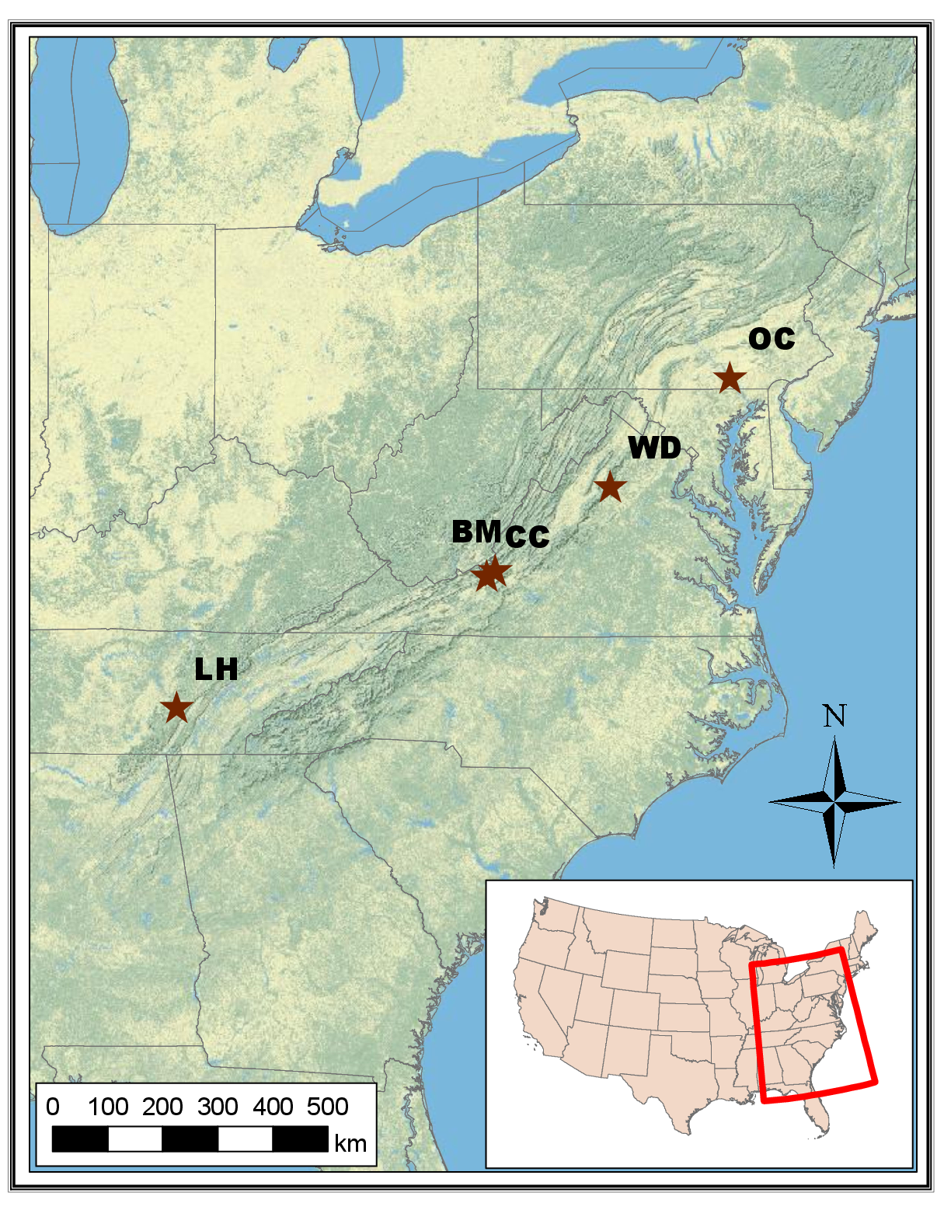

Figure 1: Regional chronology sample locations.

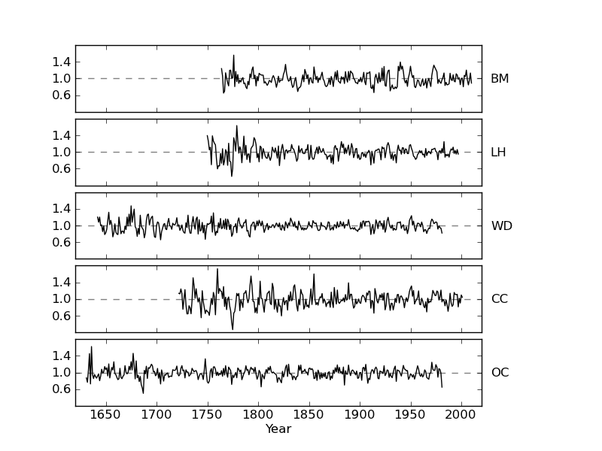

Figure 2: Plots of the five chronologies used in the principal component analysis. The top panel shows the chronology built from the sample data at Brush Mountain (BM), while the others are the regional chronologies from Lynn Hollow (LH), Watchdog Mountain (WD), Craig Creek (CC), and Otter Creek (OC).

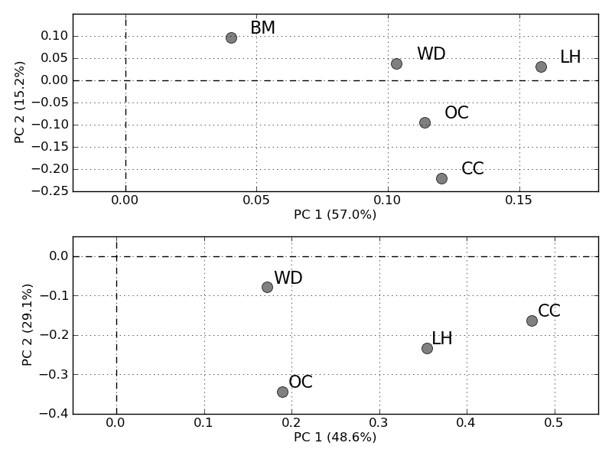

Figure 3: Top: Scatter plot of the loadings for the five chronologies analyzed in the first PCA which covered the period 1845-1981. Bottom: Scatter plot of the loadings for the five chronologies analyzed in the second PCA which covered the period 1750-1981.

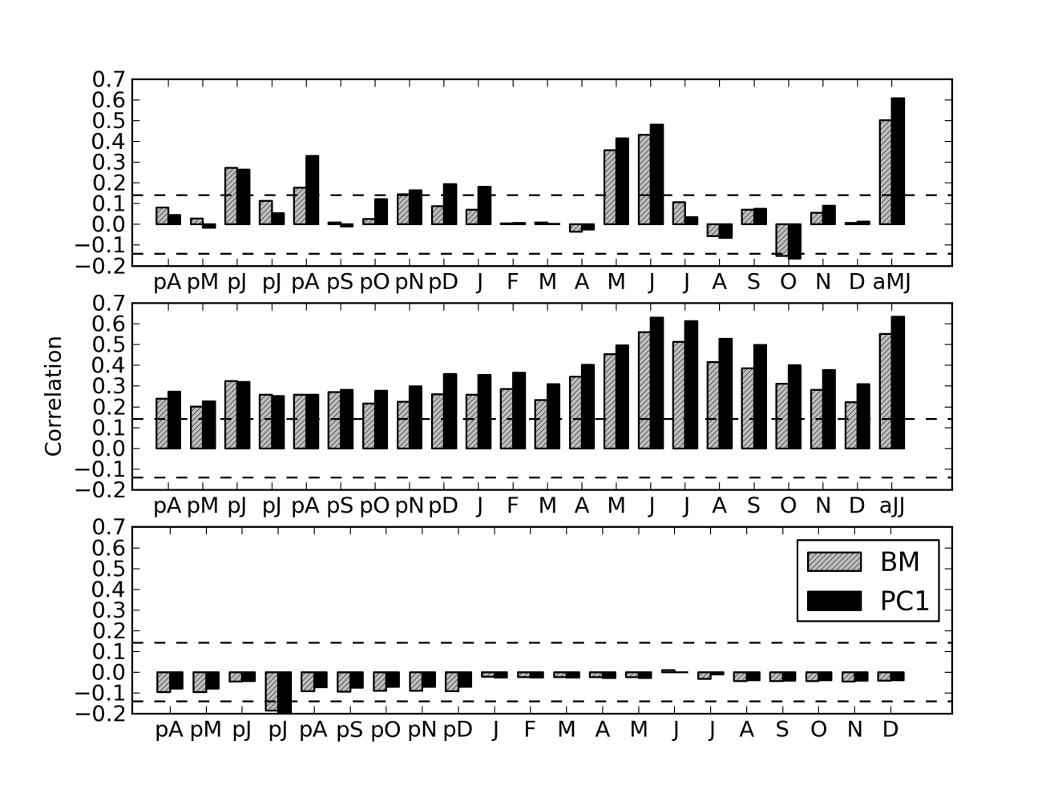

Figure 4: Top: Correlation between the growth proxies (BM or PC1) and the monthly precipitation from previous April (pA) through December (D) as well as for average May and June (aMJ). Middle: Correlation between the growth proxies (BM or PC1) and average PDSI from previous April (pA) through December (D) as well as for average June and July (aJJ). Bottom: Correlation between the growth proxies (BM or PC1) and average monthly temperature from previous April (pA) through December (D).

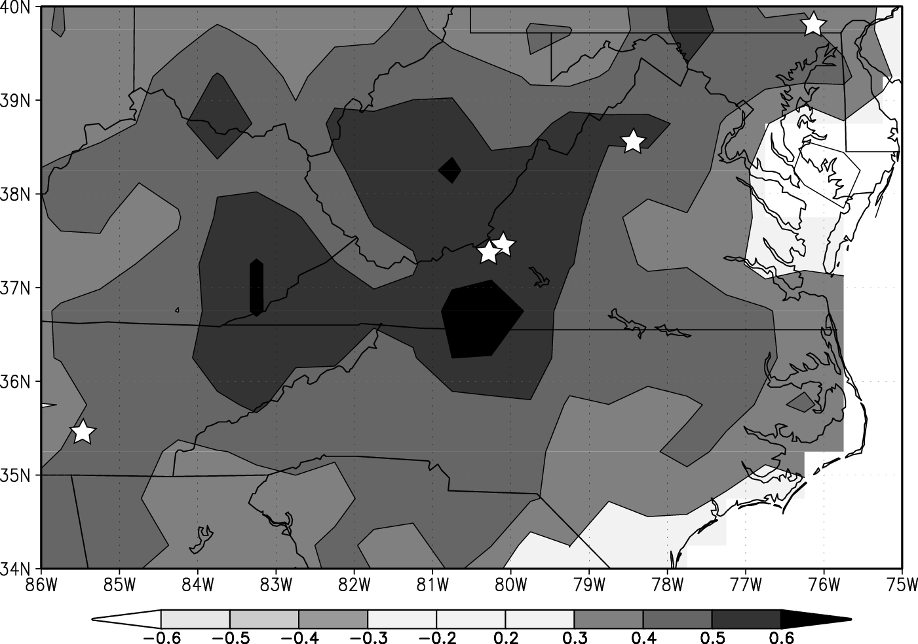

Figure 5: Correlation map showing the correlation between the first principal component and averaged May-June precipitation. Stars indicate the locations of the sites where the tree-rings used to develop the contributing chronologies were sampled.

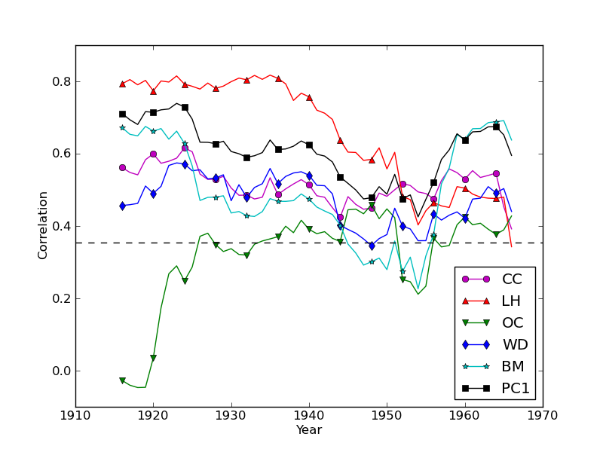

Figure 6: A 31-year windowed correlation plot showing the correlations between each growth proxy (chronologies and first principal component) and mjPR. Correlation points are plotted above the window centers.

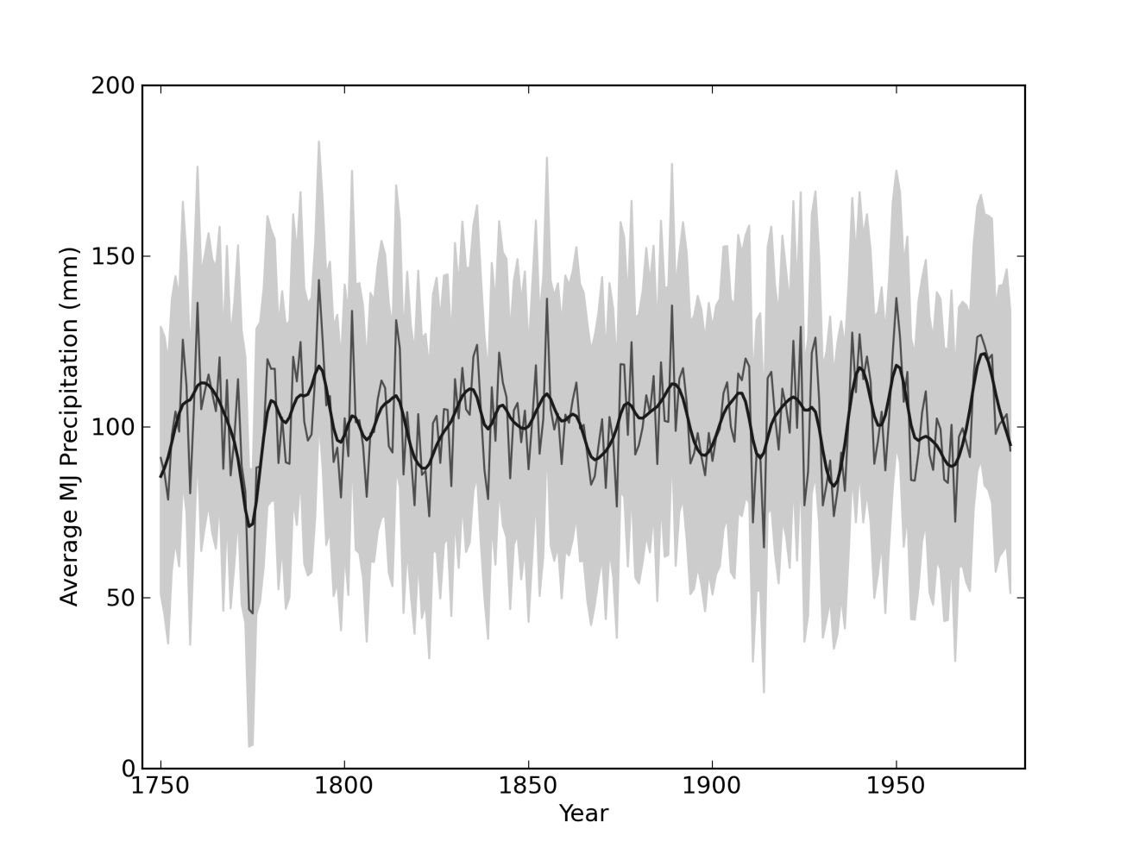

Figure 7: Average May-June precipitation (mjPR) reconstruction (grey curve), smoothed estimate showing decadal-scale variable (black curve), and the reconstruction 95% credible interval (shaded grey region).

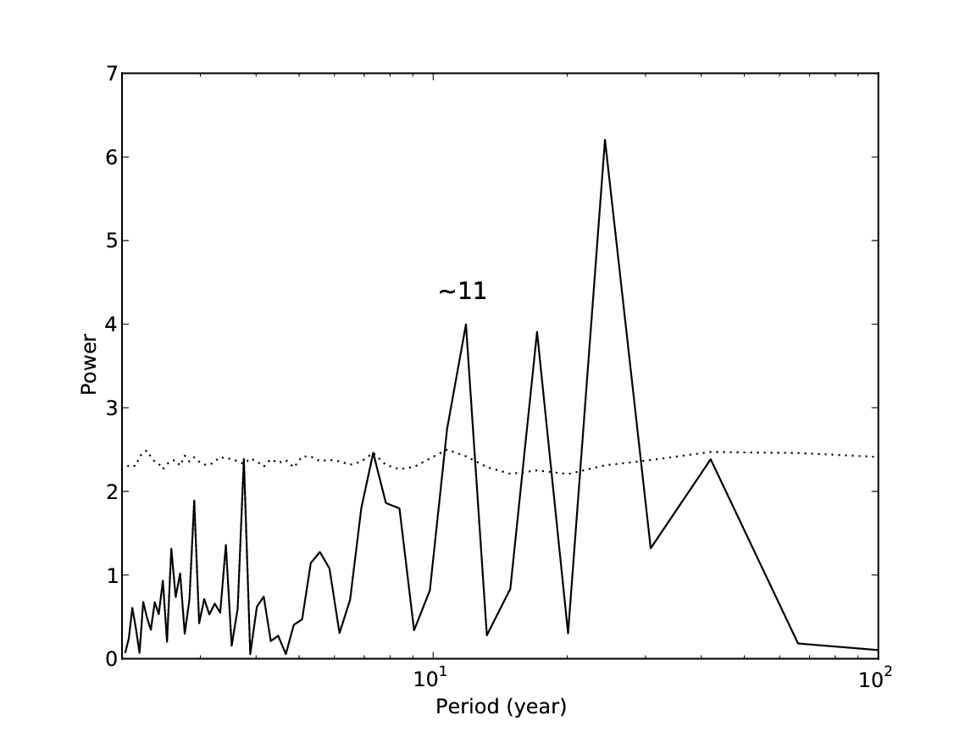

Figure 8: Periodogram showing periodicity of high amplitude at approximately 11, 17, and 24 years.

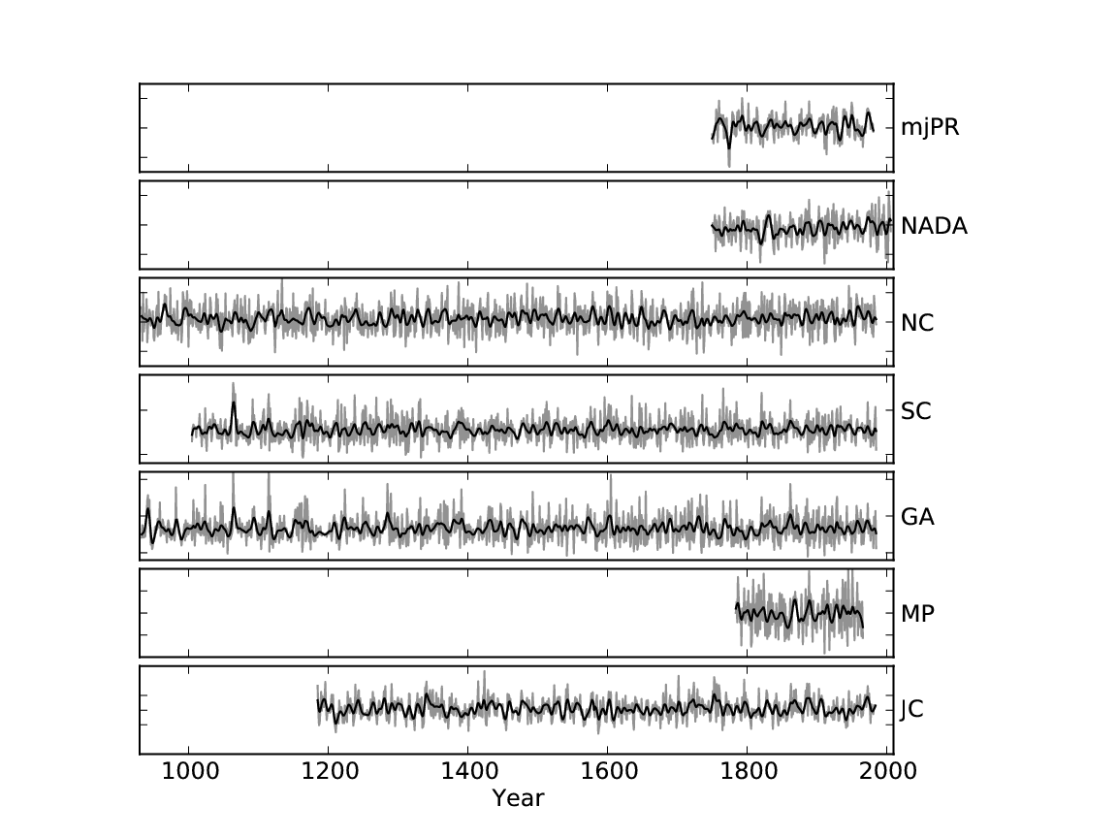

Figure 9: Time series plots showing annual- and decadal-scale variability for the mjPR and six compared moisture reconstructions for the period 933-2008.

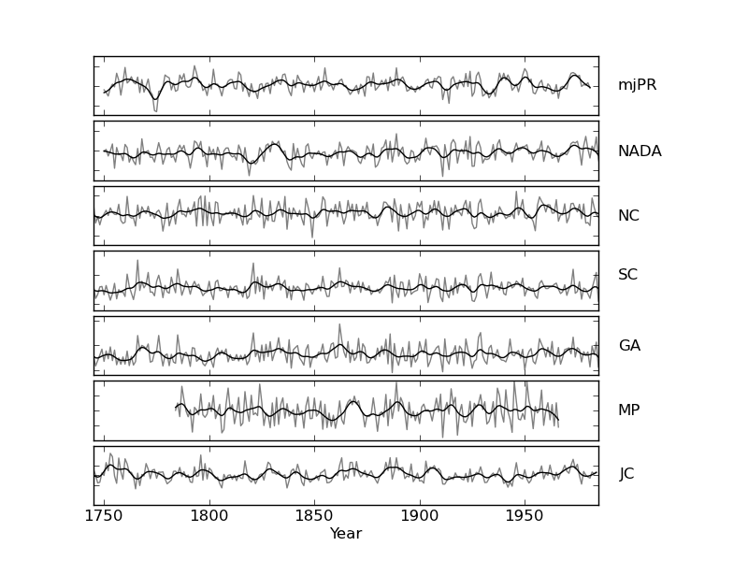

Figure 10: Time series plots showing annual- and decadal-scale variability for the mjPR and six compared moisture reconstructions for the period 1745-1985.

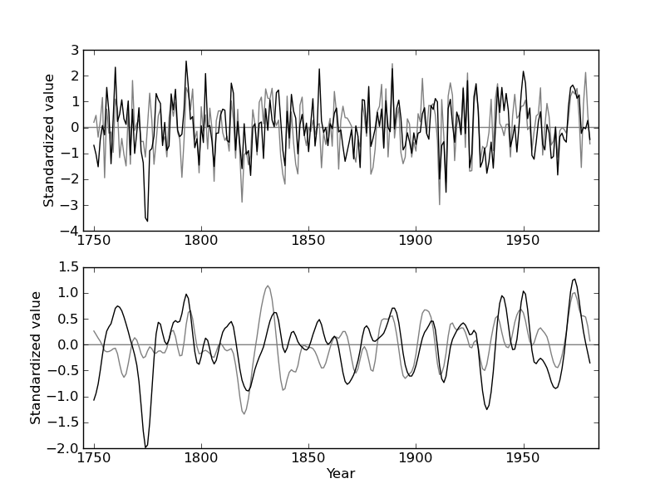

Figure 11: Both the mjPR reconstruction and the Cook PDSI reconstruction are standardized and plotted against time to highlight both the similarities and the differences. Particularly notable differences include the year 1774, and the interval 1855-1863.

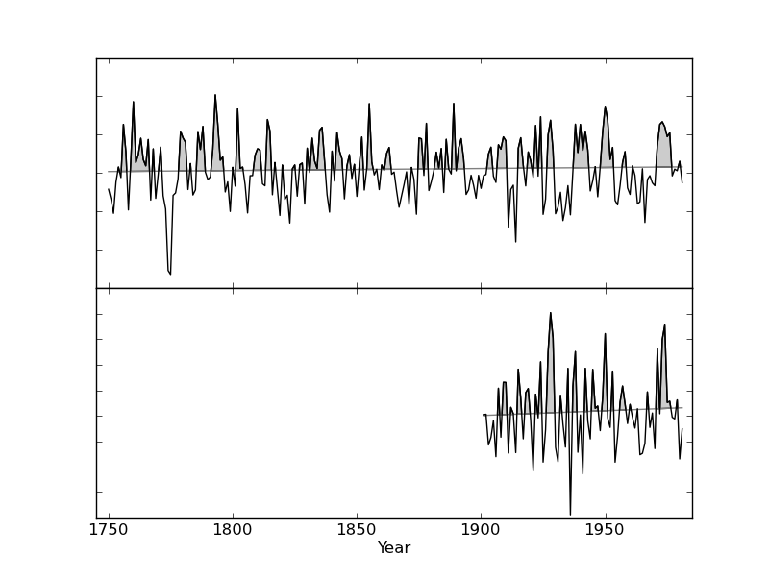

Figure 12: The mjPR reconstruction (top panel) and the mjPR instrumental record (bottom panel). Lines show the best-fit regression line through the time series data to indicate any dominant trends. Areas falling above the best-fit lines and the time series data are shaded grey to indicate periods of higher precipitation. Note the correspondence of wetter and drier years between the top and bottom panels.

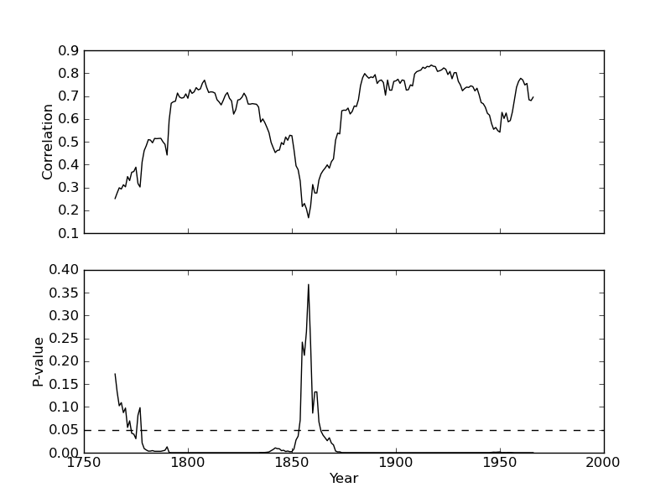

Figure 13: A 31 year windowed correlation plot between the mjPR and Cook PDSI reconstructions shows the discrepancy during the 1855-1863 interval. In the top panel correlation values are plotted about window centers, while the bottom panel shows the corresponding p-value (black) as well as the line of significance (dashed).

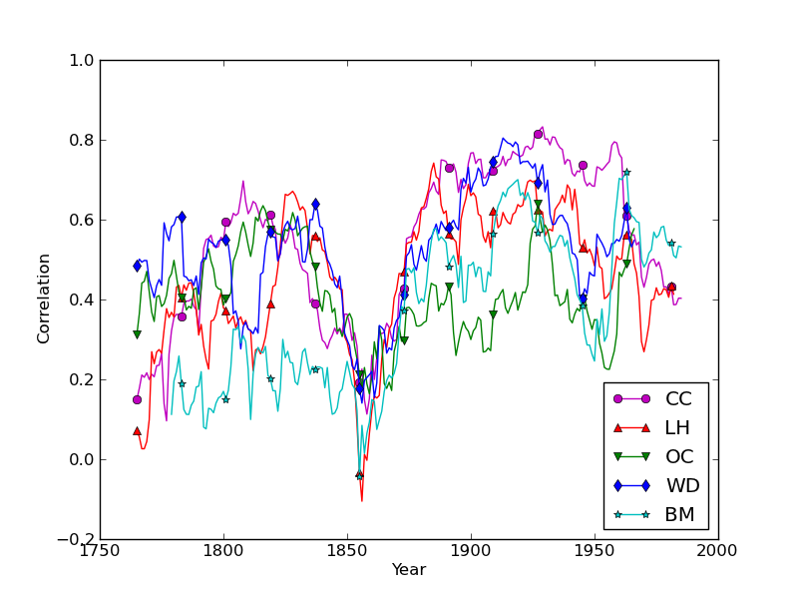

Figure 14: A 31 year windowed correlation plot between each of the chronologies and the Cook PDSI reconstruction. Note the interval of abrupt poor correlation during the years 1855-1863.

### References

[1]    North Carolina Natural Heritage Program (NCNHP). An Inventory of the Significant Natural Areas of Ashe County, North Carolina, 1999. URL <http://www.ncnhp.org/Images/Ashe10-10-2005.pdf>. Accessed September 2012.

[2]    C.E. Zipper, J.A. Burger, J.G. Skousen, P.N. Angel, C.D. Barton, V. Davis, and J.A. Franklin. Restoring forests and associated ecosystem services on appalachian coal surface mines. Environmental management, 47(5):751–765, 2011.

[3]    RK Pachauri and A. Reisinger. Climate Change 2007: Synthesis Report. Contribution of Working Groups I, II and III to the Fourth Assessment Report of the Intergovernmental Panel on Climate Change. Intergovernmental Panel on Climate Change, 2007.

[4]    K. Kattenberg, F. Giorgi, H. Grassl, G.A. Meehl, J.F.B. Mitchell, R.J. Stouffer, T. Tokioka, A.J. Weaver, and T.M.L Wigley. Climate models–projections of future climate. In J.T. Houghton, LG Meiro Filho, B.A. Callander, N. Harris, A. Kattenburg, and K. Maskell, editors, Climate change 1995: The science of climate change: contribution of working group I to the second assessment report of the Intergovernmental Panel on Climate Change, pages 285–357. Cambridge University Press, 1996.

[5]    R. Seager, A. Tzanova, and J. Nakamura. Drought in the southeastern United States: Causes, variability over the last millennium, and the potential for future hydroclimate change. Journal of Climate, 22(19):5021–5045, 2009.

[6]    S. Sobolowski and T. Pavelsky. Evaluation of present and future North American Regional Climate Change Assessment Program (NARCCAP) regional climate simulations over the southeast United States. Journal of Geophysical Research, 117:D01101, 2012.

[7]    E.R. Cook, C.A. Woodhouse, C.M. Eakin, D.M. Meko, and D.W. Stahle. Long-term aridity changes in the western United States. Science, 306(5698):1015–1018, 2004.

[8]    U. Büntgen, D.C. Frank, R.J. Kaczka, A. Verstege, T. Zwijacz-Kozica, and J. Esper. Growth responses to climate in a multi-species tree-ring network in the Western Carpathian Tatra Mountains, Poland and Slovakia. Tree Physiology, 27(5):689–702, 2007.

[9]    D.C. LeBlanc. Temporal and spatial variation of oak growth-climate relationships along a pollution gradient in the midwestern United States. Canadian Journal of Forest Research, 23 (5):772–782, 1993.

[10]    D.W. Stahle and M.K. Cleveland. Large-scale climatic influences on baldcypress tree growth across the southeastern united states. In P.D. Jones, R.S. Bradley, and J. Jouzel, editors, Climatic variations and forcing mechanisms of the last 2000 years, I41, pages 125 – 140. NATO ASI, 1993.

[11]    E.R. Cook, D.M. Meko, D.W. Stahle, and M.K. Cleaveland. Drought reconstructions for the continental United States. Journal of Climate, 12(4):1145–1162, 1999.

[12]    H.C. Fritts. Tree rings and climate. London, New York, San Francisco.: Academic Press, 1976.

[13]    R.L. Phipps. Comments on interpretation of climatic information from tree rings, eastern North America. Tree-ring bulletin, 42:11–22, 1982.

[14]    K. Peters, GC Jacoby, and E.R. Cook. Principal components analysis of tree-ring sites. Tree-Ring Bulletin, 41:1–19, 1981.

[15]    KJ Anchukaitis, MN Evans, A. Kaplan, EA Vaganov, MK Hughes, HD Grissino-Mayer, and MA Cane. Forward modeling of regional scale tree-ring patterns in the southeastern United States and the recent influence of summer drought. Geophysical Research Letters, 33(4):L04705, 2006.

[16]    G.C. Jacoby and R. D’Arrigo. Reconstructed northern hemisphere annual temperature since 1671 based on high-latitude tree-ring data from North America. Climatic Change, 14(1): 39–59, 1989.

[17]    C. Pan, SJ Tajchman, and JN Kochenderfer. Dendroclimatological analysis of major forest species of the central Appalachians. Forest Ecology and Management, 98(1):77–87, 1997.

[18]    J.H. Speer, H.D. Grissino-Mayer, K.H. Orvis, and C.H. Greenberg. Climate response of five oak species in the eastern deciduous forest of the southern Appalachian Mountains, USA. Canadian Journal of Forest Research, 39(3):507–518, 2009.

[19]    D.L. Rubino and B.C. McCarthy. Dendroclimatological analysis of white oak (Quercus alba L., Fagaceae) from an old-growth forest of southeastern Ohio, USA. Journal of the Torrey Botanical Society, pages 240–250, 2000.

[20]    M.A. Stokes and T.L. Smiley. An introduction to tree-ring dating. University of Arizona Press, 1996.

[21]    R.L. Holmes. Computer-assisted quality control in tree-ring dating and measurement. Tree-ring bulletin, 43(1):69–78, 1983.

[22]    H.D. Grissino-Mayer. Research report evaluating crossdating accuracy: a manual and tutorial for the computer program COFECHA. Tree-ring research, 57(2):205–221, 2001.

[23]    E.R. Cook and K. Peters. Calculating unbiased tree-ring indices for the study of climatic and environmental change. The Holocene, 7(3):361–370, 1997.

[24]    E.R. Cook and K. Peters. The smoothing spline: a new approach to standardizing forest interior tree-ring width series for dendroclimatic studies. Tree-ring bulletin, 41:45–53, 1981.

[25]    R.A. Monserud. Time-series analyses of tree-ring chronologies. Forest Science, 32(2): 349–372, 1986.

[26]    E.R. Cook. The decomposition of tree-ring series for environmental studies. Tree-Ring Bulletin, 47:37–59, 1987.

[27]    S. Wold, K. Esbensen, and P. Geladi. Principal component analysis. Chemometrics and intelligent laboratory systems, 2(1):37–52, 1987.

[28]    National Research Council (US). Committee on Surface Temperature Reconstructions for the Last 2000 Years. Surface temperature reconstructions for the last 2,000 years. Natl Academy Pr, 2006.

[29]    J.H. Speer. Fundamentals of tree-ring research. University of Arizona Press, 2010.

[30]    D.W. Stahle, M.K. Cleaveland, D.B. Blanton, M.D. Therrell, and D.A. Gay. The lost colony and Jamestown droughts. Science, 280(5363):564–567, 1998.

[31]    D.W. Stahle and M.K. Cleaveland. Reconstruction and analysis of spring rainfall over the southeastern US for the past 1000 years. Bulletin of the American Meteorological Society;(United States), 73(12), 1992.

[32]    D.L. Druckenbrod, M.E. Mann, D.W. Stahle, M.K. Cleaveland, M.D. Therrell, and H.H. Shugart. Late-eighteenth-century precipitation reconstructions from James Madison’s Montpelier plantation. Bulletin of the American Meteorological Society, 84(1):57–72, 2003.

[33]    HC Fritts, J. Guiot, GA Gordon, and F. Schweingruber. Methods of calibration, verification, and reconstruction. Methods of Dendrochronology, pages 163–217, 1990.

[34]    Y. Li. Dendroclimatic Analysis of Climate Oscillations for the Southeastern United States from Tree-ring Network Data. PhD thesis, University of Tennessee, 2011.

[35]    P.A. Robertson. Factors affecting tree growth on three lowland sites in southern Illinois. American Midland Naturalist, pages 218–236, 1992.

[36]    R. Zweifel, L. Zimmermann, F. Zeugin, and D.M. Newbery. Intra-annual radial growth and water relations of trees: implications towards a growth mechanism. Journal of Experimental Botany, 57(6):1445–1459, 2006.

[37]    RE Dickson and PT Tomlinson. Oak growth, development and carbon metabolism in response to water stress. In Annales des Sciences Forestières, volume 53, pages 181–196, 1996.

[38]    C.D. Oliver. Forest development in North America following major disturbances. Forest ecology and management, 3:153–168, 1980.

[39]    M. Beniston, HF Diaz, and RS Bradley. Climatic change at high elevation sites: an overview. Climatic Change, 36(3):233–251, 1997.

[40]    D.C. Edwards. Characteristics of 20th century drought in the United States at multiple time scales. Technical report, DTIC Document, 1997.

[41]    R.A. Pielke Jr and C.N. Landsea. La niña, el niño and atlantic hurricane damages in the United States. Bulletin of the American Meteorological Society, 80(10):2027–2033, 1999.

[42]    D.J. Hancock and D.N. Yarger. Cross-spectral analysis of sunspots and monthly mean temperature and precipitation for the contiguous United States. Journal of Atmospheric Sciences, 36:746–746, 1979.

[43]    K. Lassen and E. Friis-Christensen. Variability of the solar cycle length during the past five centuries and the apparent association with terrestrial climate. Journal of Atmospheric and Terrestrial Physics, 57(8):835–845, 1995.

[44]    E.R. Cook, D.M. Meko, and C.W. Stockton. A new assessment of possible solar and lunar forcing of the bidecadal drought rhythm in the western United States. Journal of Climate, 10 (6):1343–1356, 1997.

[45]    G.C. Reid. Solar irradiance variations and the global sea surface temperature record. Climate Change: Natural forcing factors for climate change timescales 10-1 to 10-5 years, 2:7, 2002.

[46]    National Research Council Board on Global Change. Solar Influences on Global Change. The National Academies Press, 1994. ISBN 9780309051484. URL <http://www.nap.edu/openbook.php?record_id=4778>.

[47]    J.E. Nichols and Y. Huang. Hydroclimate of the northeastern United States is highly sensitive to solar forcing. Geophysical Research Letters, 39(4):L04707, 2012.

[48]    S.W. Franks. Assessing hydrological change: deterministic general circulation models or spurious solar correlation? Hydrological Processes, 16(2):559–564, 2002.

[49]    R.A. Warrick et al. Drought in the great plains: A case study of research on climate and society in the USA. Climatic constraints and human activities, 10:93–123, 1980.

[50]    C.M. Ruffner and M.D. Abrams. Relating land-use history and climate to the dendroecology of a 326-year-old Quercus prinus talus slope forest. Canadian Journal of Forest Research, 28(3):347–358, 1998.

[51]    State of California. Drought conditions in California. Technical report, Department of Water Resources, 1990.

[52]    M.P. Lawson and C.W. Stockton. Desert myth and climatic reality. Annals of the Association of American Geographers, 71(4):527–535, 2005.