**Manual TLS 1.2 Configuration**

1. Download TLSSettings.zip from [andydeangelis/TLS_PowerShell_Standalone](https://github.com/andydeangelis/TLS_PowerShell_Standalone/archive/refs/heads/main.zip).
2. Copy TLSSettings.zip to server where the changes are to be made and extract the contents.
   1. NOTE: Where you download the zip file doesn’t matter, as the batch file will create the C:\Scripts\TLS directory, copy the contents to that directory and run the PowerShell script from there.
3. On the server where changes are to be made, right click the TLSSettings.zip file, and then click Extract All. Accept the defaults and then click OK.

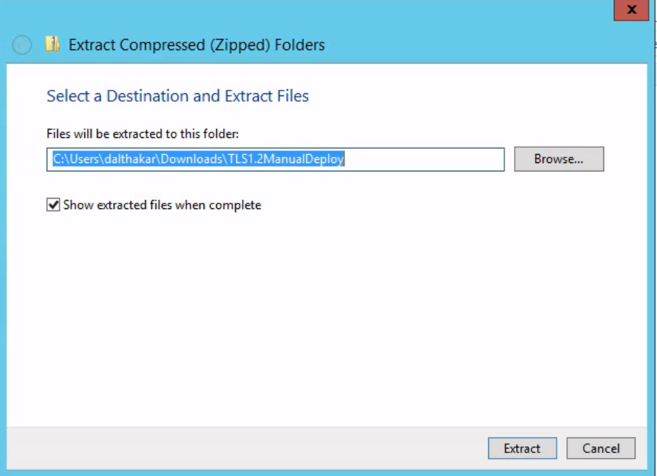

1. Right click the **applyTLSSettings.bat** file and then select “Run as administrator.”

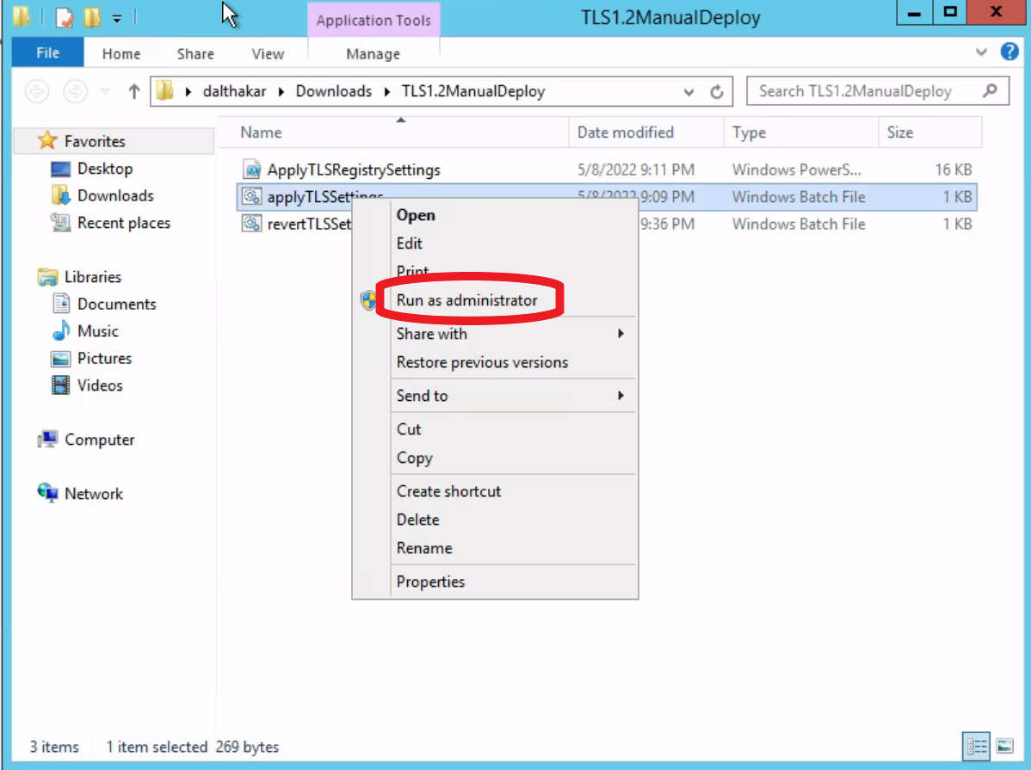

1. The script generates a log file located in C:\scripts\TLS\reports for any errors.

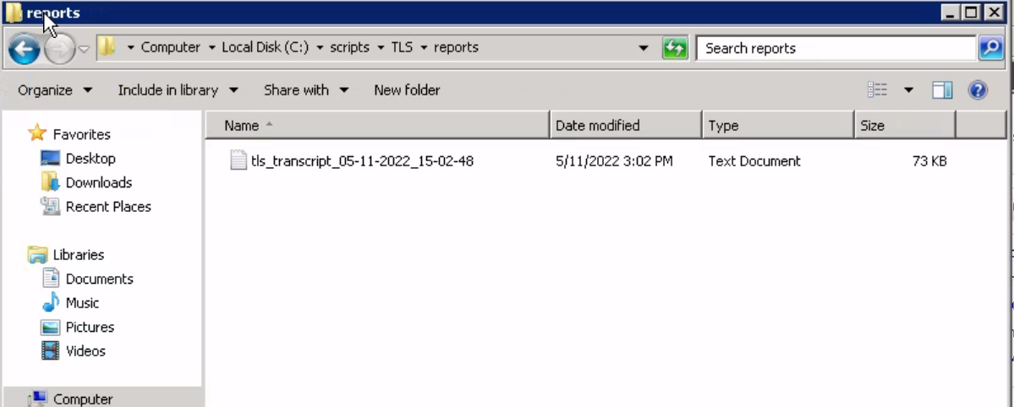

1. Reboot the server for the changes to take effect.

**TLS 1.2 Deployment Rollback**

1. On the server needing a rollback, navigate to C:\scripts\TLS\.
2. Right click the **revertTLSSettings.bat** file, and the select “Run as administrator.”

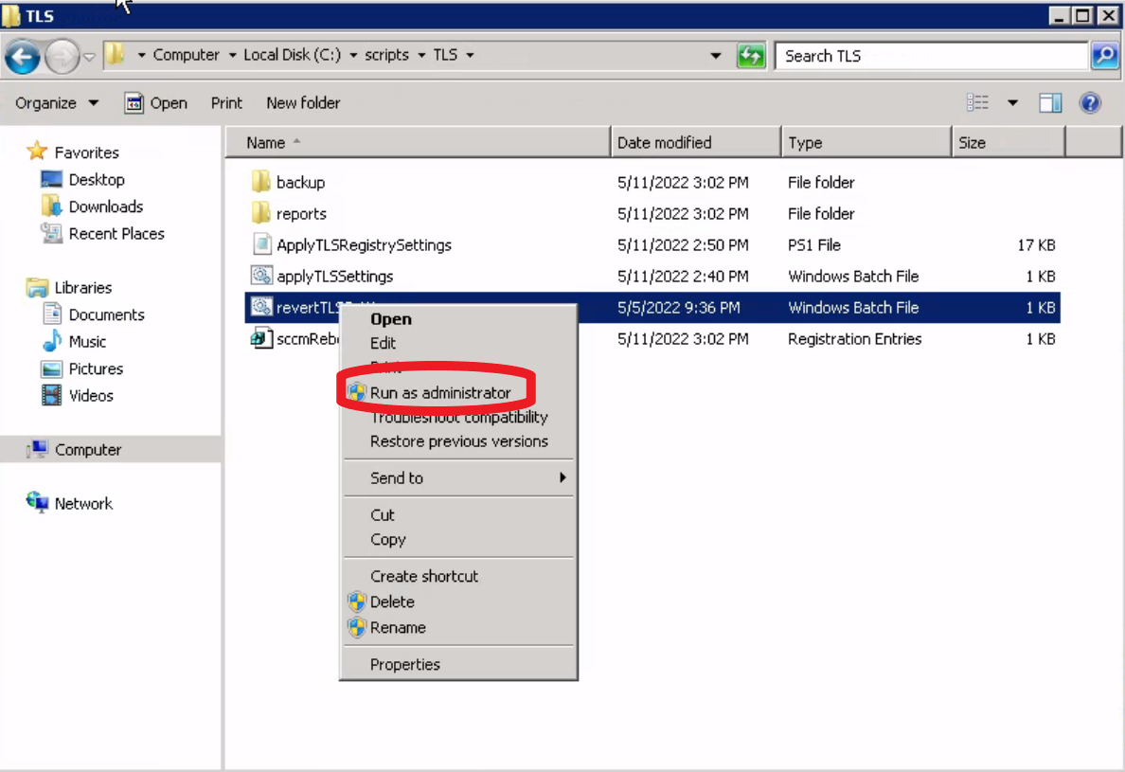

1. In the resulting command prompt window, review the out for any errors, and then press any key to close the command prompt window.

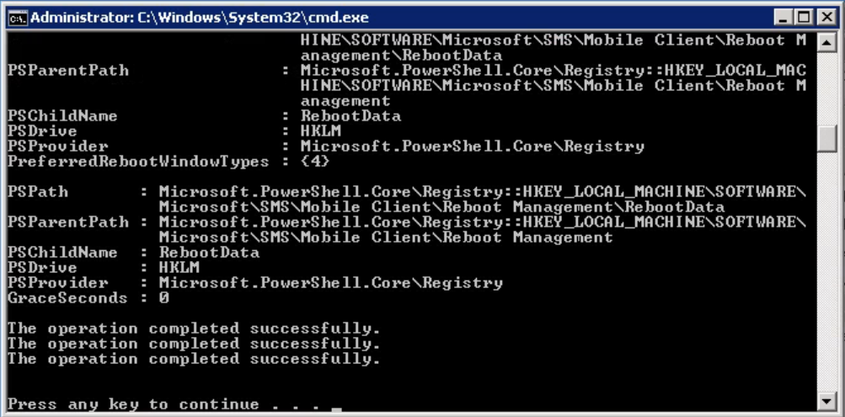

1. Reboot the server for the changes to take effect.