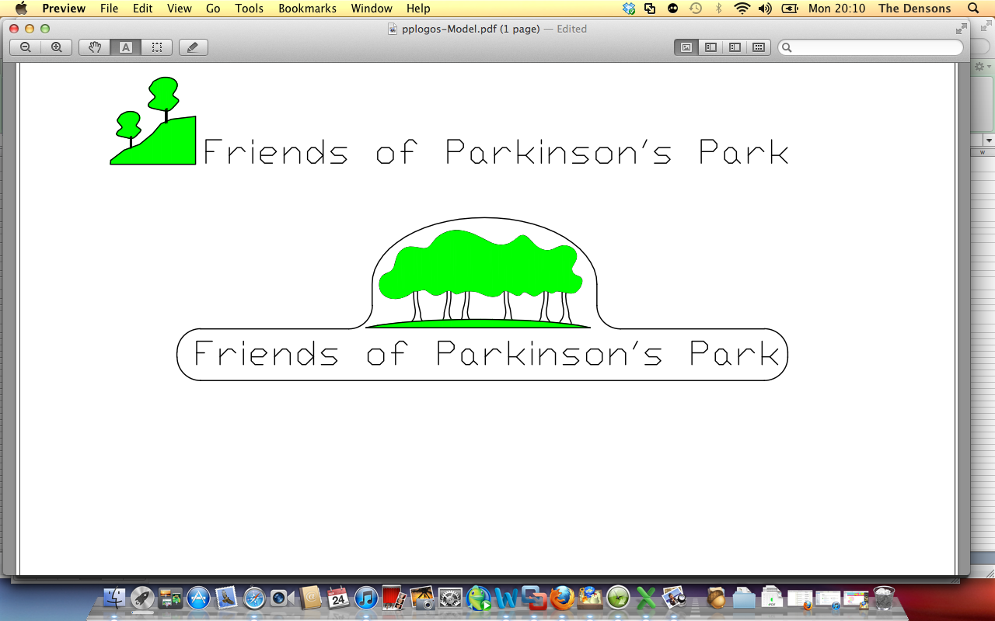

Annual General Meeting

Minutes for 2013-2014

7-9 pm 30th April 2014 at Guiseley Methodist Church

Friend Attendees

Josie Brooks
Jenny Kirkby
Chris Parapia ( Chairperson)
Barbara Winfield
Ann Riley
Liakat Parapia
Sue Jackson
Richard Lamb
Martyn Hornsby Smith
Vivien Hornsby Smith
Mary Walker
Tim Riley
Pauline Riley

Apologies Received from
Colin Alexander
Andy Cheetham
Nicola Denson
John Denson

Item 1 Welcome and Apologies (CP)

Chris welcomed everyone to the meeting and read out apologies as received above.

Item 2 Chairpersons Annual Report

Chris thanked all the committee members, friends and supporters of Friends of Parkinsons Park for their outstanding contribution to this year’s achievements.
She also gave a brief overview of the events and work carried out during the last 12 months, including the Archeological Survey undertaken in July 2013, Children’s Play Session in August run by Aireborough Extended Services and Leeds Play Network,Traditional Children’s Gala held in September 2013 and Christmas lantern parade held in December 2013. There have been more planting of spring bulbs once again kindly donated by Groundwork Trust, further development of entrances with plants, Friends Social Evening in November 2013, installation of additional benches, wildflower area development and litter picking and continued efforts to reduce anti-social behaviour in the park.
All donations and fundraising efforts were also acknowledged as was the support of our local councillors and our MP Stuart Andrew.
Chris outlined the challenges still to come for the Friends including continuing negotiations with Bellways and Meadfleet and with other council stakeholders.
Paths and access are particularly important as is the push to secure the long term preservation and tenure of the park in perpetuity for the people of Guiseley, both for our generation and those who will follow after us. Parkinson’s park is really the only piece of wild open space left in the Guiseley area and we must strive hard to ensure that it stays that way.
Chris also thanked Jenny for her fascinating talk about the history of Parkinson’s Park and the contribution of Barbara in enabling this to come to fruition.

Item 3 Strategic Marketing, Land Officer and Education Report ( Jennifer Kirkby)
Proposed by by Chris Parapia and seconded by Barbara Winfield

Item 4 IT and Facilities Annual Report Proposed by Josie Brooks and seconded by Martyn Hornsby Smith

Item 5 Ecology Officers Report ( Josie Brooks) Proposed by Barbara Winfield and seconded by Liakat Parapia .

Item 6 History and Education Report Barbara Winfield. Proposed by Vivien Hornsby Smith and seconded by Richard Lamb

Item 7 Fund Raising Officer Annual Report ( Chris Parapia in the absence of Nicola Denson) proposed by Josie Brooks and seconded by Martyn Hornsby Smith

Item 8 Treasurers Annual Report ( reported by Chris in the absence of Colin Alexander)Treasurer. The meeting accepted and approved the accounts and was proposed by Chris Parapia and seconded by Vivien Hornsby Smith

Item 9 Appointment of Independent Assessor
The meeting approved the appointment of Tony King as the independent Assessor. Proposed by Chris Parapia and seconded by Jenny Kirkby

Item 10 Review of objectives and approval of plan objectives for 2014/2015. There were no changes to the objectives for the forthcoming year.

Item 11 Discussion and review of planned programme of work for 2014/15
A written schedule of the programme of work proposed was circulated to all present and was approved and agreed. Proposed by Chris Parapia and seconded by Josie Brooks

Item 12 Review of Friends Subscriptions for 2014/15
This item was deferred in the absence of Colin Alexander

Item 13 Discussion of Constitution Amendments received by 18th April 2014
Chris reported that she had received no requests for amendments by the due date.

Item 14 Election of up to 10 Committee Officers
No other nominations or resignations have been received by the due date. All officers to continue to serve in their current roles for the forthcoming year.

Item 15 All Our Stories Project
This item was incorporated into Jenny Kirkby’s Report( Item 3)

Item 16 AOB

Date of Next AGM

Wednesday 23rd April 2015 at 7pm. Venue to be confirmed.

Please note that the date has now been changed to Wednesday 13th May at 7.30pm at Guiseley Methodist Church.

