Friends of Parkinson’s Park Management Plan
2025-35

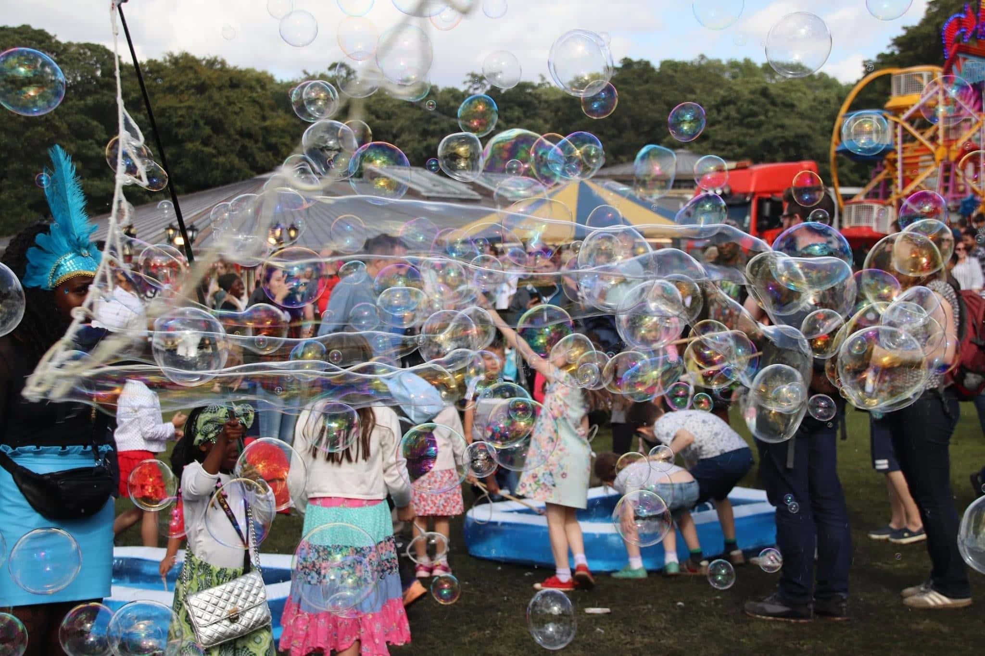
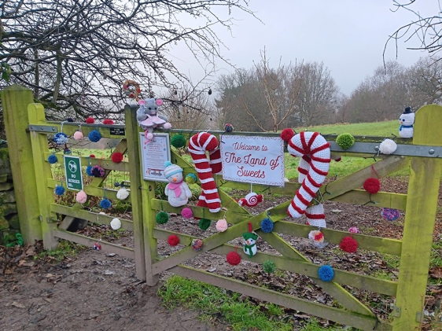
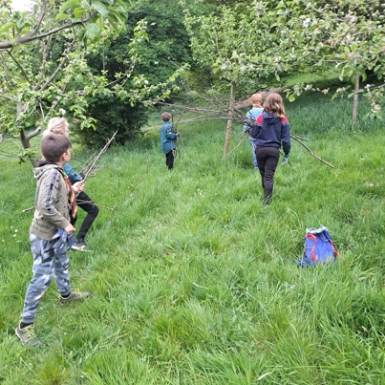
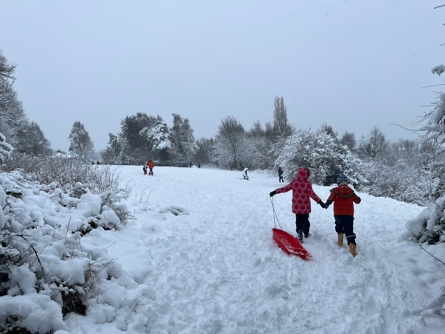
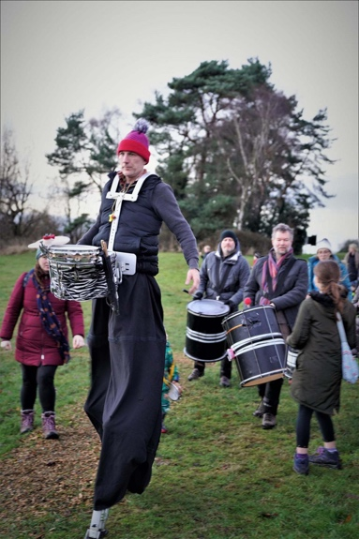
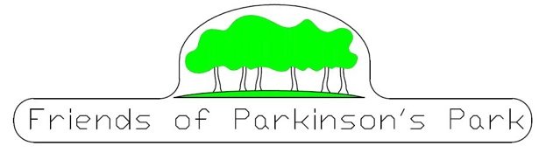



Friends of Parkinson’s Park Management Plan
Winter 2025/26
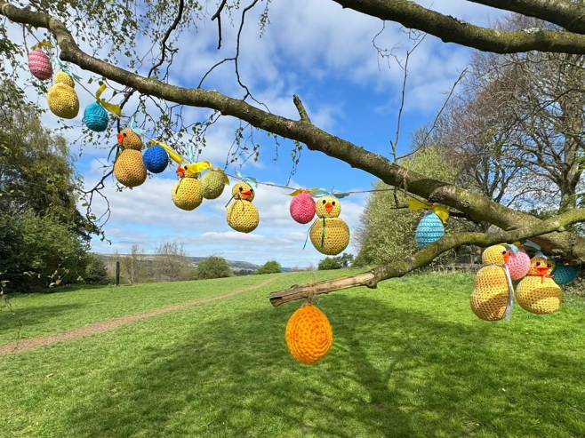
Parkinson’s Park is located in Guiseley and sits on the hillside between Netherfield Road, and Kelcliffe Lane, behind what used to be Crompton Parkinsons factory site and is now Edison Fields housing estate. It is accessible from entrances on Hillside Avenue, Nethercliffe Crescent, Kelcliffe Lane, Greenshaw Terrace, Oxford Avenue, Edison Way and Tesla Lane.

The land has long been a greenspace having been given to the people of Guiseley to use as a park by Frank & Albert Parkinson in the 1930’s: it has been used for walks, play, and events ever since.

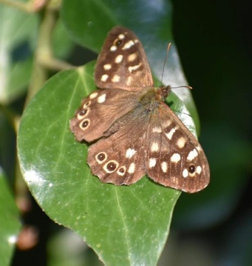
Currently Leeds City Council classes Parkinson’s Park primarily as a Natural Green Space where ecological conservation, development and education is the focus. Its secondary uses are as a Community Park and a Green Corridor as it links different urban and landscape areas.

The park has an interesting mix of different habitats and biodiversity, which supports a wide range of plants and wildlife. For more history, environment, ecology and geology of the park please see our website https://parkinsonspark.co.uk

The park is owned by Bellway Homes, and basic maintenance is done by Meadfleet. Although the park is not owned by Leeds City Council we try and adhere to their Park Byelaws and their Dogs in Public Spaces Protection Order when managing the park (appendix 1).

The Friends of Parkinson’s Park CIC (FOPP) was set up to consolidate the existing group who had already been working for several years to make the park an attractive green space for community use and events. They came together initially after the park had become overgrown and unloved for a few years.

Our central aim is to ensure a well-managed public ‘landscape’ park that honours its social, cultural and environmental heritage. This plan will set out how we intend to do this.

The map overleaf gives a good overview of the park and its various environments and how we are trying to develop them.

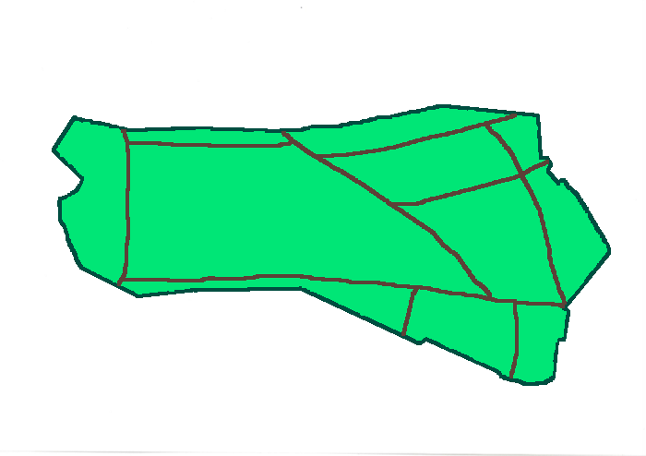

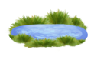










Bog Garden
Orchard
Farmgate Entrance
Hillside Entrance
Sheepfold
Entrance
Bottom Copse
WARNING:
Steep Slope
Nethercliffe
Entrance
Oxford Ave Entrance
Greenshaw Entrance
Edison Way Entrance
Bluebell Wood
Tesla Entrance
Top Copse
Noticeboard

Natter bench

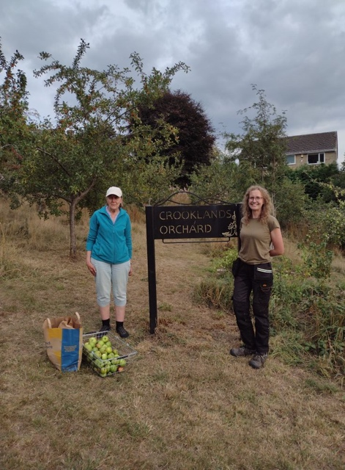
Some key areas of the park include the top and bottom copse, the bog garden, the wildflower meadow, the orchard and bluebell wood. Apart from the seats, signage and paths our facilities are mainly natural, which fits with our aims to keep the park as a greenspace with low key additions.

The park attracts a wide age range of visitors and most live locally and visit more than once a week. They are often walking their dog, taking children to school or using the park as part of their fitness route. People’s visits are usually around half an hour, but the benches around the park encourage people to sit and relax for a while longer, especially on a lovely sunny day where you can see for miles.

Most people get to the park on foot and in consultation have shown to be happy with the park facilities given the park’s ethos, although issues of litter/dog poo and dogs off leads are often brought up.

We are currently trying to develop the paths with at least one, probably at the top, being accessible to improve access for all. We are also trying to get the bridlepath at the top redone as it is currently in a very poor state. This is ideally how the path would be accessed.

Cycles, horses, motorbikes and electric bikes are not allowed in the park for safety reasons, fires and fireworks should not be lit, and BBQs are forbidden. Dogs should be under their owners close control and have good recall if they are off the lead. This is in line with LCC Parks Byelaws.

Friends of Parkinson’s Park Committee and Current Roles

FOPP is entirely run by volunteers, none of whom get any type of payment for the roles they fulfil. Meetings are held approximately every 6 weeks and are quorate when three directors are present. We have a standard agenda that allows us to discuss the relevant issues and come to an agreement on what our priorities are for the next period and what work needs to be done. The group, park improvements and events are entirely funded by donations and grants.

Directors

- Chris – Chair, Maintenance Director (oversight of maintenance plan), Volunteer Co-ordinator and Meadfleet link
- Susan – Vice Chair and Secretarial Director (minutes, agendas, AGMs)
- Ryan – Finance and Funding Director
- Nicola – Project Planning and Publicity Director (Oversight of project improvement plan and Facebook)
- Josie – Ecology Director
- Hazel – Membership Director (processing membership, keeping details up to date, sending out relevant information)
- Andy Cheetham – Technical and Facilities Director (Website and Email)

The current outstanding roles are:
- Events (Oversight of events plan) and Marketing Director (Newsletter)

We always need more committee members and volunteers and apart from the above role we would also benefit from a:
- Volunteer & Working Party Co-ordinator

New Directors/Committee members would need to take on one of these roles.

We work with a wide range of other organisations and local groups. Our main stakeholders are:

- Bellway
- Friends of Parkinson’s Park
- Community
- Local ward Cllrs
- Local organisations
- Local businesses
- National Agencies
- West Yorkshire Police
- Local Churches

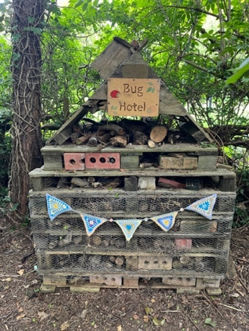
We are also lucky to have several key groups we work with in the park. They are:
- Honey Badger Explorers
- Good Grief Guiseley
- Aireborough Rotary
- Guiseley Methodist Church Green Team

- Guiseley Primary school
- Open Country
- Incredible Edible
- St Oswald’s Eco Team
- Aireborough Together
- 14th Airedale Scouts

Funding

As mentioned previously we don’t receive any regular funding, but we are well supported by the local community with donations, especially at our two local events the Gala and the Lantern Parade and have been successful in the past at receiving grants from the local council and Councillors, Heritage Lottery and Green Leeds, amongst others. Our accounts are available at Companies House and are filed annually.

AGM and Consultation

Previously we have held an annual AGM, which was well attended, and it is our intention to have these again to allow us to feed back to people what has been going on and to try and encourage more volunteers. These will be held in an accessible venue and publicised using local community channels, including the park notices and Facebook.

We are also hoping to hold an annual consultation event, either at the AGM, at the gala or independently to get feedback on our plans and hold discussions about any new ideas.

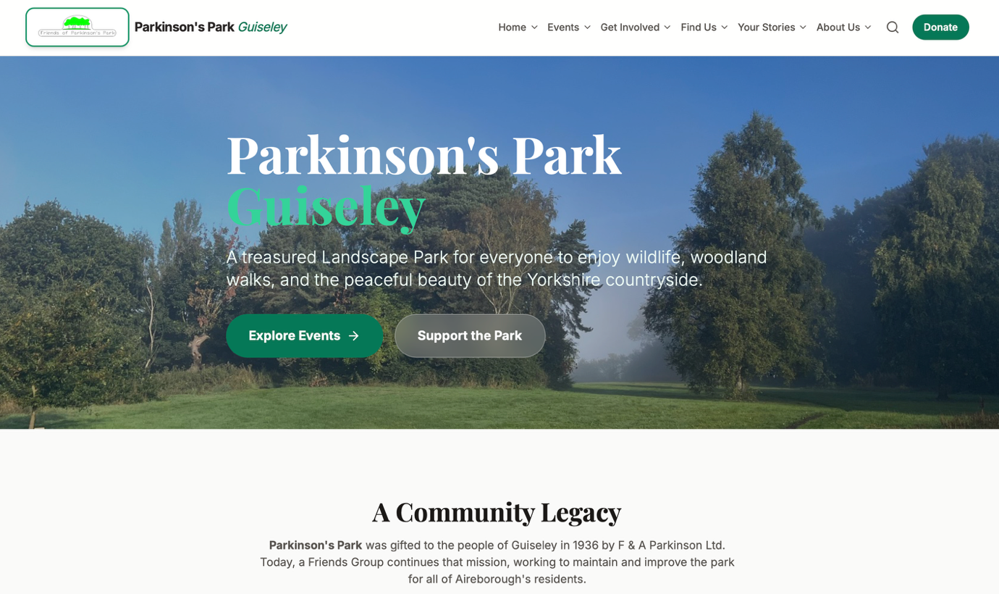

Our website, which has recently been updated (the previous format Wordpress is not used as much anymore), Facebook and notices in the park and at key local venues are the main ways we currently communicate with local residents and those who have moved further afield but have fond memories of the park and want to keep in touch.

We publish a list of events for the year so people can see what’s going on and hopefully either put it in their diaries or offer to help. We also sometimes get articles in the local paper, The Wharfedale Observer, which helps raise our profile to a wider audience.
There are a number of leaflets available for the park including an i-spy leaflet for children, one on the orchard and its fruit trees and a history leaflet produced with funding from the Heritage lottery. There are also several interpretative boards around the park, all these documents are also available on our website.

We also produce a short round up note that is handed out at the gala, but if we had someone who was willing to take on the task we would love to produce an annual newsletter.
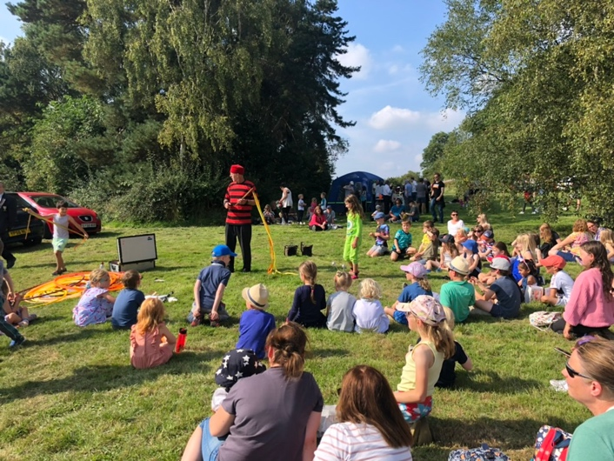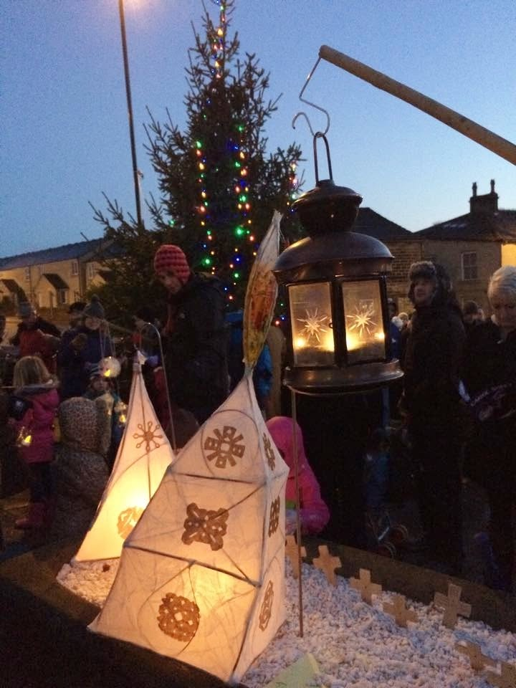

Our main two events every year are the gala held in September (usually on the first Sunday) and the Lantern Parade. These are both well attended and thought of in the local community. We also hold working parties focussing on specific projects and areas of the park, joining in with the Great British Spring Clean in March.

As a group we have regular walkabouts in the park and have bi-annual walkabouts with Meadfleet to discuss the current and future work programme and raise any issues, for example rotten steps, broken gate latches, trees in need of attention.
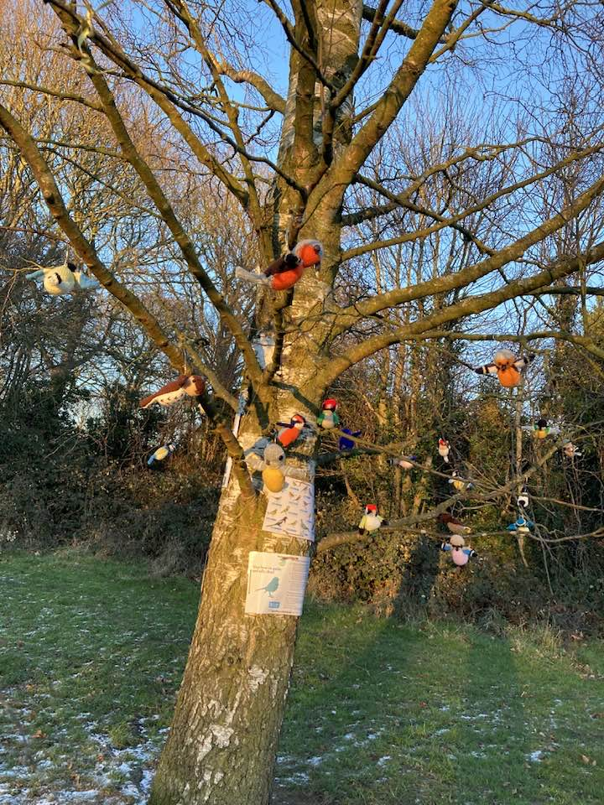
The Celebration Tree is a key focal point in the park and is often used as a meeting point for users. During Covid we increased the decorations and it is now decorated every month with a different theme. Local residents are encouraged to add their own decorations, and the schedule is posted well in advance so people can join in.

We also help to raise our community profile by being involved with events other groups run including Guiseley Carnival, St Oswald’s Christmas Tree Festival, Love Parks, Aireborough Together events and monthly walks and we are going to be involved in 2026 with Aireborough’s first Kindness Festival, which is being organised by Full Circle.

For a full timetable of all events throughout the year see Appendix 3.

In the past we have discussed having a membership scheme and this is something we would be very keen to develop so watch this space
Previous Projects Carried out

We may not have had a full plan in the past that brought everything together, but this did not have an impact on the amount of work that has been undertaken in the last 15 years. Some of the park projects that have been completed include:
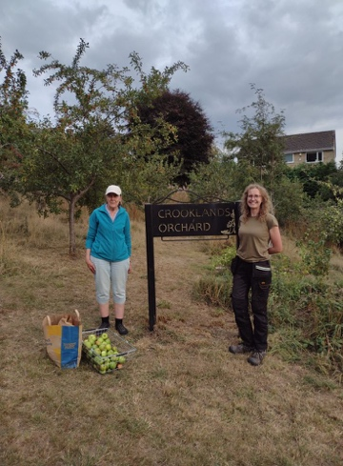
Crooklands Community Orchard – grant from Leed Inspired, LCC - apple details available on website.
Benches – personal donations and grants from Local Councillors.
Trail Leaflets and Noticeboard Interpretation Boards – Heritage Lottery Fund and Ark Display and available on our website.
Bog Garden – grants from Northern Horticultural Society, Green Leeds, Meadfleet and Local Councillors. Work carried out by Open Country and Tel Landscape Architects.
Hibernaculum (Bug House) – with Guiseley Primary school.
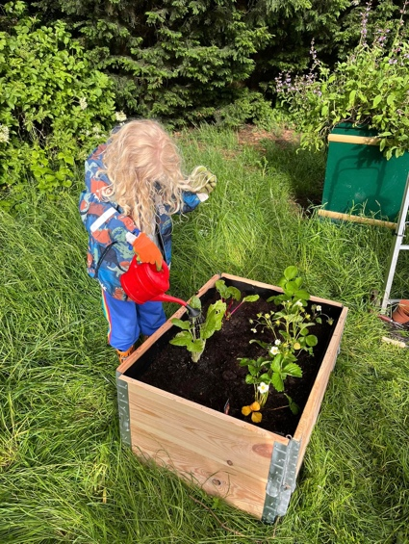
Jubilee Walk Hedgerow – grant from Woodland Trust.
Hedge Laying – funded by Bellway Homes.
Farm Gate Wildflowers – grants and seeds from various organizations.
Farm Gate Herbs – Incredible Edible Aireborough.
Great Brow Acid Grassland Enhancement – RHS grant for heather.
Entrance Improvements – Individual FOPP Members each of an area.
Bulb planting – from bulbs received from Groundwork each year.
Dry Stone Wall Maintenance – Otley Dry Stone Walling Association.
Woodchip paths – woodchip donations and grant from Green Leeds, Meadfleet and local Councillors.
Bird & Bat Boxes – donations from Brooks Ecologicial and Meadfleet.
Wildflower, tree and shrub areas at the bottom of the Park were planted by Bellway as a condition of their planning permission.
Greenshaw Woodland – This was planted in January 2020 by Brooks Ecological. It consists of 100 native trees, underplanted with woodland plants such as primroses.
Benches – purchased in memory of loved ones, from local councillors, and The Brethren of Harewood Masonic Lodge. Plaques indicating all bench donors are on individual benches.

Our current CIC report gives a more in depth look at what we’ve achieved over the past year (and past ones) and is available on our website. This is how we report back to the government on how successful we feel we have been on this. We were designated as a CIC in 2016 and our constitution is attached at appendix 2.

Current Plan 2025-35

This new plan has been written over Winter 2025/26 and will be presented at our next AGM for consultation and adoption. It will be updated on an ongoing basis and will be reviewed every 10 years.

We have not yet done any formal consultation on this plan, but we have discussed the issues on an ongoing basis with local residents and groups. We will hopefully do some more formal consultation at the gala this year, which will feed into the plan.

We hope the plan will showcase the work we have already done and give us focus for the future making sure new fulfil our requirements and keep the park as a treasured greenspace in the minds of local people.

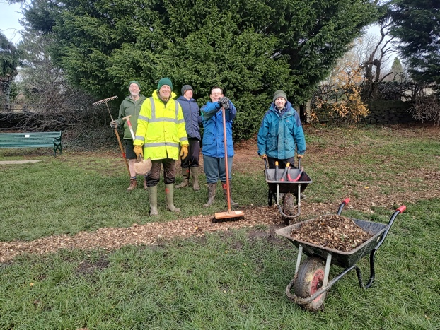
Looking at our previous aims and consultation carried out the main items that are outstanding include the issue with siting dog bins/additional bins. We used to have bins much nearer the park but they were moved onto the road for operational issues. Whilst most dog owners do use the bins provided and pick up after their dog, and often other dogs, we do still have issues in the park and the paths leading to it.

We also have not been able to solve the issues of better paths, and whilst wood chipping them regularly helps it is not a long terms solution. This will continue to be investigated with local Cllrs and the landowners. Particularly when the ground is muddy the park becomes inaccessible for wheelchairs and buggies.

Environmental Policy

The park is obviously beneficial to the wider area in just being a large greenspace, but as a group we are keen to enhance this by diversifying the numbers of flora and fauna found on the site, whilst keeping a natural and traditional feel. This means that local wildlife and the trees and the plants are the most important thing for us.

We do not use any chemicals in the park, and should the need arise would not use a peat-based compost. Weeds are tackled by strimming, cutting and hand weeding. Where possible materials are reused, for example dead wood for fences and pinecones used to refill the hibernaculum. The grass cuttings are left to enrich the grass and soil, and bugs are encouraged with branches being left in piles and areas being left rough. We also have a wildlife corridor at the far end of the park where a wide buffer of brambles is left. This makes the perfect habitat for a wide range of insects and small mammals as they can’t be disturbed by humans or dogs very easily.

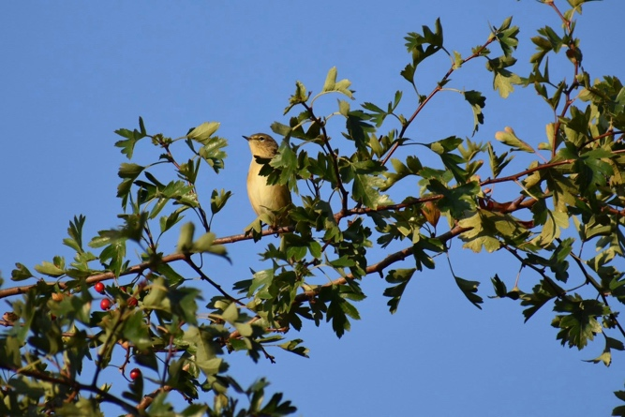
We also try and attract a wide range of birds, insects and other creatures with the building of the bog garden, putting up bird and bat boxes, wildflower planting, the building of the hibernaculum, habitat conservation, orchard planting and many other activities and improvements.

It would be nice if we could also add to the pick your own produce around the park. We currently have an herb planter, apple, pear and plum trees, rhubarb, blackberries, crab apples, sloes, wild garlic to name but a few.

Maintenance

Regular grass cutting and maintenance is undertaken by Meadfleet from the payments collected by residents. The park is allocated £3000 per year for maintenance from this funding and this is mainly spent on cutting the grass six times a year April-October, strimming the orchard, hedge and bramble cutting and general maintenance. Although FOPP do ad hoc maintenance as required, for example to the gate locks.

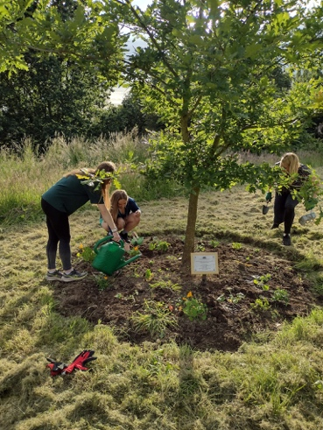
Meadfleet are also responsible for the regular monitoring of trees on site and those that are identified as dangerous are dealt with as a matter of urgency. They also carry out an annual tree survey to assess any future issues.

Friends of Parkinson’s Park look after litter picking in the park but Meadfleet deal with litter in the area close to the houses at the bottom of the park

Although the park is kept natural this still takes a lot of work by all involved and we are always on the lookout for more helpers.

One of the main issues we have in the park is litter and dog owners not picking up after their dog. Users are encouraged to take their waste home with them and there are several bins at the park entrances. We are very lucky in that quite a few of our users have or borrow or litter pickers on a regular basis and pick litter in the park. We also have some very kind dog owners who will pick up other dogs’ waste.

The park does suffer from occasional anti-social behaviour and we would with the local Councillors, police and residents to stop this when it arises. We would also like to work more closely with the local school so young people, and others, understand how to behave in communal areas such as parks.
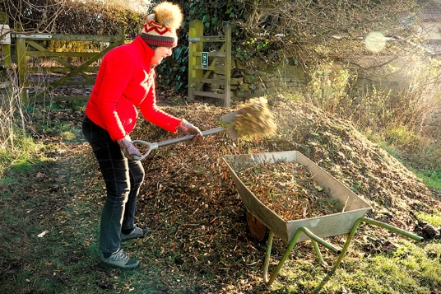
As mentioned previously we have regular working parties and Open Country are frequently employed in the park or offer to do some work if they have received funding from elsewhere. Other groups who help us keep the park clean and tidy include Litter Free Guiseley, Honey Badger Scouts, young people doing their Duke of Edinburgh badge, and other girl guide and scout groups.

Our dry-stone walls have in the past been inspected and maintained by the Otley & Yorkshire Dales Branch of the Dry Stone Wall Association and we work with the Green group from St Oswald’s Church who have been at the forefront of the revitalisation of the rhubarb patch.

See attached maintenance plan for more information.

Even given all this assistance the park is still a large greenspace and to make the task of keeping it maintained we have broken it down into a number of areas which different people help oversee. These include the different entrances, the copses, the wildflower meadows. For a full list please see the maintenance work plan. We do currently have some areas that are unadopted which are:

- Edison Fields entrance
- Tesla Lane entrance
- Bluebell Wood
- Bottom Copse
- Foss’ Field

Project Improvement Plan

Our aim is to help manage and create a greenspace that welcomes everyone into a relaxing, safe managed natural space. It is not solely for any one person or animal, and we all need to co-exist.

Some things we would like to see in the park in the future to develop it as a place for everyone are an accessible path, closer working with local schools, continuation and possible extension of events, membership and Friends scheme and a newsletter.

The project improvement plan at the bottom of the document sets out our priorities for the forthcoming few years and includes what will be done, by whom and when. It will also identify if we need any funding or other resources, including if we are working with other organisations to deliver the objective.

As we are currently a small group of volunteers one of our targets is to increase the number of people wanting to help with the park and hopefully take on different projects.

We used to host other events like Apple Day, Little Friends of Parkinsons’ Park and Heritage weekends but we would need to recruit some more volunteers to be able to run these in the future.

Monitoring and review

The plan will be monitored for progress at each committee meeting, and we will feed back to stakeholders and the community via our AGM, consultation, Facebook and newsletter. We will also carry out an annual review of the plan in Jan/Feb of each year.

Appendices List

Appendix 1 - Leeds City Council Park By-Laws and Dogs in Public Spaces Protection Order
Appendix 2 - Constitution
Appendix 3 – Timetable of events
Appendix 4 – Maintenance Plan
Appendix 5 – Project Improvement Plan

