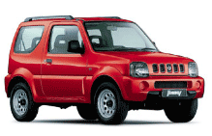 | SUZUKI JIMNY  Preluare contract leasing  An fabricatie: 2001  Culoare: rosu  Km la bord: 8.200  Echipare: inchidere centralizata, geamuri actionate electric, oglinzi reglabile electric, imobilizator motor, servodirectie, airbag sofer, airbag pasager, centuri de siguranta pretensionate, aer conditionat, radiocasetofon Clarion + 4 incinte acustice  6.000 Euro + 5 rate a 427 Euro
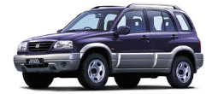 | SUZUKI GRAND VITARA 2.0i  Preluare contract leasing  An fabricatie: 2001  Culoare: albastru metalic + bandouri laterale bej  Km la bord: 6.800  Echipare: inchidere centralizata, geamuri actionate electric, oglinzi reglabile electric, imobilizator motor, servodirectie, airbag sofer, airbag pasager, centuri de siguranta pretensionate, aer conditionat, radiocasetofon Clarion + 4 incinte acustice  7.500 Euro + 5 rate a 548 Euro
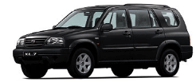 | SUZUKI GRAND VITARA XL - 7  Preluare contract leasing  An fabricatie: 2001  Culoare: negru  Km la bord: 13.300  Echipare: inchidere centralizata, geamuri actionate electric, oglinzi reglabile electric, imobilizator motor, servodirectie, airbag sofer, airbag pasager, ABS, centuri de siguranta pretensionate, aer conditionat, radiocasetofon Clarion + 4 incinte acustice  9.300 Euro + 5 rate a 679 Euro
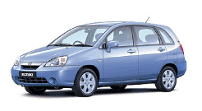 | SUZUKI LIANA  Preluare contract leasing  An fabricatie: 2001  Culoare: bleu  Km la bord: 8.800  Echipare: inchidere centralizata, geamuri actionate electric, oglinzi reglabile electric, imobilizator motor, servodirectie, airbag sofer, airbag pasager, airbaguri laterale, ABS, centuri de siguranta pretensionate, aer conditionat, radiocasetofon Pioneer + 4 incinte acustice  6.000 Euro + 5 rate a 455 Euro
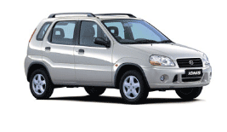 | SUZUKI IGNIS  Preluare contract leasing  An fabricatie: 2001  Culoare: gri metalizat  Km la bord: 6.300  Echipare: inchidere centralizata, geamuri actionate electric, oglinzi reglabile electric, imobilizator motor, servodirectie, airbag sofer, airbag pasager, ABS, centuri de siguranta pretensionate, aer conditionat, radiocasetofon Clarion + 4 incinte acustice  5.500 Euro + 5 rate a 402 Euro

