Goals:

. Wie erreichen wir alle Bewohner der Gemeinde Horw, speziell neue Gruppen?

. Interaktive Lösungen zur Steigerung der Partizipation gesucht

. Stärkere Einbindung aller Nutzergruppen der Plätze

Survey-Access-Ideas:

. OnSite QR-Code

. OnSite Tablet / digital Station

Survey-Ideas:

. 3D (oder 2D) Objekte auf Platz platzieren und verschieben (à la Sims haus bauen)

. Wettbewerb / andere Ideen anschauen und bewerten (AR-Event?)

Tools:

. bimObjects

( <https://www.bimobject.com/en-us/product> / <https://www.polantis.com/objects/types>)

. Web- / App-Developement-Tools

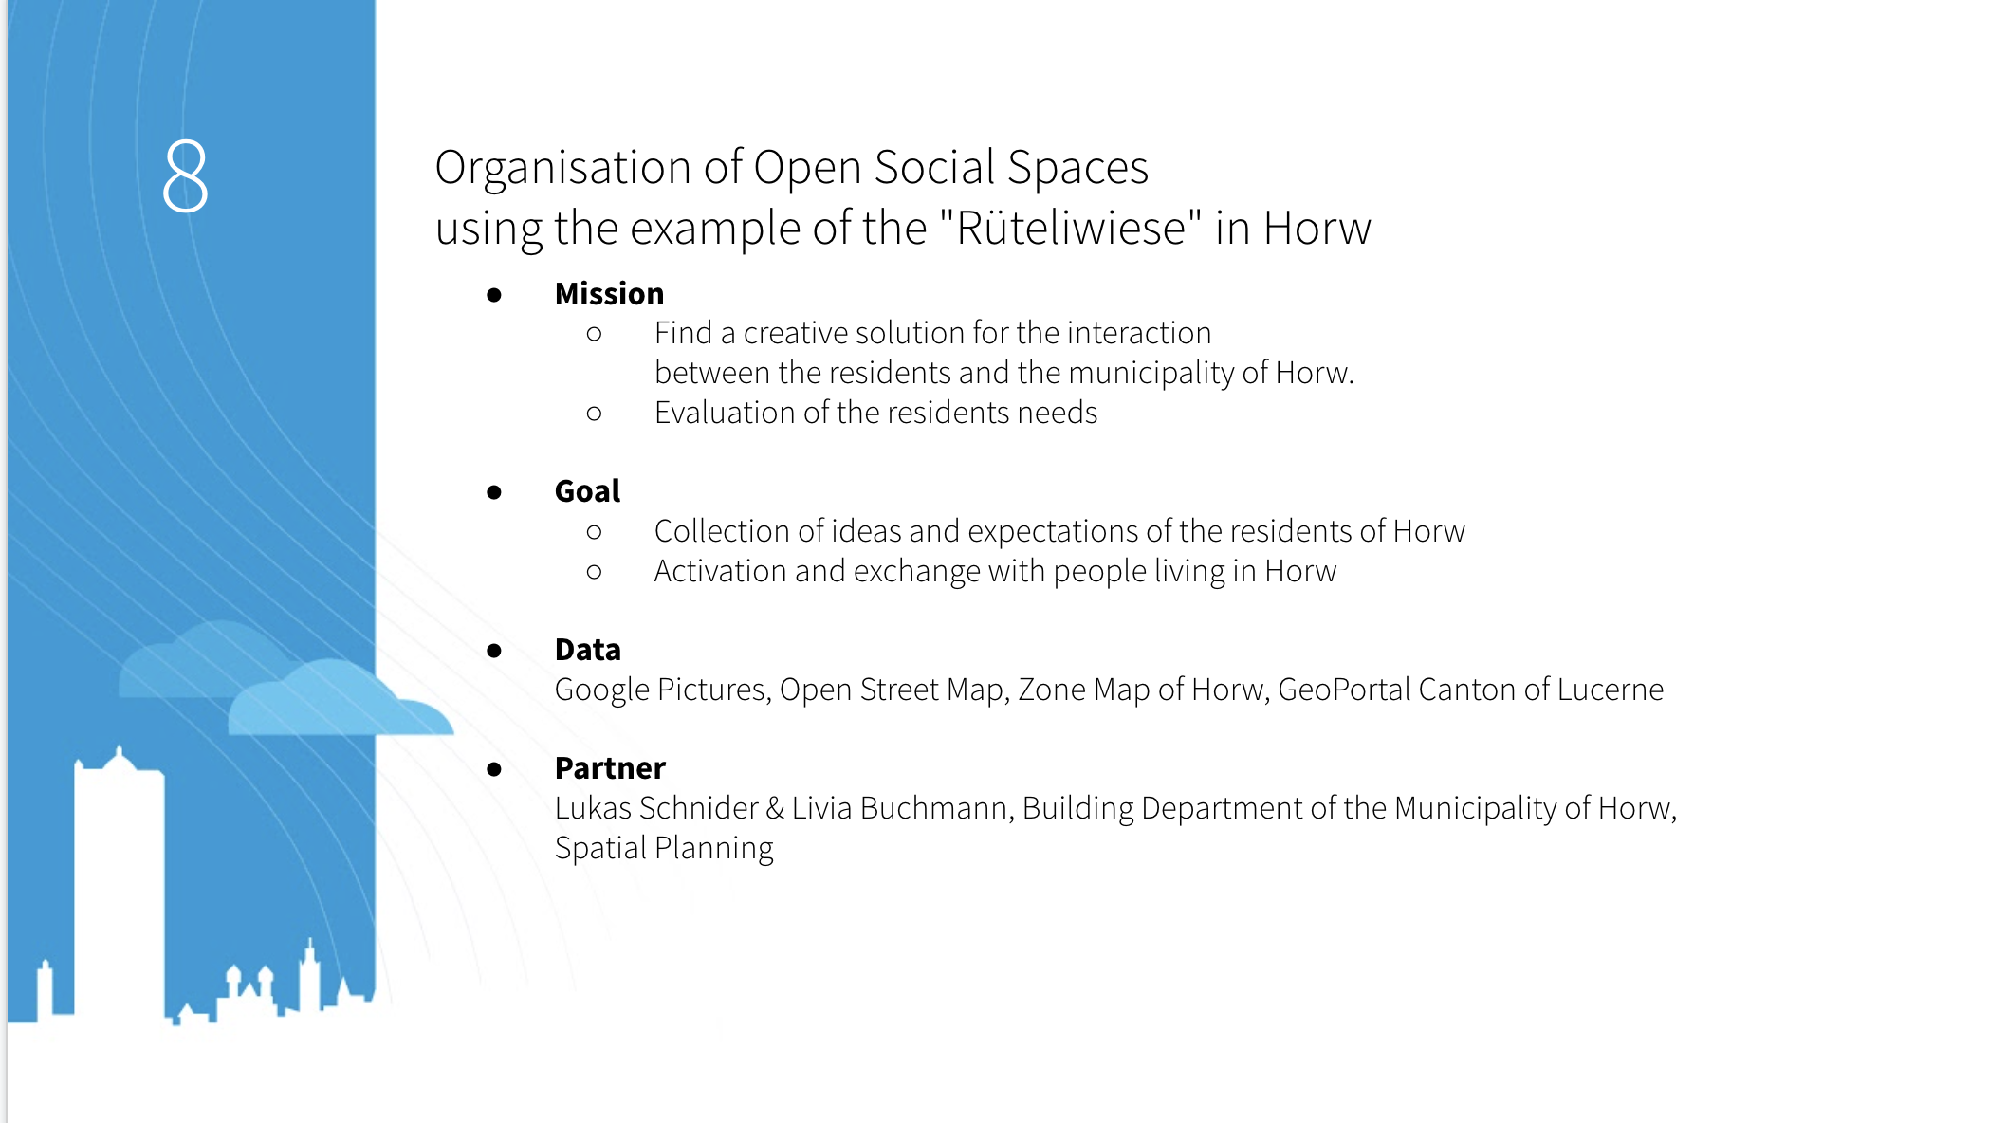

Abklärungen:

. Web-Apps vorhanden **(**[**https://github.com/ignacio-chiazzo/ARKit**](https://github.com/ignacio-chiazzo/ARKit)**, WebGLStudio.js, )**

. Sind schon

APIs (js):

* Geodaten (Gino, Andy)  
  <https://wiki.openstreetmap.org/wiki/API>
* 3D Objekte downloaden (Stefan)

<https://archive3d.net/> (Easy Access)

<https://3dsky.org/> (Quality Content)

bim-objects

turbosquid

<https://grabcad.com/>

CGTrader

* AR (Gianni, Stefan)

<https://developers.google.com/ar/discover/concepts>

<https://ar-js-org.github.io/studio/> <https://github.com/AR-js-org>

<https://bitstars.github.io/droidar/>

<http://www.mixare.org>

<http://www.arreverie.com/artoolkit.html>

<https://www.adobe.com/ch_de/products/aero.html>

https://in.pycon.org/cfp/2019/proposals/exploring-augmented-reality-with-python~e0rKb/

<https://bitesofcode.wordpress.com/2017/09/12/augmented-reality-with-python-and-opencv-part-1/>

https://bitesofcode.wordpress.com/2018/09/16/augmented-reality-with-python-and-opencv-part-2/

<https://www.smashingmagazine.com/2016/02/simple-augmented-reality-with-opencv-a-three-js/>

AR-Demo: <https://cdn.soft8soft.com/demo/applications/augmented_reality/augmented_reality.html>

Anleitung:

<https://developers.google.com/web/updates/2018/06/ar-for-the-web>

<https://codelabs.developers.google.com/codelabs/ar-with-webxr#0>

Library:

<https://immersive-web.github.io/webxr/>

* AR-Copy (Andy)  
  Github: https://github.com/cyrildiagne/ar-cptext  
  it’s already implemented into an app: <https://play.google.com/store/apps/details?id=app.arcopypaste&hl=en&gl=US>

