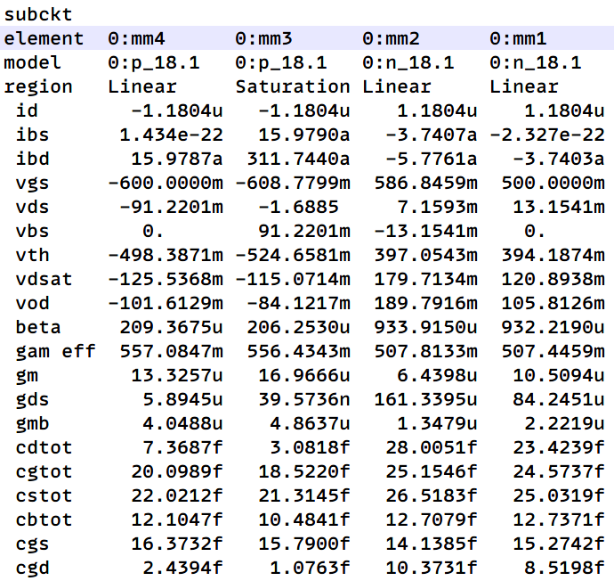

1st Vin/Vb1/Vb2/Vb3=0.5/0.6/1.1/1.2V W/L=3/1

Vod=Vov

Vds>Vdsat=>saturation=>keep modifying Vb

Vov1+Vov2+Vov3+Vov4<0.6V=>swing>1.2V

Av>40dB=177.827941V/V

Av=130m but don’t care now

Body effect in MM2 MM3

Modify Vgs closer to Vth , let Vds saturate more easier

Observe the Vth value carefully to do the upper details (tune Vgs closer to Vth)

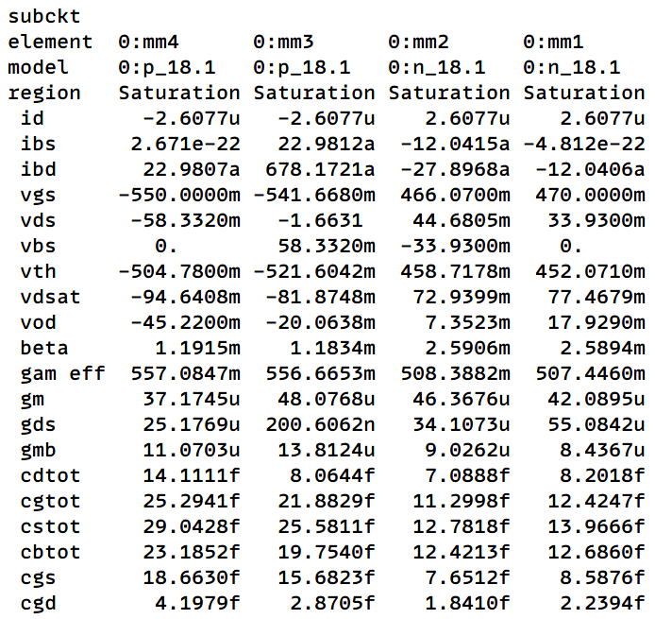

4 mos saturates => Vin/Vb1/Vb2/Vb3=0.47/0.5/1.2/1.25V

(w/l)1=4/0.5 (w/l)2=4/0.5 (w/l)3=8/0.5 (w/l)4=8/0.5

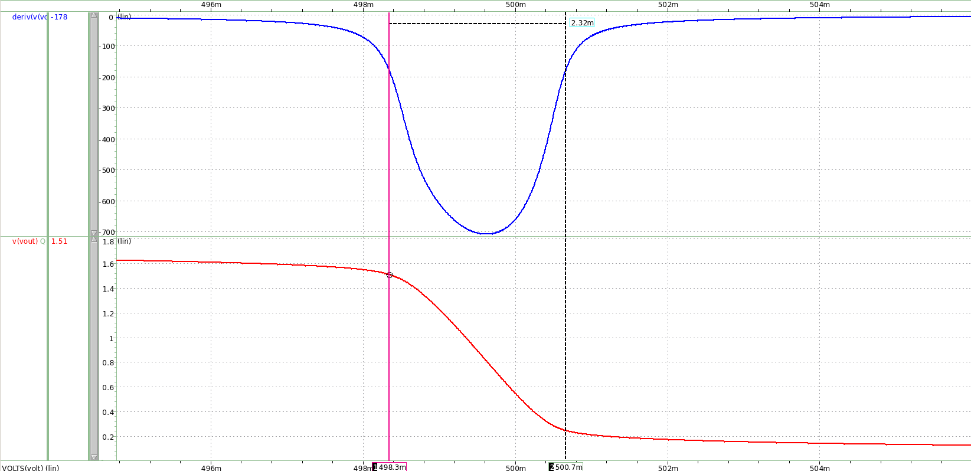

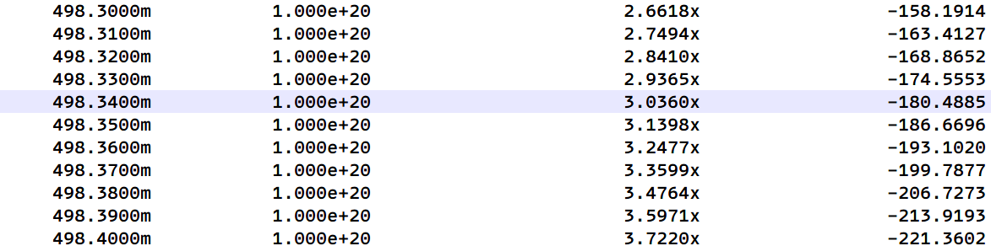

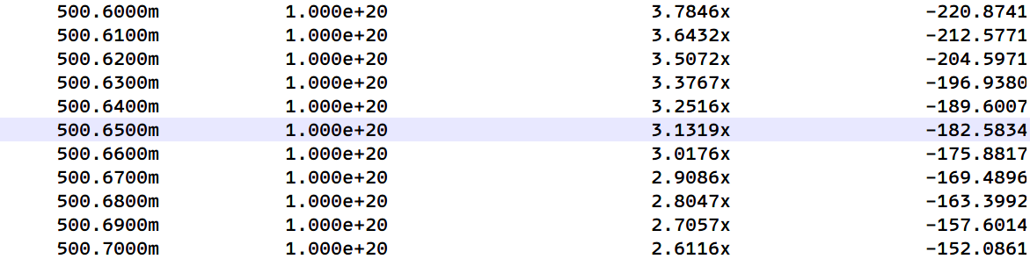

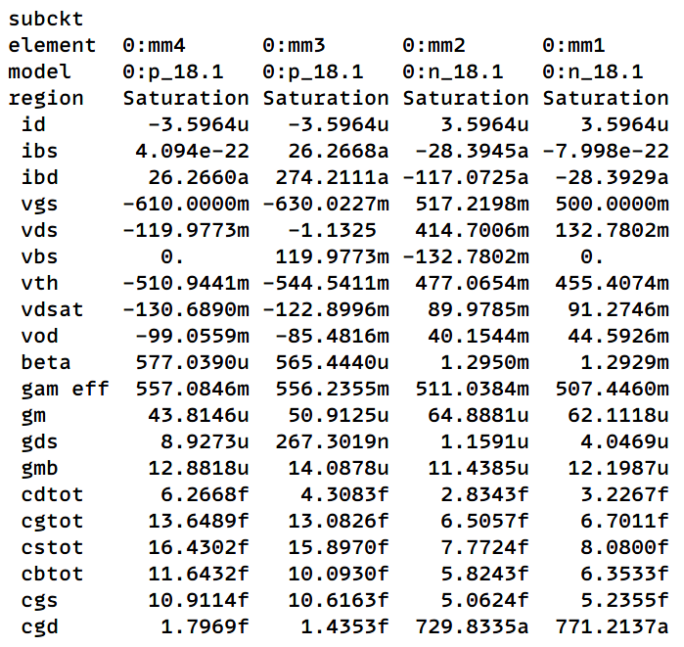

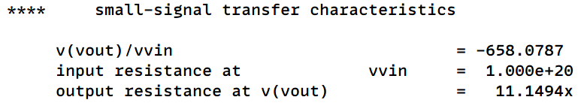



4 mos saturates => Vin/Vb1/Vb2/Vb3=0.5/0.65/1.05/1.19V

(w/l)1=2/0.5 (w/l)2=2/0.5 (w/l)3=4/0.5 (w/l)4=4/0.5