We decided to fast prototype with the NZ Government's covid-19 dataset.

We played around with the interactive data portal on stats.nz to determine which factors we may be able to extract from the covid-19 dataset.

Encounters:

* Covid-19 dataset had multiple sheets. Had to figure out how to import/extract a single sheet for use in jupyterlab
* When trying to merge DHB population dataset with vaccination dataset, variable names for the same variable appeared differently. This had to be mended
* Looking for a good question to ask regarding the covid timeline per region
* Trying to find regions in common with datasets
* Lots of irrelevant data in the large covid-19 dataset, proving difficult to extract any useful information
* Some variables only contain information for very few regions
* Found potentially useful variable of traffic count per region
* Searching for more datasets regarding useful societal factors
* Want to avoid retrieval of data through downloading a CSV; we want this process to be automatic
* Trying to match DHB regions with other regional measures
* Figuring out how to use the Web API to automate data extraction on stats.nz and this is proving difficult

How do various societal factors affect vaccination uptakes in different DHB regions?

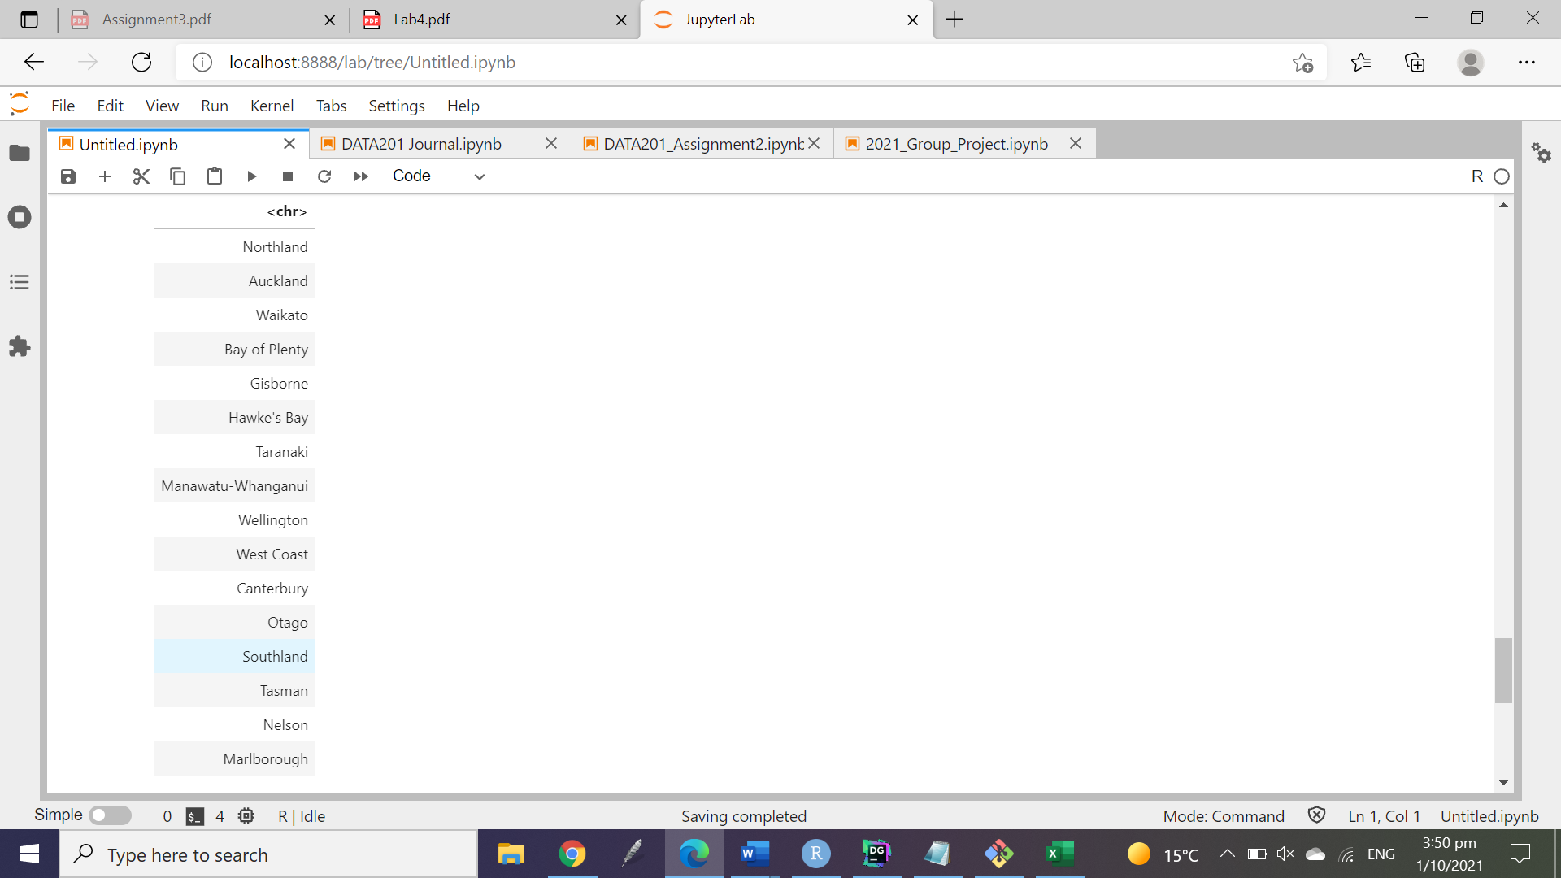

List of regions with usable population data: "Northland", "Auckland", "Waikato", "Bay of Plenty", "Hawke's Bay", "Taranaki", "Manawatu-Whanganui", "Wellington", "West Coast", "Canterbury", "Gisborne", "Otago"