**Lab 11: LCD Display (1)**

**103061207 徐安廷 An-Ting Hsu**

**Design Specification**

1. **LCD Display (Animation)**

* Experiment Goal:

Let the LCD display play the animation in “picture.coe” which is given by teacher.

* Block Diagram:

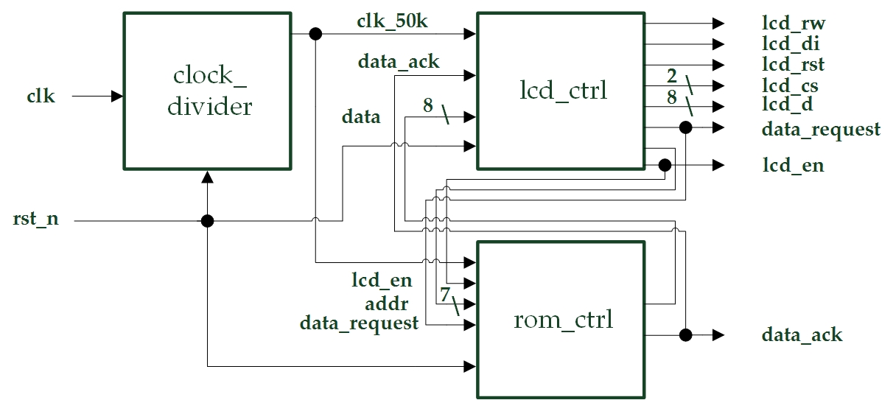

* I/Os:

Inputs: clk, rst_n.

Outputs: lcd_rst, lcd_rw, lcd_di, lcd_e, data_ack, data_request, [1:0] lcd_cd, [7:0] lcd_d.

1. **(Bonus) LCD Display (Animation with Name)**

* Experiment Goal:

Add my name into the animation in experiment 1.

* Block Diagram:



* I/Os:

Inputs: clk, rst_n.

Outputs: lcd_rst, lcd_rw, lcd_di, lcd_e, data_ack, data_request, [1:0] lcd_cd, [7:0] lcd_d.

**Design Implementation**

1. **LCD Display (Animation)**

* First, download the example codes in ilms. Second, understand the codes. Third, add an additional state and a pause counter in LCD controller to play the animation repeatly as request.
* I/O Pin Assignments:

|  |  |  |
| --- | --- | --- |
| **Port Name** | **Assignment** | **Function** |
| **clk** | R10 | FPGA board oscillator input |
| **rst_n** | N3 | Active low reset input button |
| **lcd_rst** | E3 | LCD reset output |
| **lcd_e** | F5 | LCD enable output |
| **lcd_rw** | C2 | LCD read/write control output |
| **lcd_di** | C1 | LCD data/instruction output |
| **data_request** | H5 | request for the memory data output |
| **data_ack** | H6 | data re-arrangement buffer ready indicator output |
| **lcd_cs[0]~lcd_cs[1]** | F4, E1 | LCD frame selection output |
| **lcd_d[0]~lcd_d[7]** | F6, D3, E4, G6, H7, D1, D2, F3 | LCD data output |

1. **(Bonus) LCD Display (Animation with Name)**

* Design my name to show on the LCD and add it into picture.coe file.
* I/O Pin Assignments:

|  |  |  |
| --- | --- | --- |
| **Port Name** | **Assignment** | **Function** |
| **clk** | R10 | FPGA board oscillator input |
| **rst_n** | N3 | Active low reset input button |
| **lcd_rst** | E3 | LCD reset output |
| **lcd_e** | F5 | LCD enable output |
| **lcd_rw** | C2 | LCD read/write control output |
| **lcd_di** | C1 | LCD data/instruction output |
| **data_request** | H5 | request for the memory data output |
| **data_ack** | H6 | data re-arrangement buffer ready indicator output |
| **lcd_cs[0]~lcd_cs[1]** | F4, E1 | LCD frame selection output |
| **lcd_d[0]~lcd_d[7]** | F6, D3, E4, G6, H7, D1, D2, F3 | LCD data output |

**Discussion**

* It was my first time to use the LCD display. The codes which teacher gave to us are really complicated, and I spent lots of time on understanding it. Though the codes is hard to understand, but once I find out that I only need to add an additional state and a pause counter, I finished the experiment in a short time.

**Conclusion**

* The LCD display is a main part in my final project. So, I need to know its working principle very well, and try to make the best use of it.

**References**

* Teaching Handouts <LCD Display (1)> p.2~22

→Helps me to understand how the states work in LCD controller and ROM controller.