**Lab 5: Stop Watches**

**103061207 徐安廷 An-Ting Hsu**

**Design Specification**

1. **30-Second Down Counter with Two Buttons**

* Experiment Goal:

Use the previous 30-second down counter in lab3 bonus. With one pause button and one reset button.

* 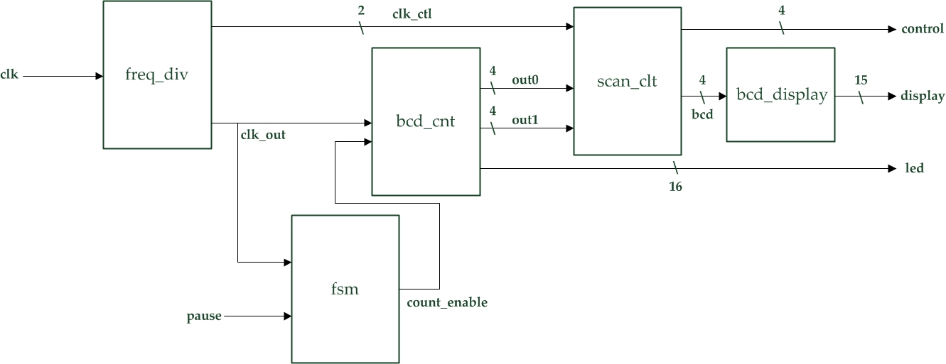Block Diagram:
* I/O:

Inputs: clk, pause, rst_n.

Output: [3:0] control, [14:0] display, [15:0] led.

1. **30-Second Down Counter with One Button**

* Experiment Goal:

Improve previous experiment that make the pause and reset into one button. When the button has a longer press reset the counter, otherwise pause the counter time.

* 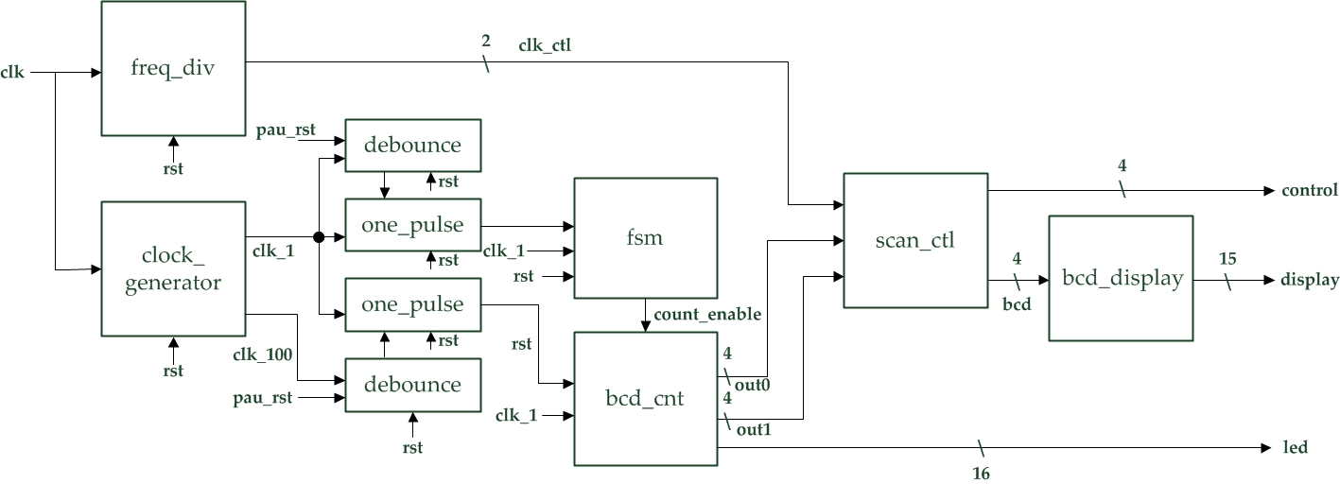Block Diagram:
* I/O:

Inputs: clk, pau_rst.

Outputs: [3:0] control, [14:0] display, [15:0] led.

**Design Implementation**

1. **30-Second Down Counter with Two Buttons**

* Construct a finite state machine which has two states for pause and start counting statement. Define the signal from the fsm as an enable for the down counter. So, we can get a down counter with pause/start and reset function.
* I/O Pins Assignment:

|  |  |
| --- | --- |
| **clk** | R10 |
| **pause** | P4 |
| **rst_n** | N3 |
| **control[0]~control[3]** | V8, U8, V6, T6 |
| **display[0]~display[14]** | U5, T7, R7, V7, V4, T4, T3, R5, N5, R3, U7, T5, V5, N4, P6 |
| **led[0]~led[15]** | K4, K3, L5, K5, H4, H3, L7, K6, G3, G1, J7, J6, F2, F1, H6, H5 |

1. **30-Second Down Counter with One Button**

* Assign pause/start and reset function to a same button. Pause/start function has the same design as the first experiment. The reset button signal is connect to a debounce circuit which has a slower clock input, so we can get a longer press reset.
* I/O Pins Assignment:

|  |  |
| --- | --- |
| **clk** | R10 |
| **pau_rst** | N3 |
| **control[0]~control[3]** | V8, U8, V6, T6 |
| **display[0]~display[14]** | U5, T7, R7, V7, V4, T4, T3, R5, N5, R3, U7, T5, V5, N4, P6 |
| **led[0]~led[15]** | K4, K3, L5, K5, H4, H3, L7, K6, G3, G1, J7, J6, F2, F1, H6, H5 |

**Discussion**

* I spent lots of time on doing second experiment, and also try various kind of version. I tried to use counter to do the long time pressing reset once, but it came out as an unsolved bug. The display shows one 0 all the time. So, I discuss with my classmates which makes me to use the debounce circuit to complete the lab.

**Conclusion**

* After this lab, I have learned how to use finite state machine(fsm), debounce circuit and one pulse circuit. Those circuit are so important which are all contained in our daily life electric devices. Such as electric watches, smart phones, digital cameras etc.

**References**

1. **30-Second Down Counter with Two Buttons**

* Teaching Handout < Using Push Buttons > p.17~18

→The use of the finite state machine.

1. **30-Second Down Counter with One Button**

* Teaching Handout < Using Push Buttons > p.7~9

→The use of the clock generator, debounce circuit and one pulse.