**Lab 6: Simple Calculator (Pre-Lab)**

**103061207 徐安廷**

**Design Specification**

* **I/Os:**

Inputs: clk, rst_n, [3:0] col_n

Outputs: pressed, [3:0] row_n, [3:0] key

* **State Diagram:**

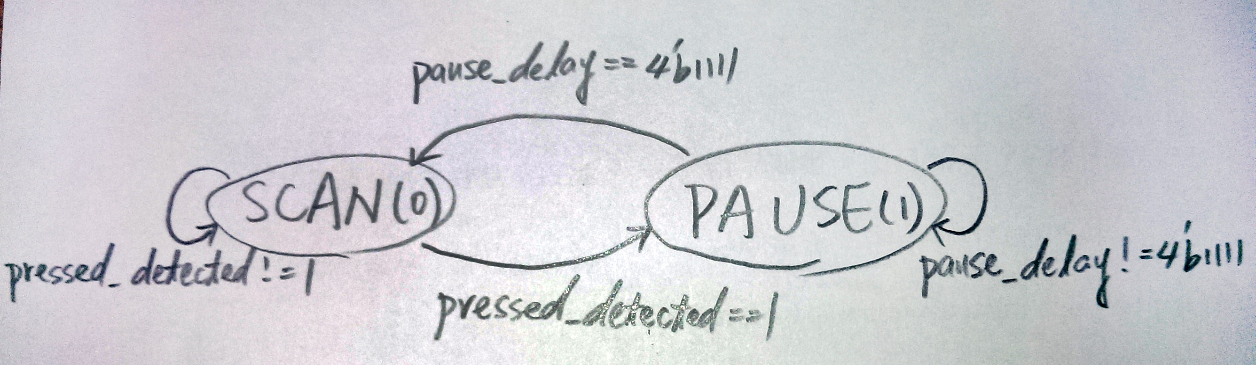

* **Block Diagram:**

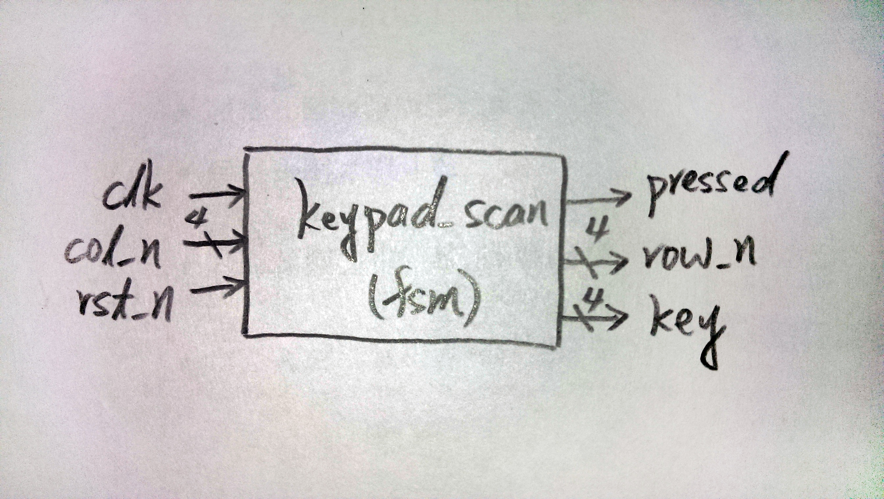

**Simulation**

