**Lab 7: Electronic Clock I (Time Display)**

**103061207 徐安廷 An-Ting Hsu**

**Design Specification**

1. **Electronic Clock**

* Experiment Goal:

Construct an electronic clock which can support two modes: AM/PM and 24-hour.

* Block Diagram:

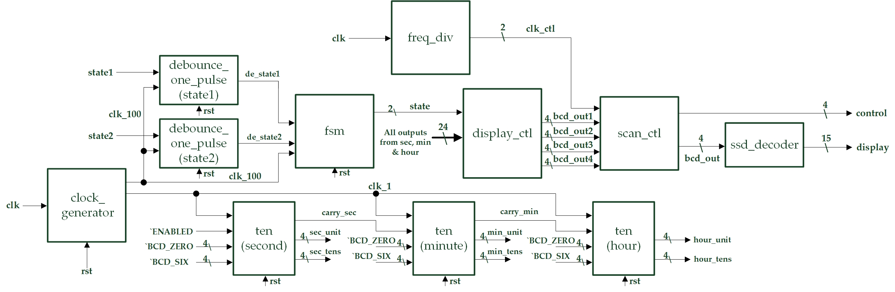

* State Diagram:

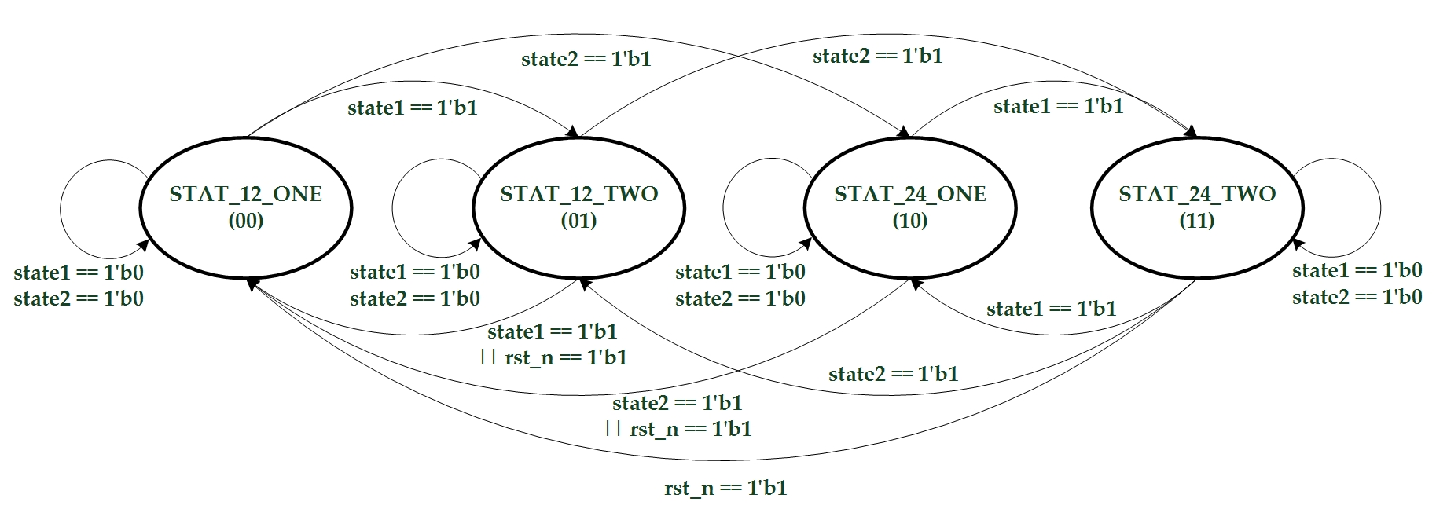

* I/Os:

Inputs: clk, state1, state2, rst_n.

Outputs: [3:0] control, [14:0] display.

* Details about some module:
  + display_ctl: Determines what is going to show on the 14-degment display according from fsm’s state.

1. **Calendar (No Leap Year)**

* Experiment Goal:

Adjust experiment 1’s electronic clock to support day, month and year timer.

* Jan/March/May/July/Aug/Oct/Dec: 1-31, Feb: 28, Apr/June/Sept/Nov: 30
* No leap year function.
* Block Diagram:

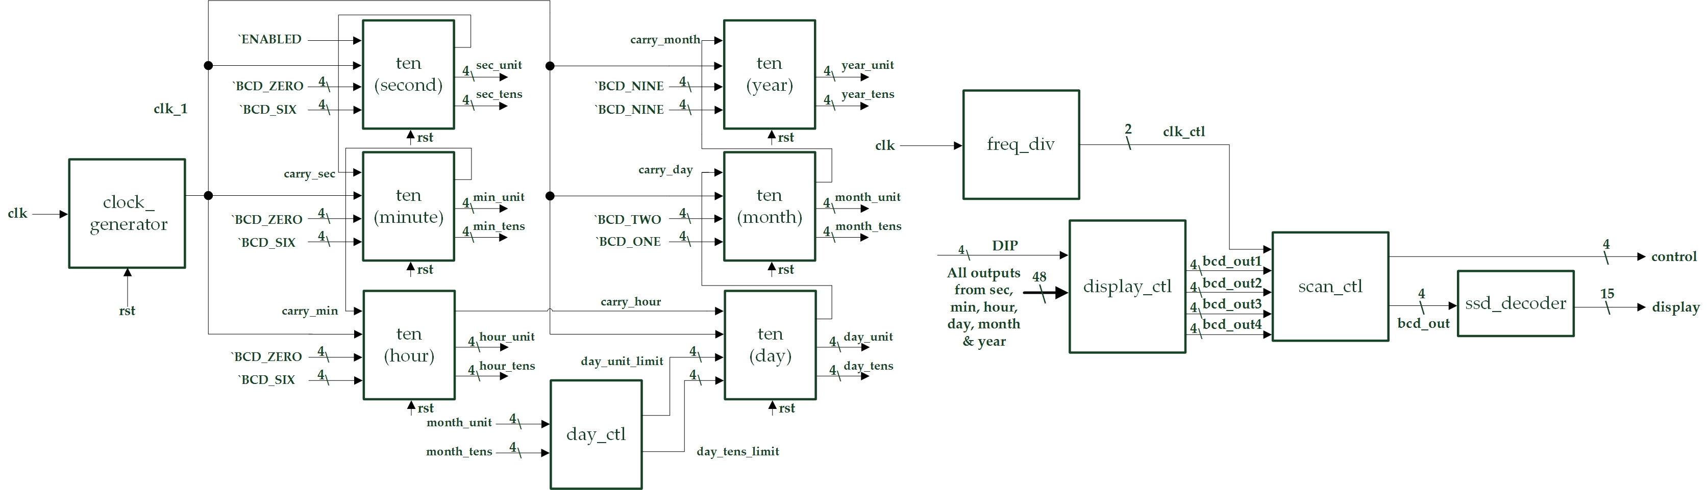

* I/Os:

Inputs: clk, rst_n, [3:0] DIP.

Outputs: [3:0] control, [14:0] display.

* Details about some module:
  + day_ctl: Determines what the day limit is according from the month value.
  + display_ctl: Determines what is going to show on the 14-degment display according from 4-bit DIP input.

|  |  |
| --- | --- |
| **DIP[3]~DIP[0]** | **Things to show on 14-SD** |
| 0000 | Seconds & minutes in 12-hr mode |
| 0001 | Seconds in 24-hr mode |
| 0010 | Hours in 12-hr mode |
| 0011 | Hours & minutes in 24-hr mode |
| 01xx | Month & Day |
| 1xxx | Year |

1. **(Bonus) Calendar (Leap Year Support)**

* Experiment Goal:

Adjust exp 3 to support leap year function.

* Block Diagram:

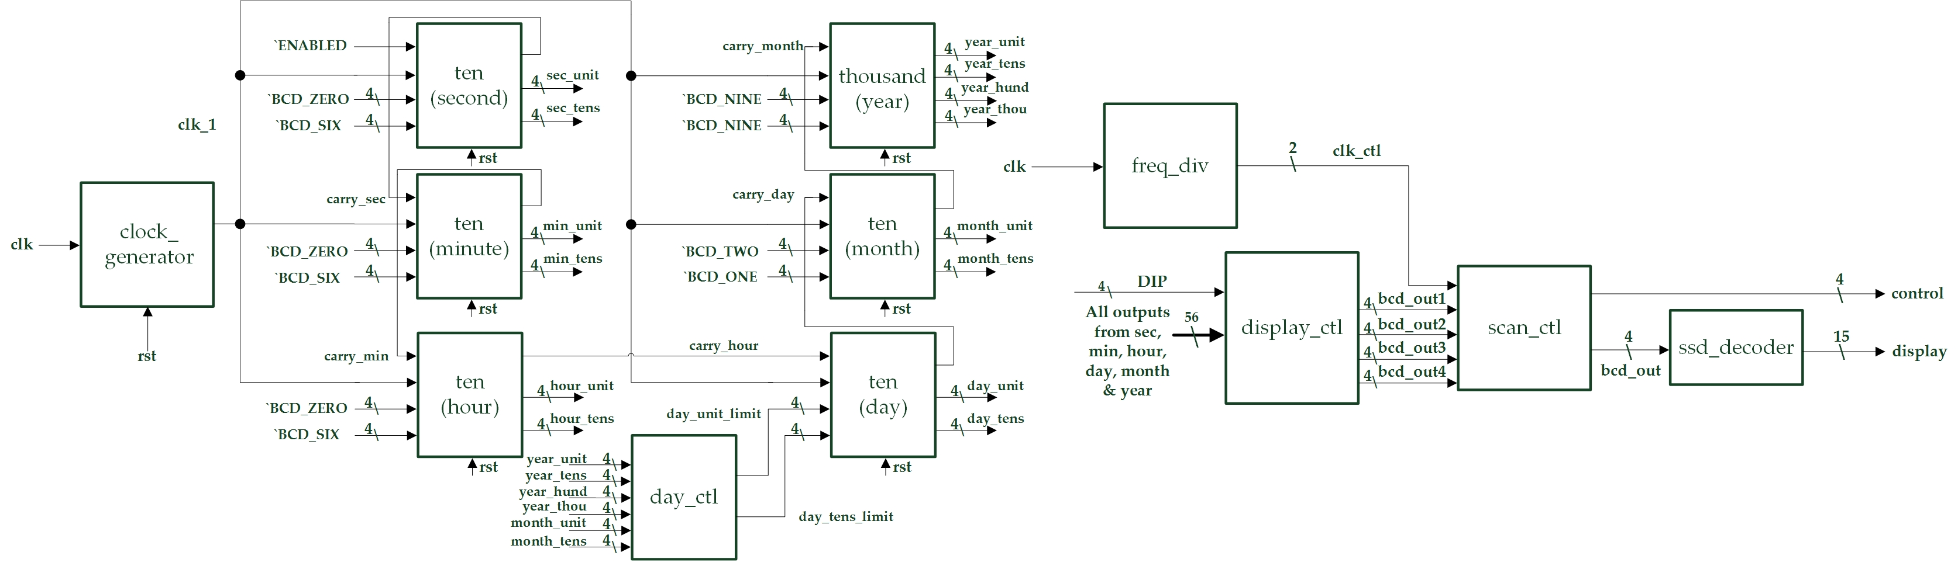

* I/Os:

Inputs: clk, rst_n, [3:0] DIP.

Outputs: [3:0] control, [14:0] display.

* Details about some module:
  + day_ctl: Determines what the day limit is according from the month and year value.

**Design Implementation**

1. **Electronic Clock**

* Construct three basic units which contains two up counter each, and each unit represents second, minute and hour. The second unit will always increase its value when reach a positive edge clock signal. Minute and hour units will increase its value when second or minute reaches their limit value. Send these units’ value to a display controller which will determine what the thing are going to show according from the finite state machine.
* I/O Pins Assignment:

|  |  |
| --- | --- |
| **clk** | R10 |
| **rst_n** | T2 |
| **state1** | N3 |
| **state2** | P4 |
| **control[0]~control[3]** | V8, U8, V6, T6 |
| **display[0]~display[14]** | U5, T7, R7, V7, V4, T4, T3, R5, N5, R3, U7, T5, V5, N4, P6 |

1. **Calendar (No Leap Year)**

* Add day, month and year counters into first experiment. And, the day limit is determined by a controller which will passes correct day limit by the current month value.
* I/O Pins Assignment:

|  |  |
| --- | --- |
| **clk** | R10 |
| **rst_n** | T2 |
| **DIP[0]~DIP[3]** | L2, M1, M3, N1 |
| **control[0]~control[3]** | V8, U8, V6, T6 |
| **display[0]~display[14]** | U5, T7, R7, V7, V4, T4, T3, R5, N5, R3, U7, T5, V5, N4, P6 |

1. **(Bonus) Calendar (Leap Year Support)**

* Adjust the day controller in experiment 2 to support leap year function.
* I/O Pins Assignment:

|  |  |
| --- | --- |
| **clk** | R10 |
| **rst_n** | T2 |
| **DIP[0]~DIP[3]** | L2, M1, M3, N1 |
| **control[0]~control[3]** | V8, U8, V6, T6 |
| **display[0]~display[14]** | U5, T7, R7, V7, V4, T4, T3, R5, N5, R3, U7, T5, V5, N4, P6 |

**Discussion**

* I spent lots of time debug on the first experiment. One of the main bugs is the hour counter will count to 20 not 00 when it reach the limit value. I found that the bug is in the upcounter module. I miss exchange the place of two if else statement “load_default == `ENABLED” & “increase == `DISABLED”, so the counter will not load the default value properly. The other problem I met is that I can’t use don’t care symbol “x” in the case statement, so I googled the solution to my problem. I learn that I need to change “case” statement into “casex” statement, so the don’t cares can work properly.

**Conclusion**

* After the lab I understand the electronic clock in our daily life basic working principle and know how to construct my own clock. Though there was some problems during the experiment, I think those precious experiences will improve my coding skills. And, it will help me to finish the final project easier.

**References**

1. **Electronic Clock**

* Teaching Handout <Universal Counter> p.2~p.7

→Helps me to construct a counter which can count to a particular value and back to the initial value.