Part 1
- Select, for each boat, the sailor who made the highest number of reservations for that boat.
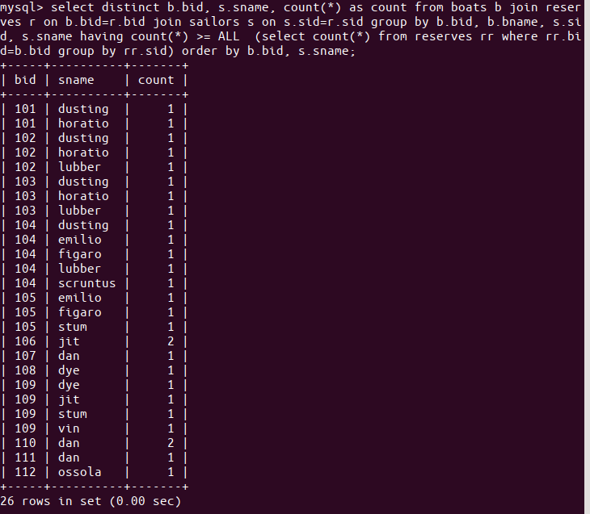
- List, for every boat, the number of times it has been reserved, excluding those boats that have never been reserved (list the id and the name).
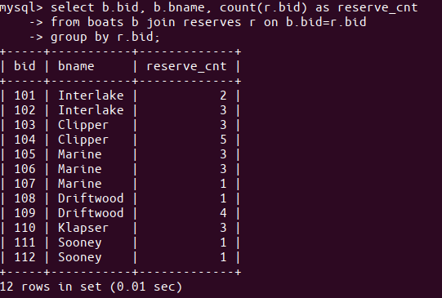
- List those sailors who have reserved every red boat (list the id and the name).
None having reservations to all 6 red boats
>> all reservations, with sailors and boats shown
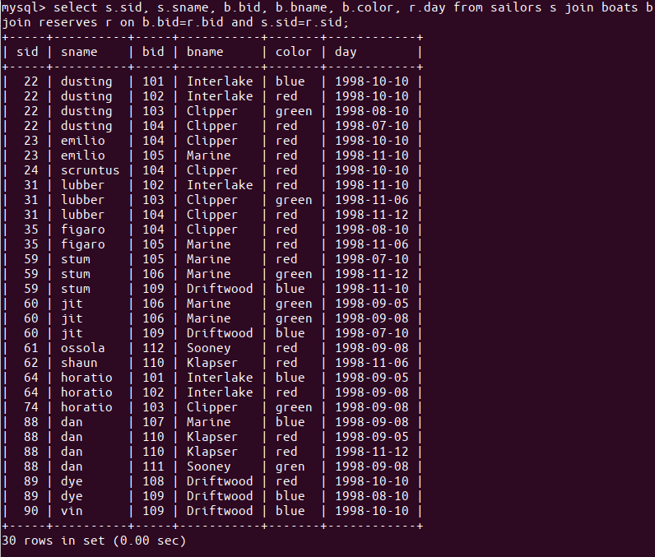
>> all red boats
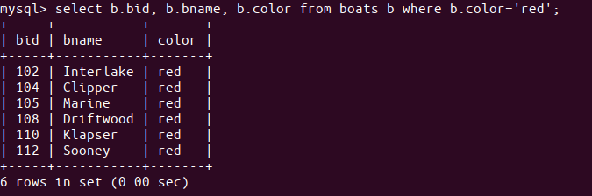

- List those sailors who have reserved only red boats.
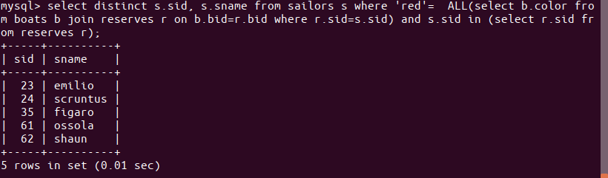
- For which boat are there the most reservations?
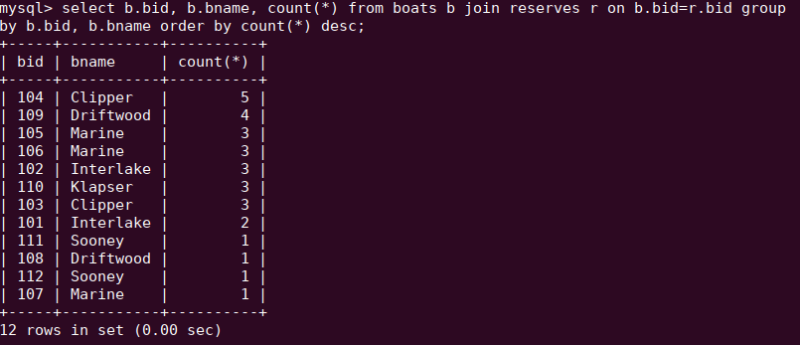
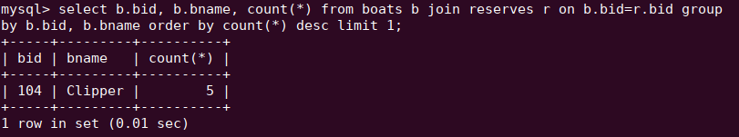

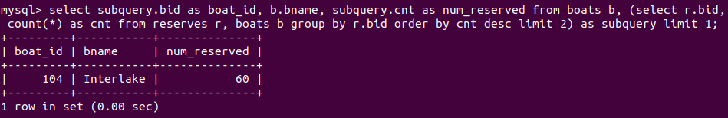

- Select all sailors who have never reserved a red boat.
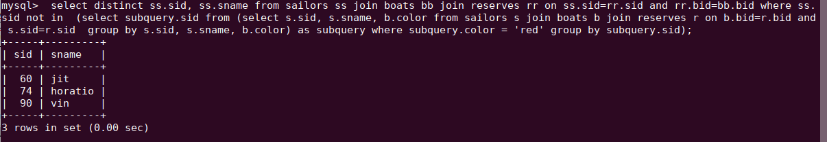
- Find the average age of sailors with a rating of 10.
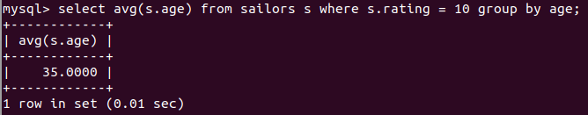

Part 2

Represent the sailors and boats schema using an ORM - I prefer SQLAlchemy but students have the freedom to choose their own language and ORM. Show that it is fully functional by writing tests using the data from part 1 (writing the queries for the questions in Part 1) - I prefer pytest but students are have the freedom to choose their own testing framework.

Part 3

Students are hired as software consults for a small business boat rental that is experiencing a heavy influx of tourism in its area. This increase is hindering operations of the mom/pop shop that uses paper/pen for most tasks. Students should explore “inefficient processes” the business may have and propose ideas for improvements - in the form of a brief write-up. Expand the codebase from part 2 to include a few jobs, reports, integrity checks, and/or other processes that would be beneficial to the business. Use the data provided in part 1 and expand it to conduct tests and show functionality. Examples include, but are not limited to:

Bi weekly payment query
Monthly accounting manager
Daily inventory control
Inventory repair tracker (and cost analysis)

“Extra Credit”

Use a web code review platform so I can write comments for review. I should get a link to a review platform and be able to easily write comments - perhaps after linking with github or creating a free account. Ones that I have found good are codacy.com and reviewable.io. This will help prepare you for the final project and is highly recommended.

