Department of Computer Science, National Chengchi University
Digital Systems Final Examination, 6/22/2005

- [Terminology] Acronyms: (a) TTL (b) OLED (c) HDL (d) CMOS (e) BCD (10%)
- [Adder] (a) Construct a full adder using two half adders and an OR gate. (5%) (b) Design the correction-detector circuit for a single-digit BCD adder. (5%)
- [Johnson counter] Design a MOD-8 Johnson counter and show its state transition diagram.(6%)
- [Synchronous counter] (a) Design a MOD-5 synchronous counter using D flip-flops. (6%) (b) Compare the advantages and disadvantages of asynchronous vs. synchronous counter. (4%)
- [Synchronous counter design] (a) Fill in the blanks in the following J-K excitation table. (4%)

Transition at Output | Present State | Next State | J | K
0→0 | 0 | 0
0→1 | 0 | 1
1→0 | 1 | 0
1→1 | 1 | 1

(b) Use the above table to design a synchronous counter with the following counting sequence: 0→1→2→4→7, and repeat. You should write down the complete design procedure and draw the final implementation using J-K flip-flops. (10%)
6. [Multiplexer] The following figure shows how to use 74HC151 MUX to implement the logic function: Z=AB’C’+A’BC’+ABC.
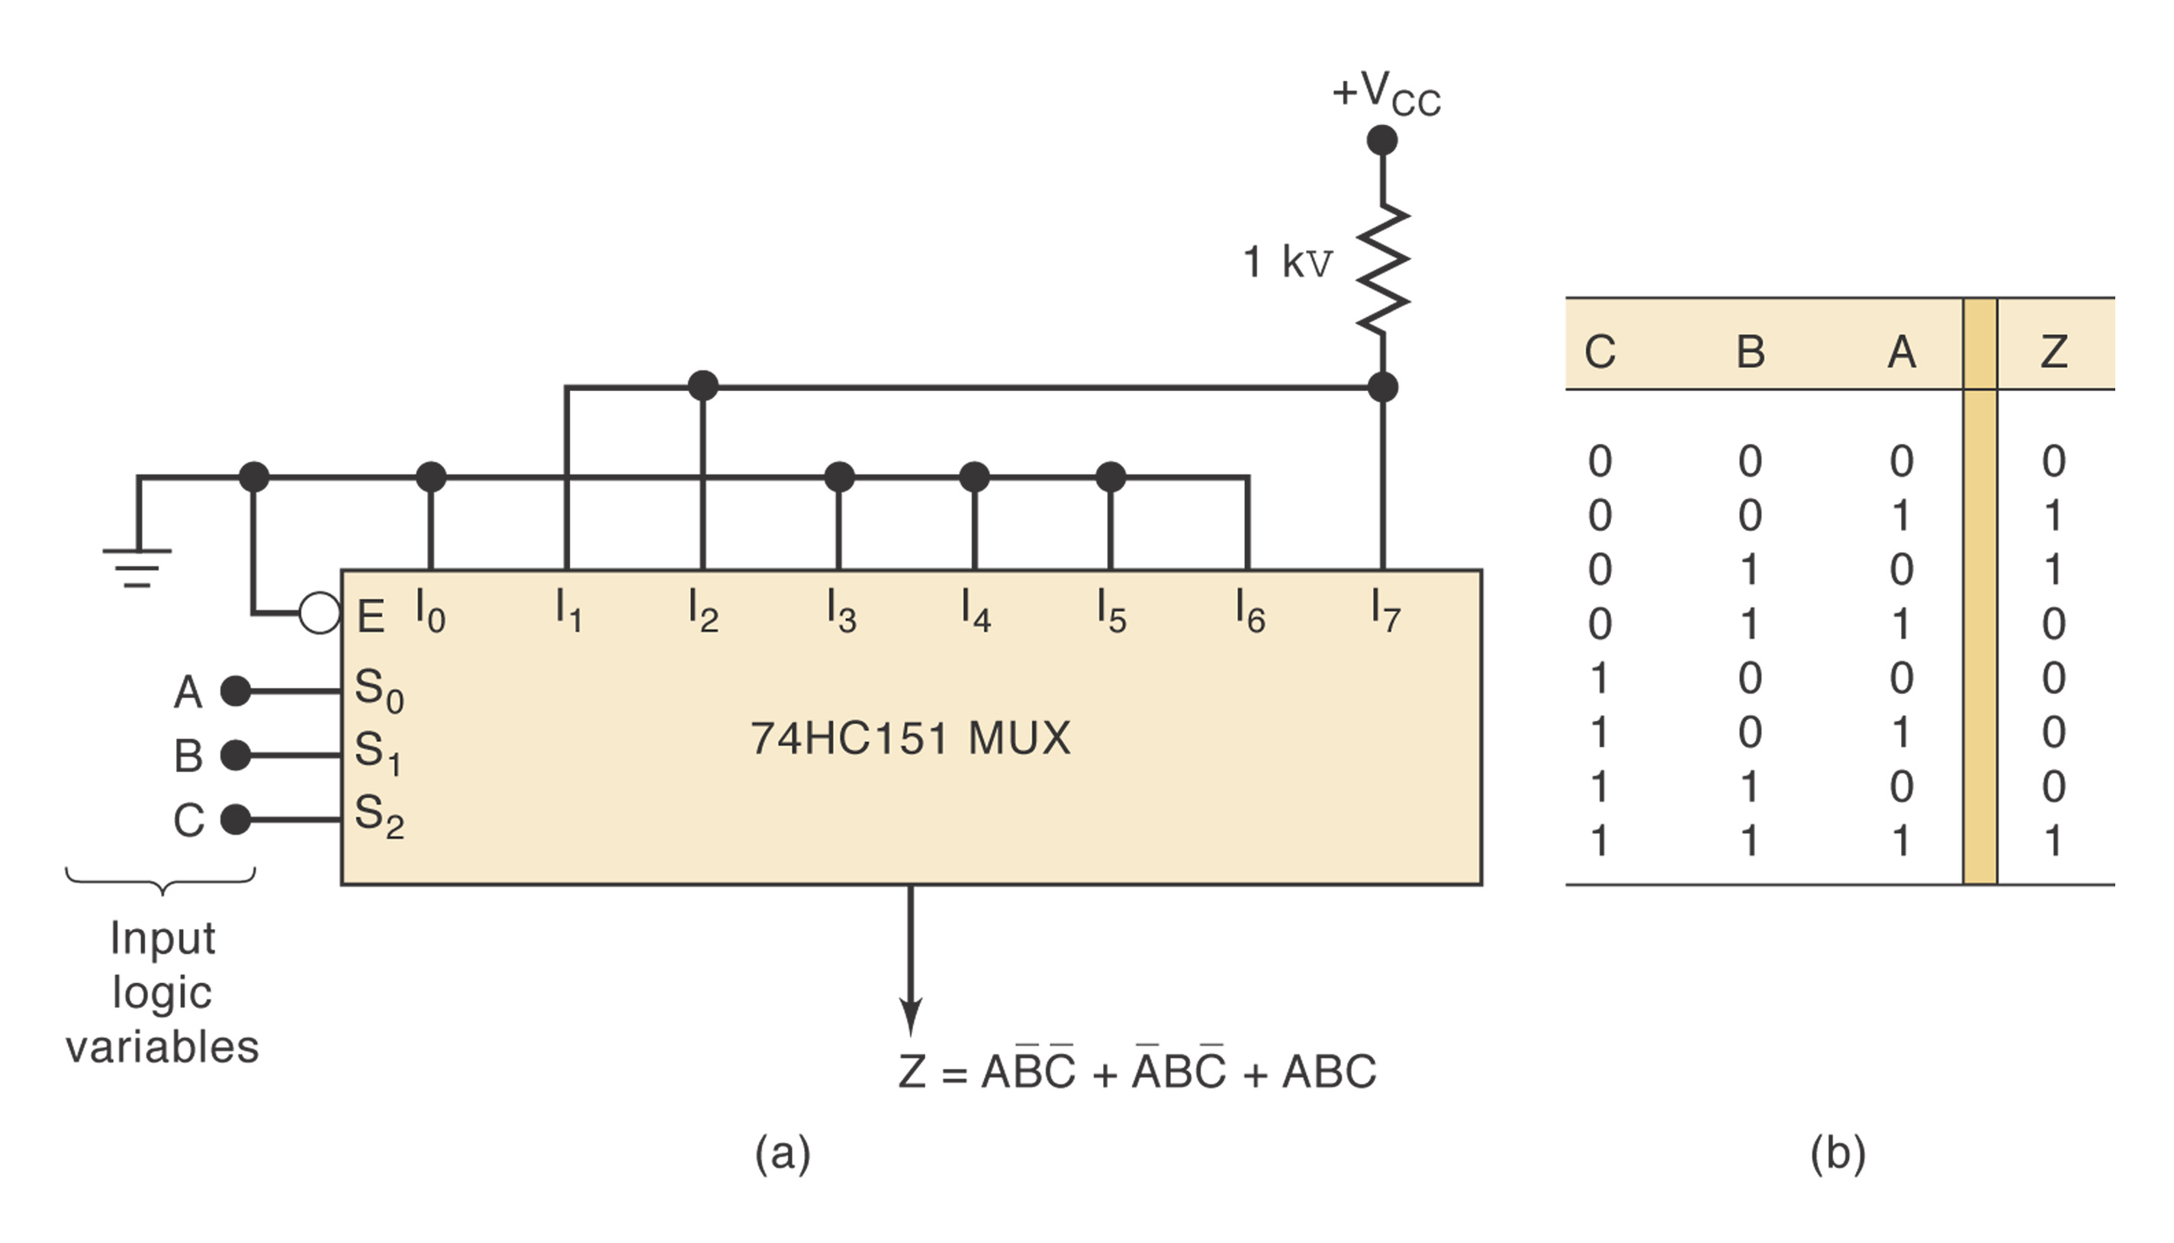
Show how a 74151 can be used to generate the function Z=AB+BC+AC (5%)

7. [MSI Circuit] Describe the functionality of the following circuit.
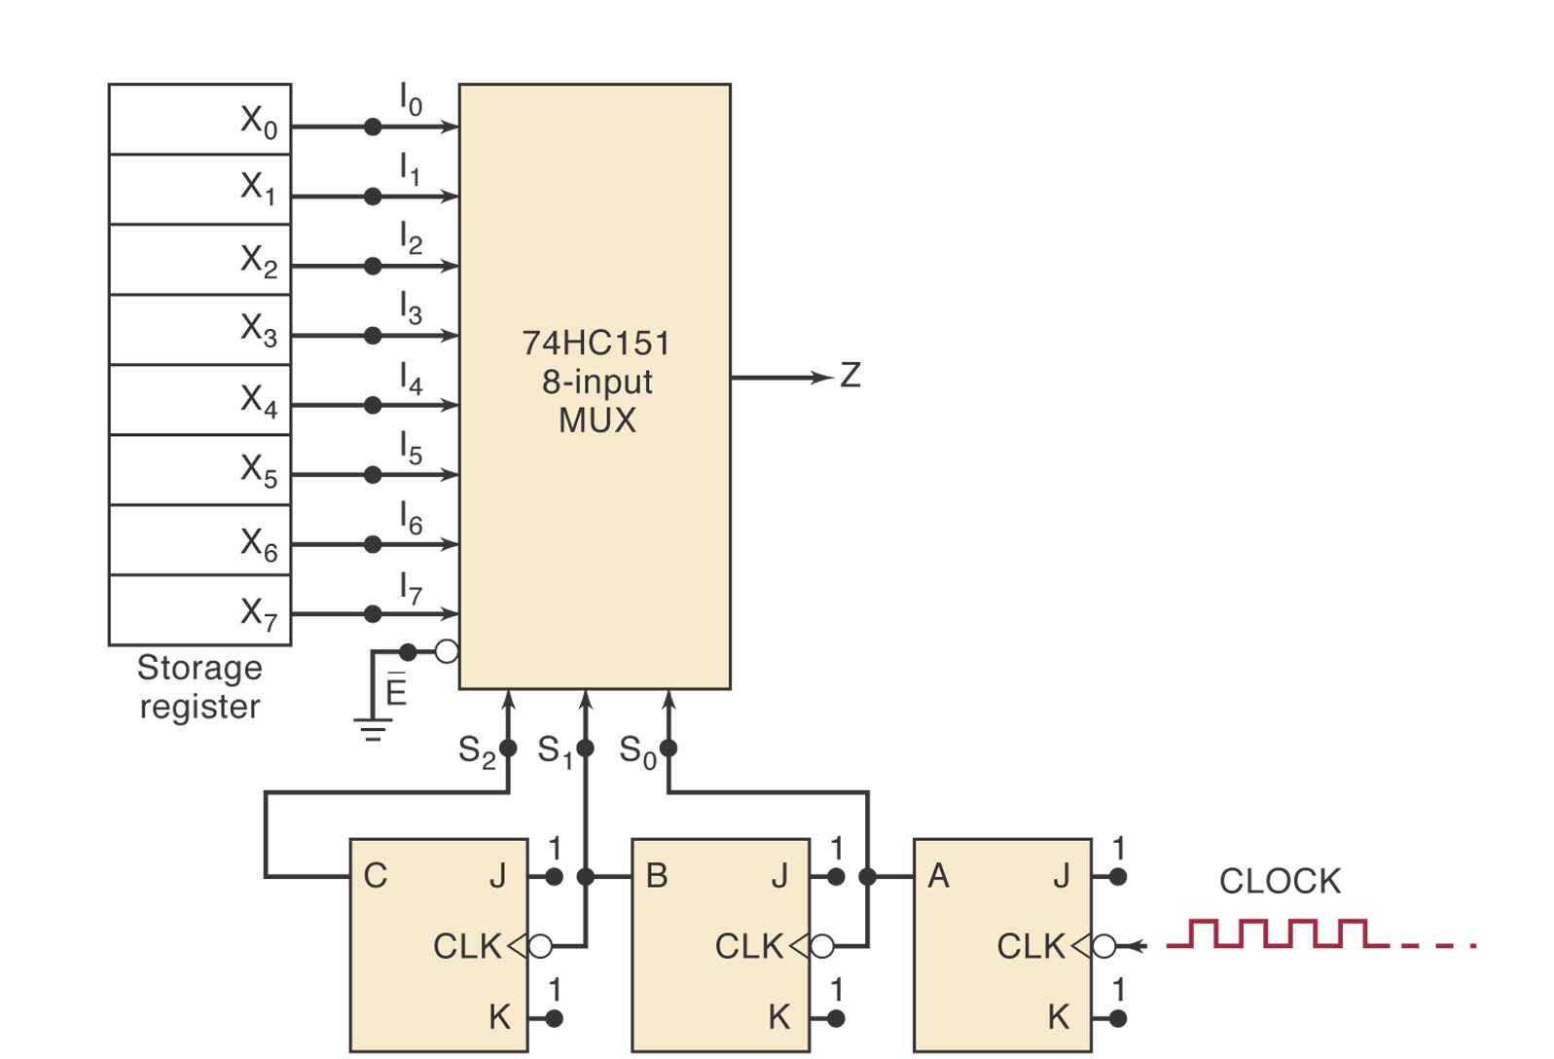

8. [Analog to digital converter] (a) Illustrate how a 4-bit successive-approximation ADC converter works assuming that the analog input V_{A} is 10.4V and the step size is 1V. (8%) (b) For each of the following statements, indicate which type of ADC (digital-ramp, SAC or flash) is being described: (7%)
(1) Fastest method of conversion
(2) Needs a START signal
(3) Requires most circuitry
(4) Does not use a DAC
(5) Generates a staircase signal
(6) Uses an analog comparator
(7) Has a relatively fixed conversion time independent of V_{A}.
9. [Memory devices] (a) For a DRAM cell shown below, which switches are closed during the WRITE operation? Which switches are closed during the READ operation? (4%) (b) List 3 applications of ROM. (6%)
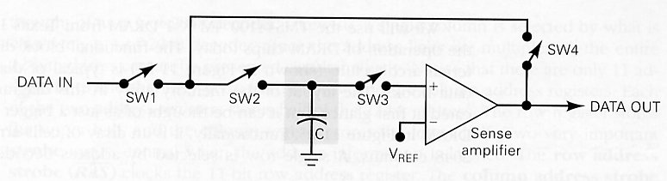

10. [AHDL] Modify the following code to perform a 3-digit BCD-to-binary converter. (5%) 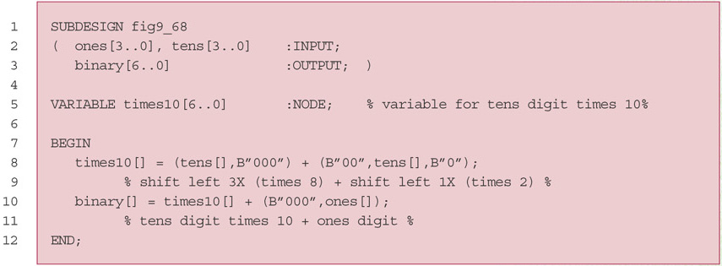

11. [Digital IC families] Given the following data sheet for 74ALS00 NAND gate IC: (a) What is the maximum average power dissipation of a single gate? (3%) (b) What are the noise margins? (4%) (c) How many 74ALS00 NAND gate inputs can be driven by a 74ALS00 NAND gate output? (4%)
