**University of Toronto**

**Faculty of Applied Science and Engineering**

**MIE1622**

**Computational Finance and Risk Management**

**Final Group Project Report**

| **Group** | Group 9 |
| --- | --- |
| **Team Members** | Junyu Jiang  Yijia Gao  Yinjie Meng  Zijie Zhao  Ren Li |
| **Date**  Apr. 17, 2022 | |

**Table of Contents**

**Introduction** **3**

Functions 3

Objectives 3

Constraints 3

**Chatbot Design** **3**

**Algorithm Explanation** **4**

**Result** **5**

Use Case 1: Low Risk and Low Return Preference 6

Use Case 2: Medium Risk and Medium Return Preference 7

Use Case 3: High Risk and High Return Preference 8

**Reference** **9**

**Appendix**

# 

# Introduction

Robo-advisors are online digital platforms that provide automated, algorithm-driven investment services with little human supervision. Usually, a typical robo-advisor asks questions about peoples’ financial situation and their future investing goals, then converts data into the system and creates personalized investing strategies. In this project, a robo-advisor chatbot is created using IBM Watson Assistant and aims to provide asset investing advisory service for short-term investment users [1].

## Functions

* Provide automatic short-term investment plan with user preferences on assets, holding period, amount, risk tolerance
* Simulate future money-on-hand to analyze key statistics at the end of holding period

## Objectives

* Ease to access of automatic investment advisory interface
* Forecasting results can be easily viewed and compared
* Consider flexibility on asset inclusion for both users with or without prior investment knowledge

## Constraints

* User must interact in the Python-programmed environment
* All inputs must be entered in the similar format as required by the robot
* The user interface shall comply with ISO 9241-210:2019 in *Ergonomics of Human-system Interaction for Interactive System* [2]

# Chatbot Design

We designed a robo-advisor that provides investing suggestions for short-term investing (the holding period is fewer than 100 days). The main idea of this system is that it guides potential customers to tell the chatbot the amount of money they want to invest, the holding period, the assets they want to invest and their risk tolerance level.

In Watson assistant, the designed dialog will start when customers type in “I want to invest”. Then, customers will be asked to type in answers of questions designed in the chatbot by following the logic of the system. The flow chart of the questions is shown below:

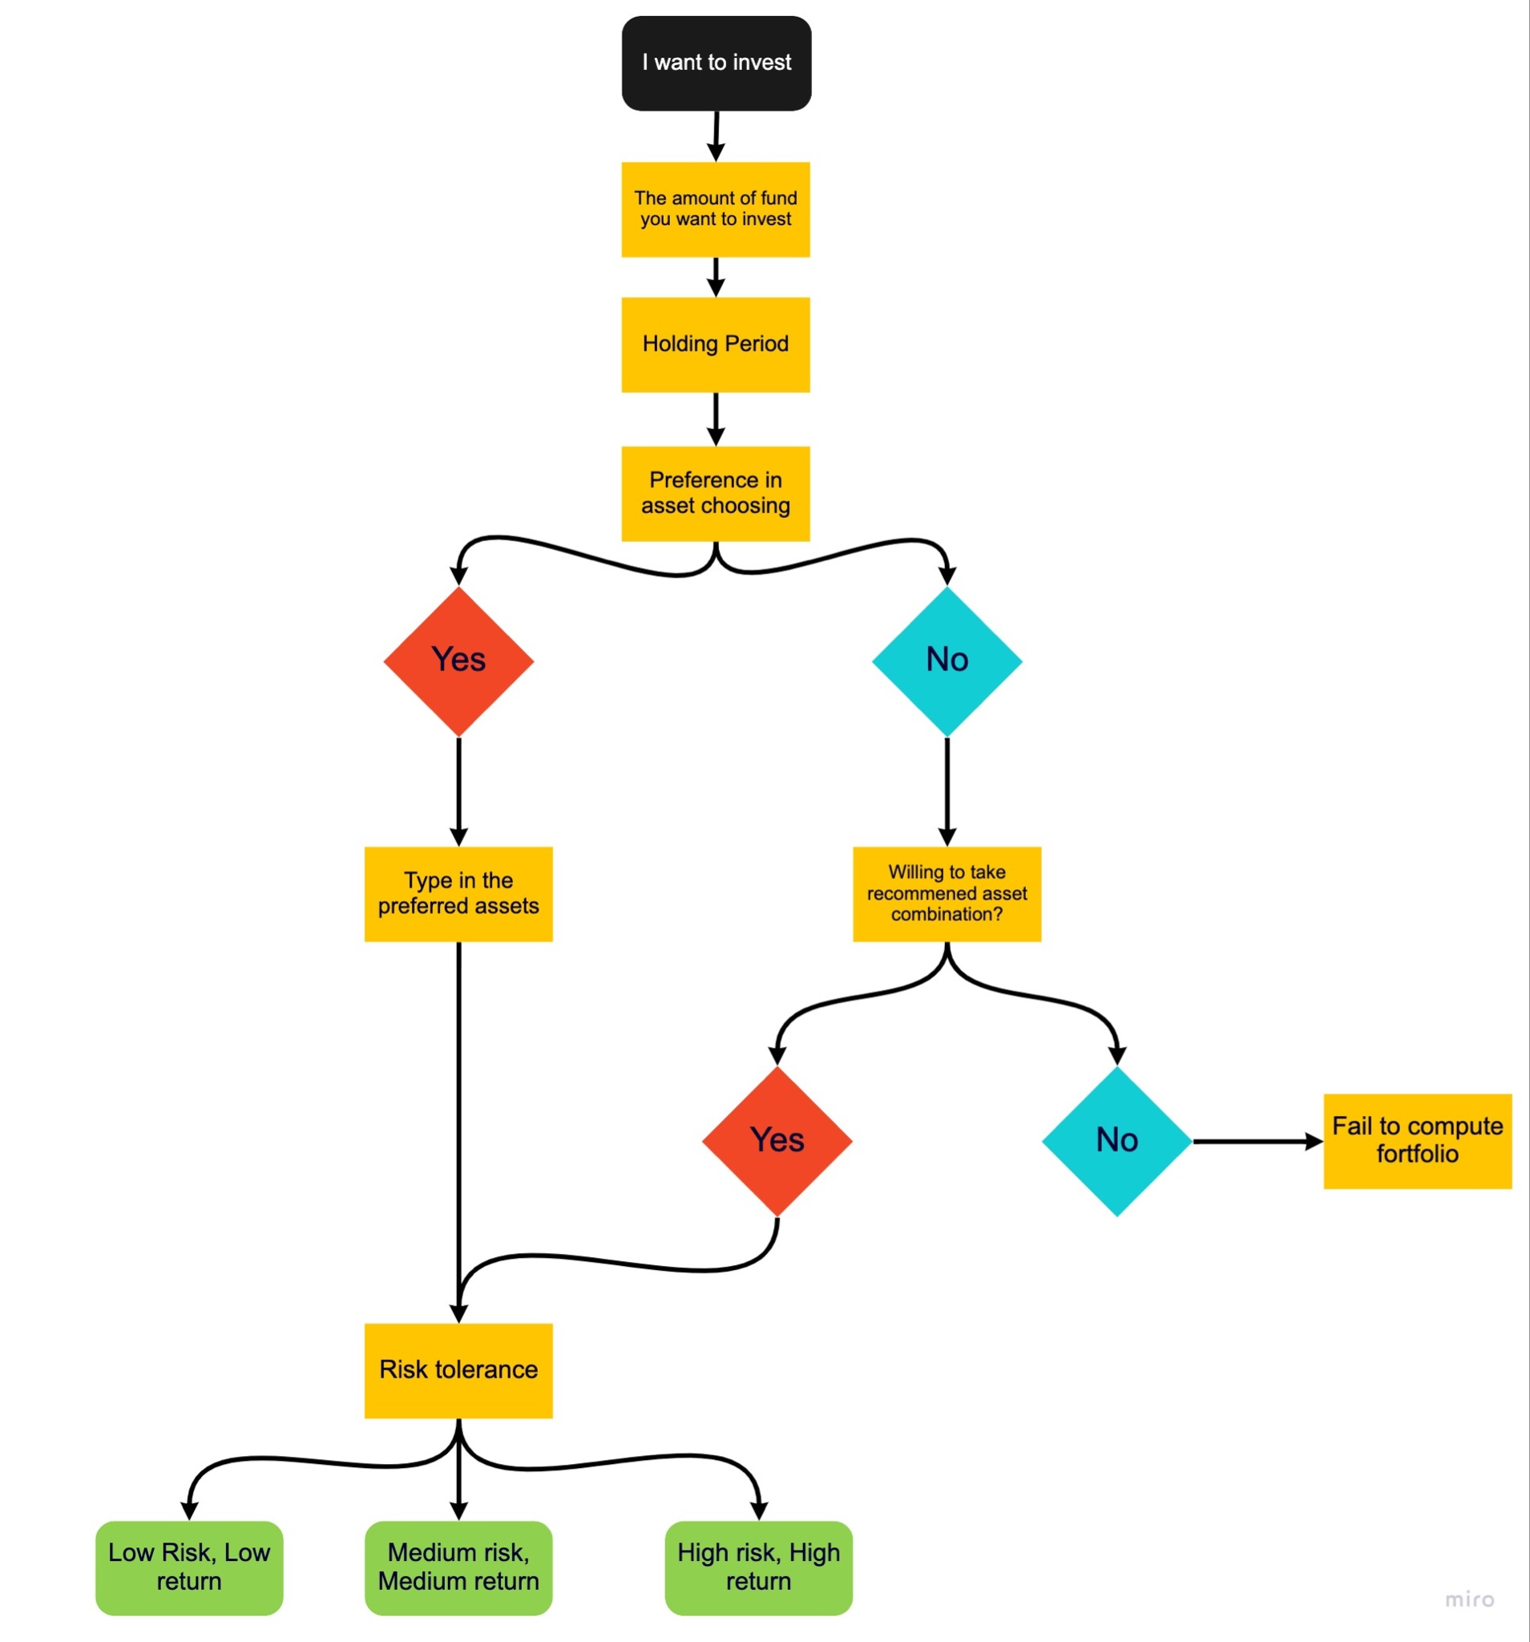

Figure 1. Robot-advisor Process Flowchart

One of the unique features of our chatbot is that it provides personalized investing experience, no matter you are new to investing or professional investors. If you have your own preferences of stocks that you want to invest, you can tell the chatbot and it can help you build your preferred portfolio; if you do not have a preference, a fixed choice of ETFs chosen by our team will be provided to you, which contains SPY (S&P 500 ETF) , VTV (Value stocks ETF), VUG (Growth stock ETF), GOVT (U.S treasury bond ETF), EEMV (MSCI Emerging Markets Min Volatility Factor ETF), CBOE (Chicago Board Options Exchange stock), and QQQ (Nasdaq-100 Index tracking ETF).

After finishing the Chatbot questions, the answer of these questions will be used as input feed into our investing model. Watson Assistant API is used to import the Chatbot system into IPython notebook so that the input answers can be used directly in the Python environment.

# Algorithm Explanation

# 

The algorithm first downloads the previous 2 years data of the chosen assets and calculates the expected return and covariance matrix between the chosen assets.

Depending on the user's preference, the algorithm calculates the suitable weight for the user. There are three risk levels and return levels for users to choose from, low risk low return, medium risk medium return and high risk high return.

If the user chooses low risk low return, the algorithm outputs the Minimum Variance portfolio for the user. The weight of the Minimum Variance portfolio satisfies the following optimization problem.

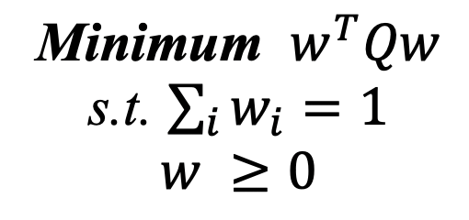

If the user chooses medium risk medium return, the algorithm outputs the Sharpe Ratio portfolio for the user. The weight of the Sharpe Ratio portfolio satisfies the following optimization problem.

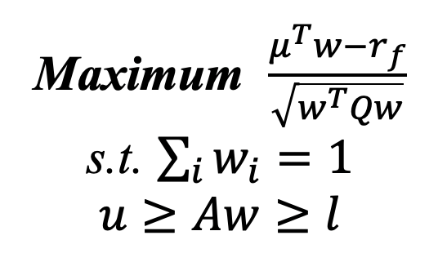

If the user chooses high risk high return, the algorithm outputs the Maximum Return portfolio for the user. The weight of the Maximum Return portfolio satisfies the following optimization problem.

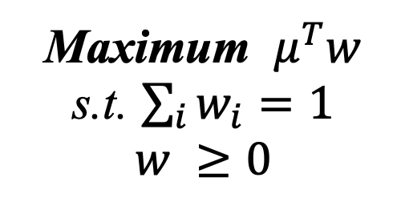

After calculating the weight, the algorithm uses Monte Carlo Simulation of 10000 scenarios to predict the future value of the portfolio and produce a plot of probability density function and basic statistics of the future value of the portfolio to make a clear view for the user.

# Result

For user case demonstration, we assume that the user enters the initial cash to be $10,000, holding period of 50 days. Additionally, the user has limited knowledge of asset investment and would like the chatbot to help them plan the short-term investment based on their risk preferences. After inputting these parameters to the chatbot, the algorithm will solve for their optimal portfolio.

The outputs are Distribution of Ending Balance and a zoomed-in view of distribution neglected tails in both ends (10th to 90th percentile). They are organized to illustrate the frequency of occurrence of each possible outcome of ending balance simulated many times. Vertical axis shows the frequency count and horizontal axis shows the simulated ending balance in dollar amount. Specifically, users are interested in how much amount they are most likely to gain, as well as the worst and best case scenario of return in the end.

## Use Case 1: Low Risk and Low Return Preference

With low risk and low return preference and all other inputs hold, the chatbot suggests the user to invest money $8431.7 into VUG, $1215 into CBOE, $248.98 into VTV, $104.32 into SPY, which most of the money is allocated into the basket of large-growth stocks [3]. It is suitable for passive investors to gain a well-diversified large growth and cost efficient portfolio.

Based on the cash allocation and holding the investment for 50 days, the algorithm simulates the portfolio to have an average ending balance of $10328.18. Within 90% of the behavior of market conditions, the user will gain a maximum profit of $2770.99 (it was $10,000 initially) during a bullish market, and could possibly lose $1780.67 in maximum during bearish market. If the market behavior is extreme, the maximum ending balance could double the initial cash on hand, whereas the minimum ending balance could shrink the initial balance to $5662.71.

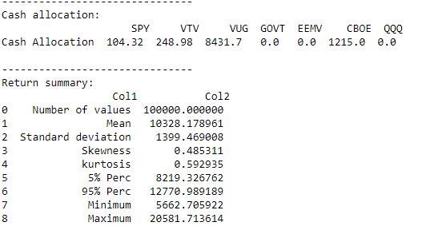

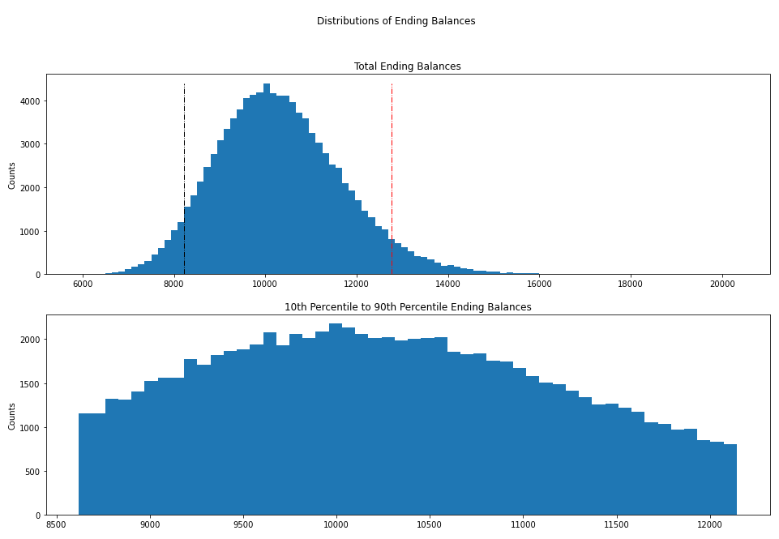

Figure 2. Low Risk and Low Return Preference Outputs

## Use Case 2: Medium Risk and Medium Return Preference

With a medium risk preference and all other inputs held, the chatbot suggests the user to invest $7915.21 into CBOE and the rest of the money into GOVT. Most cash is allocated into the CBOE Global, which is poised for effective capital deployment and profitable on high trading volumes in index options and volatility products [4].

Based on the cash allocation and holding the investment for 50 days, the algorithm simulates the portfolio to have an average ending balance of $12323.42. Within 90% of the behavior of market conditions, the user will gain a maximum profit of $14763.39 (it was $10,000 initially) during a bullish market, and could possibly lose $5275.98 in maximum during a bearish market. If the market behavior is extreme, the maximum ending balance could be 8.8 times of the initial cash on hand, whereas the minimum ending balance could shrink the initial balance to $1174.17.

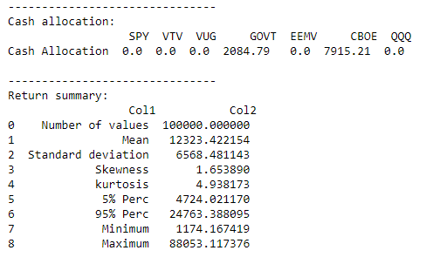

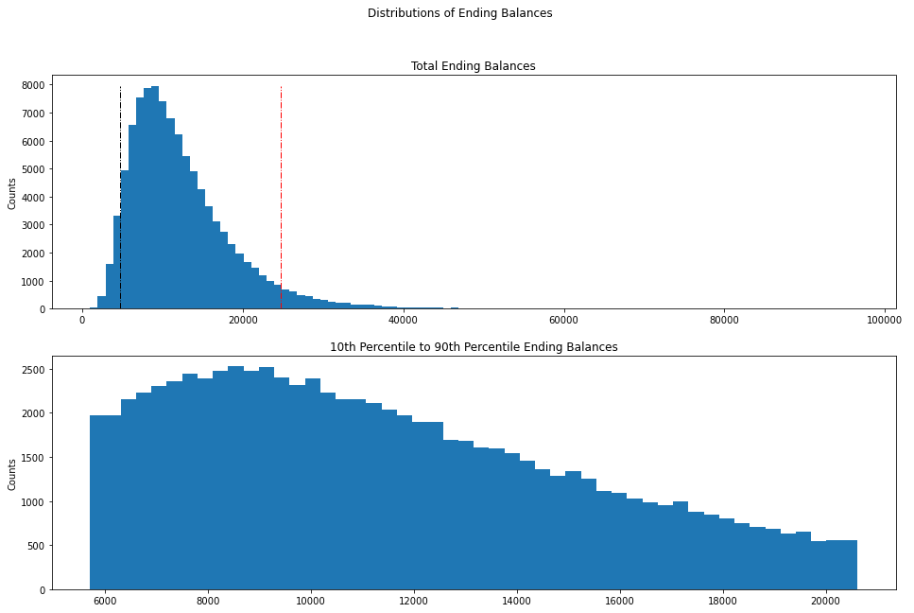

Figure 3. Medium Risk and Medium Return Preference Outputs

## Use Case 3: High Risk and High Return Preference

With a high risk and high return preference and all other inputs hold, the chatbot suggests the user to invest almost all cash into GOVT, which indicates performance of the overall US Treasury market [5]. Treasury bonds are considered to be the safest that the investor would not lose the principal and hold the bond until the end. Although the GOVT is not considered as high risk from intuition, it indeed leads to relatively higher return during the volatile market.

Based on the cash allocation and holding the investment for 50 days, the algorithm simulates the portfolio to have an average ending balance of $13488.52. Within 90% of the behavior of market conditions, the user will gain a maximum profit of $23717.14 (it was $10,000 initially) during a bullish market, and could possibly lose $6789.45 in maximum during bearish market. If the market behavior is extreme, the maximum ending balance could be 20 times of the initial cash on hand, whereas the minimum ending balance could shrink the initial balance to $460.97.

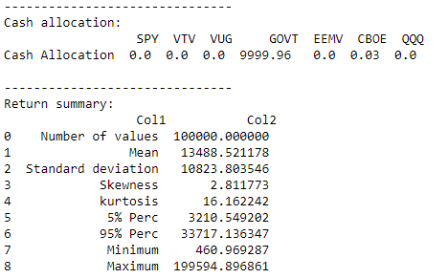

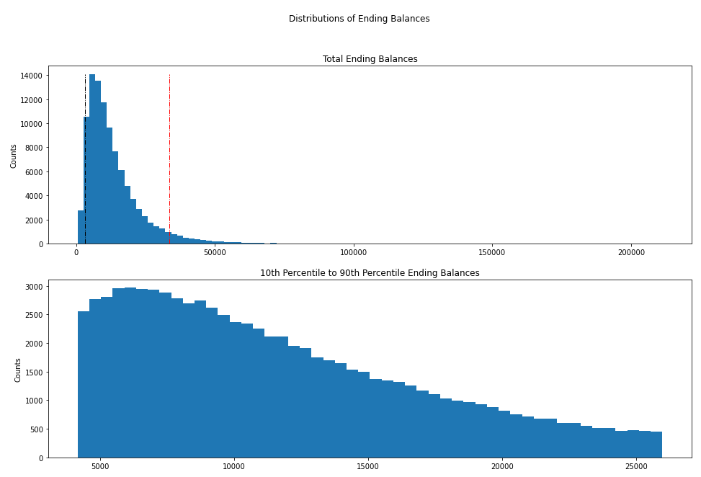

Figure 4. High Risk and High Return Preference Outputs

# Reference

[1] IBM Cloud Docs. (n.d.). Retrieved April 17, 2022, from https://cloud.ibm.com/docs/assistant?topic=assistant-getting-started

[2] ISO 9241-210:2019 Ergonomics of human-system interaction — Part 210: Human-centred design for interactive systems

[3] Vanguard ETF profile. Vanguard. (n.d.). Retrieved April 17, 2022, from *https://investor.vanguard.com/etf/profile/VUG*

[4] Cboe Global Markets. Retrieved April 17, 2022, from https://www.cboe.com/

[5] *Ishares U.S. treasury bond ETF: Govt*. BlackRock. (n.d.). Retrieved April 17, 2022, from https://www.ishares.com/us/products/239468/ishares-us-treasury-bond-etf

**Appendix**

Chatbot Assistant system — interface samples::

