

User’s Manual

v1.0

Table of contents
Intro 3
Board description 4
What’s the current firmware can do 5
How it works 5
PCB 6
Connectors 6
Buttons and switches 6
Keyboard 7
Hotkeys 7
Board assembly guide 8
The components 8
Assembly 8
Smoke test 8
Firmware flashing 8
AVR flashing 9
CPLD EPM3128 and FPGA EP4CE6 flashing 9
First run after flashing the firmware 9
Firmware upgrade using a Flash Tool 10

Intro
Dear user! Welcome to the retro computers world!
You’re reading a Karabas-Pro development board user’s manual. You’ll be able to recreate one of the famous 8-bit computers from 199x – ZX Spectrum compatible machine named Profi2+.
The following manual will be useful for people who is making the board from scratch or for the already assembled and working board owners.
The project is open-source, licensed by the Open Source Hardware License. All the source code, including the pcb design and firmware are located in git repository - https://github.com/andykarpov/karabas-pro. Feel free to join and collaborate with the project. Let’s make it better ;)
One of the main feature of this project, that highlights it from the others FPGA-based clones is the real floppy disk drive and a hard disk drive (Compact Flash, actually) controllers, so you can use a real floppy disks or Gotek emulator with this board and all the software written for the disked ZX Spectrum and Profi CP/M (Microdos).
To start you’ll need the following:
- VGA compatible monitor with 50Hz support or TV with RGB inputs
- 12V 2A DC power supply (center contact - positive)
- PS/2 keyboard and PS/2 mouse
- Sound output device (headphones or active speakers, etc.)
- Mechanical Atari-like joystick
- CF-card (not all vendors are good. Better to choose a Sandisk with 2-8Gb capacity)
- SD-card
- 3.5” spectrum-ready floppy disk drive or Gotek emulator with FlashFloppy firmware
- Some amount of time and patience :)
If the board is not flashed, you’ll also need:
- Altera USB Blaster, byte blaster or other compatible programmer
- AVR programmer (USBasp, TinyISP or other with 6-pin interface)
- Quartus Programmer software to flash the CPLD and FPGA
- avrdude or similar software to flash AVR chip

Board description
Karabas-Pro PCB fits into the 3.5” floppy drive dimensions. You will be able to mount the floppy disk drive using the board’s mounting holes.
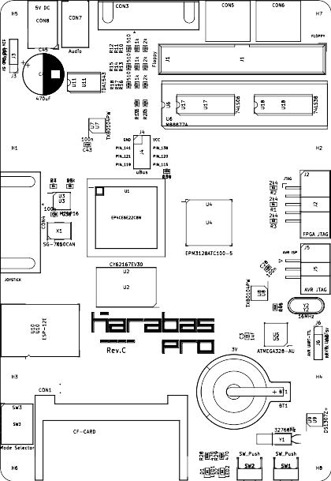
The PCB contains the following main components:
- FPGA Altera EP4CE6E22C8N
- Configuration flash EPCS16 (M25P16, W25Q16, ...)
- CPLD Altera EPM3128
- Static RAM 2MB
- FDD conttoller (BDI) based on the MB8877A chip
- PS/2 keyboard, mouse and RTC supported by Atmega 328P controller
- Audio DAC TDA1543 (or TDA1543A)
- SD card connector
- CF card connector
- DB9 connector for the mechanical (Atari) joystick

What’s the current firmware can do
The current firmware is releasing for all pcb revisions (A,B,C,D), and is able to recreate the following hardware:
- Profi machine with all specific control ports (CMR0, CMR1)
- T80 soft processor
- 1 MB of RAM by Profi standard (port #dffd)
- RGB 15kHz or VGA 30kHz 50Hz video output
- Pentagon video mode (320 lines, 49 Hz)
- Profi video mode (512x240, 50 Hz)
- Profi 16-color palette
- Turbosound emulation (2x AY-3-8912)
- Profi covox and Soundrive emulation
- SAA1099 sound chip emulation (only available for EP4CE10 FPGA yet)
- XT keyboard emulation (via the 5th bit of the port #FE)
- Kempston mouse and serial mouse implementation (via the COM1 serial port emulation)
- RTC support
- ZXUNO based UART to access ESP8266 at 115200bps
- 4 switchable rom banks
- Turbo mode 7MHz
- Experimental support for 60Hz vertical refresh rate
- TurboWG mode (speed up the FDD head movements)
- New ports decoding scheme to support a modern PQ-DOS operating system

How it works
After switching on a power to the board, the FPGA will read and start a configuration from the SPI flash device. Then the loader will start a logic to copy the ROMs into the upper area of RAM using a direct access to the RAM. The machine is in the reset state during this operation. After copying all the ROMs into the RAM, a forced reset signal is triggered to start the machine. Now it’s ready to work.
In parallel with the boot process the AVR micro controller initializes the keyboard, mouse and RTC chip. Also the controller will copy the contents of all registers of the RTC chip into FPGA by SPI bus (the controller is always master, FPGA side is a slave). Then the controller sends the keyboard matrix content, mouse and joystick events to the FPGA side in the infinite loop, as well as once per second it sends the RTC time registers.
The external peripherial devices (BDI, HDD) are serviced by the CPLD Altera EPM3128. All required ZX-BUS signals are transferred between FPGA and CPLD by internal parallel 16-bit controlled bus.

PCB
The PCB is released on the two-sided FR4 1.6mm board. The dimensions are: 147 x 101 mm.

Connectors
- CON8 – 5 x 2.1 mm DC socket to power the board (5V 2A for revisions A,B,C,C1, 12V 2A for revision D and higher)
- CON7 – 3.5 mm audio jack (TRS)
- CON3 – 15-pin D-SUB to connect VGA monitor or TV (via VGA-to-SCART cable)
- CON5 – Mini Din 6 to connect a PS/2 keyboard
- CON6 – Mini Din 6 to connect a PS/2 mouse
- CON4 – 9-pin D-SUB to connect a machanical Atari-like joystick
- CON1 – 50-pin slot to connect a Compact Flash memory card as HDD storage
- CON2 – an SD card slot
- J6 – 4-pin header AVR UART (5V TTL)
- J5 – 6-pin shrouded header for AVR ISP
- J2 – 10-pin shrouded header for JTAG (both FPGA and CPLD, they are chained)
- J4 – 8-pin general purpose connector (free pins from the FPGA)
- J3 – 4-pin header to power the FDD from the board

Buttons and switches
- SW1, SW2 – general purpose tact buttons. Currently – unused for rev.A, B. For rev.C and higher – it’s a hard reset and hard reset + S buttons (to enter the internal keyboard port test).
- SW3 – debug dip switches (only for boards rev.C and higher)

Keyboard
The keyboard can work in 2 modes:
- Extended PC XT keyboard
- Classic ZX Spectrum 40-pin keyboard
The extended mode uses an additional bit of port #FE to transfer a functional and extended keys.

Hotkeys
- Menu + F1 – switch to ROMSET 0 – a standard Profi ROM with Service 2.3 and embedded FatAll software by Savelij
- Menu + F2 – switch to ROMSET 1 – an alternative Profi ROM with PQ-DOS BIOS
- Menu + F3 – switch to ROMSET 2 - FlashTool by Doctor Max
- Menu + F4 – switch to ROMSET 3 - Diag ROM
- Menu + F5 – toggle the TurboFDC state (for boards rev.D alpha 2 and higher)
- Menu + F7 – toggle the SSG stereo mode (ABC / ACB / mono)
- Menu + F8 – toggle the emulated SSG chip type (AY / YM)
- Menu + F9 – toggle the VGA / TV modes
- Menu +F10 – toggle the vertical refresh rate – 50Hz / 60Hz
- Menu + F11 – toggle the Turbo mode 7MHz / normal 3.5MHz
- Menu + F12 – toggle the NMI event to the CPU
- PrtScr – switch the keyboard mode between a standard 40-key (Spectrum) and the extended PC XT mode
- Pause – stops the CPU by /WAIT signal
- Ctrl+Alt+Del – throws a RESET signal
- Ctrl+Alt+Esc – throws a NMI signal
- Ctrl+Alt+Backspace – throws a RESET signal + S button to enter the internal keyboard port test service (available only in ROMSET 0)
- Menu + Tab – swaps the FDC drive letters from A<>B

Board assembly guide
In this chapter a community experience to assemble and start the machine is collected. Reading this part of manual is not guaranteed to the success, but will close it as much as possible.

The components
It’s very important to source the electronic components from the confirmed sellers to avoid non-working or partially-working results. The author had a bad experience with many AliExpress sellers multiple times.

Assembly
Before starting the assembly process – please carefully inspect the PCB. The factory optical and electric control is not enough. Please doublecheck the traces and pads for unwanted shorts or damages. Also please check the power lines with your multimeter if there is no shorts in between them and ground.
The next step – it’s recommended to solder all big SMD chips, like FPGA, CPLD, AVR, flash, etc. DIP components can be skipped on this step.
Then please place and solder all passive and active 2- and 3-pin SMD components (resistors, capacitors, generator, LEDs, etc).
The next step is to clean your soldering from flux by alcohol (liquid or wipes).
The final step is a soldering of all the through hole components (DIP sockets, ICs, connectors, pin headers, electrolytic capacitors, buttons, etc).

Smoke test
Before the first run please inspect the assembled board for soldering joints quality, as well as check the power lines for shorts. Then you can power the board with the laboratory power unit with current protection at 200mA. If the protection logic is not triggered – then everything is ok and you can try to run the board from the normal power supply.

Firmware flashing
Now you can flash the firmware. The order of flashing is not so important, but you can start from flashing an AVR controller, then CPLD with FPGA.
The pre-build releases are published on github repository as git tags (releases), as well as the latest release is always pre-compiled here: https://github.com/andykarpov/karabas-pro/tree/master/firmware/releases/profi

AVR flashing
To flash the Atmega328P, please connect the programmer to the appropriate socket J5 (AVR ISP). Please do not power the board from the programmer. The board should be powered from the external DC supply when programming.
The example of calling avrdude from the command line to flash the AVR using UsbASP programmer:
avrdude -c usbasp -p m328p -U flash:w:karabas_pro_revD.hex -U lfuse:w:0xFF:m -U hfuse:w:0xDE:m -U efuse:w:0xFD:m
When using other programmers, please flash the karabas_pro.hex (or karabas_pro_revD.hex for rev.D and higher) with the following fuse bits:
- Low: 0xFF
- High: 0xDE
- Extended: 0xFD
P.S. Some users reported about difficults when programming the extended fuse. You can skip flashing the extended fuse at all, leaving a factory value there.

CPLD EPM3128 and FPGA EP4CE6 flashing
To flash the CPLD and FLGA chips, it’s enough to donwload and install a standalone version of the Quartus Programmer. It’s small enough and you don’t need to download and install a full release of the Quartus software. Version is not important, but not less than 13.0 will be enough for most cases.
Flashing steps:
Open the karabas_pro_tda1543.cdf or karabas_pro_tda1543a.cdf file in Quartus Programmer (it depends on what DAC chip is installed on your board).
Then you’ll have to tick the checkboxes Program/Configure behind the CPLD and FPGA (in all rows) and push the Start button.
After successful flashing you’ll have to re-apply the power to the board to start the core.

First run after flashing the firmware
First, you need to connect the VGA monitor, PS/2 keyboard and mouse to the board. If everything is ok – you’ll have to see a welcome screen of the Profi service menu. Congratulations, now your karabas-pro is ready! :)

Firmware upgrade using a Flash Tool
To upgrade your FPGA firmware without a USB Blaster – there is a special tool located in the ROMBANK2 – Flash Tool by Doctor Max. With this utility you’ll be able to upgrade your FPGA configuration from SD card (rbf-file), as well as upgrade your ROMBANKs contents.
To enter the Flash Tool please use a hotkey Menu+F3.
Please put the desired FPGA firmware rbf-file and/or bin-files of your ROMBANKs you want to upgrade on SD card.

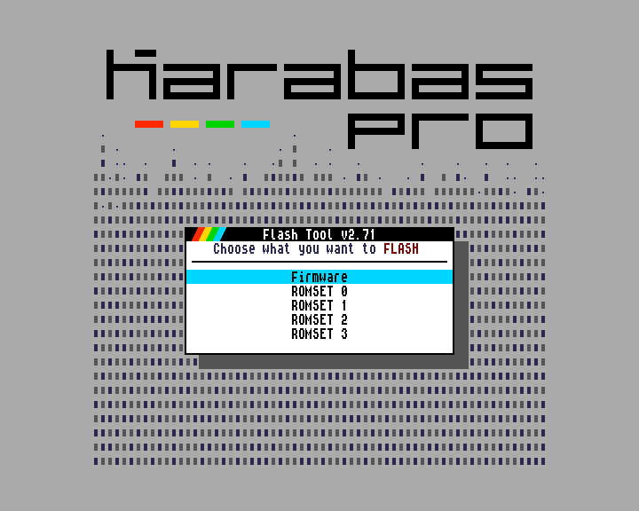
After choosing an action (Firmware upgrade or ROMSET upgrade), you’ll be asked to confirm the action by accepting an agreement:
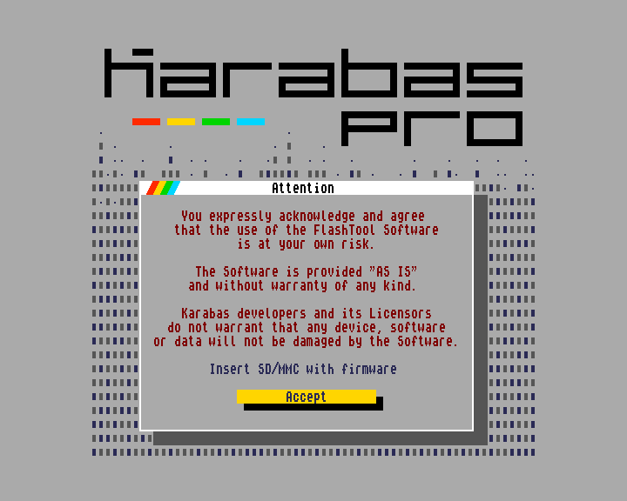
Then you’ll have to choose a file from SD card and then wait until the writing process is finished:
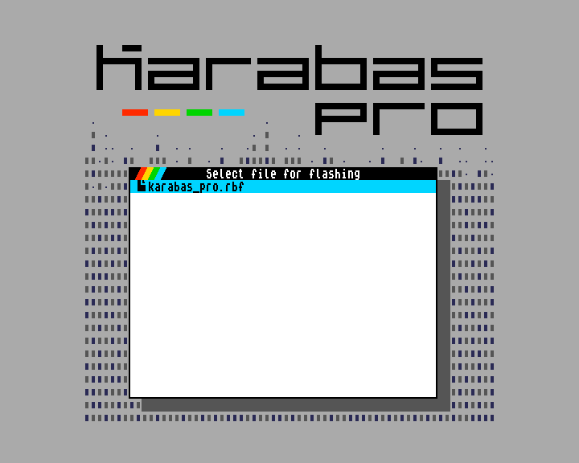
If you’re finished working with flash tool, please re-apply the power to the board to force the firmware to re-read the new configuration and ROM updates from the flash memory on start.

