Testedness is defined by the following formula:
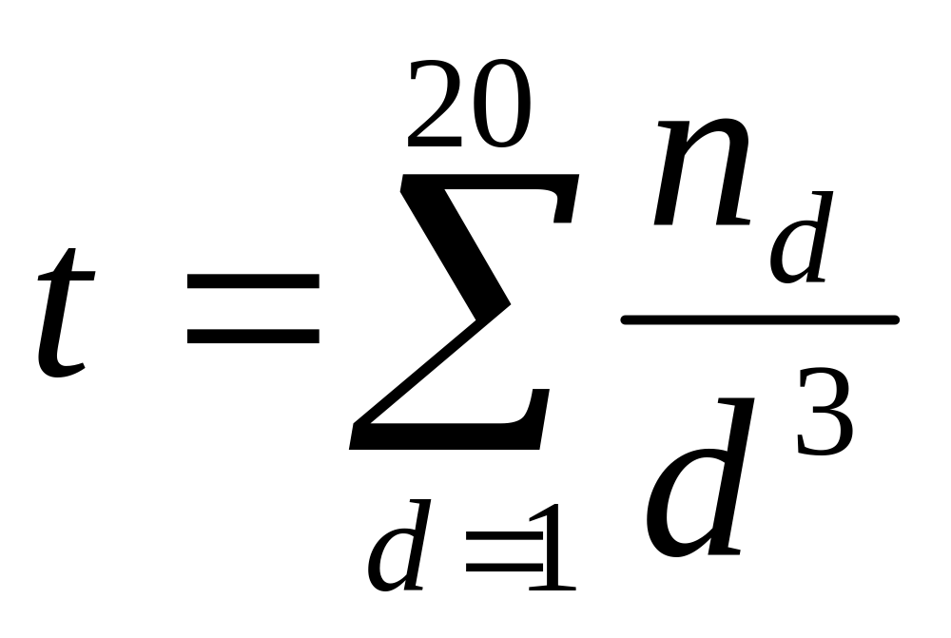
Where
t is the testedness
d is the test distance
n_{d} is the number of calls at test distance d

Assertion density for a test is defined as:
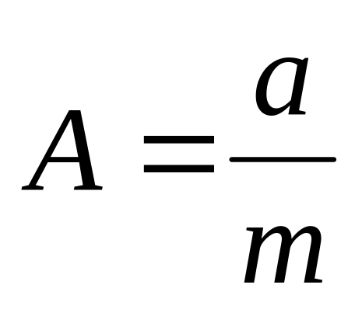
Where
A is the assertion density for that method
a is the number of assertions made during the execution of that test
m is the number of methods called during the execution of that test

