Source Code: <https://github.com/andylin77nchu/1111_IoT_FinalProject.git>

* Yolov7 main code should be download in GitHub.

Step 1: Clone YOLOv7 SourceCode

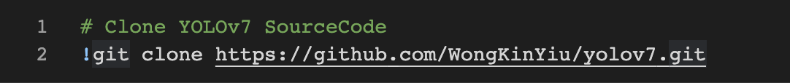

Step 2: Install requirements.txt

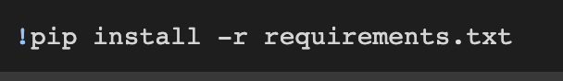

Step 3: Download Training Weights



Step 4: Prepare traindata

Create customdata.yaml in /data/ define training data path, number of classes and class name

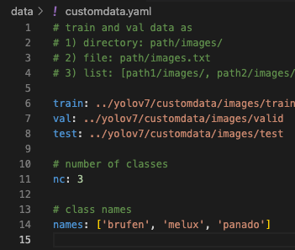

Step 5: Edit utils/loss.py



Step 6: Edit cfg/training/yolov7.yaml



Step 7: Start Training

Argument setting following:

--workers 8

--device 0

--batch-size 20

--data data/customdata.yaml

--img 640 640

--cfg cfg/training/yolov7.yaml

--weights 'yolov7_training.pt'

--name yolov7-custom

--hyp data/hyp.scratch.custom.yaml

--epochs 300

Weight output path is: runs/train/yolov7-*/weights/

Inference output path is: runs/detect/