Information retrieval CS7263

Andy Vu

Programming assignment 1

Email Statistics:



Word frequencies without stop word removal:



Word frequencies with stop word removal:



Plotted word distribution with stop word removal:

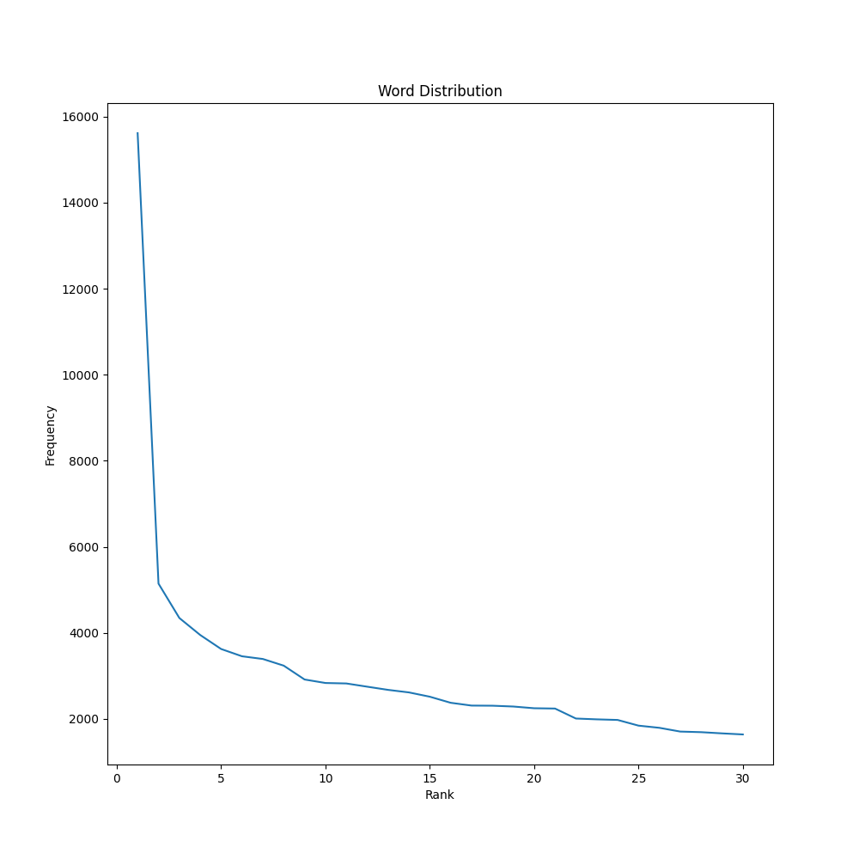

Plotted word distribution with stop word removal on a log-log plot:

