This is a demonstration of how to use Officer

This is some text.

| label | value |
| --- | --- |
| Pie charts are confusing | 51 |
| Pie charts are hard too read | 91 |
| Pie charts are my favourite | 10 |
| Pie charts are just wrong | 18 |

This is some more text:

Lorem ipsum dolor sit amet, consectetuer adipiscing elit. Maecenas porttitor congue massa. Fusce posuere, magna sed pulvinar ultricies, purus lectus malesuada libero, sit amet commodo magna eros quis urna.

And a nice chart can go here. Or a terrible one:

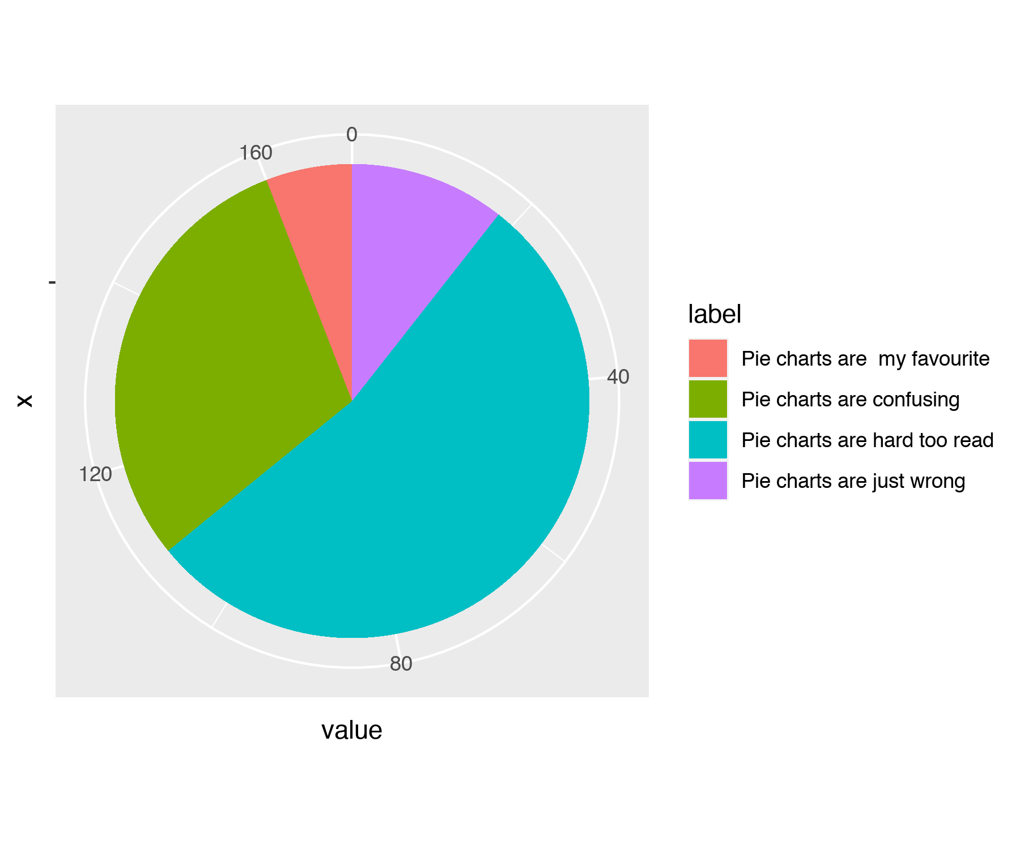

(the end)