# Website title

The title of the website is Andy’s Experiences

# Team member

The sole member of this project is me (Andy Nguyen).

# Introduction

The main webpage shows some of the places that I have visited in the past and my experiences with them. There is also a welcome page and a personal information page so that people can know more about me.

# Website organization

## Welcome page

This page shows the current weather of the place the reader is in, along with a greeting and a random fact that is dynamically updated.

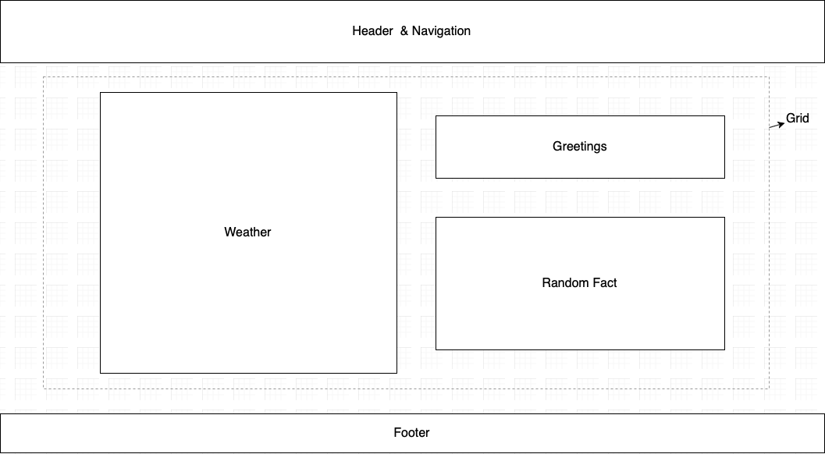

## Places I visited page

This page shows some images and a short paragraph about the locations that I have visited. The images for each place are put into a carousel. There is also a table showing the years that I visited those places.

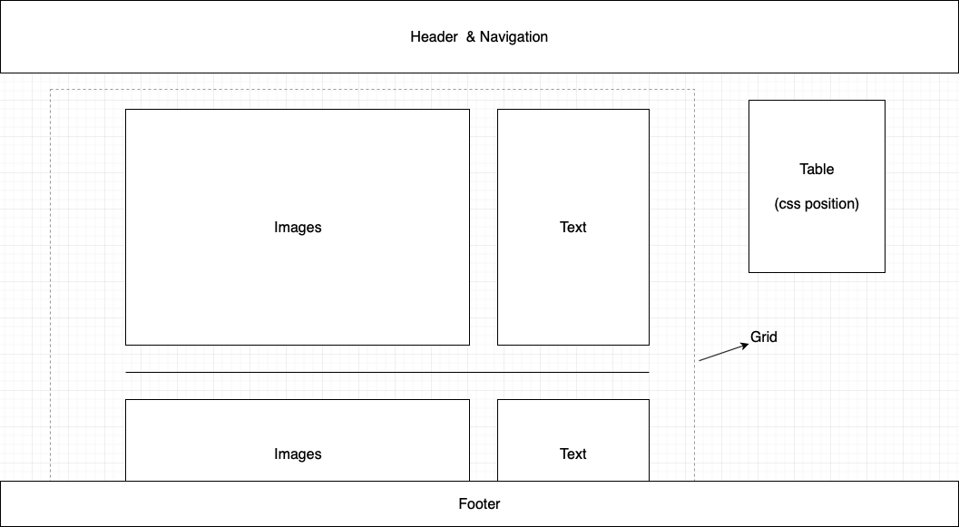

## About me page

This page includes a picture of me, my contact information, personal summary, education history and work experiences.

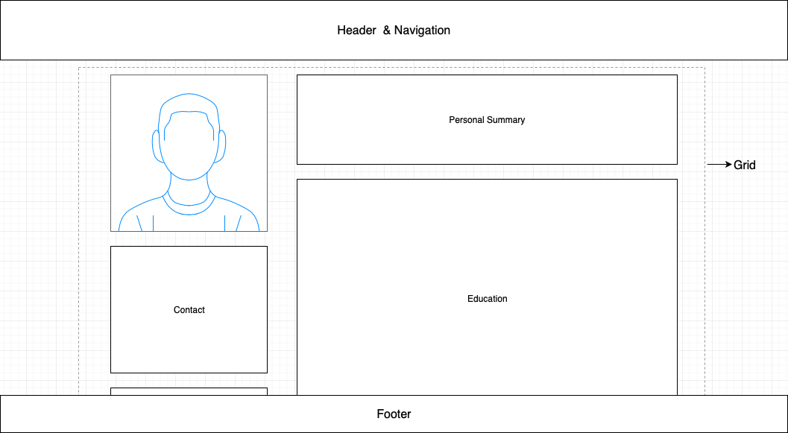

# Multimedia

The images for weather conditions will be taken from unsplash.com. For places I visited page, the pictures and videos will be my own.