DOCUMENT 1 OF 2 · PROJECT ARCHITECTURE DOCUMENT
Explainable Multimodal Early-Warning System for Supply-Chain Disruptions
General overall project: the integrated five-person system, its work division and the team paper.

Document map
Sections 1–4  Project | Project objective, overall system architecture, five-person work division, library-based integration architecture.
Sections 5–8  Delivery | Publication plan for the team paper (Paper 1), contribution mapping, final end-to-end architecture, risks and open decisions.
Companion  Document 2 | Individual Research Contribution: the deeper research contribution of Person 1-5 and the basis of Paper 1.

Status of this document
This is a planning and architecture document. It contains no experimental results, no dataset claims and no accuracy figures. All numbers shown in examples are illustrative placeholders and are labelled as such.
Publication quality depends on actual novelty, experimental rigour, datasets, baselines, results and the requirements of the chosen journal or conference. Nothing here guarantees acceptance or impact.

Draft v1.0 · October 2026

PART 1 — GENERAL OVERALL PROJECT
Integrated project developed collaboratively by all five members

1. Project Objective
The system aims to detect and predict potential supply-chain disruptions before they become severe. A single data source rarely gives a reliable early signal: delays appear first in logistics records, warnings in news, and causes in weather or geopolitical events. The project combines these heterogeneous modalities into one early-warning pipeline.

Data modalities to be integrated
- Structured supply-chain data: orders, inventory, supplier and lead-time records.
- Historical / time-series data: demand, delivery times, prices, congestion indicators.
- News and textual information: reports on strikes, port closures, supplier incidents, policy changes.
- Weather and environmental events: storms, floods, earthquakes and other natural hazards.
- Geopolitical / external events: sanctions, conflict, trade restrictions, infrastructure failures.
- Logistics / transportation information: shipment status, routes, port and carrier information.

Outputs of the final system
Output | Description
Disruption probability | Estimated likelihood that a disruption occurs for a supplier, route or node within the prediction horizon.
Risk level | Discretised category (for example low / medium / high) derived from probability and thresholds defined by the team.
Possible disruption type | Class of disruption, such as transport delay, supplier failure, weather or geopolitical disruption.
Expected disruption horizon | Estimated time window in which the disruption is expected to materialise.
Major contributing factors | Ranked factors from structured, text and event modalities that drive the warning.
Explainable warning | Human-readable explanation linked to evidence, with a confidence indication.

2. Overall System Architecture
The pipeline moves from raw data sources through four modality-specific branches into a shared multimodal fusion model, and ends in an explainable alert. Figure 1 shows the full flow. Each stage has a named owner so that responsibility is unambiguous.
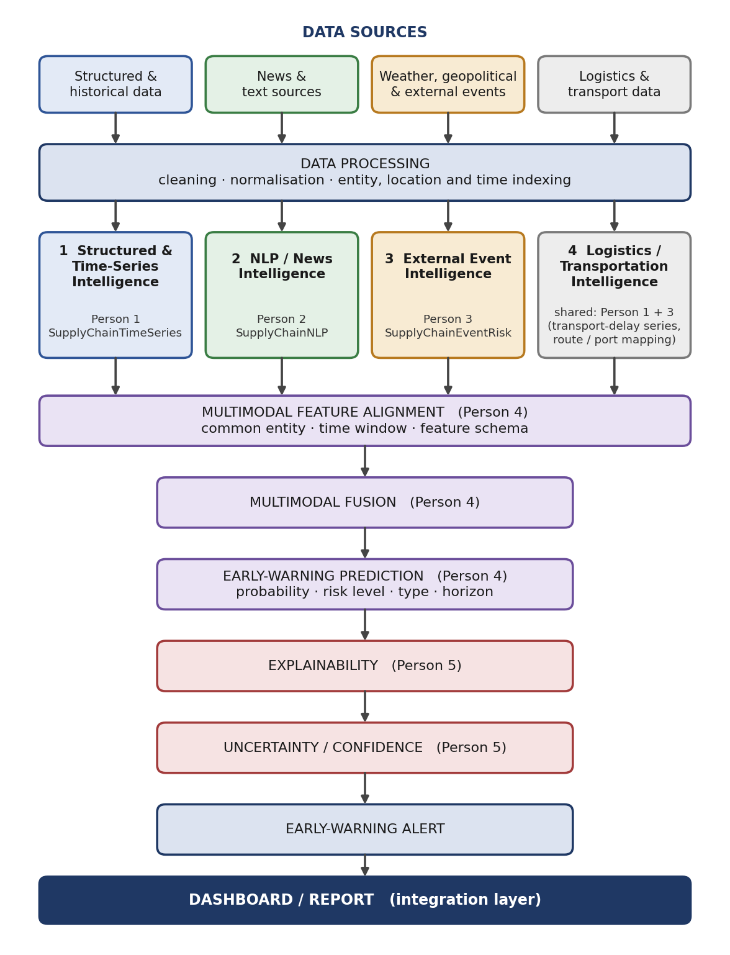
Figure 1. Overall system architecture (Part 1). Colours indicate the owning team member.

2.1 Stage overview
Stage | Purpose | Primary owner
Data sources | Heterogeneous raw inputs: structured, time-series, text, external-event and logistics data. | Each module owner for their own sources
Data processing | Cleaning, normalisation, entity / location / time indexing inside each library. | Persons 1, 2, 3
Modality-specific feature extraction | Four branches turn raw data into modality-specific features and risk indicators. | Persons 1, 2, 3
Multimodal feature alignment | Align features to a common entity, time window and schema. | Person 4
Multimodal fusion | Combine aligned modality features into a joint representation. | Person 4
Early-warning prediction | Disruption probability, risk level, type and horizon. | Person 4
Explainability | Attribution and evidence for why the warning was raised. | Person 5
Uncertainty / confidence | Estimate how reliable the prediction is. | Person 5
Early-warning alert | Combine risk level, confidence and explanation into one alert. | Persons 4 and 5
Dashboard / report | Thin presentation layer that renders library outputs. | Shared (integration)

2.2 Modality-specific branches
Branch | Content
1 Structured & Time-Series Intelligence | Supply-chain records and temporal signals converted into temporal risk features (Person 1).
2 NLP / News Intelligence | Events, entities, severity and embeddings extracted from news and text (Person 2).
3 External Event Intelligence | Weather, disaster, geopolitical and infrastructure events mapped to supply-chain nodes (Person 3).
4 Logistics / Transportation Intelligence | Cross-cutting branch. Transport-delay and lead-time series are produced inside SupplyChainTimeSeries (Person 1). Route, port and infrastructure mapping is produced inside SupplyChainEventRisk (Person 3). No sixth library is created, so the five-library structure is preserved.
All four branches merge into the multimodal fusion module.

3. Five-Person Work Division
The division is module-based, not task-based. No member is assigned a purely supporting role such as data collection, documentation or dashboard work. Every person has a meaningful coding component and a research component, and every person develops an independent Python library that is later imported into the integrated system.

Person 1 — Structured & Time-Series Intelligence
Library | SupplyChainTimeSeries
Responsibilities | - Supply-chain data preprocessing  - Time-series feature engineering  - Demand and lead-time analysis  - Anomaly detection  - Temporal risk features  - Forecasting / risk modelling
Possible files | preprocessing.py · feature_engineering.py · anomaly_detection.py · forecasting.py · risk_features.py · pipeline.py
Example functions | clean_supply_data() · create_lag_features() · calculate_moving_average() · detect_anomaly() · calculate_inventory_risk() · generate_timeseries_features()
Output | Structured temporal risk features. Also transport-delay and lead-time series for the logistics branch.

Person 2 — NLP & News Intelligence
Library | SupplyChainNLP
Responsibilities | - News preprocessing  - Named entity recognition  - Event extraction  - Supply-chain relevance detection  - Sentiment / event severity  - Text embeddings  - News-based disruption indicators
Possible files | preprocessing.py · ner.py · event_extraction.py · sentiment.py · embeddings.py · relevance.py · pipeline.py
Output | Structured information extracted from news and text. Illustrative output format:  Event: Port disruption · Location: Shanghai · Severity: 0.82 · Risk: 0.76  (example values for format only, not results)

Person 3 — External Event & Spatial Intelligence
Library | SupplyChainEventRisk
Responsibilities | - Weather events and natural disasters  - Geopolitical events and infrastructure disruptions  - Spatial / temporal alignment  - Event severity calculation  - Mapping external events to supply-chain nodes
Possible files | weather_processor.py · geo_event_processor.py · infrastructure.py · spatial_features.py · event_severity.py · pipeline.py
Output | External-event risk features. Also route, port and infrastructure mapping for the logistics branch.

Person 4 — Multimodal Fusion & Early Warning
Library | MultimodalWarning
Responsibilities | - Feature alignment  - Multimodal fusion  - Prediction model and risk scoring  - Disruption classification  - Prediction horizon  - Comparison of fusion strategies
Possible files | feature_alignment.py · fusion.py · prediction.py · risk_scoring.py · horizon_prediction.py · pipeline.py
Fusion strategies to compare | - Early fusion: concatenate aligned features from all modalities, then train one model.  - Intermediate fusion: modality-specific encoders feed joint layers (for example gated or cross-attention fusion) before the prediction head.  - Late fusion: separate per-modality predictors whose outputs are combined at decision level.
Output | Disruption probability · risk level · disruption type · predicted time horizon

Person 5 — Explainability, Evidence & Uncertainty Intelligence
Library | ExplainableWarning
Possible files | shap_explainer.py · text_attribution.py · event_attribution.py · cross_modal.py · uncertainty.py · evidence.py · explanation_generator.py · pipeline.py
Role in the project | Takes the fused model and its prediction and produces attribution, evidence, consistency checks, uncertainty and the final explanation. This role is deliberately separated from the general project and is detailed in the companion document Individual Research Contribution.

4. Library-Based Integration Architecture
Each member develops and tests one library independently. The final system integrates all five by importing them into a common pipeline. This keeps ownership clear, allows parallel development, and lets each library be evaluated and reused on its own.

4.1 Repository structure
Project
│
├── libraries/
│ ├── SupplyChainTimeSeries/ (Person 1)
│ ├── SupplyChainNLP/ (Person 2)
│ ├── SupplyChainEventRisk/ (Person 3)
│ ├── MultimodalWarning/ (Person 4)
│ └── ExplainableWarning/ (Person 5)
│
├── integration/
│ └── pipeline.py
│
├── dashboard/
├── experiments/
├── configs/
└── tests/

4.2 Integration concept
The class and method names below are a proposed interface, to be confirmed by the team in the first integration meeting.
from SupplyChainTimeSeries import TimeSeriesProcessor
from SupplyChainNLP import NewsProcessor
from SupplyChainEventRisk import EventProcessor
from MultimodalWarning import MultimodalWarning
from ExplainableWarning import ExplainableWarning

ts_features = TimeSeriesProcessor(cfg).transform(supply_data)
news_features = NewsProcessor(cfg).transform(news_data)
event_features = EventProcessor(cfg).transform(event_data, network)

model = MultimodalWarning(cfg, fusion="intermediate")
prediction = model.predict(ts_features, news_features, event_features)

report = ExplainableWarning(cfg).explain(
model, prediction, ts_features, news_features, event_features)

4.3 Shared conventions
Convention | Rule
Independent ownership | Each member owns, versions and tests their own library. Libraries in Persons 1–3 do not import each other.
Common feature record | Every module outputs records keyed by entity identifier and timestamp, with a modality tag, feature values and metadata.
Provenance metadata | Every feature or event record carries a reference to its source (record, article or event identifier). Person 5 needs this to ground explanations in real evidence, so it is a requirement on Persons 1–3.
Configuration | Parameters live in the shared configs/ folder, not in code.
Testing | Unit tests per library in tests/, plus integration tests that run the full pipeline on a small sample.
Change control | Interface changes are agreed by all five members before they are merged.

5. Publication Plan for Paper 1
Proposed title | An Explainable Multimodal Framework for Early Warning of Supply-Chain Disruptions
Represents | The integrated five-person project described in this document.
Scope | - Overall architecture  - Multiple data modalities  - Feature extraction  - Multimodal fusion  - Early-warning prediction  - General explainability  - Overall experimental evaluation
Central question | Does the integrated multimodal framework provide effective, explainable early warning?
Venue type | Applied AI or supply-chain analytics venue. The final choice requires checking each venue’s scope, review criteria, page limits and deadlines.

5.1 Evaluation outline
The detailed experimental design of the explainability contribution belongs. Paper 1 evaluates the system as a whole:
- Modality ablation: structured only, news only, external events only, and their combinations.
- Fusion comparison: early, intermediate and late fusion on the same splits (Person 4).
- Prediction metrics: accuracy, precision, recall, F1, AUROC, AUPRC, false alarm rate and early-warning lead time.
- Protocol: time-based splits, leakage control for text and events dated after the prediction time, repeated runs and significance tests.
- Explainability: standard attribution reported as one component of the framework.

5.2 Relation to Paper 2
Paper 2 is a separate paper written from the companion document. It must not repeat Paper 1: it investigates a narrower question with deeper methodology and its own experiments. Paper 2 cites Paper 1 for the framework, overlap is disclosed to venues according to their policies, and authorship for both papers is agreed with the supervisor early, based on actual contribution.
Publication readiness
Final publication quality depends on actual novelty, experimental rigour, datasets, baselines, results and the target venue’s requirements. This document makes no claim about acceptance or impact.

6. Contribution Mapping
Team member | Technical module | Library | Coding | Research contribution
Person 1 | Time-Series | SupplyChainTimeSeries | Yes | Temporal risk representation
Person 2 | NLP | SupplyChainNLP | Yes | Text-based disruption intelligence
Person 3 | Event / Spatial | SupplyChainEventRisk | Yes | External-event impact modelling
Person 4 | Multimodal Fusion | MultimodalWarning | Yes | Early-warning prediction
Person 5 | XAI + Evidence + Uncertainty | ExplainableWarning | Yes | Explainable and uncertainty-aware warning
All five members have independent code ownership and an individual research contribution.

7. Final End-to-End Architecture
Figure 2 combines the five libraries, the shared pipeline, and the Person 5 module that turns a prediction into risk, confidence, evidence and explanation. The dashed line marks the module’s access to input features and source records, which is why provenance metadata (Section 4.3) is a requirement.
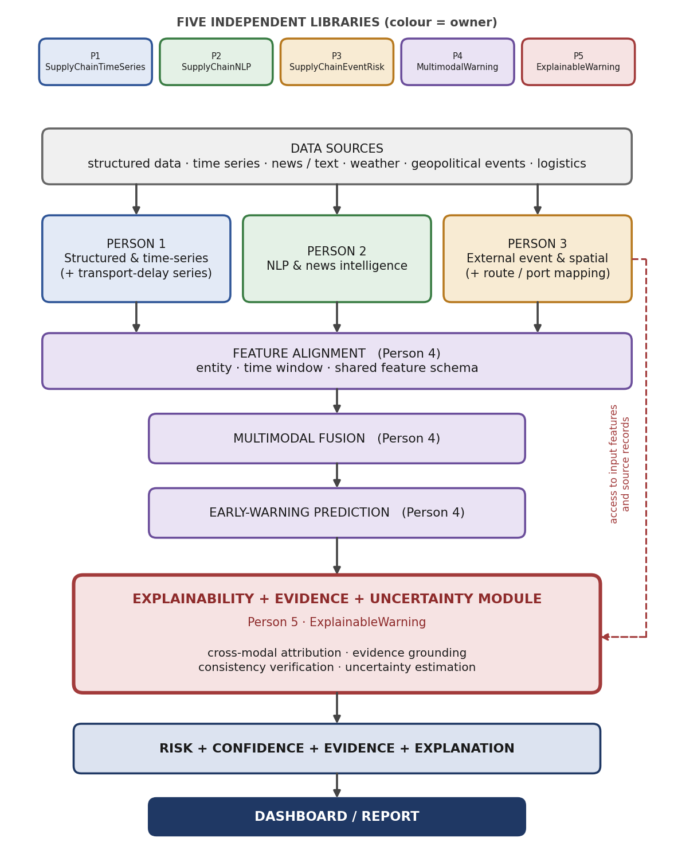
Figure 2. Final end-to-end architecture. Colours indicate the owning library.

8. Risks and Open Decisions

Risks
Risk | Why it matters | Mitigation
Ground-truth disruption labels | Supervised early warning needs reliable labels for when disruptions occurred; these are often hard to obtain. | Decide the label source early (curated disruption records or event-derived labels). If semi-synthetic data is used, state it clearly.
Data licensing and coverage | Some sources restrict redistribution or lack coverage for the chosen region or products. | Check licences before committing; keep the scope narrow enough to be well covered.
Missing modalities | News or events may be absent for some entities and periods. | Design fusion to handle missing modalities and test it.
Interface drift | Five independently developed libraries can diverge. | Fix the common feature record early (Section 4.3) and run integration tests.
Uneven workload | Fusion and explanation depend on the outputs of Persons 1–3. | Agree interfaces and sample data in the first weeks so Persons 4 and 5 can start on mock inputs.

Open decisions
- Dataset sources, domain and region scope, and the label strategy.
- Prediction horizons and risk-level thresholds.
- Authorship policy for both papers, agreed with the supervisor.
- Shortlist of target venues for each paper.
- Confirmation of the proposed library interfaces in the first integration meeting.

