DOCUMENT 2 OF 2 · INDIVIDUAL RESEARCH CONTRIBUTION
Evidence-Grounded Cross-Modal Explainability and Uncertainty-Aware Early Warning
Individual research contribution (Person 5) to the project “Explainable Multimodal Early-Warning System for Supply-Chain Disruptions”. Foundation for Paper 2.

Document map
Section 1  Context | Where the module sits in the team project, its scope, and what it needs from the other four libraries.
Sections 2–7  Research | Research problem, specific architecture, example explanation, research questions, experimental design, evaluation metrics.
Sections 8–9  Delivery | Publication plan for Paper 2, risks and open decisions.
Companion  Document 1 | General overall project: the integrated five-person system and the team paper (Paper 1).

Status of this document
This is a planning and architecture document. It contains no experimental results, no dataset claims and no accuracy figures. All numbers shown in examples are illustrative placeholders and are labelled as such.
Publication quality depends on actual novelty, experimental rigour, datasets, baselines, results and the requirements of the chosen journal or conference. Nothing here guarantees acceptance or impact.

Draft v1.0 · October 2026

SPECIFIC INDIVIDUAL RESEARCH CONTRIBUTION
Evidence-Grounded Cross-Modal Explainability and Uncertainty-Aware Early Warning

1. Context and Scope
This contribution is one module of a five-person project that detects supply-chain disruptions early by fusing structured data, time series, news, external events and logistics information. The team’s general project is described in the companion document. Person 5 owns the library ExplainableWarning, which takes the fused model’s prediction and produces attribution, evidence, consistency checks, uncertainty and an explanation.

1.1 Position in the overall system
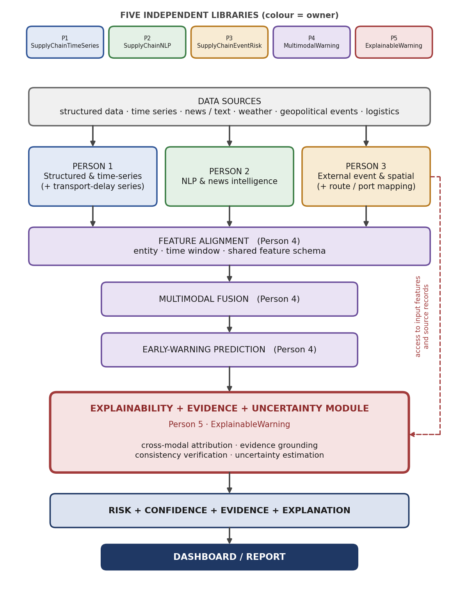
Figure 1. Position of the Explainability, Evidence & Uncertainty module in the end-to-end system.

1.2 Scope
In scope (this contribution) | Owned by other members
- Feature, text, event and cross-modal attribution  - Evidence retrieval and grounding  - Evidence consistency verification  - Uncertainty estimation and calibration  - Explanation generation and report  - Evaluation of explanation quality | - Feature extraction from each modality (Persons 1–3)  - Feature alignment, fusion model and prediction (Person 4)  - Dashboard integration (shared)

1.3 Inputs required from the other libraries
Source | Needed by this module | Why
Person 1 · SupplyChainTimeSeries | Temporal risk features with series and time-window references. | Numerical attribution and structured evidence.
Person 2 · SupplyChainNLP | Extracted events and text items with source identifiers and embeddings. | Text attribution and news evidence.
Person 3 · SupplyChainEventRisk | Event records and event-to-node mappings with source identifiers. | Event attribution and external-event evidence.
Person 4 · MultimodalWarning | Trained early, intermediate and late fusion models, predictions, aligned inputs and access to model internals. | Attribution needs the model itself, not only its outputs.
Provenance requirement. Every feature, text item or event record passed to this module must carry a reference to its source (record, article or event identifier) and a timestamp. Without this, explanations cannot be grounded in real evidence. The interface is a proposal to be confirmed with the other four members.

2. Research Problem
An ordinary multimodal early-warning system may output only a score such as “disruption probability = 84%”. A score alone does not let a decision-maker judge whether the warning should be trusted or acted on. The questions below remain unanswered, and each is addressed by a specific component of this contribution.
Question a decision-maker will ask | What a bare probability cannot provide | Addressed by
Why is the risk high? | No reasons, only a number. | Attribution (A–D)
Which modality contributed most? | Fusion hides modality-level contribution. | Cross-modal attribution (D)
Which specific features caused the warning? | Feature influence is internal to the model. | Numerical attribution (A)
Which news or event evidence supports the warning? | No link to real source records. | Text / event attribution and evidence retrieval (B, C, E)
How certain is the prediction? | Probability is not necessarily calibrated. | Uncertainty estimation (G)
Is the explanation faithful to the model? | An explanation can look plausible without reflecting the model. | Fidelity and stability evaluation
Is the evidence actually consistent with the prediction? | Retrieved evidence may not agree with the prediction. | Evidence consistency verification (F)

Novelty must be verified
The intended contribution is an integrated pipeline that links attribution to source evidence, verifies that evidence, and attaches calibrated uncertainty, for multimodal supply-chain early warning. Whether this combination is novel must be confirmed by a systematic literature review before it is stated as a claim in any paper.

3. Specific Architecture
The explainability engine sits after the multimodal model and its prediction. It consumes the prediction together with the aligned inputs of all three modality libraries, and produces an auditable report. Components are lettered A–G to match Figure 2.
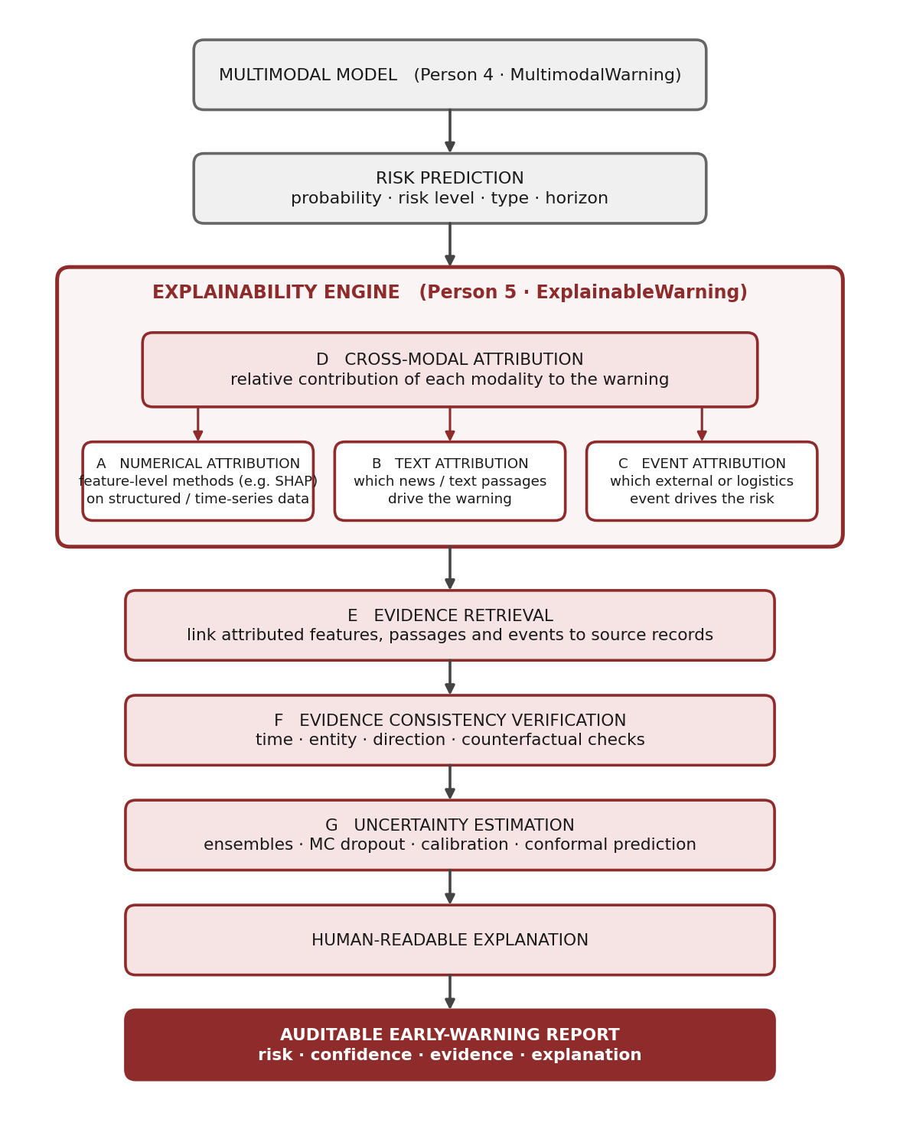
Figure 2. Architecture of the Explainability, Evidence & Uncertainty module (Part 2).

A. Feature-level attribution
Purpose | Identify which structured and time-series features push the prediction up or down.
Candidate methods | SHAP or other suitable attribution techniques (for example gradient-based or perturbation-based methods). The method will be selected through comparison, not assumed.
Output | Ranked feature contributions per prediction, including the time window of influential lags.

B. Text attribution
Purpose | Identify which news or text information contributes to the warning.
Approach | Attribute the prediction to specific articles, sentences or extracted events produced by SupplyChainNLP, using perturbation (masking or removing items) and attribution over text features or embeddings.
Output | Ranked list of text items with contribution scores and source references.

C. Event attribution
Purpose | Identify which external event (weather, geopolitical, infrastructure, logistics) contributes to the risk.
Approach | Attribute to event records and event-to-node mappings produced by SupplyChainEventRisk, including spatial and temporal relevance to the affected node.
Output | Ranked list of events with contribution scores and affected supply-chain nodes.

D. Cross-modal attribution
Calculates the relative contribution of each modality to the warning. A natural formulation is to treat each modality as a unit (a group of features) and measure its contribution through group-wise attribution or modality ablation. Attention weights alone are not assumed to be explanations; any attention-based variant must itself pass the fidelity tests of Section 7.
Modality | Share | Note
Time-series | 41% | Illustrative value only
News | 27% | Illustrative value only
External events | 32% | Illustrative value only
These percentages are illustrative examples, not fixed or expected results.

E. Evidence grounding
Each explanation is connected to actual evidence from three sources: structured evidence (specific series and time windows), news evidence (specific articles or extracted events) and external-event evidence (specific event records). Evidence retrieval links attributed features, passages and events back to their source records using the provenance metadata defined in Section 1.3.
Evidence record field | Content
evidence_id, modality | Unique identifier and which modality it comes from.
source_ref | Pointer to the original record, article or event.
timestamp, entity | When the evidence applies and which supply-chain node it concerns.
attribution_score | Contribution of this evidence to the prediction, from components A–C.
summary | Short human-readable description.

Evidence consistency verification (component F)
Retrieved evidence is checked against the prediction before it is shown. Proposed checks, to be validated experimentally:
- Temporal validity: evidence precedes the prediction time and falls inside the relevant window.
- Entity match: evidence concerns the supply-chain node or route that the warning is about.
- Direction agreement: evidence supports increased risk, not reduced risk.
- Counterfactual support: removing or masking the evidence changes the prediction or attribution as the explanation implies.
The result is an evidence consistency score and a flag for evidence that fails a check.

G. Uncertainty estimation
Several approaches will be implemented and compared. None is assumed to be the best; their suitability for temporal, multimodal data is an experimental question.
Method | Idea | Point to examine
Ensemble uncertainty | Train several models (different seeds or architectures) and use the disagreement. | Computational cost; whether diversity is sufficient.
Monte Carlo Dropout | Keep dropout active at inference and sample repeatedly. | Quality of the approximation depends on architecture.
Calibration methods | Post-hoc recalibration of probabilities (for example temperature scaling or isotonic regression). | Improves probability reliability but is not a measure of model ignorance.
Conformal prediction | Prediction sets or intervals with a coverage target. | Coverage guarantees assume conditions (such as exchangeability) that time series and distribution shift may violate.

4. Example Final Explanation
ILLUSTRATIVE EXAMPLE — NOT AN EXPERIMENTAL RESULT
The report below only shows the intended format of the output. All values are placeholders.

WARNING: HIGH DISRUPTION RISK
Disruption probability: 84%
Confidence: 91%

Major contributing factors
1. Transportation delay increased
2. Severe weather detected near the relevant route
3. Relevant port-disruption information identified in recent news

Evidence
- Structured supply-chain signal
- News evidence
- External-event evidence

Uncertainty: 9%
In the real system, “confidence” and “uncertainty” will be defined by the uncertainty method actually used; the complementary values shown here are only for illustration.

5. Research Questions
ID | Question | Addressed in
RQ1 | Does multimodal information improve early-warning performance compared with individual modalities? | Modality baselines B1–B5
RQ2 | Can cross-modal attribution identify the contribution of different modalities to a disruption warning? | Component D, fidelity tests
RQ3 | Can evidence-grounded explanations improve the faithfulness and auditability of multimodal early-warning predictions? | Components E–F, evidence consistency
RQ4 | Can uncertainty estimation improve the reliability of early-warning decisions? | Uncertainty comparison, calibration metrics
RQ5 | How stable and faithful are the generated explanations under small changes in input data? | Stability and fidelity experiments

6. Experimental Design
No results are stated here. The tables define what will be compared, so that the paper’s claims can be tested. Datasets are not yet selected; see Section 9 for the dataset and label decision.

6.1 Modality baselines
ID | Input | Purpose
B1 | Structured / time-series only | Single-modality reference
B2 | News / text only | Single-modality reference
B3 | External-event only | Single-modality reference
B4 | Structured + News | Effect of adding text
B5 | Structured + News + External events | Full multimodal input

6.2 Fusion comparison
Early, intermediate and late fusion (Person 4’s library, MultimodalWarning) are compared on the same data splits. The fusion models are produced by Person 4’s library and shared with this study.

6.3 Explainability comparison
Method | Applied to
SHAP | Structured and time-series features, and modality groups.
Other feature attribution | Alternative attribution methods on the same features, for comparison.
Text attribution | News and text items (Component B).
Cross-modal attribution | Modality-level contribution (Component D).

6.4 Uncertainty comparison
Ensemble, Monte Carlo Dropout, calibration methods and conformal prediction are evaluated on the same predictions and compared with the calibration and coverage metrics of Section 7.

6.5 Ablation of the proposed module
To show which parts of the contribution actually matter, the full module is compared against versions with a component removed:
- without cross-modal attribution (D)
- without evidence consistency verification (F)
- with each uncertainty method replaced in turn
- with each attribution method replaced in turn

6.6 Evaluation protocol
- Time-based splits: training data precedes validation and test data, so the model never sees the future.
- Leakage control: news and events dated after the prediction time are excluded from the input.
- Repeated runs: multiple random seeds, with variability reported.
- Significance: appropriate statistical tests when comparing methods.
- Robustness: explanation stability is measured under small input perturbations (RQ5).

7. Evaluation Metrics
Predictive performance and explanation quality are reported separately. Explainability is evaluated quantitatively wherever possible, not only through example screenshots.

7.1 Prediction
Metric | Note
Accuracy, Precision, Recall, F1-score | Reported per class where classes are imbalanced.
AUROC, AUPRC | AUPRC is especially relevant because disruptions are rare events.
False Alarm Rate | Share of raised alerts that do not correspond to a disruption; central to operational usefulness.
Early-warning lead time | Time between the first alert above threshold and the onset of the disruption.

7.2 Calibration and uncertainty
Metric | Note
Expected Calibration Error (ECE) | Gap between predicted confidence and observed frequency.
Brier Score | Accuracy of probabilistic predictions.
Conformal coverage / interval width | Where applicable: empirical coverage against the target, and the size of the prediction sets.

7.3 Explainability
Metric | What it measures
Fidelity | How well the explanation reflects the model: change in prediction when top-attributed features or evidence are removed or kept (deletion / insertion style tests).
Stability | Similarity of explanations (for example rank correlation or top-k overlap) under small input perturbations.
Feature attribution consistency | Agreement of attributions across random seeds, models and attribution methods.
Evidence consistency | Share of cited evidence that passes the verification checks of Component F.
Completeness | Whether attributions account for the prediction (for example additivity gap) and whether all relevant modalities’ evidence is covered.
Human interpretability | Structured rating study of explanation clarity and usefulness. The protocol, participants and any required institutional approval are defined before the study.

8. Publication Plan for Paper 2
Proposed title | Evidence-Grounded Cross-Modal Explainability and Uncertainty-Aware Early Warning for Supply-Chain Disruptions
Scope | - Cross-modal attribution  - Evidence grounding  - Explanation verification  - Uncertainty estimation  - Calibration  - Explanation fidelity  - Explanation stability  - Detailed ablation experiments
Central question | Can explanations be grounded in verified evidence and paired with reliable uncertainty?
Venue type | Venue interested in explainable or trustworthy machine learning. The final choice requires checking each venue’s scope, review criteria, page limits and deadlines.

8.1 Keeping Paper 2 distinct from Paper 1
- Paper 1 uses standard attribution as one framework component. Paper 2 introduces and evaluates the new methods.
- The experiments differ: Paper 1 evaluates overall system performance; Paper 2 evaluates explanation fidelity, stability, evidence consistency and uncertainty, with its own ablations.
- Paper 2 cites Paper 1 for the framework and shared pipeline, and does not reuse its text or figures beyond what is cited.
- Overlap is disclosed to the venues according to their policies.
- Authorship and contribution statements for both papers are agreed with the supervisor early, based on actual contribution.

Publication readiness
Final publication quality depends on actual novelty, experimental rigour, datasets, baselines, results and the target venue’s requirements. This document makes no claim about acceptance or impact.

9. Risks and Open Decisions

Risks
Risk | Why it matters | Mitigation
Ground-truth disruption labels | Prediction quality, fidelity tests and lead-time metrics all depend on reliable disruption labels. | Decide the label source early. If semi-synthetic data is used, state it clearly.
Dependence on other libraries | Attribution needs trained models (Person 4) and provenance metadata (Persons 1–3). | Agree interfaces early and develop against mock inputs until real outputs exist.
Plausible but unfaithful explanations | Readable explanations may not reflect the model. | Evaluate fidelity and stability quantitatively (Section 7).
Uncertainty under temporal shift | Calibration and coverage guarantees may degrade when data drifts over time. | Evaluate on time-based splits and report coverage honestly.
Novelty not yet verified | Related work may already cover parts of the contribution. | Complete a systematic literature review before fixing the paper’s claims.
Human evaluation cost | A rating study needs participants, a protocol and possibly institutional approval. | Define the protocol early and keep the study small and structured.

Open decisions
- Dataset sources, domain and region scope, and the label strategy.
- Which attribution and uncertainty methods enter the main comparison.
- Design of the human interpretability study.
- Authorship policy for both papers, agreed with the supervisor.
- Shortlist of target venues for Paper 2.

