3. UI Mockups and Storyboards

Picture 1: Gray and White Wire Diagram
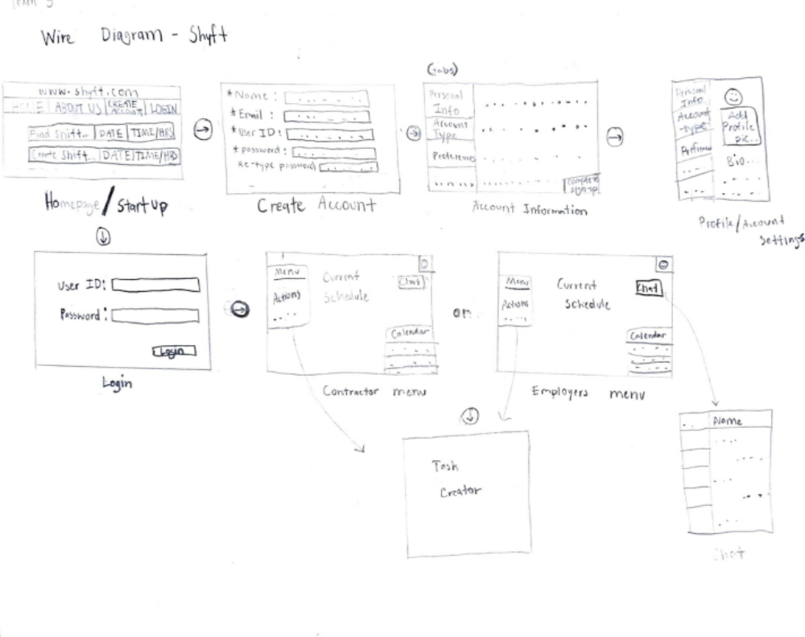

Picture 2: GUI Prototypes for Shyft
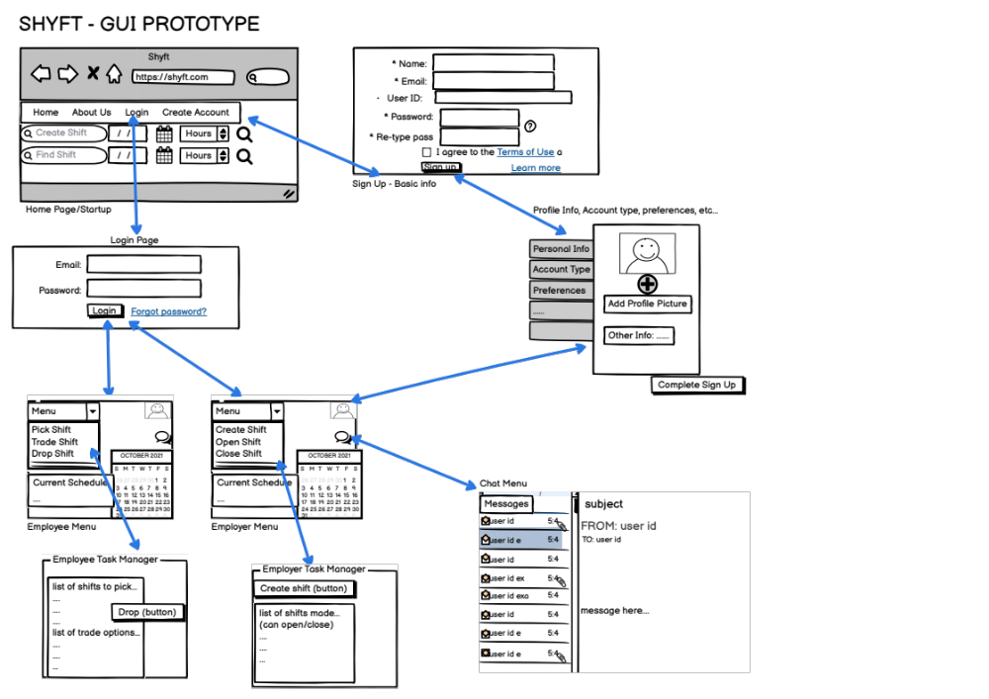

Picture 3: GUI Prototypes for Shyft – Colors and Styles (subject to change)
