How to add new information to be displayed on HtownBars Search Results:

1. Open houstonBarsFull.JSON file from your server directory:
2. Whichever categories you want to be displayed in the search results, add them (comma separated) into each bars list of properties.

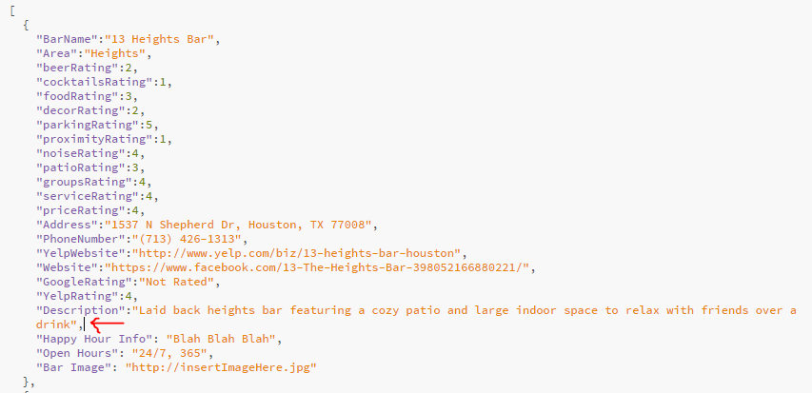

Couple of important things to note:

-Must be in format “key”: “value”

-Every new property must be comma separated except for the last property which does not require a comma after it

3. Once completed editing, save houstonBarsFull.JSON, refresh the page and you should see the new properties be dynamically displayed in the search result.