

BentoDrop User Manual
macOS • Version 1.0.4 • Build 13
GETTING STARTED

Install and connect
BentoDrop helps you manage the SD card for a 1010music Bento. Use this manual to transfer and audition samples, build a drum kit, move music between Bento and your DAW, and maintain the card.
1. On a Mac running macOS 15 Sequoia or later, open the BentoDrop DMG and drag BentoDrop into Applications. Open it from Applications.
2. Put the Bento in SD Reader Mode and connect its Device port with a USB-C data cable. Or insert the microSD card into a Mac-compatible reader. Wait for the volume to appear in Finder.
3. In BentoDrop, open Card → Set Up BentoDrop. Choose a backup folder on your Mac or another drive and grant access to the SD card. Select the volume itself in the folder picker.
4. In Transfer, confirm that Destination card names the intended volume. If Grant Access appears, select the card root again.
BentoDrop works on Apple silicon and Intel Macs that support macOS 15. Build 13 has a 760 × 700 pt minimum content area. The app requests access to the locations you choose.

OVERVIEW

Find your workspace
1. Transfer handles sample selection, conversion, the queue, and sync history.
2. Project exports stems to a DAW, imports MIDI into a project copy, and creates reusable One-Shot drum kits.
3. Card browses the mounted card and provides playback, file management, backup, restore, eject, and card setup.
4. Firmware checks Bento firmware and provides a separate factory patches reinstall.
Start each session by confirming the destination card. Before you unplug the reader or exit SD Reader Mode, finish any active operation and eject the volume.

Contents
Sample sync and history · 3–4
Audio formats and filenames · 5
Card files and backups · 6–7
Projects and DAWs · 8–9
MIDI import and drum kits · 10–13
Firmware and factory patches · 14–15
Default SD card and troubleshooting · 16–17
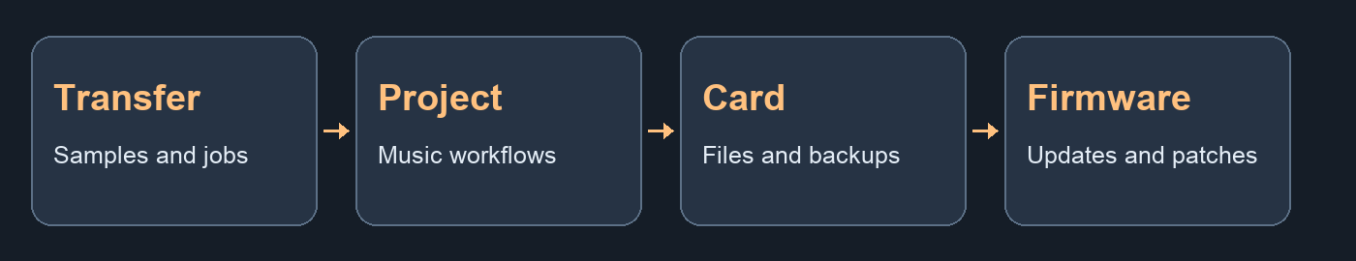
The four BentoDrop workspaces and their main tasks.

TRANSFER

Run a sample sync
1. In Transfer, click New Sample Sync. Enter a job name you will recognise in History.
2. Choose a destination under UserSamples. Use Add Files or Folders or start with items already in the queue. Review the accepted files and exclusions before running.
3. Set Existing samples for this job. Skip keeps the file already on the card. Overwrite replaces the matching destination with the converted sample.
4. Click Run Sample Sync. The progress view shows overall progress and the current filename. Keep the card connected until the job ends.
5. In Sample Sync History, click the job to review its result. Check the log for transferred, skipped, and failed files.
If a source is excluded, check its duration, extension, and whether macOS can decode it. The source file stays where it was.
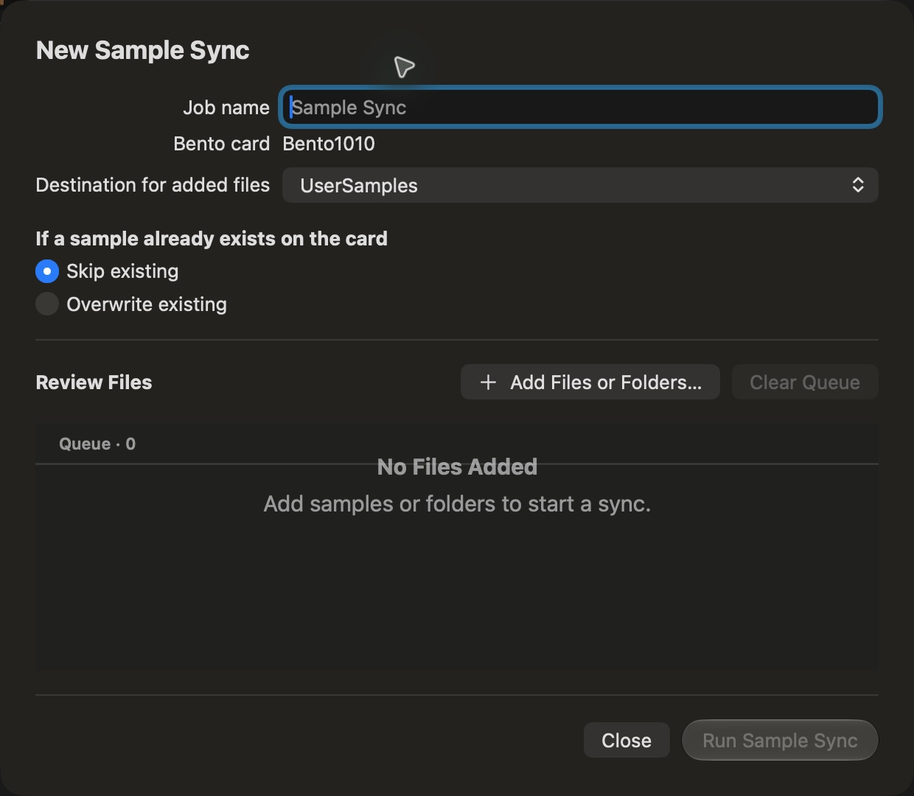
Sample Sync shows the job name, destination, existing-file policy, and queue.

TRANSFER

Manage the queue and history
1. Use Library → Add Library Folder to grant access to a reusable sample folder. Drag samples into the Queue. Right-click an item to preview it, see file information, or remove it. Rename a queued destination before transferring if needed.
2. Use Clear Queue to empty the queue. Clear Finished Items removes completed, skipped, and failed entries. The source files remain in place.
3. Click a history row to inspect that run and its file-by-file result. Use Save Log to export the log for troubleshooting.
4. Right-click a job for Reprocess Job or Delete Job. Clear the current queue first. Reprocess opens the workflow with available sources so you can review the destination and policy before running it. Delete Job removes the history entry.
Command–Return opens New Sample Sync. The Queue wand opens the Firmware workspace. If you are editing a field, finish the edit before using the queue shortcut.
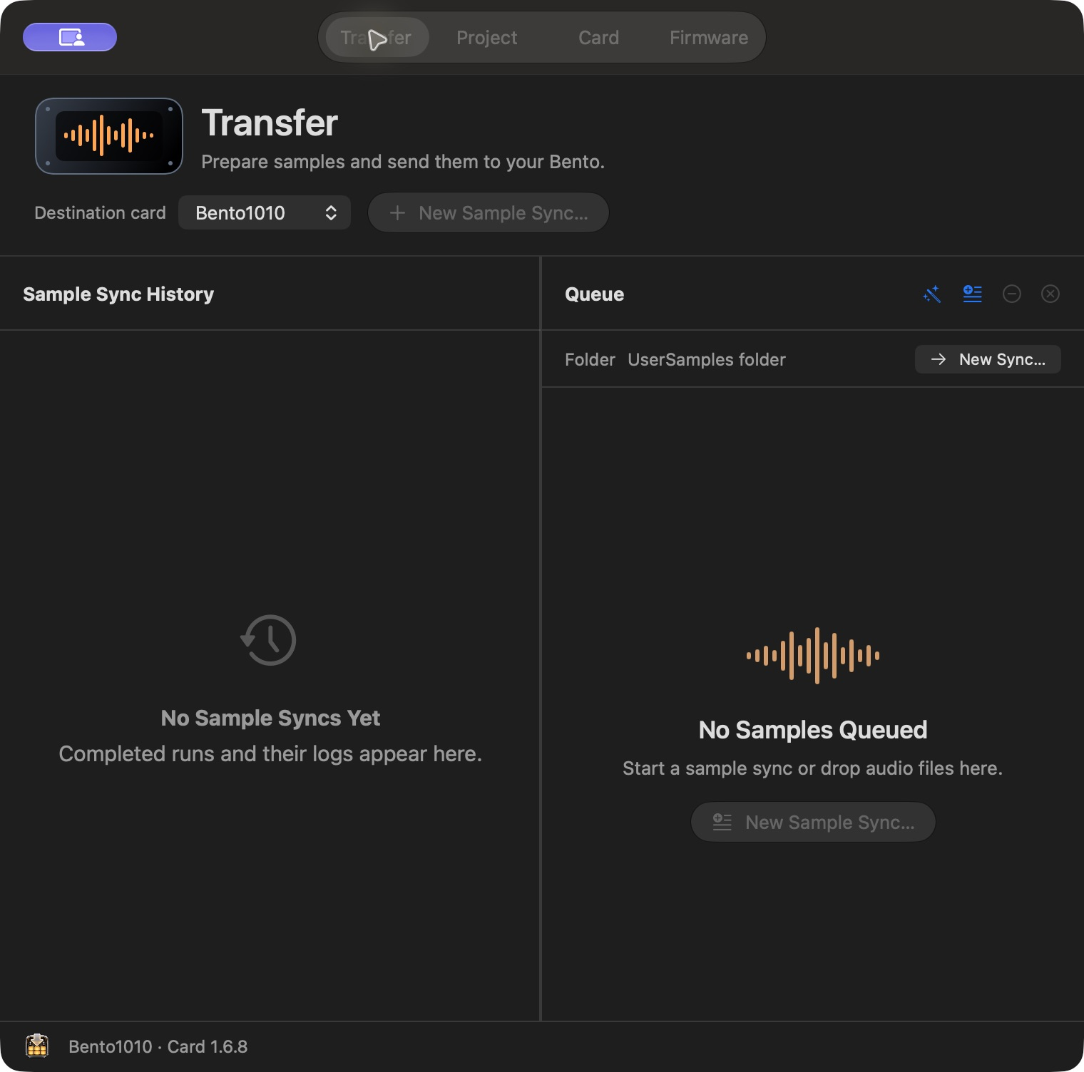
Transfer puts past sync jobs beside the current queue.

TRANSFER

Audio formats and filenames
Transferred audio is written as 48 kHz, 24-bit integer PCM WAV. Mono stays mono, stereo stays stereo, and sources with more channels are mixed down to stereo. BentoDrop validates the output before writing it to the card.
1. Accepted for inspection are WAV (.wav, .wave), AIFF (.aiff, .aif, .aifc), CAF, FLAC, MP3, MP2, AAC (.m4a, .m4b, .aac), audio-only MP4, 3GP, AU, SND, and SD2.
2. Ogg (.ogg, .oga) and Opus depend on macOS decoder support. A recognised extension still requires a readable audio stream.
3. Sample sync accepts readable, nonempty files up to 30 seconds. Trim longer material in a DAW or audio editor before adding it.
4. Export individual WAVs from Kontakt, ReCycle, sampler banks, and DAW projects before transfer. Those container and project formats cannot be converted directly.
BentoDrop prepares a .wav destination name. Review the preview path for collisions after sanitisation. Keep the full Bento path under 256 characters and avoid reserved filename characters.
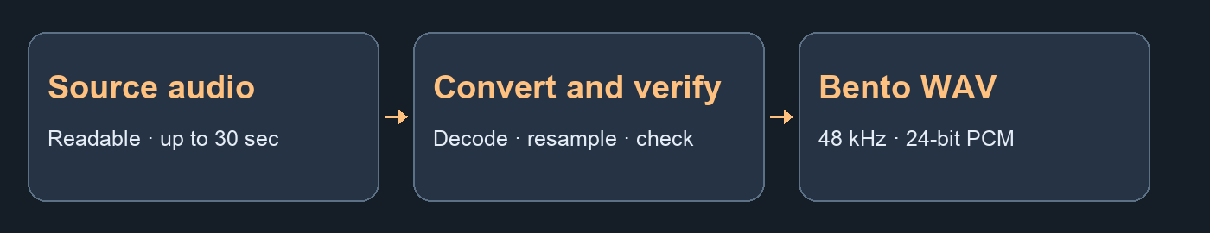
BentoDrop converts and checks the source before copying the WAV.

CARD

Browse and organise card files
1. In Card, select the intended volume and grant access. Open folders to browse card contents.
2. Right-click an audio file and choose Play to audition it from the card.
3. Drag files into another folder to move them. You can also use the context menu to move, rename, or delete files and folders. Use the new-folder button to create a destination.
4. Confirm the destination after a move. Deleting a folder removes its contents. Back up anything you need before deleting or reorganising projects and patches.
5. Use Eject when the card is idle. Wait for the volume to disappear from Finder before disconnecting or leaving SD Reader Mode.
Sample transfers write under UserSamples. Moving files that a patch or project references can break those links.
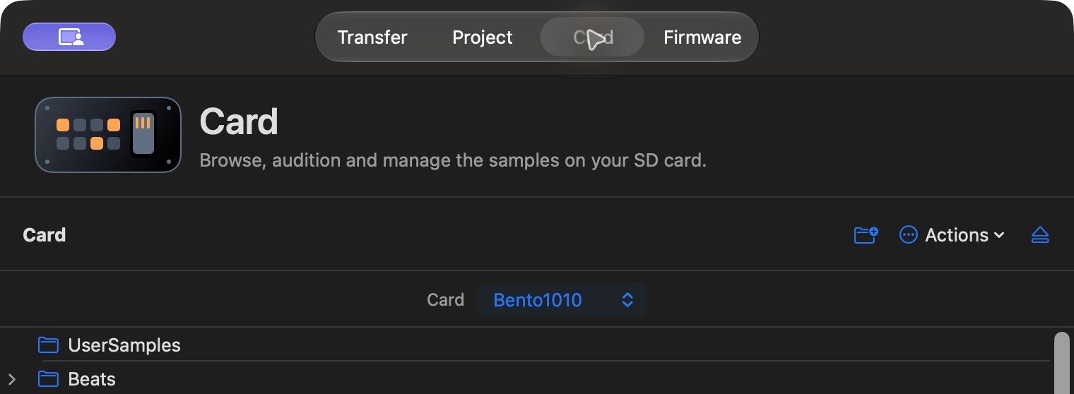
Card shows the selected volume and its file management controls.

CARD

Back up and restore the card
Back up to a separate drive or a folder on your Mac. Choose Card → Back Up Card or use the Actions menu in the Card workspace.
1. Root firmware .bin files are included. Enable Factory Patches for Patches, User Patches for UserPatches and Projects, and All User Samples for UserSamples.
2. Choose the backup destination and wait for the run to finish. Keep the dated Bento Backup folder and note which scopes you selected.
3. To restore, grant access to the destination card, choose Restore, and select the saved backup folder. Enable only the scopes you intend to restore.
4. Matching destination files can be replaced. Each file is verified before replacement. If you stop midway, completed files remain on the card.
Known macOS metadata such as Spotlight and Trash folders is skipped where applicable. If backup reports an unreadable user file, resolve its access or copy it separately. The firmware wizard also offers a full card backup or a firmware-only backup.

PROJECT

Choose a project workflow
Project brings together DAW export, MIDI import, and drum kit creation.
1. Export Bento Project starts from stems rendered by the Bento. Choose Bitwig for a DAWproject arrangement or Ableton Live for WAVs and optional MIDI.
2. Import MIDI Sequence writes selected MIDI notes into a sequence slot in a copy of an existing Bento project. Start with a project that already has the instrument track you want to play.
3. Create Drum Kit packages individual samples as a reusable Bento One-Shot patch.
Grant access to a writable Bento card before importing MIDI or saving a drum kit. DAW export can read a stem folder from the card or an accessible backup.
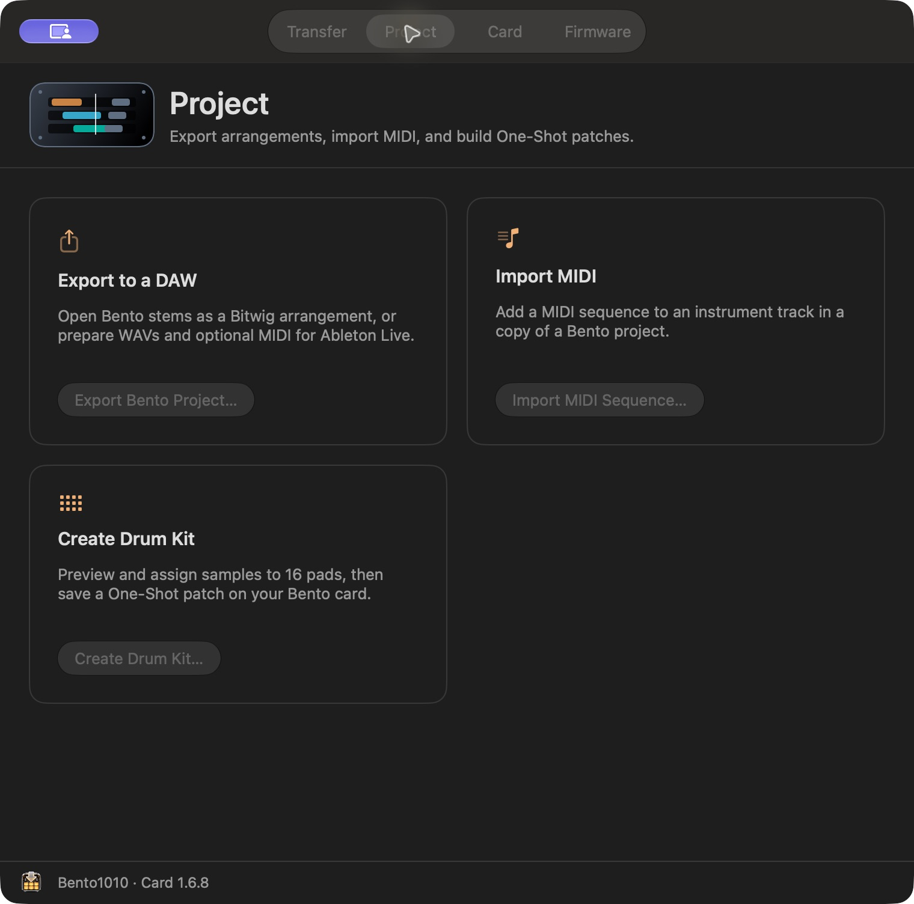
Project groups DAW export, MIDI import, and drum kit creation.

PROJECT

Export stems to Bitwig or Ableton Live
1. On Bento, choose SONG → Export Stems. When it finishes, connect the card to your Mac.
2. In BentoDrop, choose Project → Export Bento Project. Select the exported stems folder and enter the Bento song tempo in BPM.
3. Select Bitwig for an aligned .dawproject arrangement with the WAV stems and a muted reference mix. Open the exported project in a Bitwig version that supports DAWproject.
4. Select Ableton Live for a folder with WAV stems and the reference mix. Add existing MIDI files if you have them. In Live, set the song tempo and align the stems to the same start point. Import the MIDI on separate tracks and assign instruments.
5. Choose an output folder, export, and use Show in Finder to locate the result. Compare the arrangement against the reference mix.
Ableton export delivers media for import. MIDI is included only when you supply MIDI files.
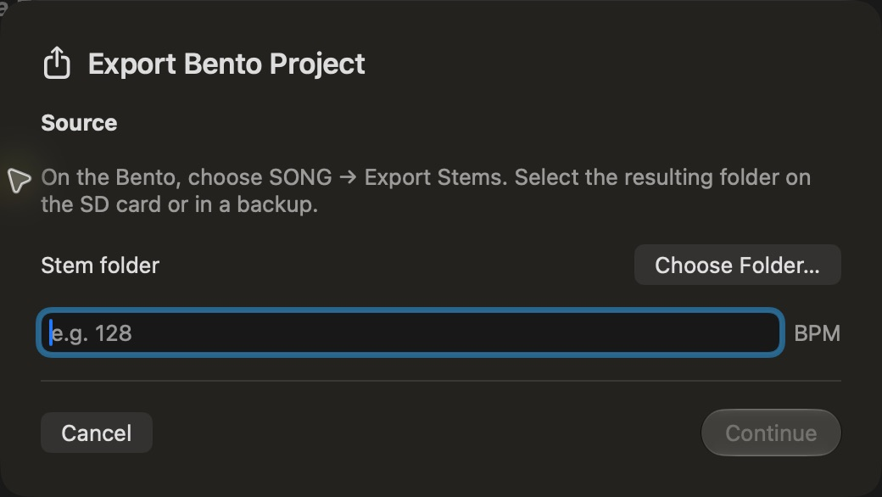
The export wizard starts with the stem folder and the Bento tempo.

PROJECT

Import MIDI into a Bento sequence
1. Open Project → Import MIDI Sequence. Choose a MIDI file and select the track or channel to use. All tracks and All channels are also available.
2. On the Bento, prepare a Granular, Multisample, Wavetable, Slicer, One-Shot or External MIDI track and save the project. Load a sound or kit for internal tracks, or set the output port and channel for External MIDI. Test the track from the pads first. In BentoDrop, choose the project folder, destination track and sequence slot.
3. Continue to review. Choose Keep MIDI lengths or set Minimum gate length to 1/16 note. That minimum lengthens short notes while keeping their start times. If the slot is occupied, explicitly choose whether to replace it in the copy.
4. Save Project Copy. The original stays in place. On the Bento, press PROJ and load the new copy. Press LAUNCH, select the slot, then press SEQ to inspect the notes.
If the slot moves and the pads produce sound but imported notes are silent, try a fresh copy with the 1/16-note minimum. For an external instrument, also check the Bento track's MIDI channel and the receiving instrument's routing.
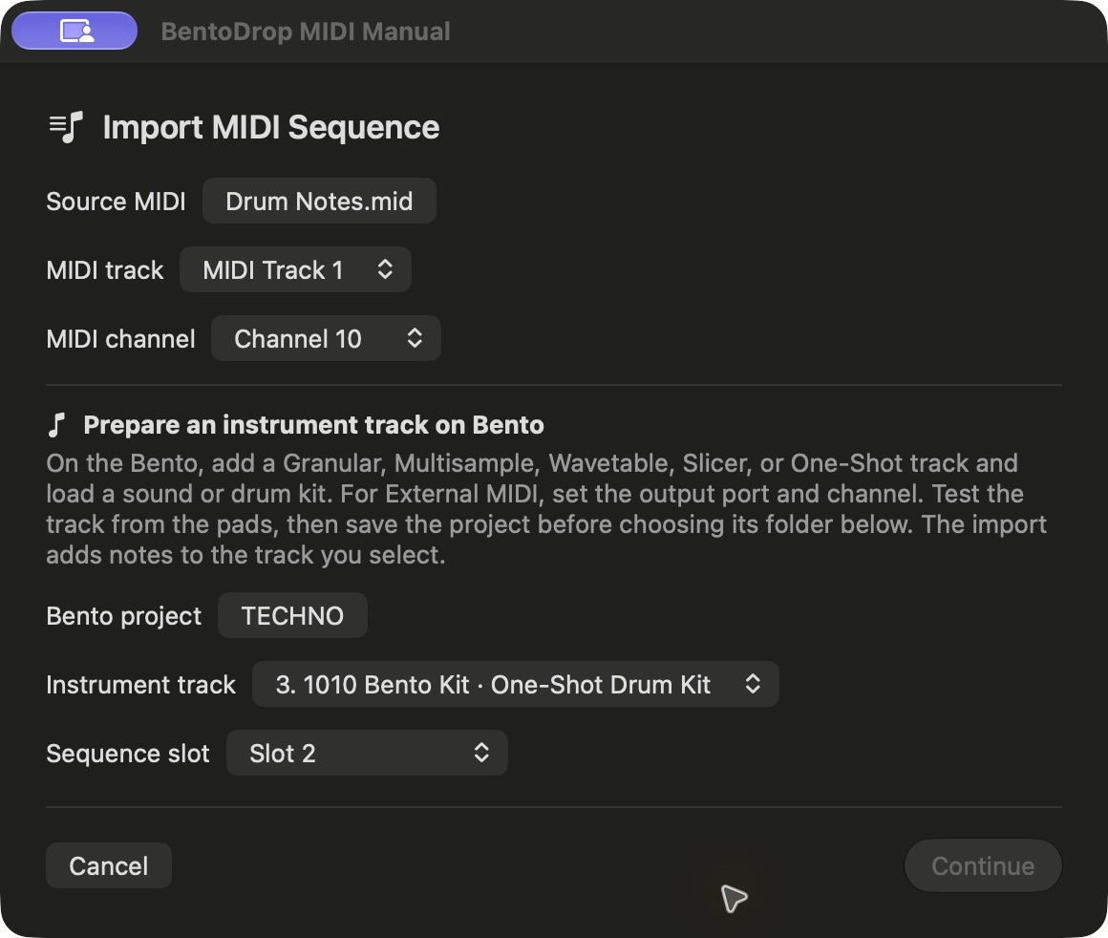
The MIDI wizard starts by asking for a MIDI file and Bento project folder.

PROJECT

Map MIDI tracks to drum pads
Use Tracks to Pads when your MIDI file has a separate track for each drum or percussion part. BentoDrop combines the parts into a single sequence slot on the selected One-Shot track.
1. On the Bento, load a One-Shot kit. Assign a sample to every pad the MIDI file will use, test those pads, and save the project.
2. In Project → Import MIDI Sequence, choose the MIDI file and saved Bento project folder. Select the One-Shot Drum Kit track and a sequence slot, then click Continue.
3. Choose Tracks to Pads under Drum mapping. The first MIDI track containing notes goes to Pad 1, the second goes to Pad 2, and so on through Pad 16. Empty tracks are skipped. The source track and channel filters do not apply in this mode.
4. Review the minimum gate and replacement setting, then click Save Project Copy. On the Bento, load the copy and launch the chosen slot on the kit track.
Put the MIDI parts in the same order as your kit pads before exporting the MIDI. For example, with Kick, Snare and Hat as the first three note-bearing MIDI tracks, load those sounds on Pads 1, 2 and 3. Files with more than 16 note-bearing tracks and mappings to empty pads are rejected.
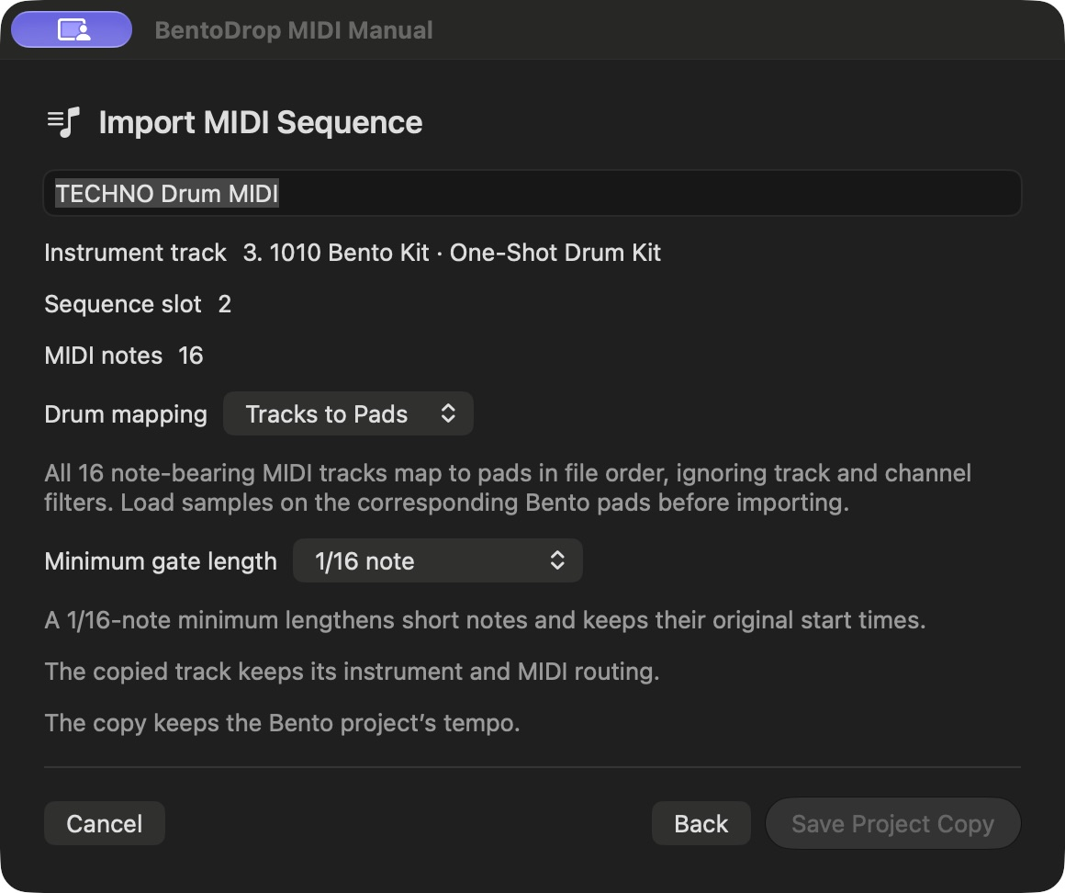
Tracks to Pads assigns note-bearing tracks in file order.

PROJECT

Map MIDI notes to drum pads
Use Notes to Pads when one MIDI track contains several drum parts and pitch distinguishes the drums. Choose the source track and channel before continuing.
1. Select the One-Shot Drum Kit track and a sequence slot, then click Continue. Choose Notes to Pads under Drum mapping.
2. Set Pad 1 MIDI note to the lowest note in the 16-note range you want to use. With the default 36, MIDI note 36 triggers Pad 1, 37 triggers Pad 2 and 51 triggers Pad 16. The mapping uses MIDI note numbers.
3. Ensure the selected notes fit the range and the corresponding Bento pads have samples. If BentoDrop reports an out-of-range note, adjust the Pad 1 note or edit the source MIDI. If it names an empty pad, load a sample on that pad and save the project on the Bento.
4. Save Project Copy, then load that copy on the Bento and launch the selected slot. Both drum mapping modes keep note start times and velocities. The minimum gate setting can lengthen short notes.
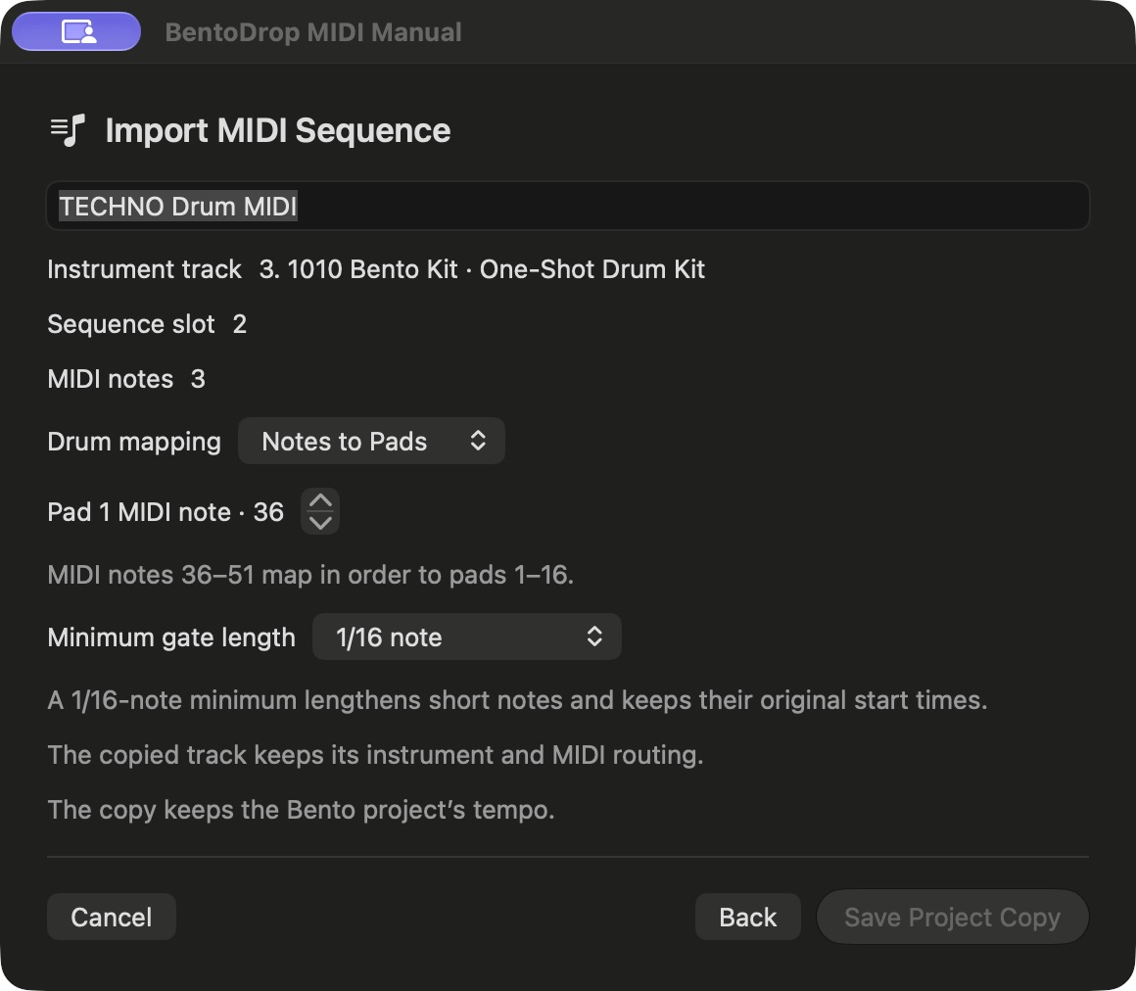
Notes to Pads maps a consecutive range of MIDI notes to the kit.

PROJECT

Create and load a drum kit
1. Open Project → Create Drum Kit and enter a kit name.
2. Use Add Samples to fill empty pads in numerical order. Pads 1–16 run left to right, top to bottom. Select a pad to assign, replace, preview, move, or clear its sample.
3. Continue to review the kit, then choose Save Drum Kit. Keep the card connected while the patch and its WAVs are written.
4. On the Bento, open an empty track’s patch browser and choose User → One-Shot. Select your saved kit.
The kit and WAVs live under UserPatches → OneShots. Keep those files together when moving or backing up the kit.
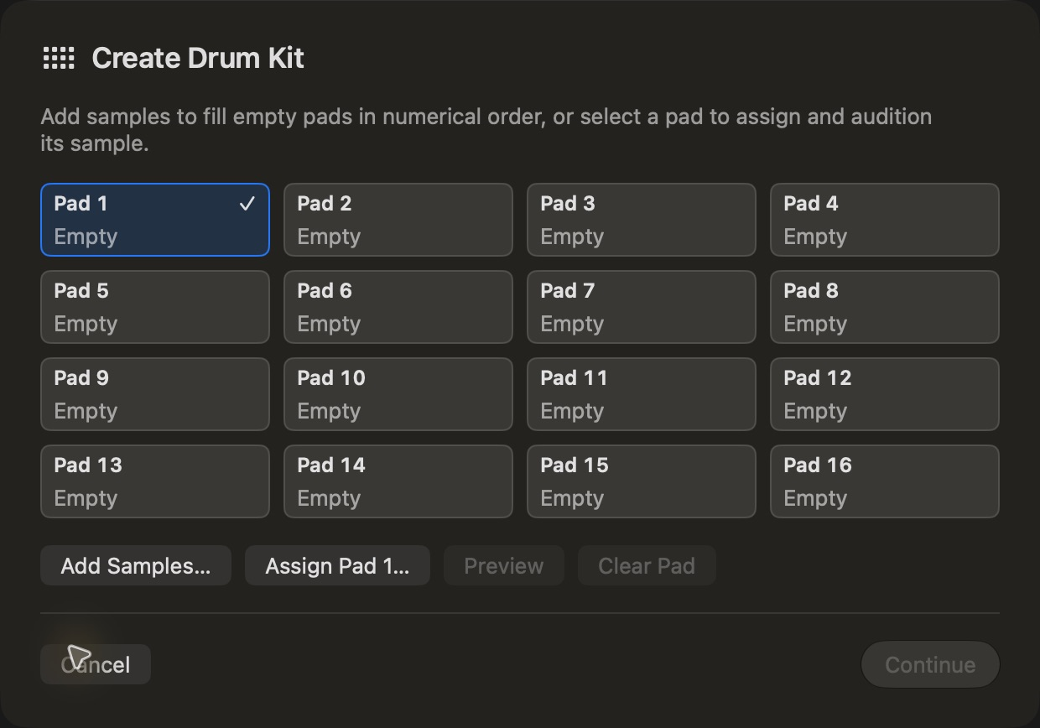
The drum kit grid starts at Pad 1 and runs through Pad 16.

FIRMWARE

Update Bento firmware
1. In Firmware, click Check for Updates or Open Firmware Wizard. BentoDrop compares the card firmware with the official release.
2. Choose a backup destination off the card. Full card saves card files and firmware. Firmware files only saves the root firmware files and omits samples, patches, and projects.
3. Download and validate the update, then choose Write Firmware. Keep the card connected while the two firmware files are written and verified.
4. Eject the card. With Bento powered off, insert the card and connect external power. Hold power until the Bootloader appears, press REC, and wait for Bento to restart. Check the running firmware version with PROJ.
If the write was interrupted, reconnect the same card and use Recover Previous Update. If the files were written and cleanup remains, use Verify and Finish. The version shown by BentoDrop refers to the card files. PROJ shows what is running on the hardware.
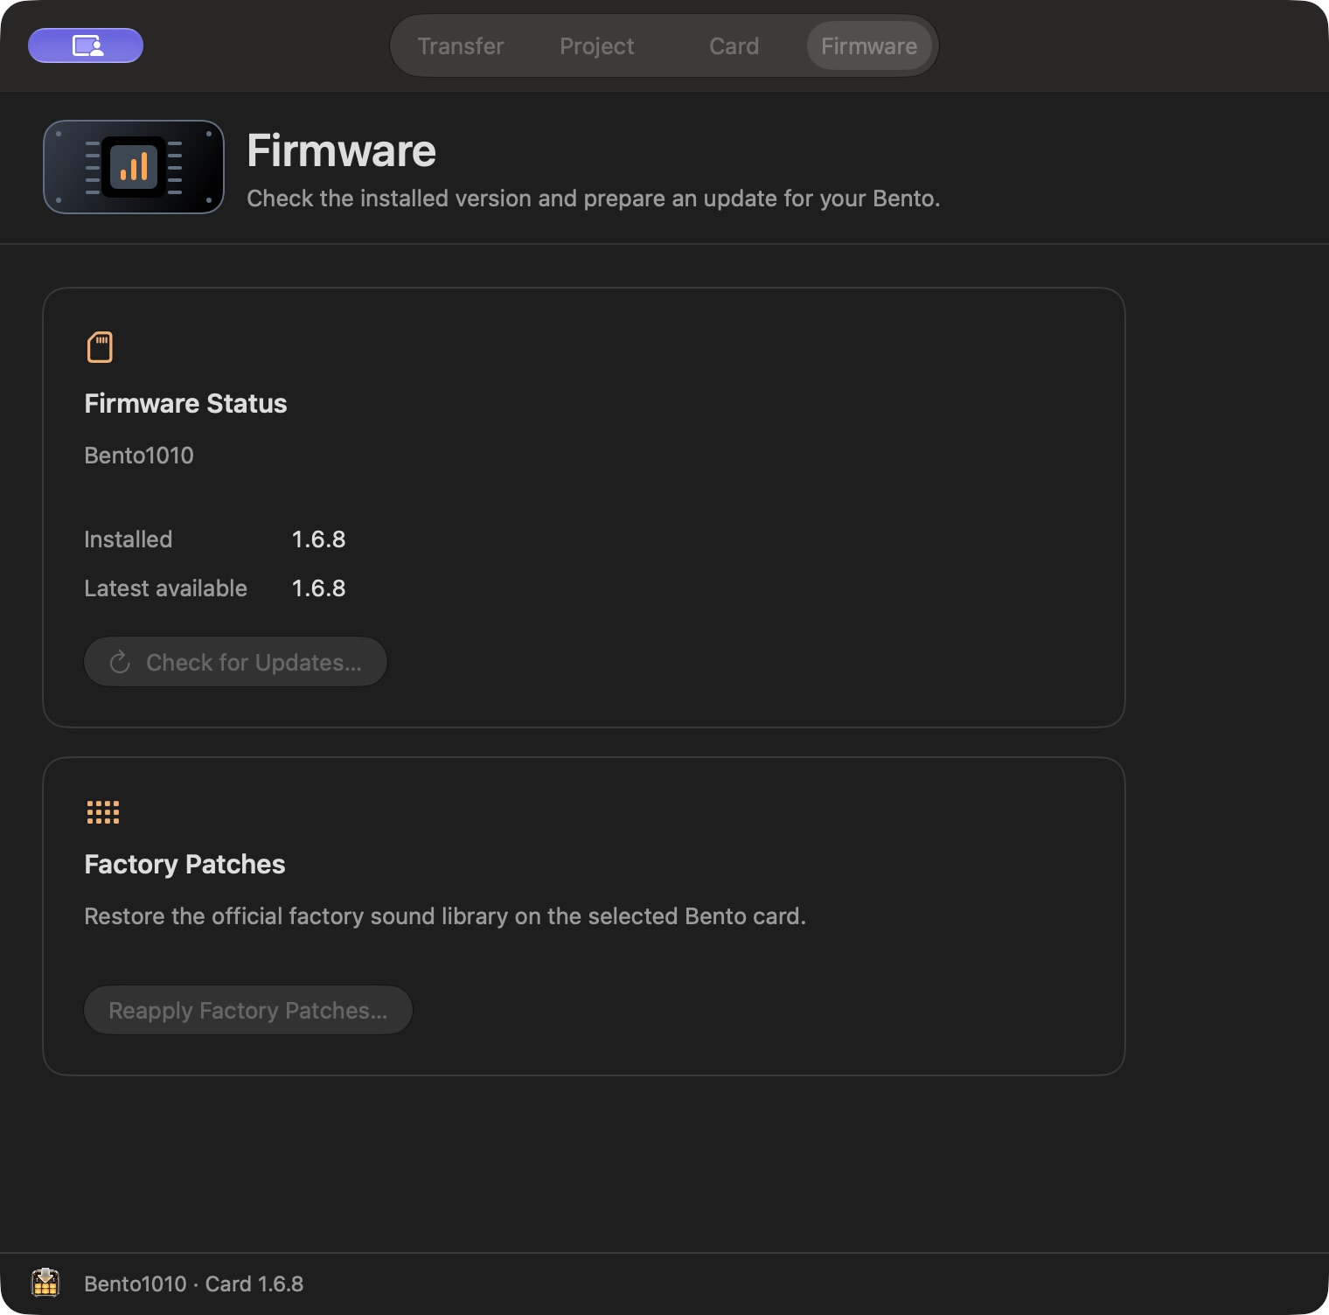
Firmware shows the version on the card and the latest version available.

FIRMWARE

Reapply the factory patches
1. Select the writable Bento SD card and open Firmware → Reapply Factory Patches. Confirm the card name before continuing.
2. Click Reapply Latest Factory Patches. BentoDrop checks the official 1010music catalogue and reuses its verified cached archive when it matches the current version.
3. Leave the card connected while BentoDrop stages and verifies the replacement Patches folder. Allow free space for the replacement alongside the original.
4. When complete, use Reveal Previous Patches to find the old folder if one existed. The installer keeps it on the card with a BentoDrop Previous Patches name.
This workflow replaces the factory Patches folder. Firmware files, Projects, UserPatches, and UserSamples stay in place.
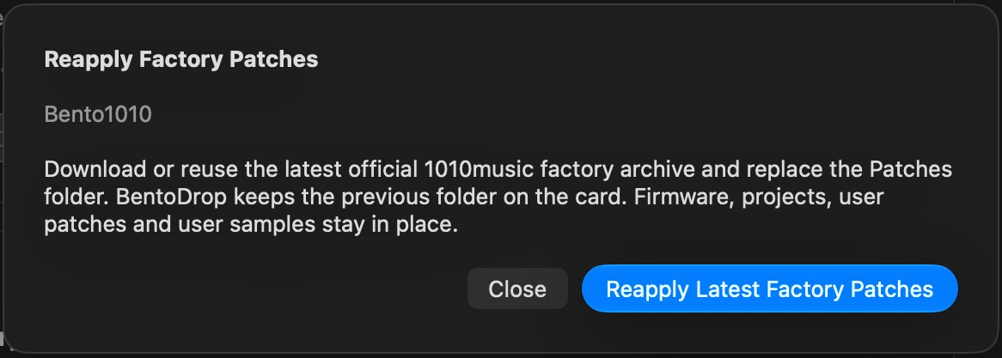
The factory patch confirmation identifies the selected card and scope.

CARD MAINTENANCE

Prepare a default SD card
Use Card → Create Default SD Card for a new card or a card you intend to format. This workflow prepares the official firmware and factory patches, then writes them to the formatted card.
1. Select the external SD card root. If it already contains files, choose a separate destination for the verified backup.
2. Choose Prepare Downloads. Wait for the official packages to download and verify before starting the format.
3. Open the official SD Association SD Card Formatter. Check the volume name and capacity carefully. Quick Format erases the selected card.
4. When formatting succeeds, return to BentoDrop and reselect the same empty card. Choose Install to SD Card. Keep it connected until verification completes.
5. Eject and follow the on-screen Bento bootloader steps if you intend to install the prepared firmware. If a write is interrupted, retry with the same card and matching downloads.
Formatting happens in SD Card Formatter. Closing BentoDrop does not stop a format already running there.

REFERENCE

Troubleshooting and support
1. Card missing or controls disabled. Check Finder first. Confirm SD Reader Mode and a USB-C data connection, or reseat the external reader. Select the volume and grant access to its root.
2. Sync skipped a file. Open the job log and check the existing-file policy, source format, decoding, duration, and destination path.
3. Firmware check reports an online error. Retry from Firmware after checking your connection. An official server error can occur even when the Mac is online.
4. MIDI plays silently. Load the saved copy, confirm the correct track and slot, test the pads, then try the 1/16-note minimum. Check external MIDI routing when applicable.
5. A restore or firmware write stops. Keep the backup. Reconnect the original card and use the relevant recovery or verification step before ejecting.
Open Help → Bento Drop Help for in-app guidance. Include the app version and build, macOS version, Bento firmware version, the affected workflow, and a relevant sync log or screenshot when reporting an issue.
BentoDrop support • Report an issue • BentoDrop downloads

