USE master

IF EXISTS(SELECT NAME FROM SYSDATABASES WHERE name='Demo')

DROP DATABASE Demo

GO

CREATE DATABASE Demo

ON PRIMARY

(

NAME='Demo_data',

FILENAME='G:\DB\try\Demo_data.mdf',

SIZE=10MB,

FILEGROWTH = 5MB

)

LOG ON

(

NAME='Demo_log.ldf',

FILENAME='G:\DB\try\Demo_log.ldf',

SIZE=5MB,

MAXSIZE=1000MB,

FILEGROWTH=10%

)

GO

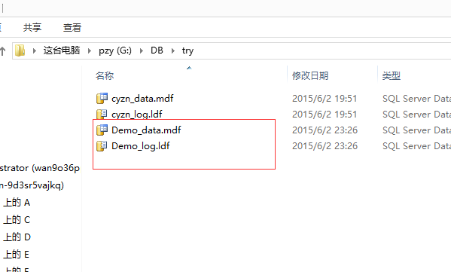

USE Demo

IF EXISTS(SELECT NAME FROM SYSOBJECTS WHERE NAME='Department')

DROP TABLE Department

GO

CREATE TABLE Department

(

dp_id INT IDENTITY(1,1) PRIMARY KEY, --IDENTITY(1,1)自动增长

dp_name VARCHAR(10) NOT NULL,

--CONSTRAINT Unique_Name UNIQUE NONCLUSTERED(dp_name),

--加上唯一约束后会按照该字段排序

)

INSERT INTO Department(dp_name) VALUES ('地科系')

INSERT INTO Department(dp_name) VALUES ('工程系')

INSERT INTO Department(dp_name) VALUES ('仪器系')

INSERT INTO Department(dp_name) VALUES ('信息系')

INSERT INTO Department(dp_name) VALUES ('经管系')

INSERT INTO Department(dp_name) VALUES ('人文社科系')

INSERT INTO Department(dp_name) VALUES ('外语系')

SELECT * FROM Department

GO

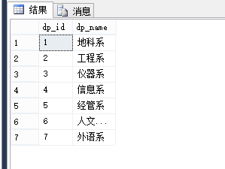

USE Demo

IF EXISTS(SELECT NAME FROM SYSOBJECTS WHERE NAME='Teainfo')

DROP TABLE Teainfo

GO

CREATE TABLE Teainfo

(

tea_id NCHAR(18) PRIMARY KEY,

tea_name VARCHAR(6) NOT NULL,

tea_tel NVARCHAR(11) NULL,

tea_sex CHAR(2) CONSTRAINT tea_sex CHECK (tea_sex in ('男','女')),

tea_age INT NULL,

--CREATE TABLE 时的 SQL FOREIGN KEY 约束:

dp_id INT FOREIGN KEY REFERENCES Department(dp_id)

--定义多个列的 FOREIGN KEY 约束

--CONSTRAINT fk_PerOrders FOREIGN KEY (P_Id) REFERENCES Persons(P_Id)

--ALTER TABLE 时的 SQL FOREIGN KEY 约束:

--ALTER TABLE Orders ADD FOREIGN KEY (P_Id) REFERENCES Persons(P_Id)

--定义多个列的 FOREIGN KEY 约束

--ALTER TABLE Orders ADD CONSTRAINT fk_PerOrders FOREIGN KEY (P_Id) REFERENCES Persons(P_Id)

)

GO

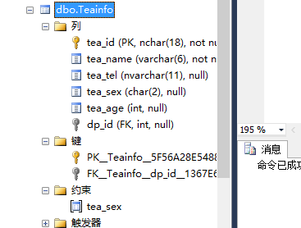

INSERT INTO Demo.dbo.Teainfo SELECT * FROM Info.dbo.Director

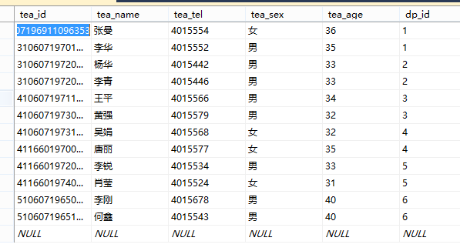

USE Demo

IF EXISTS(SELECT NAME FROM SYSOBJECTS WHERE NAME='Stuinfo')

DROP TABLE Stuinfo

GO

CREATE TABLE Stuinfo

(

stu_id CHAR(9) PRIMARY KEY,

stu_name VARCHAR(6) NOT NULL,

stu_birth DATETIME NULL,

dp_id INT FOREIGN KEY (dp_id) REFERENCES Department (dp_id),

tea_id NCHAR(18) FOREIGN KEY (tea_id) REFERENCES Teainfo (tea_id)

)

GO

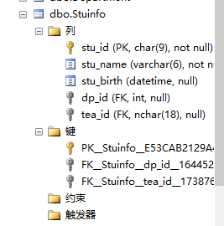

INSERT INTO Demo.dbo.Stuinfo SELECT * FROM Info.dbo.Student

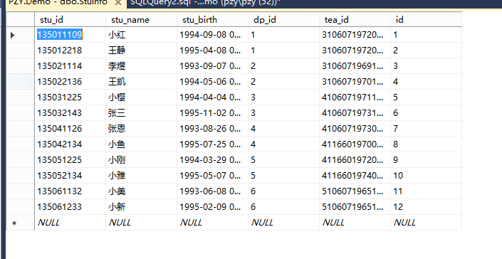

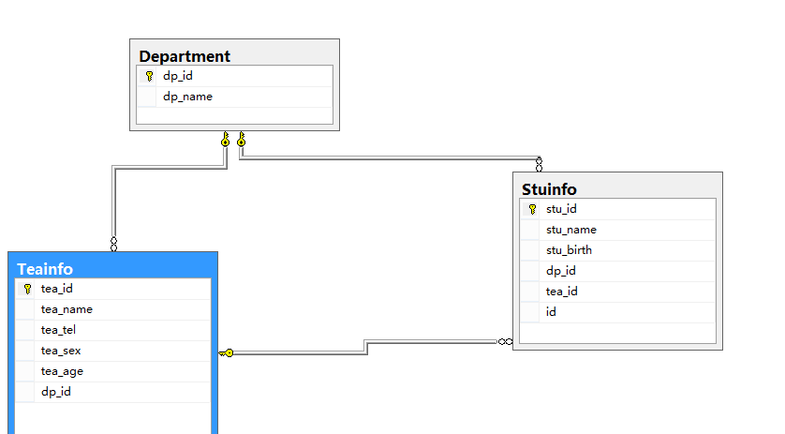

SELECT * INTO Demo.dbo.StuTest FROM cyzn.dbo.TourNav

USE Demo

GO

SELECT * INTO Test1 FROM StuTest

ALTER TABLE Test1

DROP COLUMN Heat --若不加入column，则默认删除约束

GO

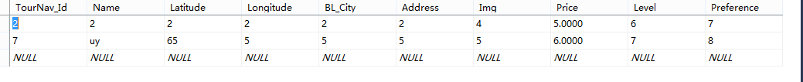

更新数据

USE Info

GO

UPDATE Test1

SET Total=StuTest.Total

FROM StuTest

WHERE Test1.Stu_ID=StuTest.Stu_ID

GO

修改数据类型

USE Info

GO

ALTER TABLE Test1

ALTER column Total DECIMAL(4,1)

GO

查询：

USE Sample

GO

SELECT DISTINCT Stu_English FROM StuTest--DISTINCT 关键词用于返回唯一不同的值。

SELECT * FROM StuTest ORDER BY Total --默认升序 ASC|DESC：升|降

INSERT INTO StuTest VALUES('135042306','彭中耀',99,99,99,297)

UPDATE StuTest SET Stu_name = 'PTSPZY' WHERE Stu_Name='彭中耀'

DELETE FROM StuTest WHERE Stu_Name='PTSPZY'

SELECT TOP 3 * FROM StuTest--TOP用法

SELECT TOP 80 PERCENT * FROM StuTest--TOP PERCENT用法 共18条记录 返回15条(14.4)

SELECT * FROM StuTest WHERE Stu_ID LIKE '%01'

SELECT * FROM StuTest WHERE Stu_ID LIKE '_____01'

SELECT * FROM StuTest WHERE Stu_ID LIKE '%[1-3]'--'%[!abc]' 最后一位不包含abc

SELECT * FROM StuTest WHERE Stu_ID IN (0510301,0510302)

SELECT * FROM StuTest WHERE Total BETWEEN 250 AND 300--BETWEEN用法

SELECT Stu_ID AS '学号',Stu_Name AS '姓名' FROM StuTest--别名（Aliases）

-- INNER JOIN：如果表中有至少一个匹配，则返回行

-- LEFT JOIN：即使右表中没有匹配，也从左表返回所有的行

-- RIGHT JOIN：即使左表中没有匹配，也从右表返回所有的行

-- FULL JOIN：只要其中一个表中存在匹配，则返回行

-- 图解SQL Join:http://segmentfault.com/a/1190000000454332

--左表无匹配显示null

SELECT StuInfo.Stu_ID,StuInfo.Stu_Name,StuTest.Total FROM StuInfo RIGHT JOIN StuTest ON StuInfo.Stu_ID = StuTest.Stu_ID

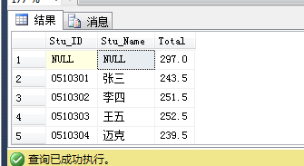

SELECT StuInfo.Stu_ID,StuInfo.Stu_Name,StuTest.Total FROM StuInfo,StuTest WHERE StuInfo.Stu_ID = StuTest.Stu_ID

SELECT StuInfo.Stu_ID,StuInfo.Stu_Name,StuTest.Total FROM StuInfo FULL OUTER JOIN StuTest ON StuInfo.Stu_ID = StuTest.Stu_ID

--UNION 结果集中的列名总是等于 UNION 中第一个 SELECT 语句中的列名

--必须拥有相同数量的列。列也必须拥有相似的数据类型

SELECT Stu_ID,Stu_Name FROM StuInfo

UNIONSELECT Stu_ID,Stu_Name FROM StuTest;

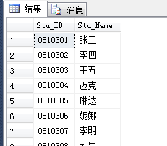

SELECT Stu_ID,Stu_Spe FROM StuInfo UNION ALL--如果允许重复的值，请使用 UNION ALLSELECT Stu_ID,Stu_Name FROM StuTest;

USE Demo

GO

SELECT stu_id,stu_name,

(CONVERT(varchar(20),YEAR(GETDATE())-YEAR(stu_birth))+'岁')

AS '年龄' FROM Stuinfo

GO

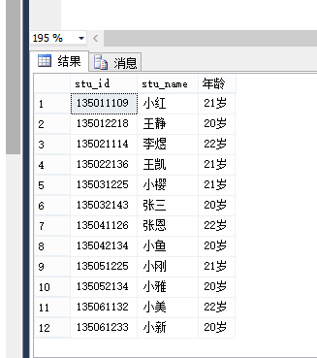

USE Demo

GO

DECLARE @a INT ,@b INT,@c VARCHAR(10),@d VARCHAR(100)

SET @b=1

SET @d=''

SELECT @a=COUNT(*) FROM Stuinfo

WHILE(@b<=@a)

BEGIN

SET @c=(SELECT stu_name FROM Stuinfo WHERE MONTH(GETDATE())=MONTH(stu_birth) AND id=@b )

IF (LEN(@c)<>0)

SET @d=@d+@c+''

IF (@b=@a)

PRINT @d+'这个月过生日,去祝福他吧'

SET @b=@b+1

END

GO

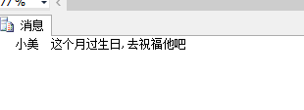

USE Demo

GO

SELECT stu_id,stu_name,YEAR(stu_birth) AS '出生年份',

YEAR(GETDATE())-YEAR(stu_birth) AS '年龄'

FROM Stuinfo

WHERE (YEAR(GETDATE())-YEAR(stu_birth))>20

GO

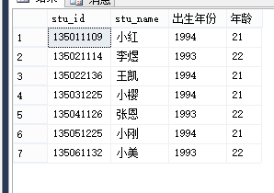

USE Demo

GO

SELECT tea_id,tea_name,tea_age FROM Teainfo

WHERE tea_age IN(SELECT tea_age FROM Teainfo WHERE tea_name='杨华' )

GO

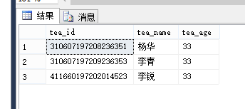

USE Demo

SELECT Stu_Spe,SUM(Stu_Test)AS '总成绩',AVG(Stu_Test)AS '平均成绩'

FROM Test

GROUP BY Stu_Spe

ORDER BY '平均成绩'

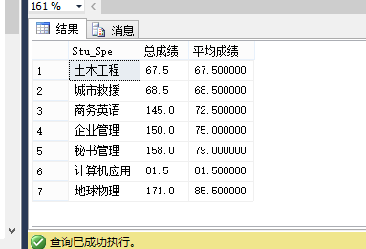

视图：

USE Demo

GO

CREATE VIEW Stu_v

AS SELECT id, stu_id,stu_name FROM Stuinfo

WHERE id>6

GO

SELECT * FROM Stu_v

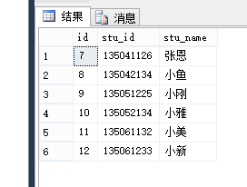 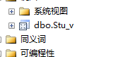

USE Demo

DROP VIEW Stu_v

USE Demo

GO

CREATE UNIQUE INDEX stu_id ON Stuinfo(stu_id)

GO

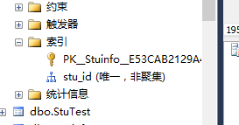

DROP INDEX Student.Stu_No

循环结构练习：

--乘法表显示格式优化

DECLARE @i INT,@j INT,@mul INT, @str VARCHAR(1000)

SET @i = 1;

SET @j = 1;

SET @str='';

WHILE(@i<=9)

BEGIN

SET @j = 1;

WHILE(@j<=@i)

BEGIN

SET @mul = @i * @j;

SET @str =@str + CAST(@i AS VARCHAR(10))+'*'+CAST(@j AS VARCHAR(10))+'='+CAST(@mul AS VARCHAR(10))+CHAR(9)

SET @j = @j + 1;

END

PRINT @str;

SET @i = @i + 1;

SET @str='';

END

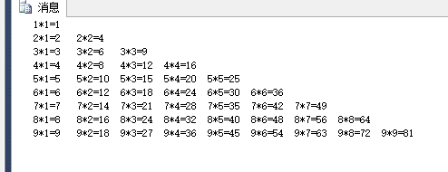

游标：

DECLARE @studyNum VARCHAR(10),@Name VARCHAR(10)

DECLARE stu_cur SCROLL CURSOR FOR

SELECT Stu_ID,Stu_Name FROM StuInfo

OPEN stu_cur

--开启游标之后，默认是位于第一行的前面，因此需要FETCH NEXT

FETCH NEXT FROM stu_cur INTO @studyNum,@Name

WHILE (@@FETCH_STATUS = 0)--判断是否有数据

BEGIN

PRINT @Name +'的学号是:'+@studyNum +'。'

FETCH NEXT FROM stu_cur INTO @studyNum,@Name--游标前进

END

CLOSE stu_cur

DEALLOCATE stu_cur

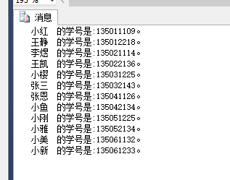

存储过程：

1.不含参数：

CREATE PROCEDURE pass1_xp

AS

SELECT * FROM StuTest WHERE Total>=250

EXEC pass1_xp

2.含参数：

CREATE PROCEDURE pass2_xp @pass INT

AS

SELECT * FROM StuTest WHERE Total>=@pass

EXEC pass2_xp 250

3.含默认参数

CREATE PROCEDURE pass3_xp @pass INT = NULL

AS

IF @pass IS NULL

BEGIN

SELECT * FROM StuTest WHERE Total > = 250

END

ELSE

BEGIN

SELECT * FROM StuTest WHERE Total > = @pass

END

EXEC pass3_xp

4.带输入参数的存储过程

CREATE PROCEDURE pass4_xp

@pass INT = NULL,

@studyNum VARCHAR(10) OUT,

@Name VARCHAR(10) OUTPUT

AS

IF @pass IS NULL

BEGIN

SELECT * FROM StuTest WHERE Total > = 250

END

ELSE

BEGIN

SELECT @Name=Stu_Name,@studyNum=Stu_ID FROM StuTest WHERE Total = @pass

END

DECLARE @pass INT,

@studyNum VARCHAR(10),

@Name VARCHAR(10)

SET @pass=297

EXEC pass4_xp @pass,@studyNum OUT,@Name OUTPUT

SELECT @Name +'的学号是：'+@studyNum

IF EXISTS(SELECT * FROM SYSOBJECTS WHERE name='pass4_xp')

DROP PROC pass4_xp

GO

USE Sample

GO

CREATE PROC pass4_xp

@TITLE VARCHAR(40) , @SUM DECIMAL OUTPUT

AS

SELECT 'Stu_Name' = Stu_Name FROM t

WHERE Stu_Name LIKE @TITLE +'%'

SELECT @SUM = SUM(Total) FROM t

WHERE Stu_Name LIKE @TITLE +'%'

DECLARE @SUM DECIMAL

EXEC pass4_xp '李',@SUM OUTPUT

SELECT @SUM

Demo(模糊查询查询系名并输出该系的总分)

IF EXISTS(SELECT * FROM SYSOBJECTS WHERE name='pass4_xp')

DROP PROC pass4_xp

GO

USE Sample

GO

CREATE PROC pass4_xp

@TITLE VARCHAR(40) , @SUM INT OUTPUT,@SPE VARCHAR(10) OUTPUT

AS

SELECT @SUM = SUM(Stu_PS) FROM StuInfo

WHERE Stu_Spe LIKE @TITLE + '%'

SELECT DISTINCT @SPE = Stu_Spe FROM StuInfo

WHERE Stu_Spe LIKE @TITLE + '%'

DECLARE @TITLE VARCHAR(40),@SUM INT,@SPE VARCHAR(10)

SET @TITLE='信息'

EXEC pass4_xp @TITLE,@SUM OUTPUT,@SPE OUTPUT

PRINT @SPE +'总分为：'+ CAST(@SUM AS VARCHAR(10))

--DISTINCT尝试

DECLARE @SPE VARCHAR(10)

SELECT DISTINCT @SPE = Stu_Spe FROM StuInfo

WHERE Stu_Spe LIKE '信息%'

PRINT @SPE

触发器：

--触发随机数次序修改

CREATE TRIGGER tgr_Reply_update_stu_order

ON Reply

FOR UPDATE

AS

DECLARE @MaxNum INT--获取最大次序

IF (UPDATE(isOk))--判断更新

BEGIN

--每次更新，在最大值的基础上+1，stu_order字段默认值必须为0

SET @MaxNum=((SELECT MAX(stu_order) FROM Reply)+1)

--获取当前被更新的行，进行更新操作（利用副本表inserted ）

UPDATE Reply SET stu_order = @MaxNum FROM Reply INNER JOIN inserted ON Reply.id = inserted.id

END