一、创建数据库

create database JXGL

on primary

(

name=jxgl_data,

filename='G:\数据库\2\jxgl_data.mdf',

size=5MB,

maxsize=50MB,

filegrowth=1MB

)

Log on

(

name=jxgl_log,

filename='G:\数据库\2\jxgl_log.ldf',

size=5MB,

maxsize=50MB,

filegrowth=10%

)

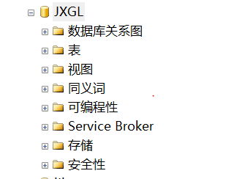

二、创建数据表

1.学生信息表

use JXGL

create table student

(

st_id varchar(9) primary key,

st_name char(8) null,

st_sex nchar(2) constraint checksex check(st_sex in('男','女')),

st_birth datetime null,

zhuanye char(8) null

) 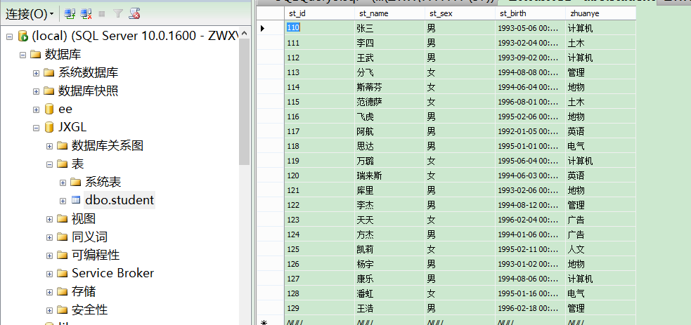

2.学校系别表

use JXGL

create table school

(

type nchar(10) not null primary key

,type_name char(15) not null

,school nchar(10) not null default '防灾科技学院'

)

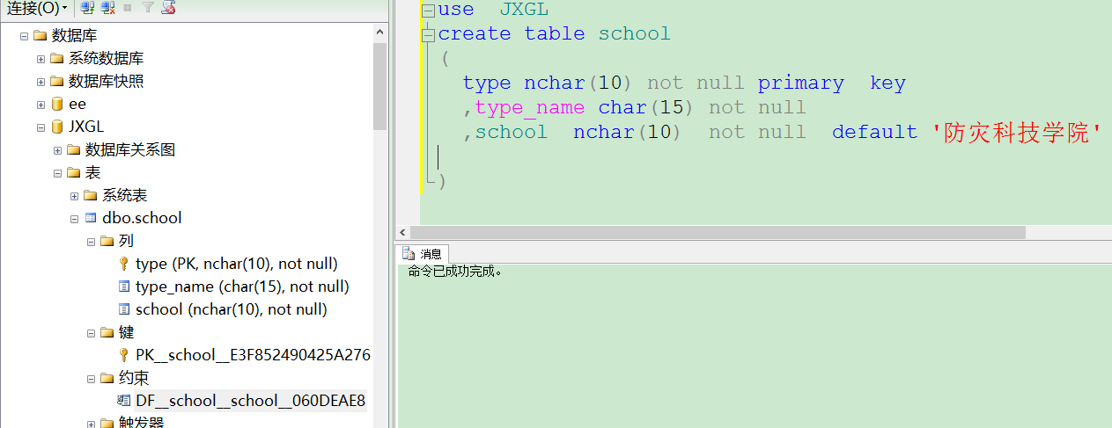

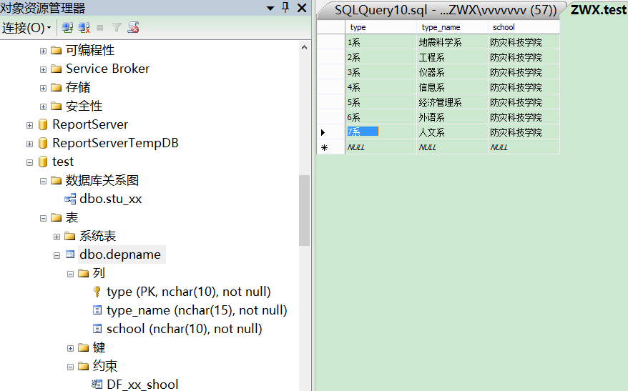

3.成绩表

use JXGL

create table score

(

st_id varchar(9) not null

,type nchar(10) not null

,math_grade int

,average int

,total int

primary key (st_id ,type)

,foreign key (st_id )references student(st_id)

,foreign key (type) references school(type)

)

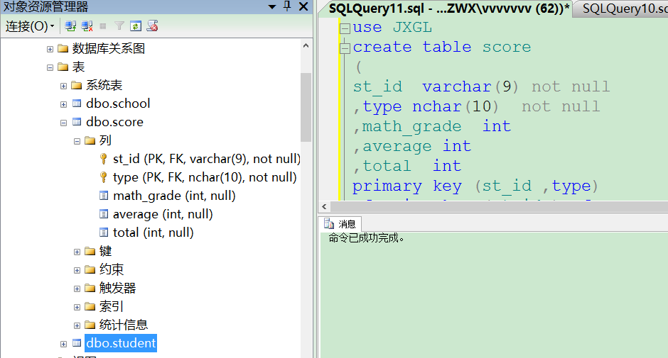 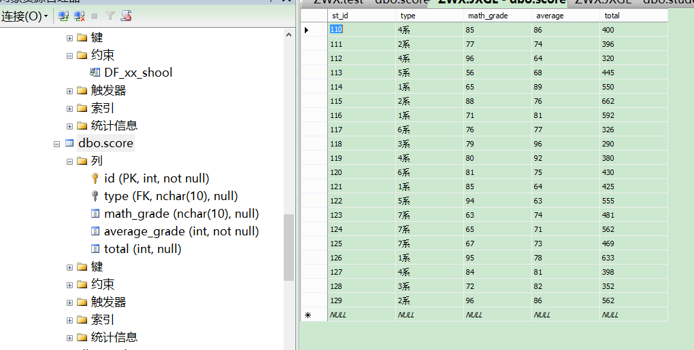

三、查询

1.查询score中的所有数据

use JXGL

select *

from score

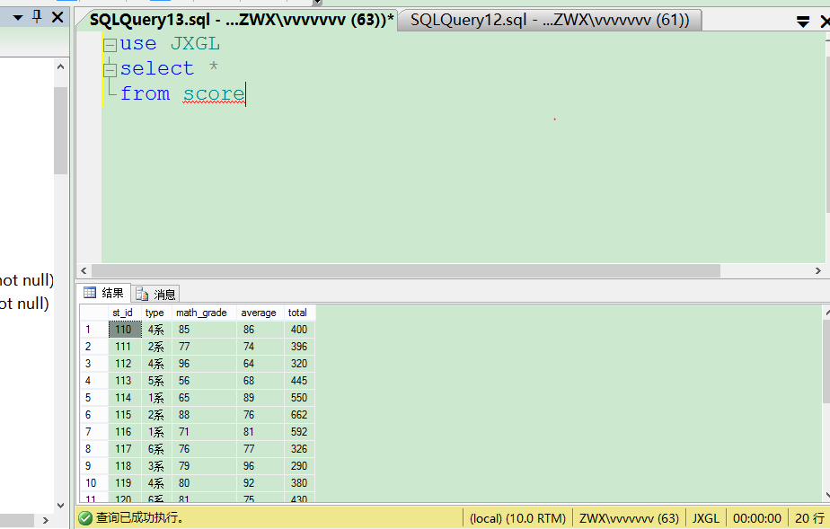

2.查询姓名年 月 日

use JXGL

select st_name,

YEAR(st_birth) ' 年'

,month (st_birth)' 月'

,DAY(st_birth)' 日'

from student

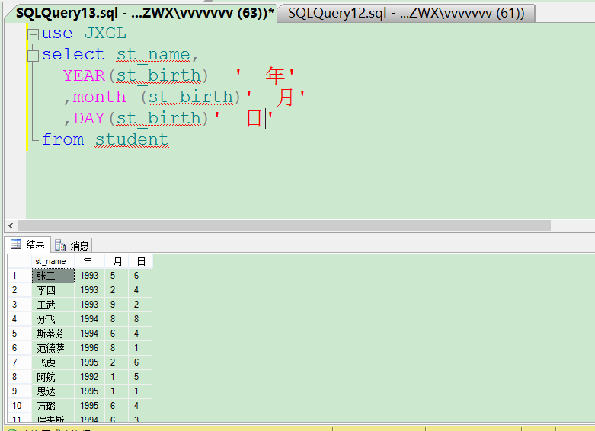

3.年龄小于20

use JXGL

select st_name,

year(GETDATE ())-YEAR(st_birth) ' 年龄'

from student

where year(GETDATE ())-YEAR(st_birth)<20

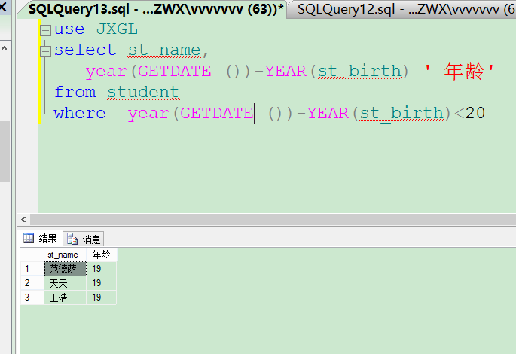

4.查询数学成绩在60~70之间的学生

SELECT [st_id]

,[math_grade]

FROM [JXGL].[dbo].[score]

where math_grade between 60and 70

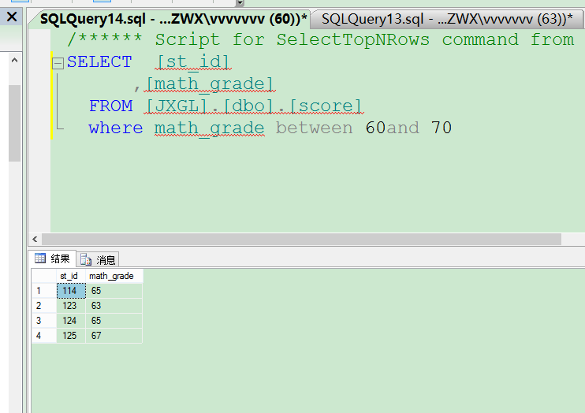

5.用in 查询math_grade 65

SELECT [st_id]

,[math_grade]

FROM [JXGL].[dbo].[score]

where math_grade in( 65 )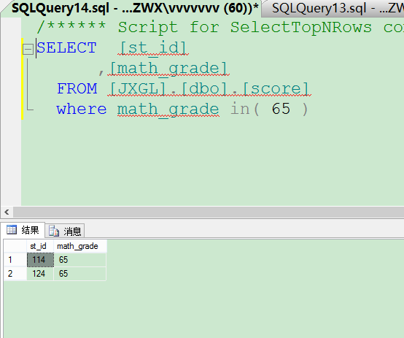

6.查询姓张的

use JXGL

select st_name

from student

where st_name like '张%'

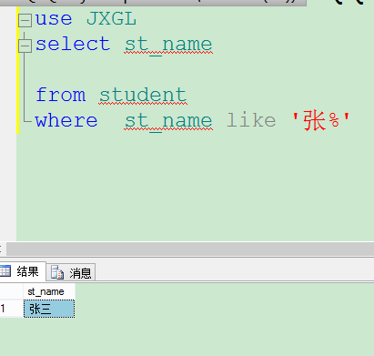

7.查询第二个字为浩的姓名

use JXGL

select st_name

from student

where st_name like '_浩'

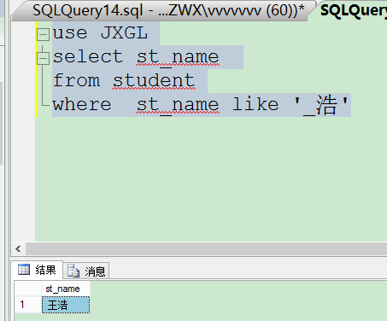

8. 查询math_grade <60 or total<400

SELECT [st_id]

FROM [JXGL].[dbo].[score]

where math_grade <60 or total<400

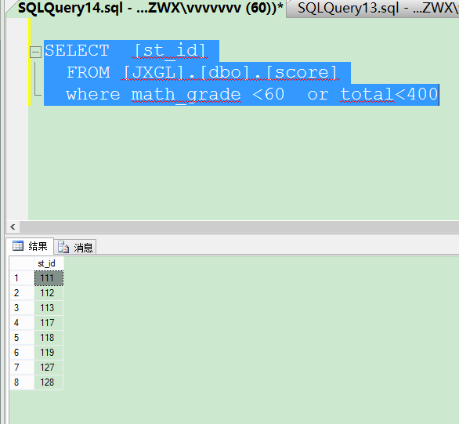

9.按年龄排序（降序）

use JXGL

select st_id,st_name,YEAR (GETDATE ())-YEAR (st_birth) '年龄'

from student

order by YEAR (GETDATE ())-YEAR (st_birth) desc 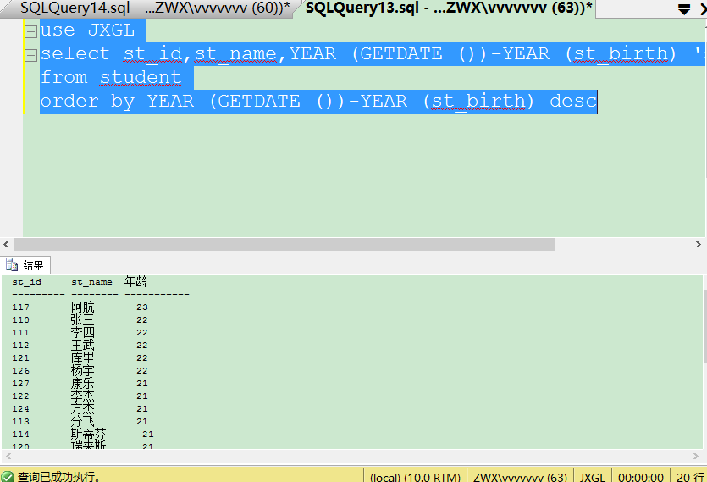

10. 10%

use JXGL

select top 10 percent*

from student

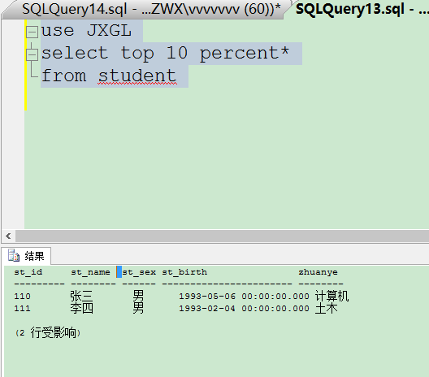

11.count

use JXGL

select COUNT (st_id) as'人数'

from student

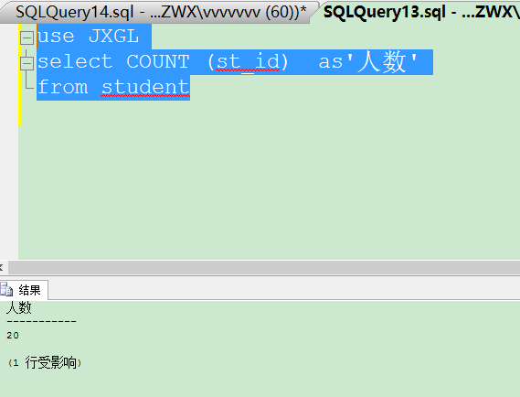

12.按系别对math­_grade 分组

SELECT TYPE,sum(math_grade)

FROM [JXGL].[dbo].[score]

group by type

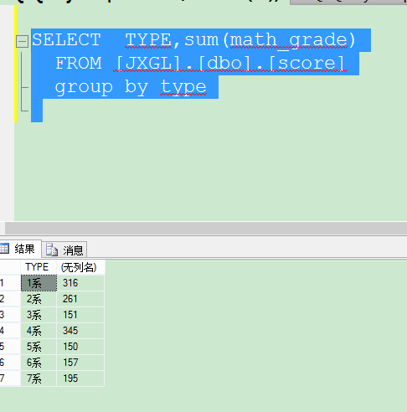

13.分类

SELECT TYPE,math_grade

FROM [JXGL].[dbo].[score]

order by type

compute avg(math_grade) by type

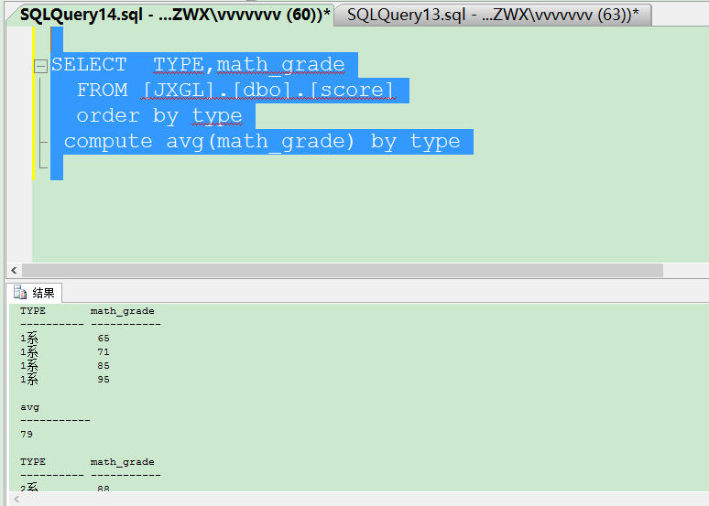

14 汇总

use JXGL

select st_id,st_name

from student

compute count (st_id)

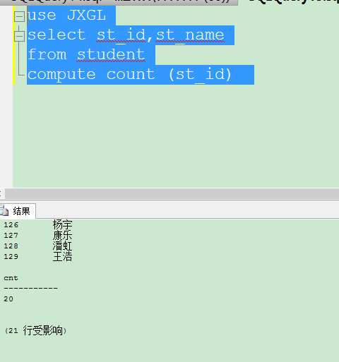

15.利用别名多表联合查询

use JXGL

select s1.[st_id]

,s1.[st_name]

,s3.[type]

,s2.[math_grade]

from student as s1,score as s2,school as s3

where s1.[st_id]=s2.[st_id] and

s2.[type]=s3.[type]

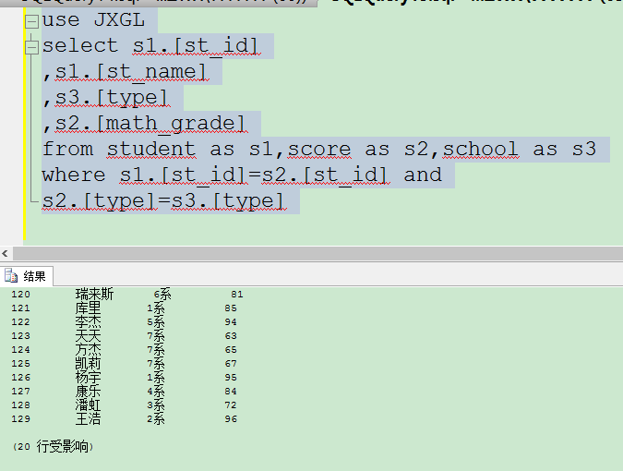

16.嵌套查询

select st_id,

math_grade

from score

where math_grade<(select AVG(math_grade)from score)

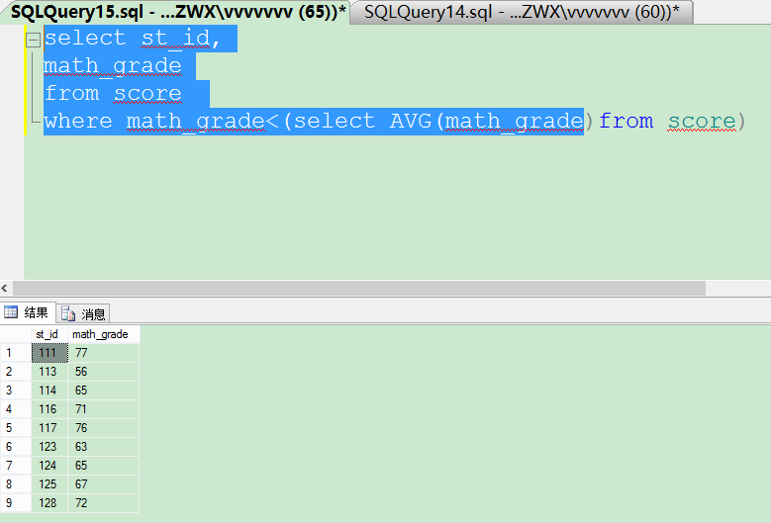

四.数据更新

1.数据插入

use JXGL

insert into student

values('130','张宇','男','1990-01-02','计算机'

) 

2.删除张宇的信息

use JXGL

delete from student

where st_name ='张宇'

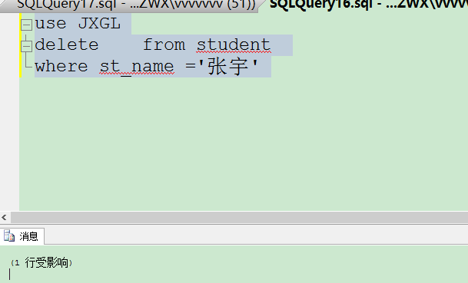

3.修改数据

use JXGL

update student

set st_sex='女'

where st_name ='张三'

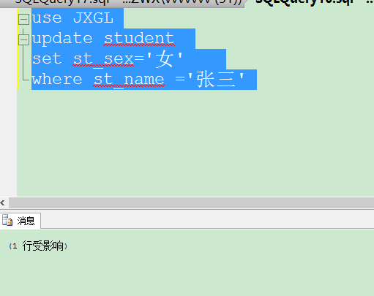

4. 将低于maTh_grade平均分的学生成绩*120%

use JXGL

update score

set math_grade =math_grade *1.2

where math_grade <(select AVG(math_grade)from score)

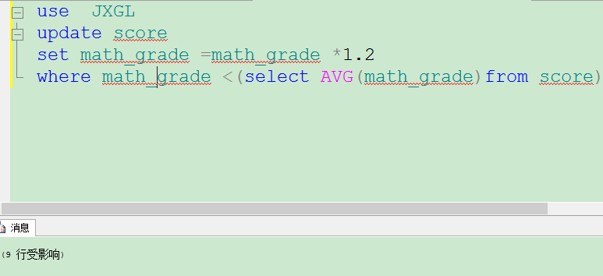

5.将math_grade*1.4，超过100的设成100

While exists(Select math_grade From d1 Where math_grade<80)

Begin

Update d1

SET math_grade=math_grade*1.2

IF (Select Max(math_grade) From d1)>100

begin

update d1

set math_grade=100

where math_grade >100

Break

end

Else

Continue

END

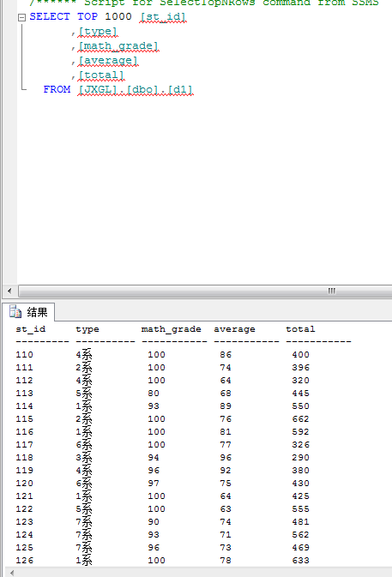

五.视图

1.创建

create view stuView

as select st_id ,st_name,zhuanye

from student

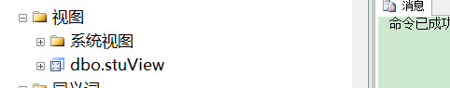

2.查看视图

select * from stuview

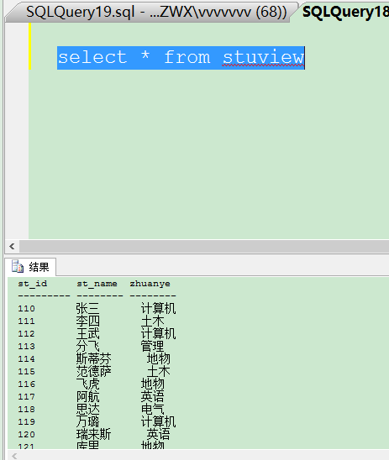

3. **查询当前数据库中所有的视图的名字和创建时间**

Select name,crdate

From sysobjects

Where Type='V' --V表示视图,U表示用户表

Order By name

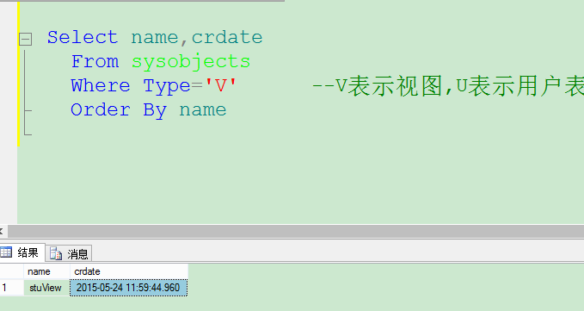

3.向视图插入数据

insert into stuview

values('144','威德','计算机')



4.更改

update stuview

set zhuanye ='广告'

where st_id ='144'



5.修改视图定义

Alter view stuview

As

Select *

From student

Where zhuanye ='计算机'

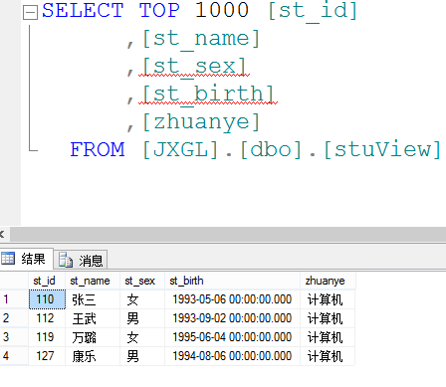

6.删除视图

drop view stuview

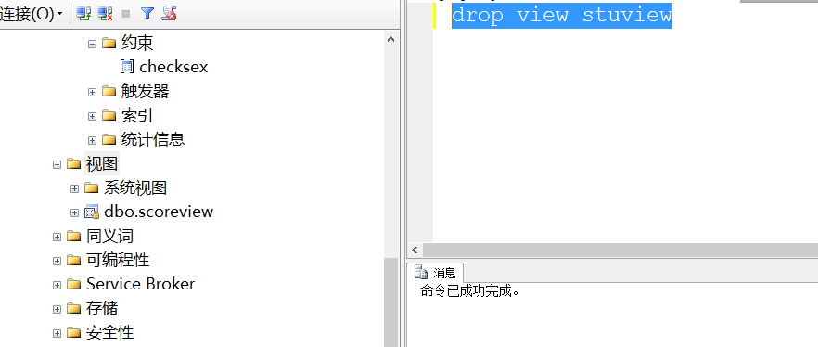

7.视图加密

Create View scoreview

WITH ENCRYPTION --视图加密语句

As

Select *

From score

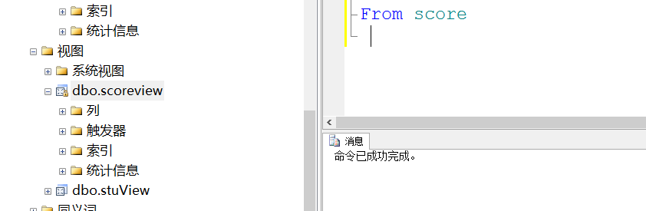

六.约束

1.增加列

为book表增加ISBN列 类型 char（10）

use TSGL

alter table book

add ISBN char(10)

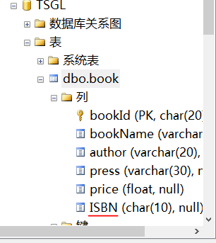

2.为ISBN列增加缺省值约束，约束名ISBNDEF 缺省值为‘71110859449’

use TSGL

alter table book

add constraint ISBNDEF default '7111085949' for ISBN

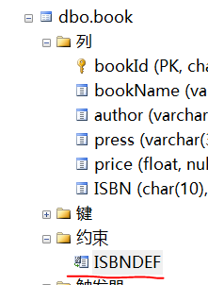

3.为reader的tel列添加CHECK约束，要求电话号4位数 约束名TEL

use TSGL

alter table reader

add constraint TEl

check(tel like ('____'))

输入1234 可以

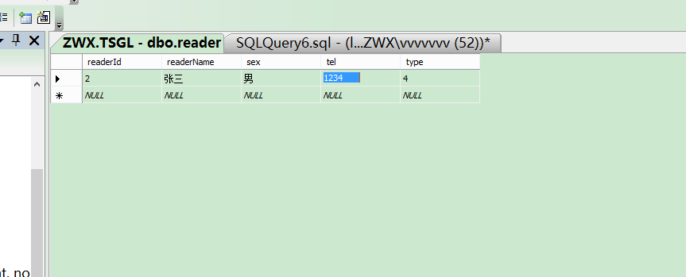

输入12345

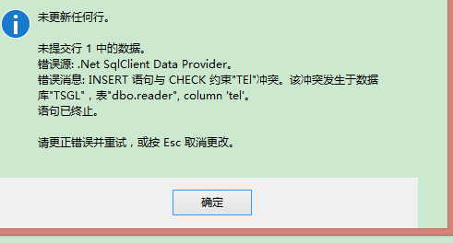

4.（1）删除book表中ISBN列增加缺省值约束

alter table book

drop constraint ISBNDEF

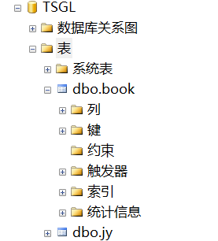

（2）删除reader表中TEL列的check约束

alter table reader

drop constraint TEL

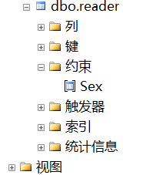

5.删除列ISBN

alter table book

drop column ISBN

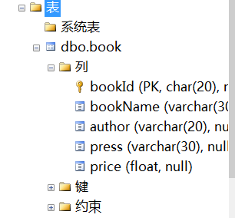

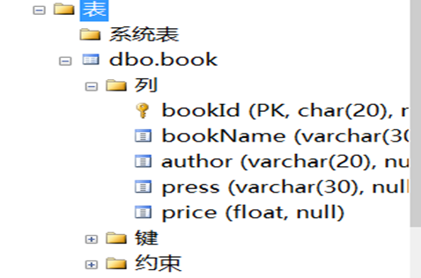

6.游标

declare @a varchar,

@b char(8)

declare s cursor scroll

for select st_id,st_name from student

open s

fetch last from s into @a,@b

print @a + @b

close s

deallocate s

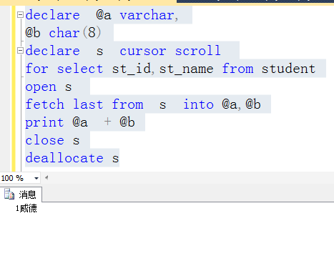

7.存储过程

（1）

Create Procedure a

As

Select * from score

Where math_grade<70

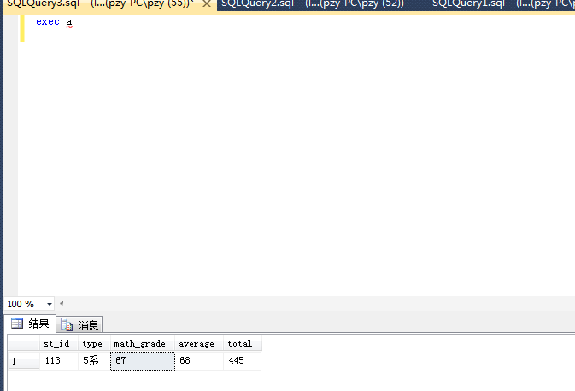

（2）不带参数的存储过程

Create Procedure a3 @a int

as

Select st_id,type,math_grade

from score

Where math_grade<@a

exec a3 80

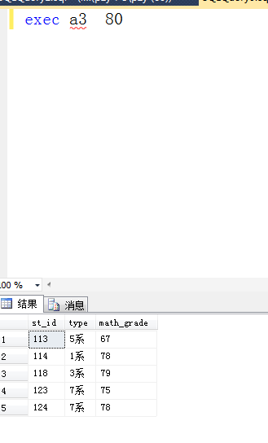

（3）默认参数

Create Procedure b1 @a int = null

As

IF @a IS NULL

Begin

select st_id,type,average from score

where average< 70

End

Else

Begin

select st_id,type,average from score

where average < @a

End

exec b1

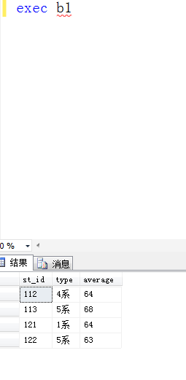

exec b1 80

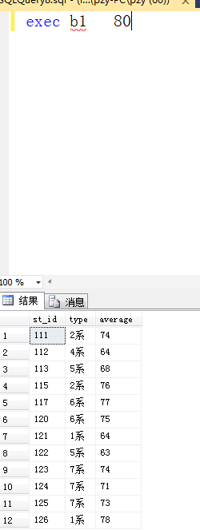

8.触发器

create trigger d1Insert

on d1

after insert

as

declare @a int

if update (math_grade)

select @a=math_grade from inserted

print @a

insert into d1

values ('132','2系',60,70,440)

