Second Order Characterization of a Motor/Pendulum
Andy Perez
MAE 334 L1
Monday 2-4:20 pm
TA: Junhee Lee
Other students in Group: Andrew Alegria
Lab 3
Measurement of Second Order SDOF Systems

1.Abstract
The Purpose of this report was to learn new experimental methods in order to determine a systems transfer function, in this case it was motor-pendulum system. The purpose included using the input and outputs of the system to calculate the transfer function. It included using the free decay of the pendulums system to calculate the damping ratio and natural frequency. It included getting measurements of the position for both the motor and pendulum. The data represented in this report includes plots of the angles of the pendulum and motor versus time for below, at and above the natural frequency. It includes a plot of the experimentally determined transfer function with respect to frequency. It provide a plot of the angles of the pendulum for free decay with respect to time. Lastly it include a bode plot of the free decay pendulum and a plot of the experimentally determined transfer function on the same graph. The conclusions drawn are that Bode plot is more accurate, take and takes less time to perform but only accounts for the pendulum, while the experimentally determine transfer function is more precise, less accurate and accounts for the motor- pendulum system. The advantage sand disadvantages help explain why the two methods results do not perfectly align on a graph.
2. Introduction
This study was performed in order to use different methods of calculating the characterization of a system and what the disadvantages and advantage are of using each method. There was much information already known about the characterization of a system. It was known that in order to characterize a system using a Bode plot the natural frequency and the damping ratio had to be known. It was already known that the damping frequency was needed in order to calculate the natural frequency, and that a logarithmic decrement was needed to calculate the damping ratio. The damping frequency is “2 times pie over the time at the end of period minus the time at the beginning of the period (wd=2pi/t2-t1)” [1]. The logarithmic increment is the “natural log of the output at the beginning of the time period over the output at the end of the time period (delta=ln(x1/x2))” [1]. The damping ratio is calculate using the equation “zeta=delta/2*pi/ (square root (1+(delta/2*pi)^2))” [1]. The natural frequency is calculate using the equation “wn=wd/square root (1-zeta^2)” [1]. Then using the damping ratio and natural frequency the transfer function is made using the second order model system equation “𝜃̈ 𝑝 + 2𝜁𝜔𝑛𝜃̇ 𝑝 + 𝜔𝑛 2𝜃𝑝 = 𝐾𝜃̈m” [2]. The specific purpose of this study was to find out the second order system of the pendulum motor system using what we already knew about transfer functions and a new method with an experimental characterization using inputs and outputs of the system for e different frequencies.
3. Experimental Methods
The materials used were a Quanser servo motorplant, a pendulum, a power amplifier, a Quanso (DAQ) Data Acquisition board and a Desktop with a Quarc Simulink program. The Data Acquisition board, motor and and power amplifier will be set up in a Qnaunser Servo Connection Setup, such as shown below [3]. 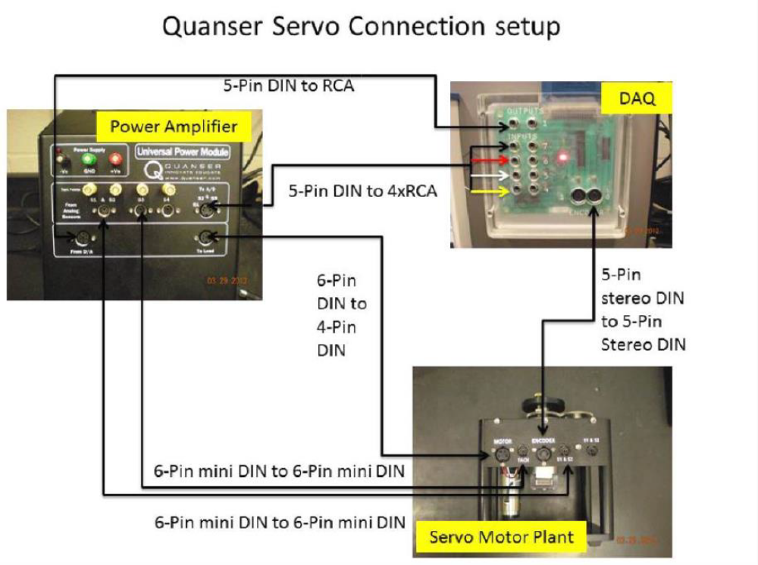

The Simulink program will send signals through the data acquisition board to the power amplifier, which will supply the current needed to drive the motor. Only 4 cables will be needed to connect the system. Then once the setup is done the Simulink program to gather the angle of the pendulum and motor will be run for 14 frequencies and the data will be stored. The angle is measured by encoders of the pendulum and motor. Then the motor will be disconnected from the pendulum and the pendulum will be allowed to operate in free decay. The angles of the pendulum free decay will be recorded. The entirety of the lab was done in a lab on the sixth floor of Furnas Hall at the University at Buffalo on a Monday during 2:00-4:20 pm.
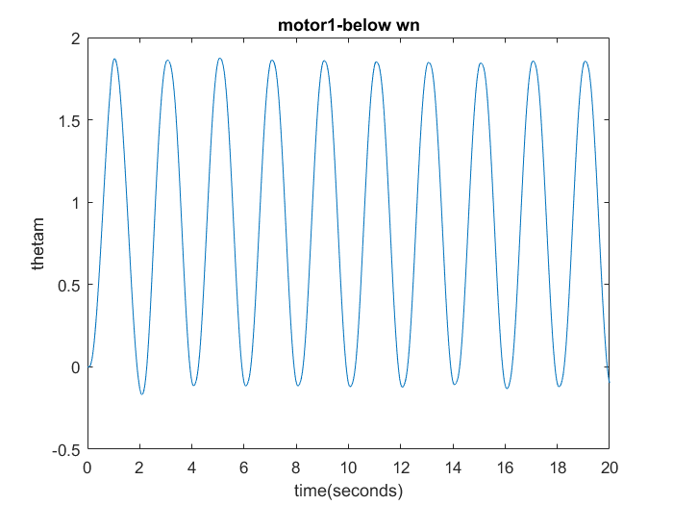
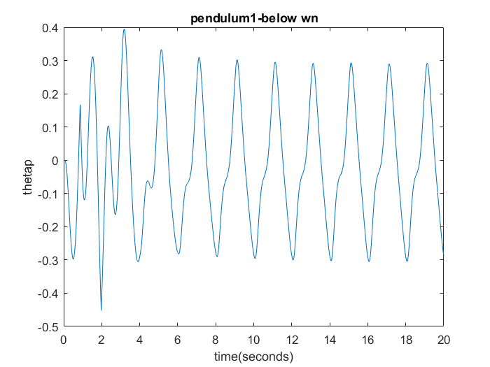
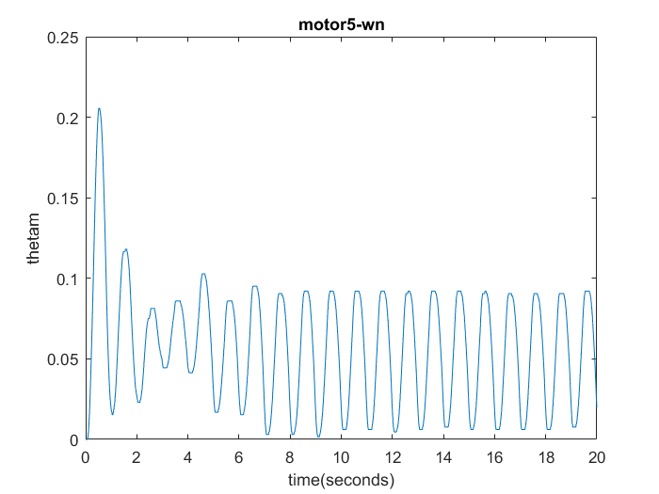
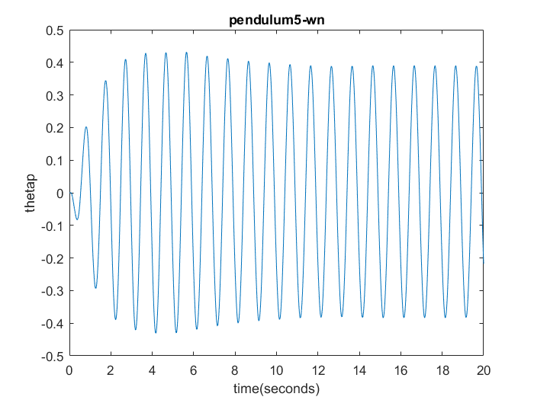
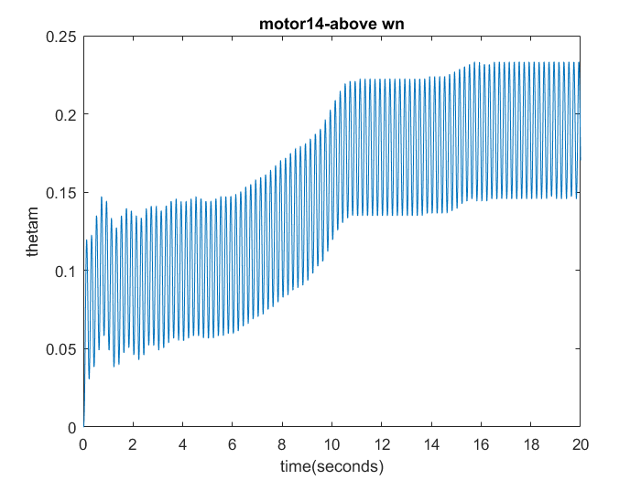
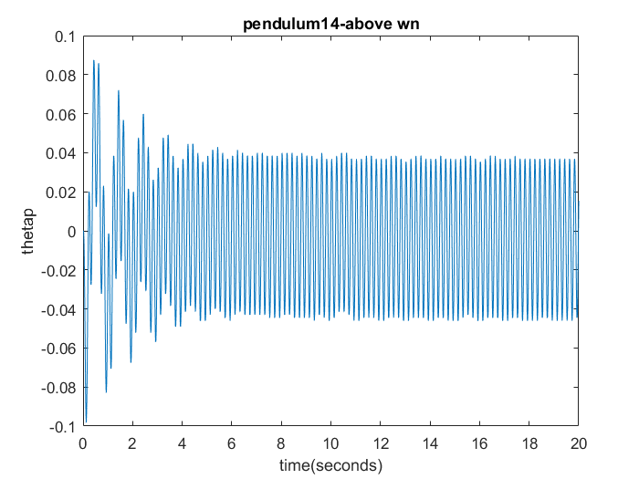
run | Am | Ap | Gn
1 | 0.8691 | -0.0228 | -0.0262
2 | 0.5895 | 0.0105 | 0.0178
3 | 0.209 | 0.0138 | 0.066
4 | 0.0791 | 0.0053 | 0.0676
5 | 0.0523 | 0.0043 | 0.082
6 | 0.0682 | 0.0041 | 0.0605
7 | 0.0145 | 0.0085 | 0.59
8 | -0.0225 | -0.0054 | 0.2385
9 | -0.0258 | -0.0031 | 0.1219
10 | 0.0391 | 0.0026 | 0.067
11 | -0.0014 | -0.0004 | 0.3027
12 | 0.0521 | -0.0044 | -0.0846
13 | 0.198 | -0.0269 | -0.1357
14 | 0.1916 | -0.0055 | -0.0286
decay | -0.1424 | -0.0006 | 0.003902

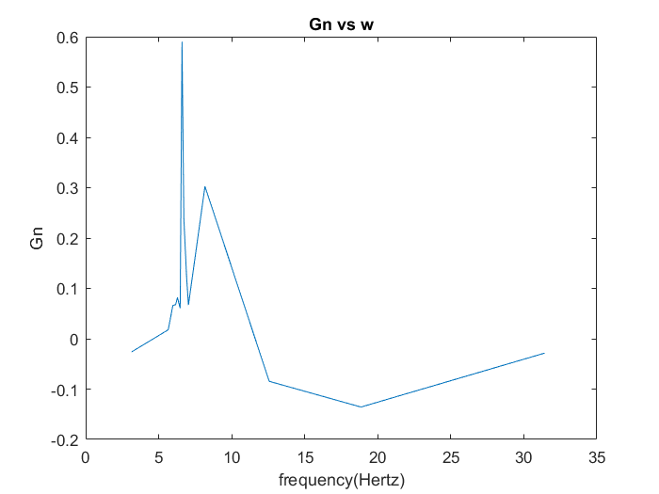
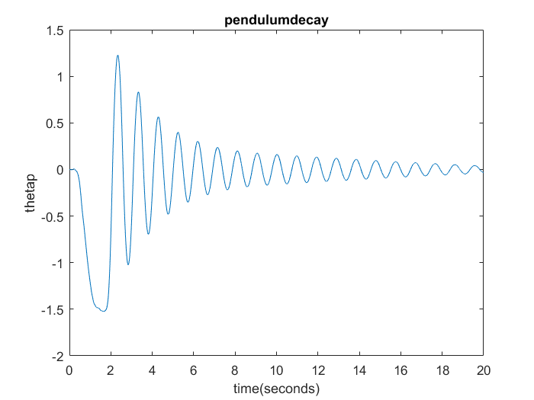
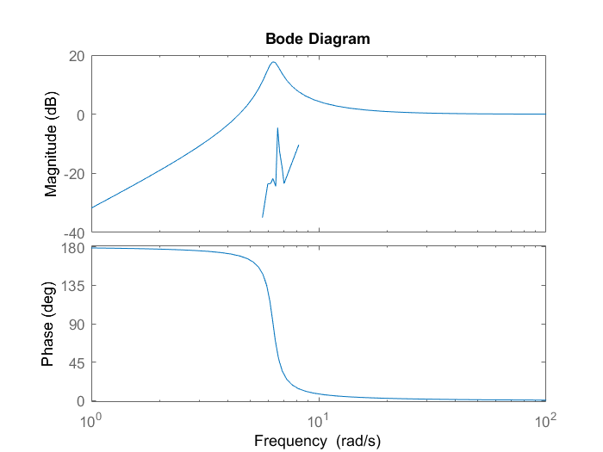
5. Discussion
1) You now know 2 methods to characterize second order systems. Method 1 involved subjecting the system to a step-response and extracting key parameters. Method 2 involves subjecting the system to many different input values and measuring the system output for each test. Compare the two methods and discuss the advantages and disadvantages.
1) Method 1 involves letting a pendulum system act in free decay and then using the time period to find out the damping frequency. Then an equation is used to find the damping ratio and natural frequency using the damping frequency and the outputs of the beginning and end of the time period that was used. Then you use the damping ratio and natural frequency to set up a transfer function and simulate a bode plot. Method 2 involves setting the motor and pendulum system to a test of different frequencies, and then taking the average of the last three periods for the motor and pendulum. It then involves dividing the pendulum average by the motor average and that that gives you an experimental characterization of the second order system with respect to frequency. The advantages of Method 1 are that it would be more accurate and take less time to do since only one experiment would have to be performed. The disadvantages of method 1 are that it only accounts for the pendulum. The advantages of method 2 include better precision since so many experiments are being performed, and that it accounts for the motor-pendulum system. The disadvantages of method 2 are that it is less accurate due to being able to compound error from so many experiments, and it takes longer to do.
2) How well does the Bode plot from the free decay match up with the experimentally determined transfer function? If there are differences, explain possible causes.
It does not match perfectly. There are differences in the positive region of decibels. The experimentally transfer function does follow the same pattern in going up or down as the frequency gets larger but the values of the Bode system are significantly higher than those of the experimentally determined transfer function. These differences can be explained by the fact that the Bode system characterizes the free decay of just the pendulum while the transfer function characterizes the motor-pendulum system. Also there is most likely to be error in the experimentally determined transfer function because it relies on a larger set of data points than the Bode plot.

Citations
[1] https://ocw.mit.edu/courses/mathematics/18-03-differential-equations-spring-2010/readings/supp_notes/MIT18_03S10_chapter_13.pdf
[2] https://ublearns.buffalo.edu/bbcswebdav/pid-4081294-dt-content-rid-15371574_1/courses/2171_17359_COMB/Lab3_additionalNotes_UPDATE_2.pdf
[3] https://ublearns.buffalo.edu/bbcswebdav/pid-4081294-dt-content-rid-15189360_1/courses/2171_17359_COMB/MAE%20334%20-%20Lab%203%20-%20Procedure.pdf

Appendix
A=[2 1.5 1 1 0.7 0.5 0.5 0.5 0.5 0.5 0.7 1.0 1.5 2];
f=[0.5 0.9 0.95 0.98 1.0 1.03 1.05 1.07 1.1 1.12 1.3 2 3 5];
load('lab3use.mat')
load('lab3data1.mat')
load('pendecay')
%figure
%plot(f,A)
t=0:.0001:.0001*200000;
figure
plot(t,lab3(:,1))
title('motor1-below wn')
ylabel('thetam')
xlabel('time(seconds)')
figure
plot(t,lab3(:,2))
title('pendulum1-below wn')
ylabel('thetap')
xlabel('time(seconds)')
figure
plot(t,lab3(:,3))
title('motor5-wn')
ylabel('thetam')
xlabel('time(seconds)')
figure
plot(t,lab3(:,4))
title('pendulum5-wn')
ylabel('thetap')
xlabel('time(seconds)')
figure
plot(t,lab3(:,5))
title('motor14-above wn')
ylabel('thetam')
xlabel('time(seconds)')
figure
plot(t,lab3(:,6))
title('pendulum14-above wn')
ylabel('thetap')
xlabel('time(seconds)')
c=.0644;
wn=1.002*2*pi ;
Gn=[-0.026200137 0.017847247 0.065994758 0.067648984 0.081953299 0.060466141 0.590032393 0.238533236 0.121947515 0.066980291 0.302714692 -0.084570983 -0.13569515 -0.028594893];
figure
plot(f*2*pi,Gn)
title('Gn vs w')
xlabel('frequency(Hertz)')
ylabel('Gn')
figure
plot(t,decay)
title('pendulumdecay')
ylabel('thetap')
xlabel('time(seconds)')
figure
plot(f*2*pi,mag2db(Gn))
title('Gn vs w')
xlabel('frequency(Hertz)')
ylabel('Gn')
hold on
H=tf([1 0 0],[1 2*c*wn wn^2]);
bode(H)
Gn';
Apm=[0.86906238 -0.022769554 0.589541368 0.01052169 0.209024195 0.013794501 0.079069454 0.005348968 0.052253356 0.004282335 0.068198415 0.004123695 0.014489454 0.008549247 -0.022453432 -0.00535589 -0.025807893 -0.003147208 0.039149299 0.002622231 -0.001383003 -0.000418655 0.052145227 -0.004409973 0.198025727 -0.026871131 0.191564389 -0.005477763 -0.142374405 -0.000555523]';

