P180 – Figure 3.2 Integer registers – p274
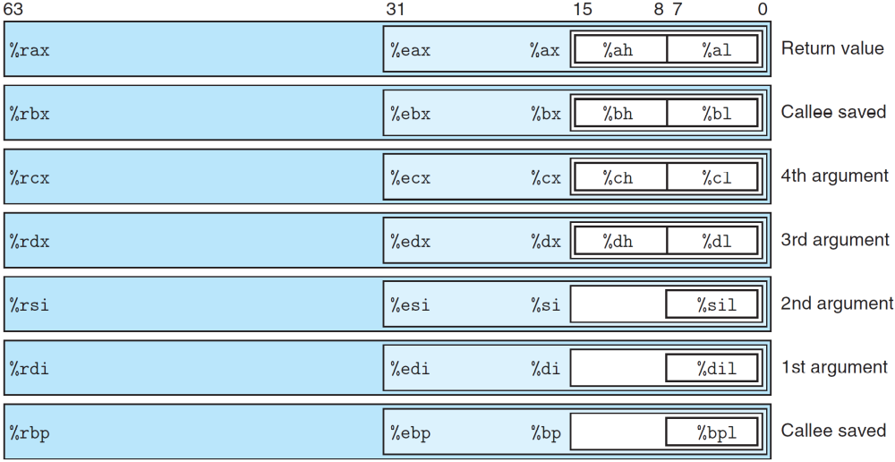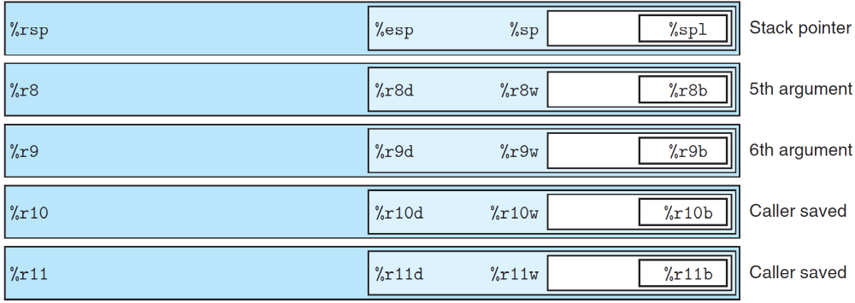
… … … …

IA32 Integer Registers -- p168
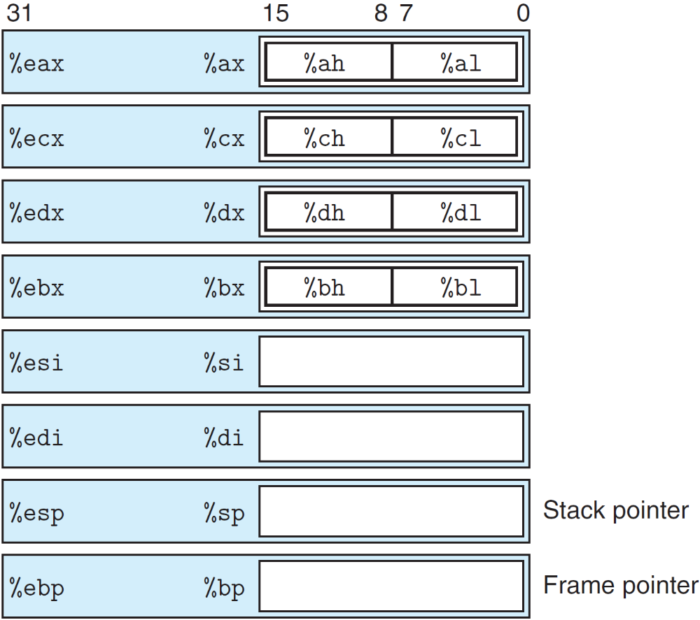

P181 – Figure 3.3 Operand forms – p169
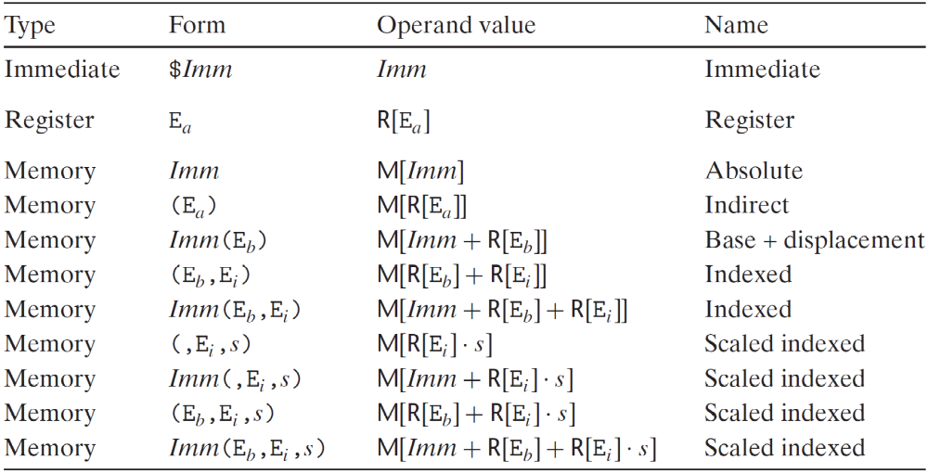

P183 – Figure 3.4 Simple data move instructions – p171
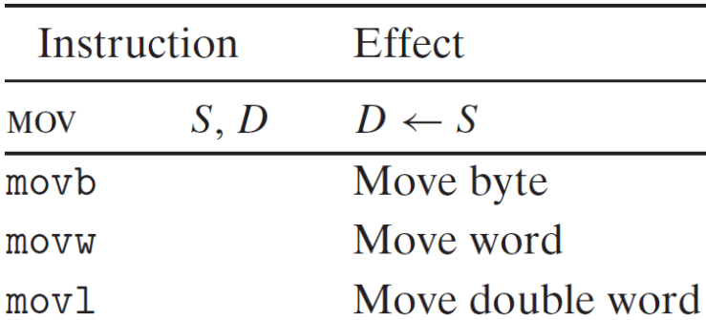

P184—Zero-extending data movement instructions – p171
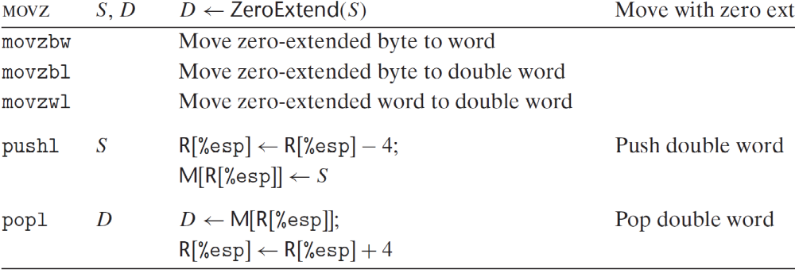

P185 – Figure 3.6 Sign-extending data movement instructions – p171
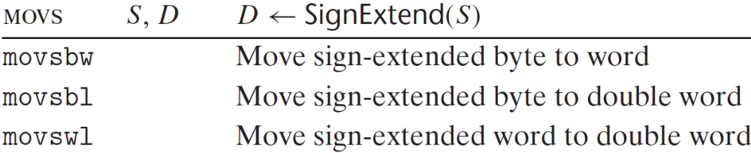

P190 – Figure 3.8 Push and pop instructions – p178
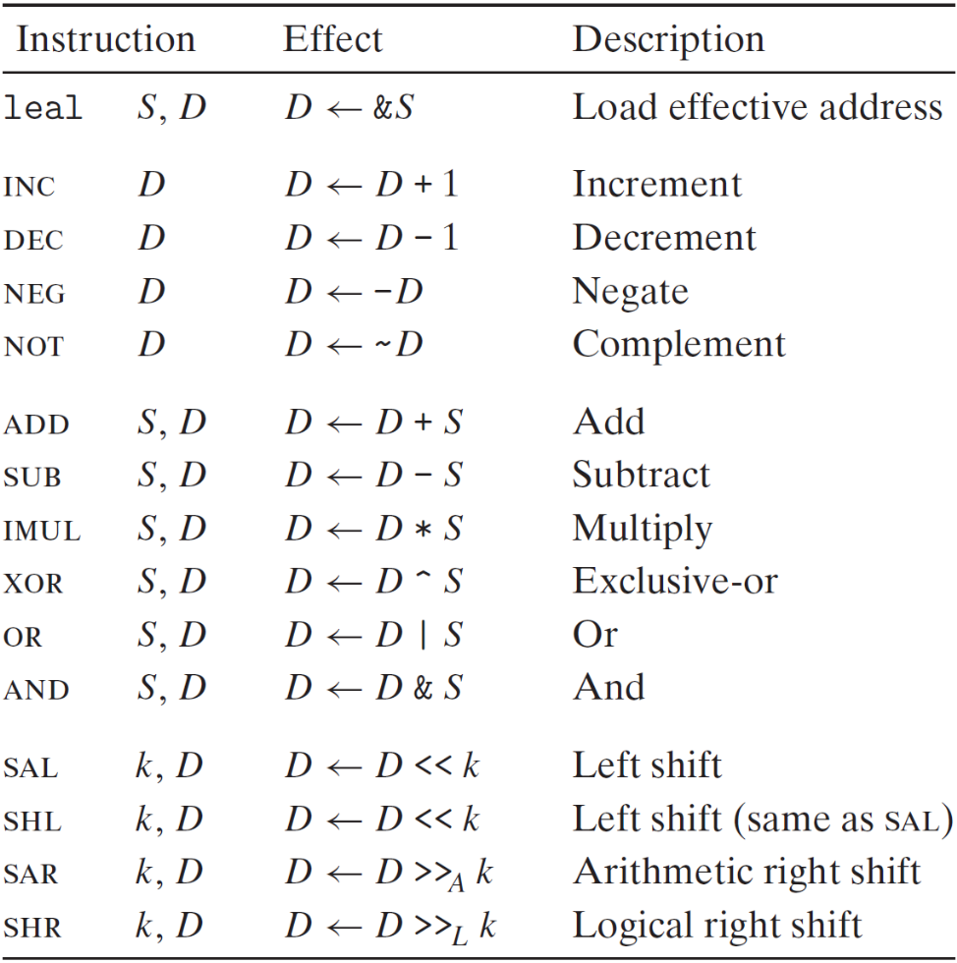

P198 – Figure 3.12 Special arithmetic operations – p182
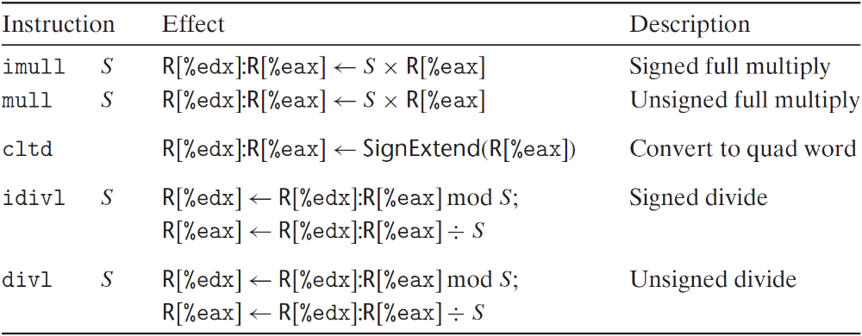

P202 – Figure 3.13 Comparison and test instructions – p186
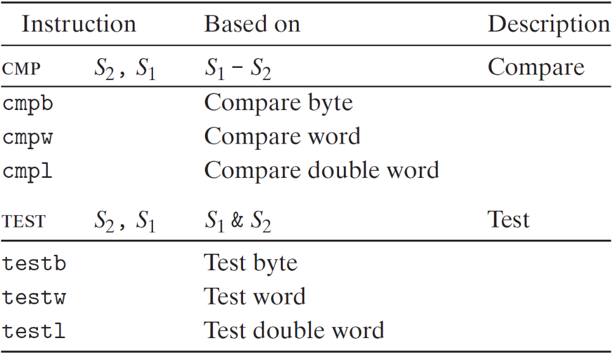

P203 – Figure 3.14 The SET instructions – p187
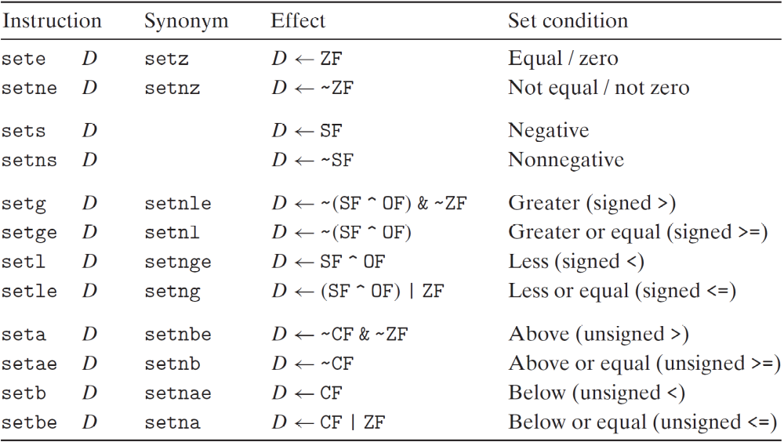

P206 – Figure 3.15 The jump instructions – p190
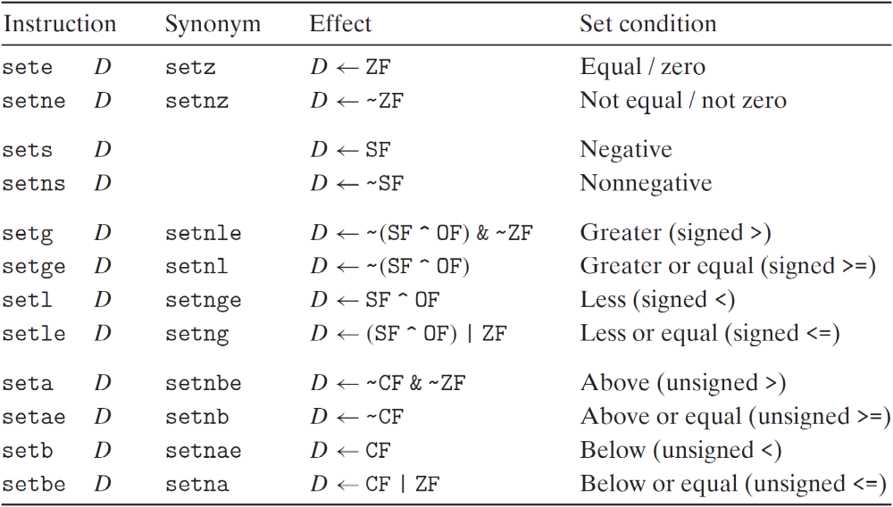

P217 – Figure 3.18 The conditional move instructions -- p210
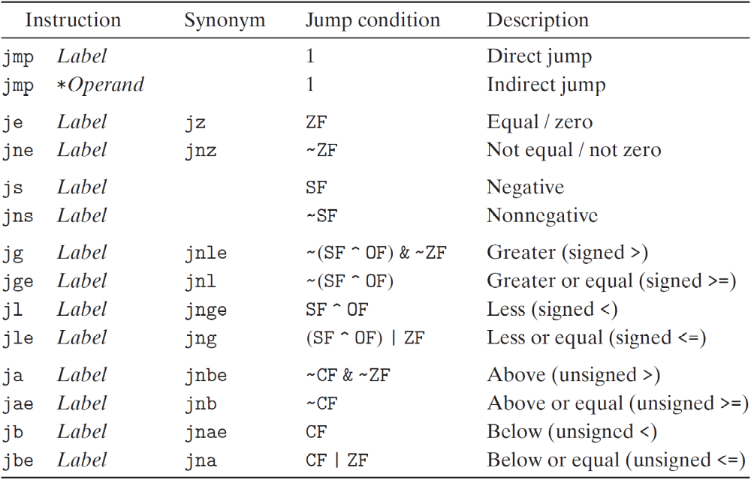

Contents
P180 – Figure 3.2 Integer registers 1
IA32 Integer Registers -- p168 2
P181 – Figure 3.3 Operand forms – p169 2
P183 – Figure 3.4 Simple data move instructions – p171 3
P184—Zero-extending data movement instructions – p171 3
P185 – Figure 3.6 Sign-extending data movement instructions – p171 3
P190 – Figure 3.8 Push and pop instructions – p178 4
P198 – Figure 3.12 Special arithmetic operations – p182 4
P202 – Figure 3.13 Comparison and test instructions – p186 5
P203 – Figure 3.14 The SET instructions – p187 5
P206 – Figure 3.15 The jump instructions – p190 6
P217 – Figure 3.18 The conditional move instructions 6

