P180 – Figure 3.2 Integer registers

P181 – Figure 3.3 Operand forms
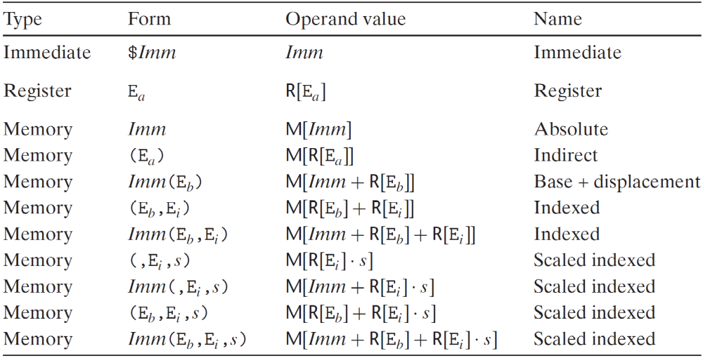

P183 – Figure 3.4 Simple data move instructions
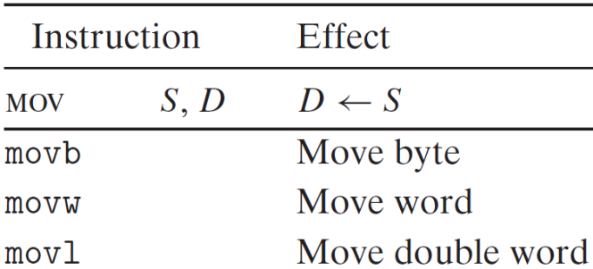

P184—Zero-extending data movement instructions
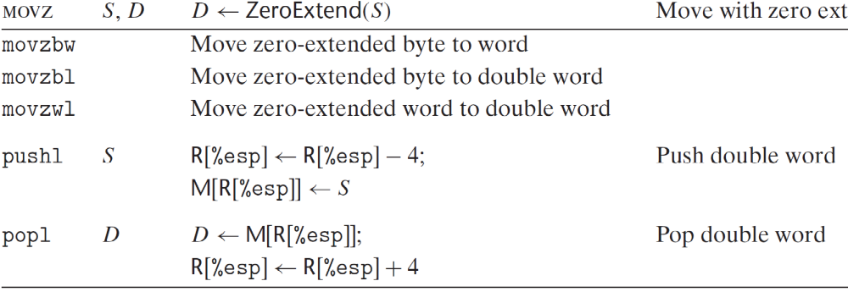

P185 – Figure 3.6 Sign-extending data movement instructions
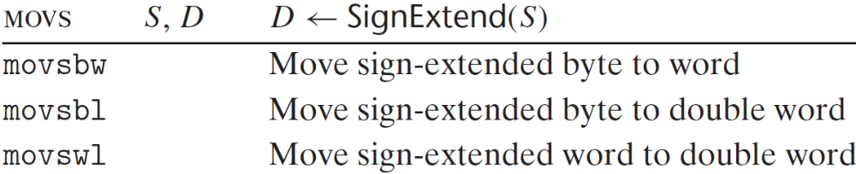

P190 – Figure 3.8 Push and pop instructions

