X1 地形

X2 經度

X3 緯度

X4 里程km

X5 路面寬度m

X6 路肩寬度

X7 小型車數

X8 大客車數

X9 大貨車數

X10 全聯結車數

X11 半聯結車數

X12 機車數

X13 總流量PCU

X14 總計車公里

X15 尖峰小時交通量PCU

X16 快車道數量

X17 機慢車道數量

L1: X6 ~ .

L2: X6 ~ X16

L3: X6 ~ X16 + X15

L4: X6 ~ X16 + X15 + X13

L5: X6 ~X16 + X15 + X13 + X17

Table LDA model

|  |  |  |  |
| --- | --- | --- | --- |
| model | LD1 | LD2 | accuracy |
| L1: X6 ~ . | 0.936 | 0.064 | 0.876 |
| L2: X6 ~ X16 | 1.578 |  | 0.738 |
| L3: X6 ~ X16 + X15 | 0.989 | 0.011 | 0.725 |
| L4: X6 ~ X16 + X15 + X13 | 0.989 | 0.011 | 0.742 |
| L5: X6 ~X16 + X15 + X13 + X17 | 0.942 | 0.058 | 0.812 |

根據表 可以觀察到雖然當所有變數都放入模型時區分的精準度高達87.6%，但是L5僅用了四個變數就可以使精準度達到81.2%。因此我們根據模型精準度和簡約度之挑選標準挑選出L1和L5並對其進行比較分析。

Table Confusion Matrix of L1 (Training and Test)

|  |  |  |  |  |  |  |  |
| --- | --- | --- | --- | --- | --- | --- | --- |
|  | Training | | | Test | | |  |
|  | 1 | 2 | 3 | 1 | 2 | 3 |
| 1 | 226 | 21 | 0 | 56 | 3 | 0 |
| 2 | 18 | 477 | 31 | 5 | 127 | 6 |
| 3 | 1 | 94 | 324 | 0 | 23 | 78 |

Table Confusion Matrix of L5(Training and Test)

|  |  |  |  |  |  |  |  |
| --- | --- | --- | --- | --- | --- | --- | --- |
|  | Training | | | Test | | |  |
|  | 1 | 2 | 3 | 1 | 2 | 3 |
| 1 | 226 | 21 | 0 | 56 | 3 | 0 |
| 2 | 18 | 477 | 31 | 5 | 127 | 6 |
| 3 | 1 | 94 | 324 | 0 | 23 | 78 |

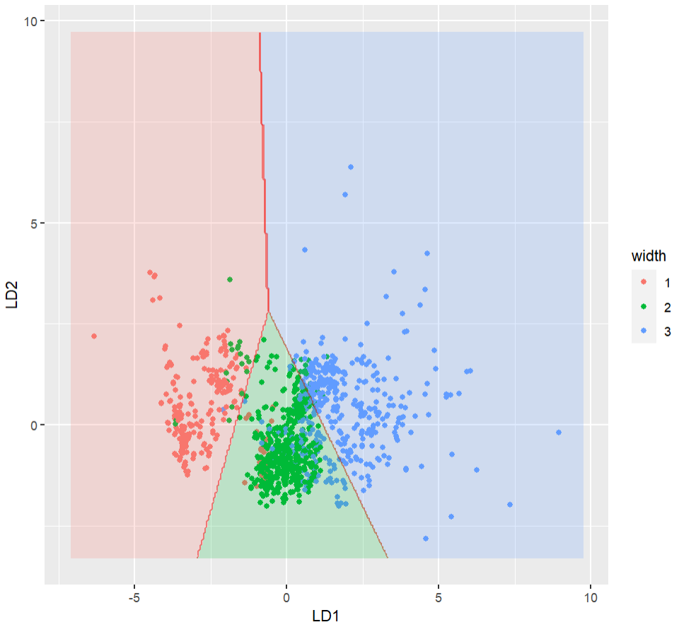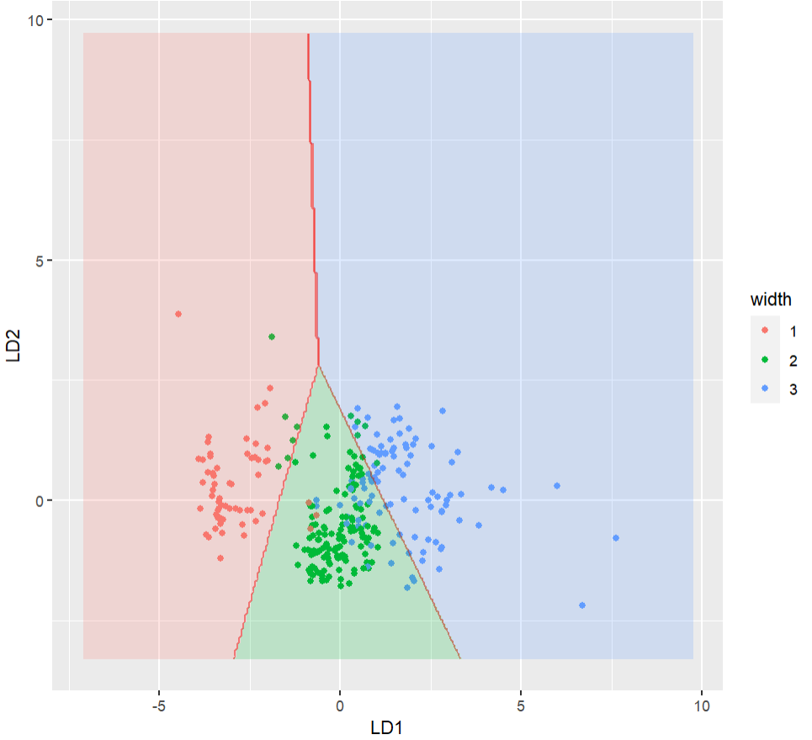

圖 L1 boundaries plot (Training and Test)

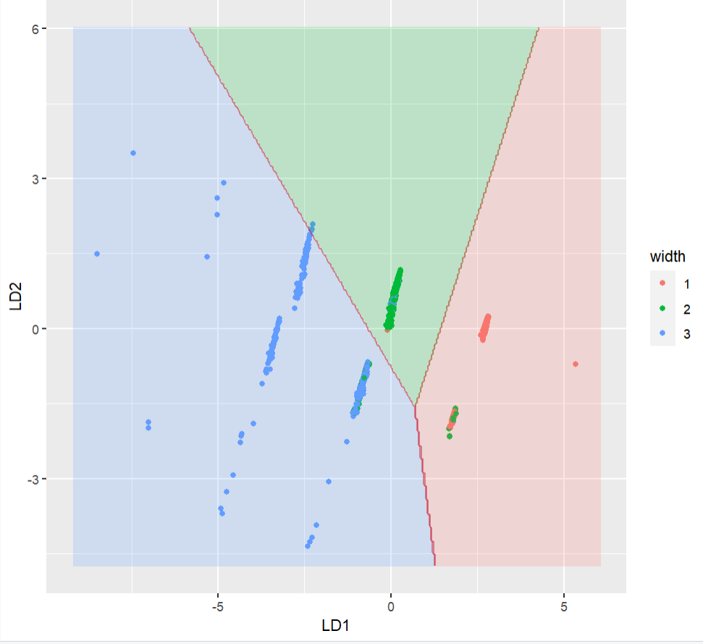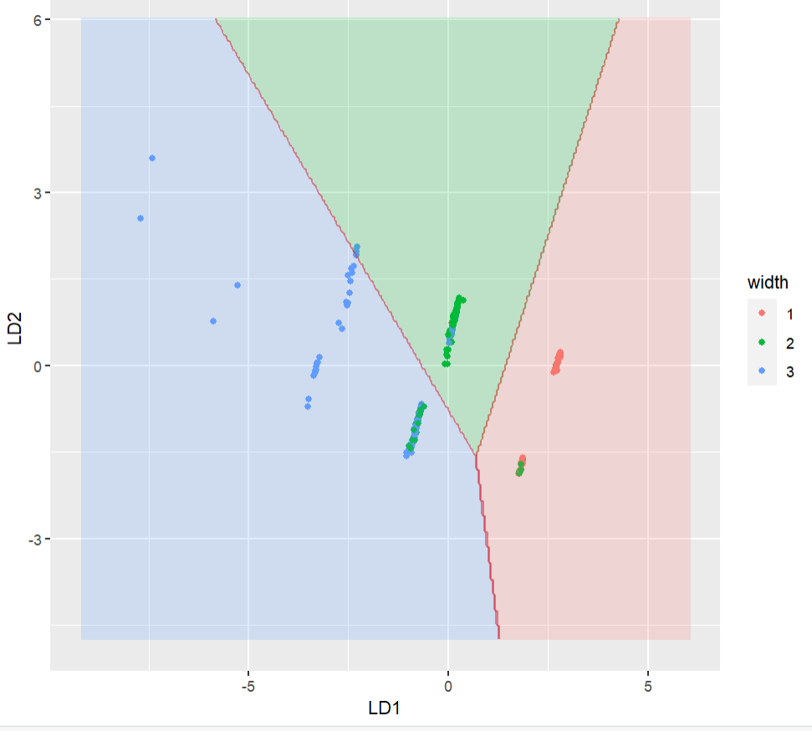

圖 L5 LDA boundaries plot (Training and Test)

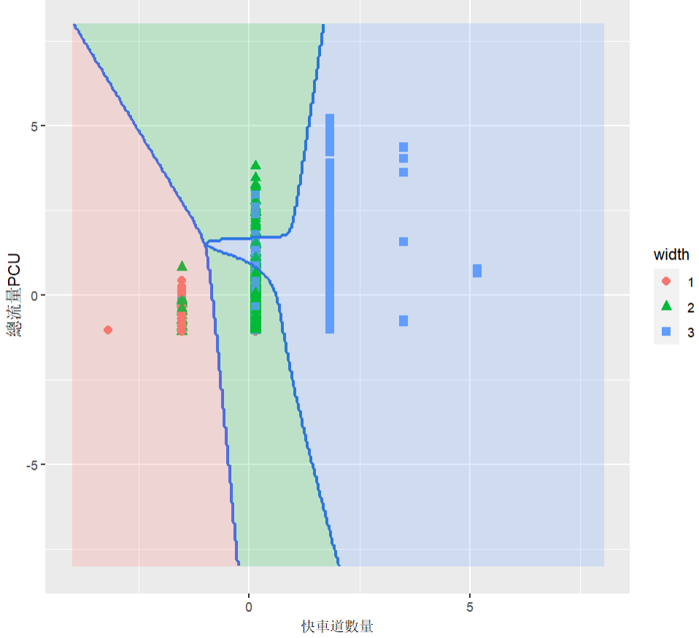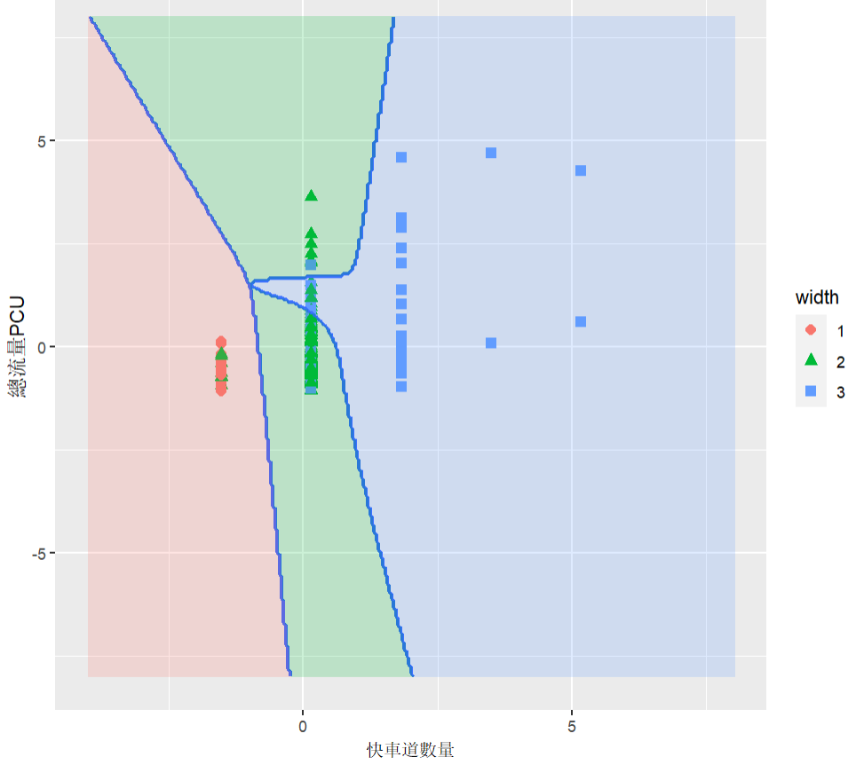

圖 M MDA boundaries plot(Training and Test)

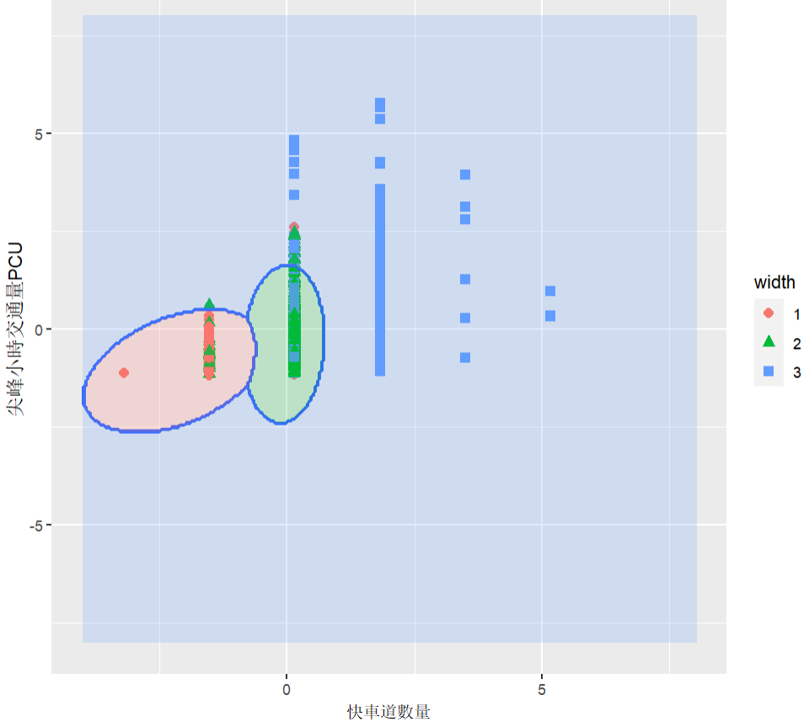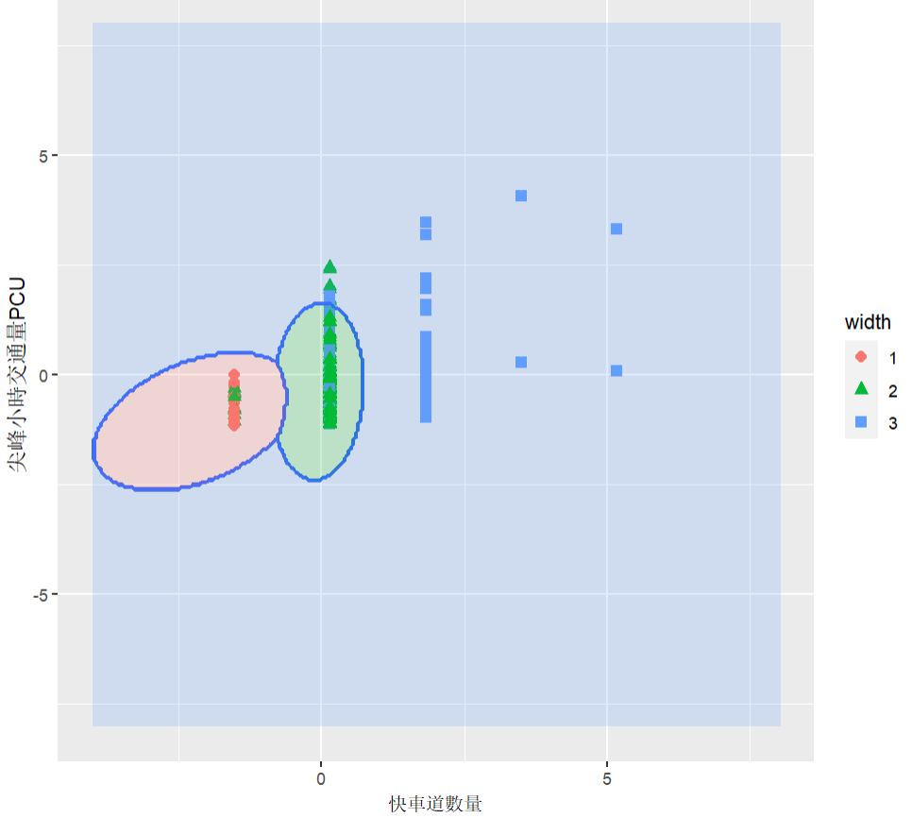

圖 Q QDA boundaries plot(Training and Testing)