DATASCI 209 Final Project, Group 4
Exploratory Visualization: Does Weather Raise Self Driving Crash Risk?
Exploring Self Driving Vehicle Safety
Team: Solomon Azariah, Sam Ho Der, Rich J Shelby, Paul Terrasi
Hypothesis owner: Solomon Azariah
Tool: Python, pandas and Altair, in Colab. Code and data: weather_eda folder in the team GitHub repo.

1. The hypothesis
Self driving vehicles crash more often in rain than their exposure to rain would predict. Put as a testable statement: the share of reported ADS crashes that happen in rain is higher than the share of time it rains in the cities where these vehicles operate.
The reasoning behind it is the common public worry: cameras and lidar degrade in rain, lane markings disappear under water, and stopping distances grow, so a general audience expects rain to be where autonomous vehicles get into trouble. If true, weather would deserve a prominent place in the final visualization. If false, the design should treat it very differently.
2. Data and inspection before visualizing
Source: NHTSA Standing General Order 2021-01 incident reports for vehicles with an Automated Driving System (ADS). Two public files were combined: the archive covering July 2021 to June 2025 under the original reporting order (137 columns) and the current file covering April 2025 to August 2026 under the amended order (116 columns). Every report an operator files is a row and the same crash appears several times as reports are updated, so the first step was to keep the latest version of each Report ID and then one row per Same Incident ID. That leaves 2,945 crashes: 1,509 from the archive and 1,436 from the current file.
Weather is recorded as a set of tick boxes (Clear, Cloudy, Rain, Snow, Fog, Severe Wind, and a few others) that differ slightly between the two schemas, so they were collapsed into one weather field by taking the worst condition ticked. Road surface is a category in the archive (Dry, Wet, Snow) and a single Wet tick box in the current file. Injury severity uses different labels in the two files and was mapped to No injury, Minor, Moderate, Serious, Fatality, Unknown. Latitude and longitude are redacted, so location is city level only.
What the raw table says before any chart: 77 percent of crashes were reported in clear weather, 18 percent cloudy, 3.9 percent (114 crashes) in rain, and under half a percent in snow, fog, or wind combined. So rain is the only adverse condition with enough cases to test, and the hypothesis is really about rain. Waymo files 78 percent of all reports; San Francisco accounts for 38 percent of crashes, followed by Los Angeles, Phoenix (with its suburbs), and Austin.
The hypothesis cannot be tested from crash counts alone, because 4 percent of crashes in rain means something different in Austin, where it rains often, than in Phoenix, where it rarely does. The derived variable that makes the test possible is an exposure baseline: hourly precipitation from the Open-Meteo historical archive for the six largest metros, aggregated to the share of hours with rain in each month, over the months each city had crash reports.
3. Exploration, step by step
Step 1. First look: counts by reported weather
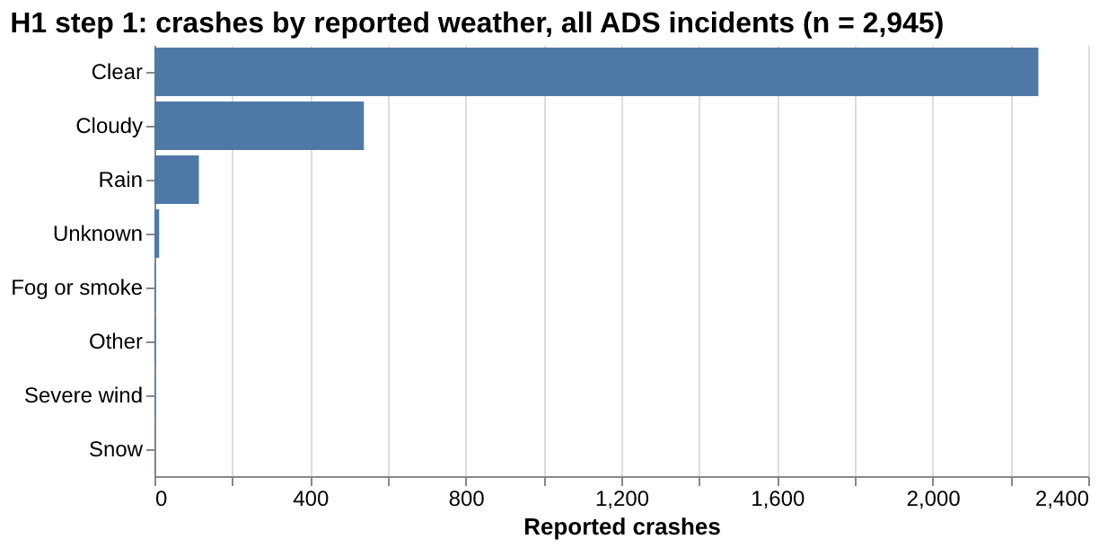
A plain bar chart of all eight weather codes. It shows that rain is the only adverse condition with enough crashes to study (114) and that snow, fog, and wind are single digits. It says nothing about risk, because there is no denominator. Starting point.
Step 2. Collapse the categories and split by metro
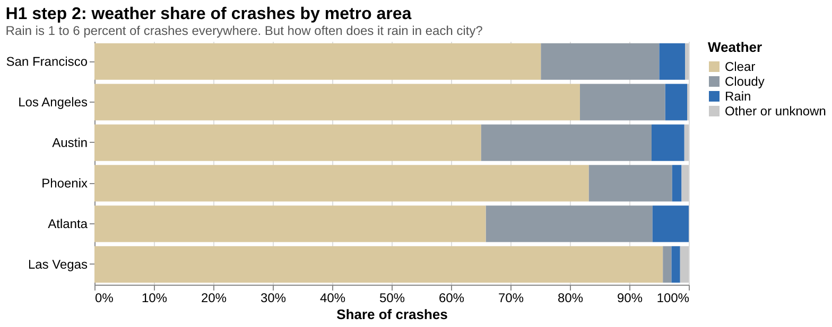
Weather collapsed to four groups and shown as a share of each metro area's crashes. Rain is 1 to 6 percent of crashes everywhere, with Austin and Atlanta highest and Phoenix and Las Vegas lowest. That is the order of how rainy the cities are, which is what prompted building the exposure variable. What did not work: a first version kept all eight codes as a stacked count, and the city differences were invisible.
Step 3. Put exposure next to outcome
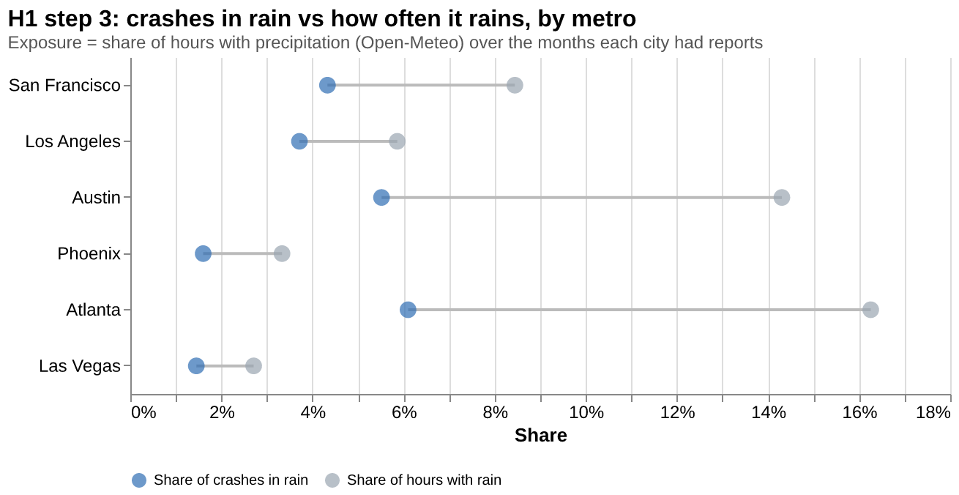
A dumbbell per metro: share of crashes in rain (blue) against share of hours with rain (gray). In all six metros the blue dot sits to the left of the gray one. This is where the hypothesis flipped: ADS crashes are under represented in rain, not over represented.
Step 4. One number per city, with uncertainty
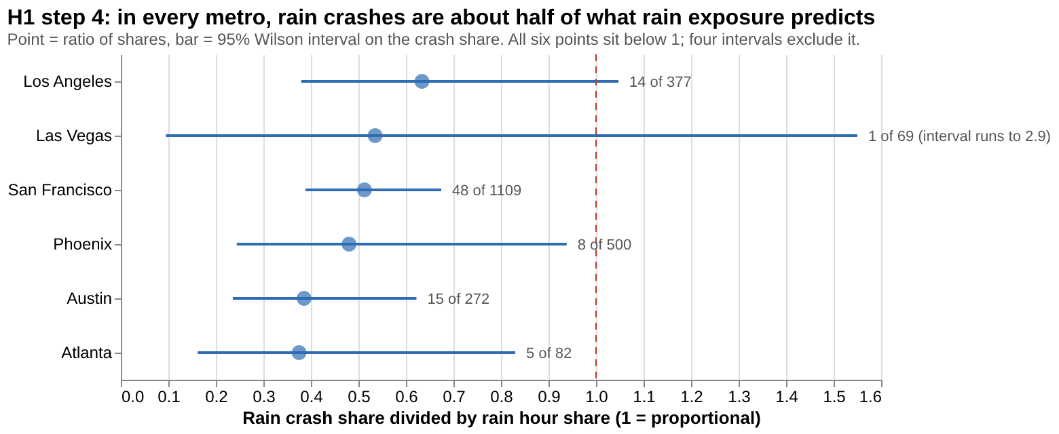
The ratio of the two shares with a 95 percent Wilson interval, sorted. A ratio of 1 means crashes happen in rain exactly as often as it rains. Every point is between 0.38 and 0.63, and in the four metros with the most data (San Francisco, Austin, Phoenix, Atlanta) the interval excludes 1. Las Vegas rests on a single rain crash and its interval is uninformative. Adding the intervals was the refinement that separated real evidence from noise.
Step 5. Does it hold over time, or is it an averaging artifact?
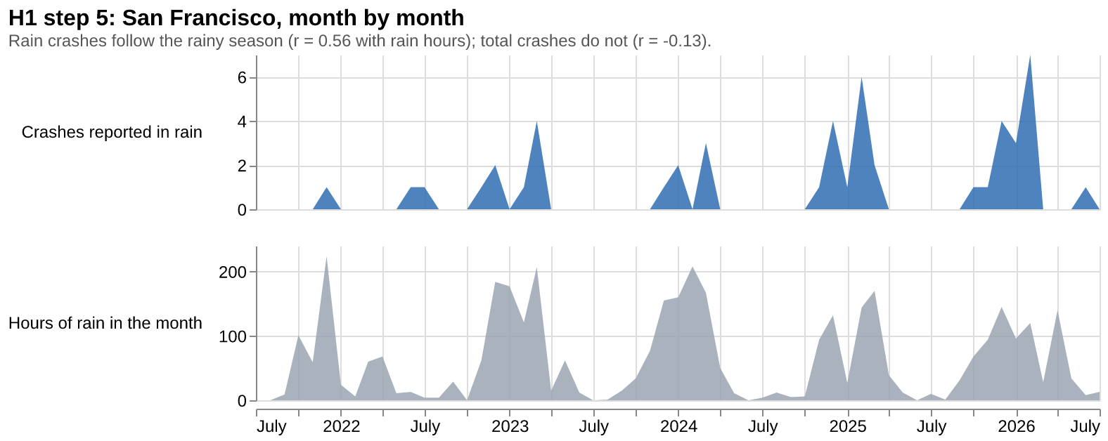
San Francisco month by month. Rain crashes rise and fall with the rainy season (correlation 0.56 with hours of rain) while total crashes do not track rain at all (correlation negative 0.13); total crashes track fleet size. The under representation is not a quirk of averaging five years together.
Step 6. Is the risk hiding in severity instead of frequency?
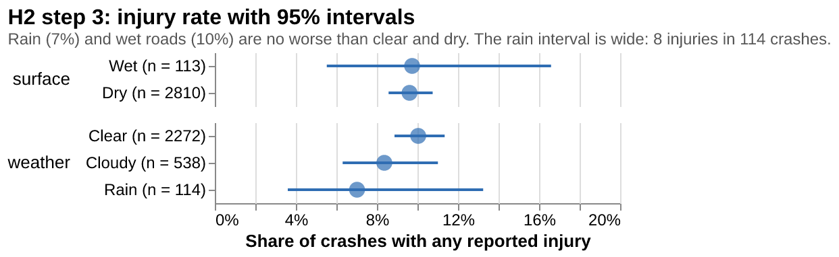
If rain crashes are rarer but worse, the hypothesis could survive in a different form. Injury rate with 95 percent intervals: clear 10.0 percent, cloudy 8.4, rain 7.0; dry roads 9.6, wet 9.7. The rain interval is wide (8 injuries in 114 crashes) but there is no sign of the increase the hypothesis would need. An earlier stacked bar of severity counts could not show this because rain was a sliver next to clear; normalizing and then moving to rates with intervals fixed it.
Step 7. Is it hiding in one operator or one season?
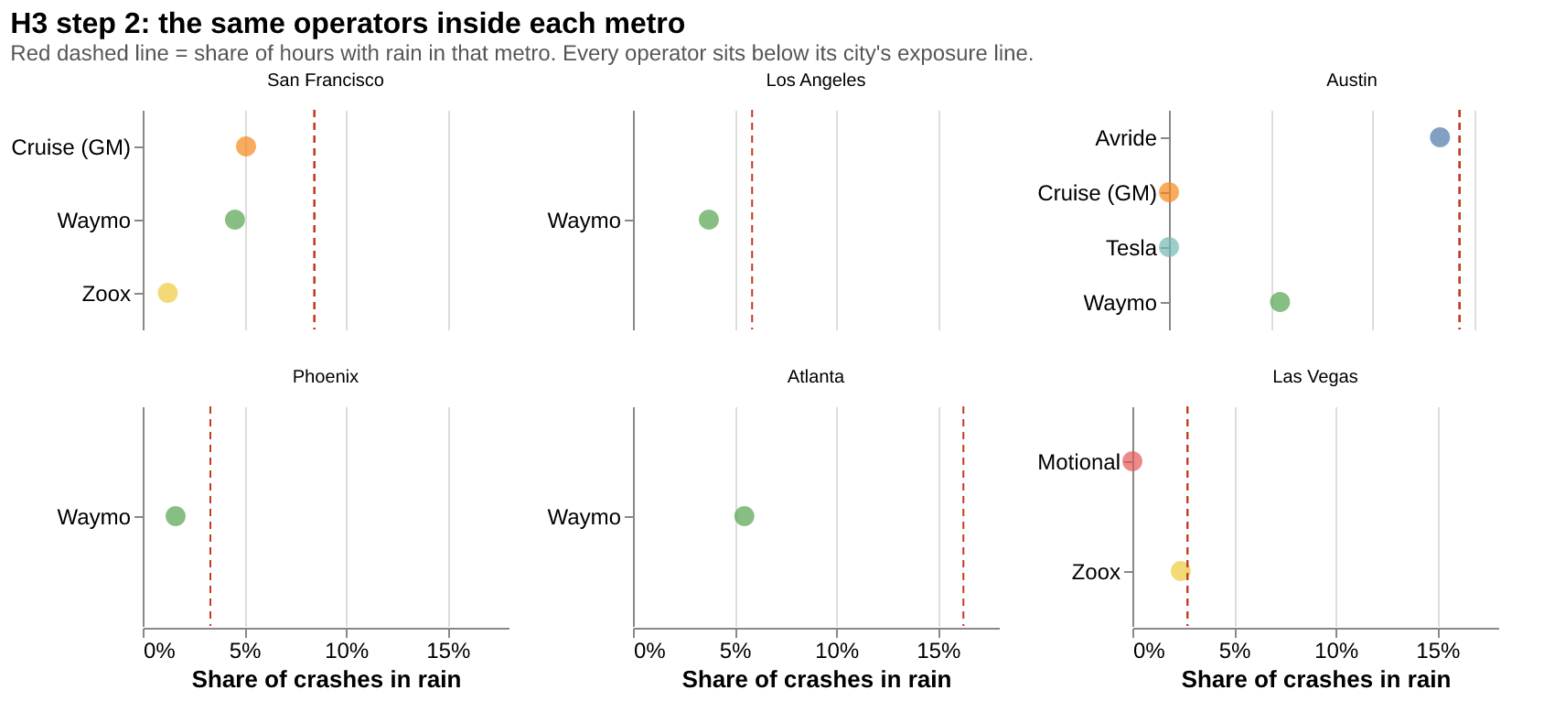
Rain share of crashes by operator, faceted by metro, with each city's rain exposure as a red dashed line. Taken across all cities Avride (11 percent) and Aurora (8 percent) look rain prone, but they operate in Texas where it rains three to four times as often as in Phoenix. Inside any one metro the operators cluster together and all of them sit below the exposure line. A seasonal heatmap (in the notebook) shows the same thing by calendar month: rain crashes follow each city's rainy season and nothing else.
4. Conclusion
The hypothesis is rejected, and the opposite appears to be true. In every metro with enough data, the share of ADS crashes that happen in rain is about half the share of time it rains, the pattern holds month by month, rain crashes are not more severe, and no operator or season breaks it.
The most likely explanation is exposure rather than skill. Robotaxi fleets drive fewer miles in rain, either because operators pull vehicles when conditions leave the operational design domain or because hours and demand differ in bad weather. The Standing General Order does not report miles driven by weather, so this data cannot separate "safer in rain" from "mostly absent in rain." The one hint of a genuine vehicle effect is in crash type: in rain the ADS more often hits fixed objects such as curbs, poles, and barriers (6 percent of rain crashes against 4 percent in clear weather), which is small but worth watching as the data grows.
What this means for the final visualization: weather belongs in the design as a filter and as seasonal context, not as a headline risk number. A prominent "crashes in rain" figure would tell a general audience the opposite of what the reported data supports. Every rate the site shows needs a denominator and an interval; the exposure table and the Wilson intervals built here are reusable for the operator and time of day sections, where the same trap exists. The single most valuable addition would be miles driven by city and month (Waymo publishes rider only miles by city), which would turn the exposure ratio into a true crash rate.
5. A note for the team: pre crash speed
A quick look at the pre crash speed field, suggested as a possible avenue, turned up a result that deserves its own hypothesis. Speed is recorded for 99.7 percent of crashes, and in 54 percent of them the ADS vehicle was at 0 mph: stopped at a light, yielding, or parked, and struck by someone else. Among moving vehicles the injury rate barely changes with ADS speed (8.5 percent at 0 mph, about 11 percent from 1 to 15 mph, 12.7 percent at 16 to 25 mph, and no higher above that). Two hypotheses fall out of this: that most ADS crashes are not caused by the ADS vehicle's motion at all, and that severity is driven by the other party's speed, which the reports do not record. Either would make a strong section for whoever takes speed, and the cleaned table in the repo already has the fields.
Appendix: refinement log and data notes
- Charts tried, in order: raw counts of eight codes (not readable) to four group shares by city (ordering suggested exposure) to dumbbell with exposure (hypothesis flipped) to ratio with intervals (quantified, Las Vegas discounted) to monthly series (holds over time) to severity rates with intervals (not hiding in severity) to operator by city facet (not hiding in one operator).
- Dead ends: stacked severity counts (rain too small to read); a box plot of pre crash speed by weather (median 0 mph in every group, no separation); monthly small multiples for the four newer metros (too few months with five or more crashes to judge).
- Data notes: two schemas merged; multi tick weather resolved to the worst condition; "Thundering" recoded as Rain; Tempe, Scottsdale, Chandler, Mesa, Gilbert folded into Phoenix; Dallas (75 crashes) excluded from exposure charts because no baseline was pulled for it; lighting exists only in the 2021 to mid 2025 reports; latitude and longitude are redacted.
- Reproduction: Group4_Weather_EDA.ipynb in the repo runs the cleaning and every chart, including the ones not shown here; ads_clean.csv is the one row per incident table other sections can use.

