How long did you spend on your solution?

Between 2 and 3 days.

How do you build and run your solution?

You should be able to built the entire solution. In case you don’t want to execute the service project from IIS, you can set the service project as a default project.

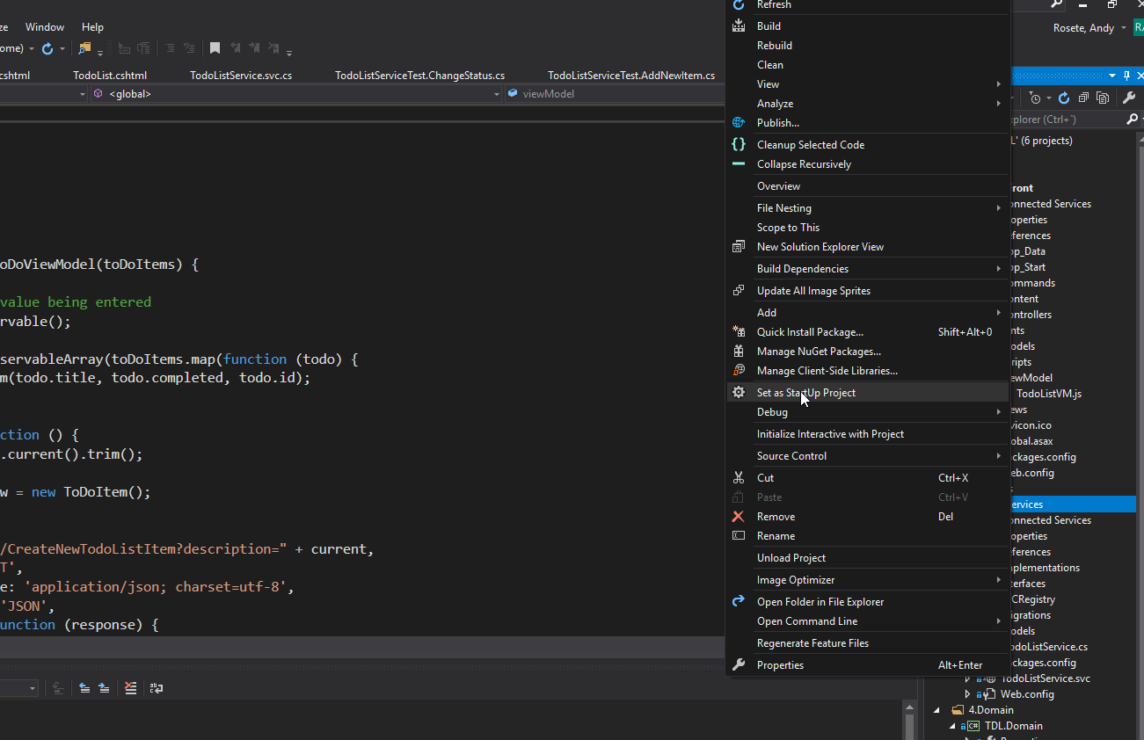

Then you can execute the service side, if you click on TodoListService.svc and press F5 you should be able to see this:

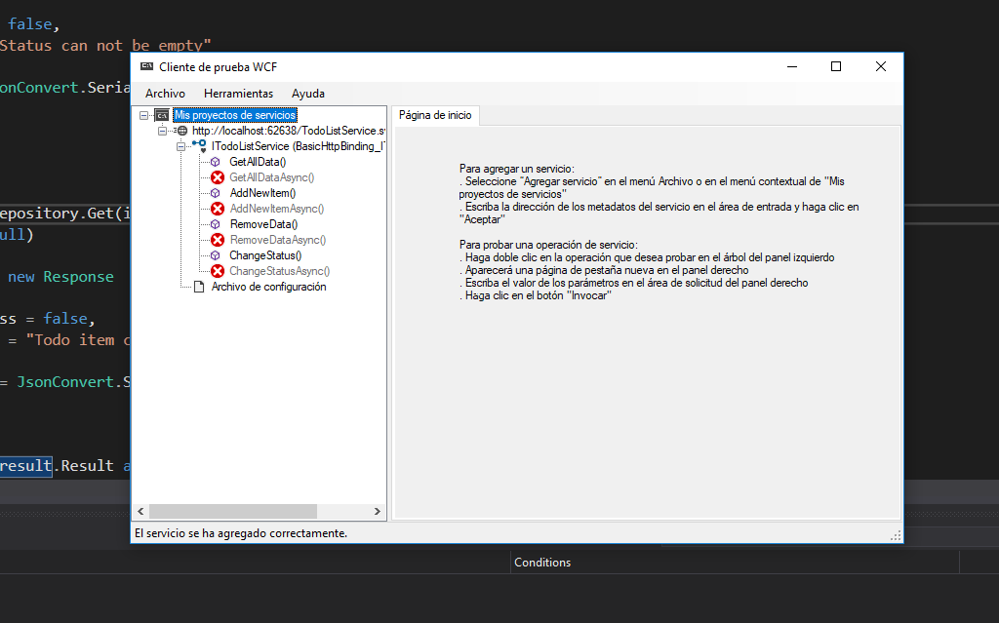

From this window you can also test the different methods implemented.

Once you have the service side running you can debug the front side and then you should be able to check the entire solution.

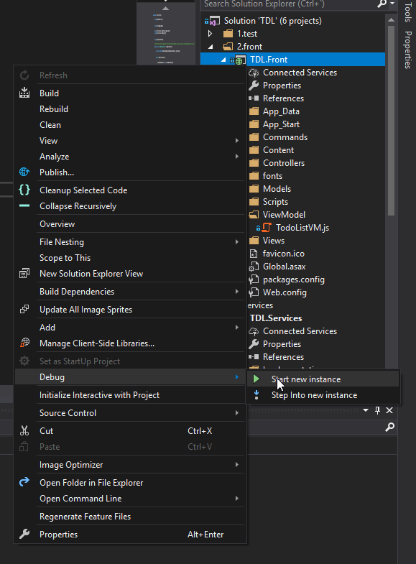

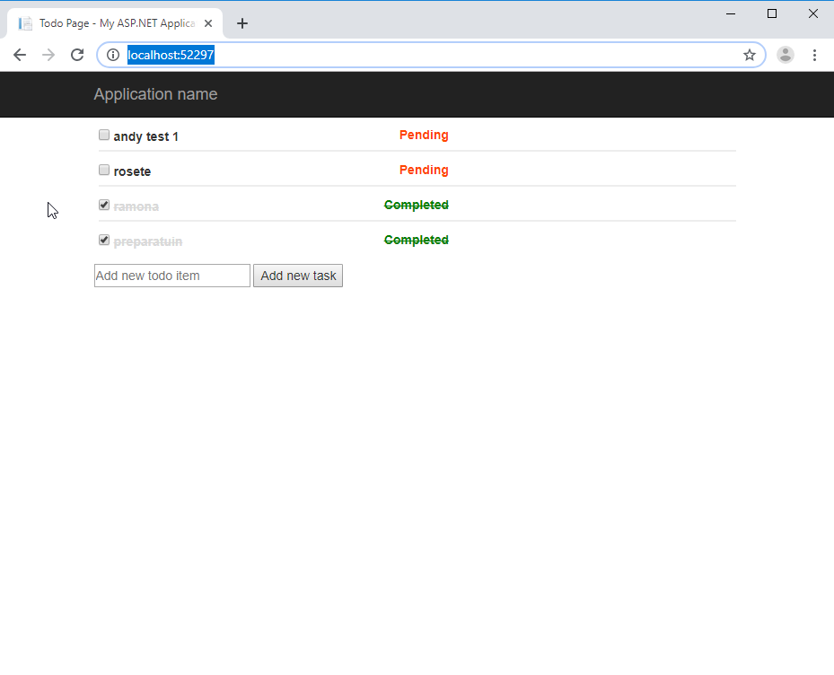

In case it didn’t work, check if the database was created

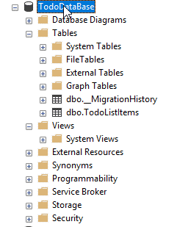

If it was not created, maybe you will need to execute and update database command to run the migration. In the package manager console set the service project as the default project and execute the following instruction.

Enable-Migrations

Update-Database -Force -Verbose

What assumptions did you make when implementing your solution?

The solution has multiple projects:

* Test (To implement unit test, it was developed only a few of them in order to show how it should be implemented)
* Front (Front side project, it has the html code, css styles and viewmodel files (javascript files) to bind the view with the controller, and add some logic to prepare the request etc )
* Services (Back end project that receive request of the front side project, validate the request and save the info in database and has the migrations (Database first project))
* Domain (Database configuration, domain model)
* Common (Has a common class that will be needed in multiple solutions)

• Why did you pick the design that you did?

For the front side, I have chosen mvc pattern with knockout because it was easy to handle the front side solution with that. In the backend it was selected a layer project to separate the responsibilities of the different projects in order make the different projects independent.

• If you were unable to complete any user stories, outline why and how would you have liked

to implement them.

I would like to implement all the unit test possible.