- Compiling project (Windows based system)
For building project you need completely installed next components:
- Microsoft Visual Studio 2012
- Marmalade SDK v7.4.1 or later with actual Community or Indie license. http://madewithmarmalade.com/
Unpack archive with project in to any folder what you like (e.g. LiftRich).
Click once on liftrich.mkb.
After some times, Visual Studio will completely adjust envelopment for project.
Switch to x86 Debug build in MSVC IDE.
Press CTRL+F5.
Enjoy with working game.

- Deploy game to device (iPhone, iPad)
Build game with x86 Debug.
Switch to GCC ARM Release in MSVC IDE.
Rebuild solution in MSVC IDE.
Run Marmalade Deploy Tool and set ARM GCC Release, iOS (iPhone, iPad, iPod), press Deploy All.
After deploying process is finished, you can find liftrich.Ipa file in the X:\YourFolder\build_liftrich_vc11 \deployments\default\iphone\release\
Just add this IPA to iTunes and install to your iPhone / iPad device.
Enjoy!

- Add new 3d model in to game
All sources of 3d models, textures you can find in 3d\3d_models folder.
To add new models in game, first you need add model id:
Open main.cpp, go to int main() function:

g_LevelManager->AddModel(my_new_model, model_id);
where is:
my_new_model – pointer to model data.
model_id – id number of 3d model (currently game has 18 models id)

For add new material:
g_LevelManager->AddMaterial((CIwMaterial*)my_new_model->m_Materials[0], materil_id);
where is:
my_new_model – pointer to 3d model data with material
material_id – id number of material (currently game has 6 materials)
Important: If your model used existing in game material, you don't need add new material in game.
Important: Only one material per model is supported! Multimaterials are not allowed!
Go to loadObjects() function and add string:
my_new_model = (CIwModel*)g_pGroup->GetResNamed("my_new_model_name", IW_GRAPHICS_RESTYPE_MODEL);
add global variable string in main.cpp:
CIwModel *my_new_model;
where is:
my_new_model – pointer to 3d model data
my_new_model_name – model name without GEO extension.

Open models.group file. Add your model name in list, see example bellow:
"./models/my_new_model_name.geo"

- Setup and Converting 3d models

To convert 3d models in GEO format you need Autodesk 3ds Max 2012 or Maya with installed Marmalade export plugin.
In 3ds max, go to Utilites -> More -> Select Marmalade Studio Exporter.
Setup export options (see image below).
Press Export button.
Important: You need correct setup a Project Data Directory!
Important: Use Reset X Form modifier before you export model in game!
Important: You need to add Model_id and Material_id in model Object Properties->User Defined (see image below)! This data needs for level exporter. This parameters also passed to render system.
If you want to add new model to game, just increase your last model id number (currently is 18). If model used existing in game material, just specify id number of existing material. If you add new material for this model, you must specify new material id number.
Important: Not allowed any symbols or spaces after Model_id=xxx string and Material_id=xxx string.
Example:
Model_id=9<CLRF>
Material_id=1
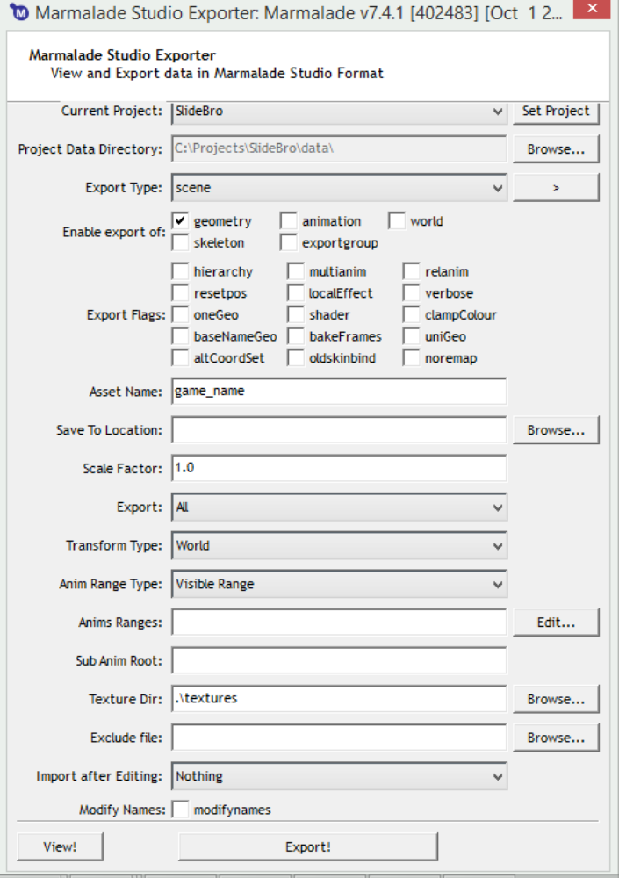

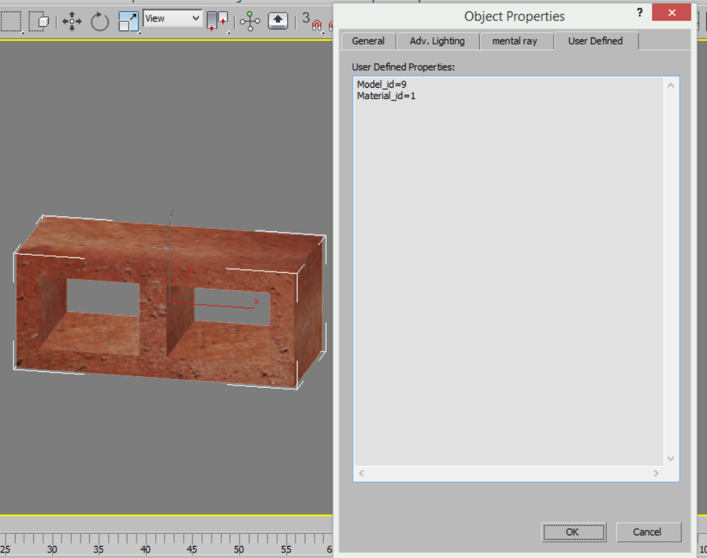

- Level export and level making.
To convert level in game format you need installed Autodesk 3ds Max 2012.
Open level.
Important: Select all scene object (CTLR+A)!
Goto Utilites -> Run Script -> Select “level_export.ms”
Go to:
X:\Users\*user-name*\Documents\3dsMax\export\
testlevel.txt – exported level data.
Important: all models in level must have Model_id and Material_id!

If you want to made new level:
Reset scene.
Merge any models to scene. Clone models if you need.
- Private keys, api keys, bundle id
AdMob interstitial
Modify string in main.cpp:
AdmobInterstitalBanner[]=”…

FaceBook API key, secret key, url:
Modify strings in Social.cpp:
FACEBOOK_APP_ID_IOS =”…
FACEBOOK_APP_SECRET_IOS =”..
Modify string in liftrich.mkb:
iphone-bundle-url-schemes="fb…
Search and modify strings in main.cpp:
g_pSocial->SetURL("http://www.liftrich.com") with your game landing page url.
Replace symbols #LiftRich with your game name tag, e.g.: #MySuperbNewGame

IAP:
Modify strings in main.cpp
g_IAP_ID_Jack = "…
g_IAP_ID_RocketPower = "…
g_IAP_ID_DoubleCoins = "…
g_IAP_ID_Save = "…

Game Center:
Modify string in score.cpp:
GAMECENTER_LEADERBOARD_CATEGORY = "…

Bundle Id and mobileprovision profile:
Setup in Maramalde deploy tool and saved in mkb file. See Marmalade SDK documentation.

- Contacts
If you have any question, please contact me:
Email: jocker3d@gmail.com
Skype: andrey.rilisoft

