**What Is One-Component Plasma?**

The One-Component Plasma model, or more simply “OCP”, is a reference model in the study of strongly coupled Coulomb systems (that is, system electromagnetic field interactions) that plays a conceptual role similar to that filled by the hard-sphere model in the theory of neutral fluids. The OCP model consists of a system of identical electrically charged point particles interacting exclusively through the Coulomb potential (electromagnetic force) and immersed in a rigid, uniform background of opposite charge to ensure overall charge neutrality. The particle dynamics are governed by the laws of classical non-relativistic mechanics (the quantum counterpart of the which is called the “jellium model” and is used as a first approximation to the conduction electron fluid in metals and dense plasmas ignoring the details of the underlying discrete ionic subsystem.)

**Methods**

In this study, numerical methods were used with a high-performance computer to plot, calculate, and return all of the data. The test was run with over 500,000 iterations per trial to achieve over 10σ statistical accuracy.

**Why Should I Care About This Research?**

Not only are the results found in this research applicable to the study of strongly coupled gasses and plasmas, but, due to the nature of the OCP system, the description of an electron’s motion in the system is also applicable to many similar systems, such as MRI machines, high voltage, low resistance wires, superconductors, and ultra-cold superfluids. In addition to this, the results of scaling the Hamiltonian and angular momentum of the system has applications in the study of ultra-cold, highly magnetic rotating bodies, such as those found in high efficiency electric motors. In each of these cases, this research allows for a higher degree of control in managing the flow of electrons in the system.

**Introduction**

In studying strongly coupled Coulomb systems, the Yukawa One-Component Plasma (OCP) model provides a simple model for describing certain properties useful in ultra-cold ionic systems- such as those seen in the cores of dwarf stars and Jovian planets, ions in ultra-cold neutral plasmas, and highly-charged dusty plasmas. In the OCP model, a system of similarly charged point particles interact classically and exclusively through the Coulomb potential, making it especially useful for studying low-energy systems. Additionally, the OCP model varies by a single parameter, Γ = EC /kTe (1) referred to as the Coulomb coupling parameter, where EC is the Coulomb energy, k is Boltzmann’s constant, and Te is the electron temperature. Eq. (1) can also be written as

Γ = q2/4πerkTe (2) where r is the Wigner-Seitz radius[2]. This parameter dictates how strongly coupled the plasma is, and is essential in understanding its dynamics. Now consider the motion of n charged particles in an ultra-cold, strongly coupled plasma described by the position vector r under the scaling transformation, with arbitrary scaling parameter a: r → r = a2 r (3) and t → t = a3 t (4) The equation of motion is invariant, meaning that if r(t) is known to be a solution, then the scaled transformation of that is also a solution. So, if our new position vector r is defined to be the Wigner-Seitz radius, then scaling it under eq. (3) should also change other properties of the OCP system. In this paper, we will explore how this universal scaling affects the motion, velocity, angular momentum, and energy of the system and, in the process, develop a deeper understanding of scaling in chaotic systems and applications of nonlinear dynamics in plasma physics.

**Conclusion**

In this project, we have reviewed some properties of the Yukawa One-Component Plasma model and how it behaves under a universal scaling transformation using nonlinear dynamics and methods from computational analysis. We have shown that the wave vector is scaled by the square of the inverse of our transformation scalar, a, and demonstrated that this leads to a very sensitive change in the chaotic motion of an electron in the system. We have shown that, due to the rapid doubling of the Zaslavskii Map and its tendency to ”reset” its doubling, that the motion of an electron in the system is very sensitive to scaling with even a small k. And we derived the transformations of the velocity, angular momentum, and energy of the whole system. The findings of this study are consistent with those of Rice University (2015), where they experimentally tested the effects of scaling in the Quench Dynamics of a similar OCP. Taken together, these findings suggest that the chaotic motion found in the extreme examples of OCP’s, such as those with very weak or very strong coupling, can be understood through simple, nonlinear systems like the Zaslavskii Map. Further research must be done on understanding the ”resetting” of the Zaslavskii Map as the tendency of the interval between the ”resets” towards 1.1 is currently unexplained. Regarding the universal scaling transformation, broadening the extent of study in applying transformations to unpredictable models may lead to a deeper understanding 5 of the fundamental processes at work in them and broader connections to other, perhaps more studied, nonlinear systems. In a lab environment, the results of this research could be used to artificially control the flow of ultra-cold plasma by varying the volume of the plasma’s container, the temperature of the plasma (very slightly so it still mainly interacts through the Coulomb-Kepler interaction), or the pressure of the plasma. By doing this, researchers could funnel the plasma into 1, 2, or however many points they want or create chaotic motion! Further research is needed to verify and perform this technique.

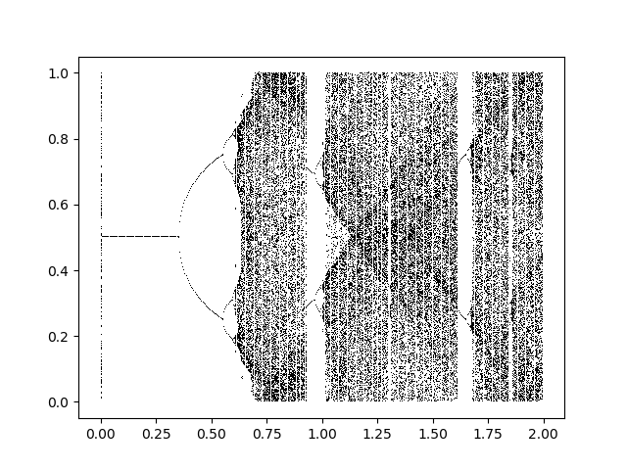

Period Doubling Series

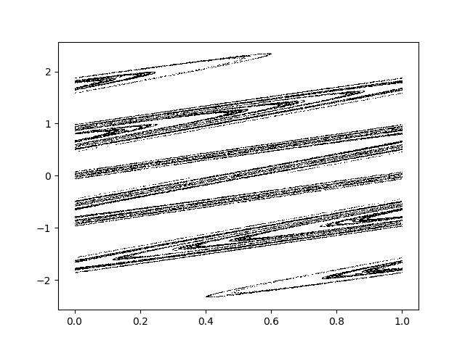

Zaslavskii Map

Attractor

a

y

x

|  |  |
| --- | --- |
| Constant | Scaling |
| k- wave vector | 1/a2 |
| γ- reset constant | 1.1 |
| v- velocity | 1/a |
| L- angular momentum | a |
| H- Hamiltonian | 1/a2 |

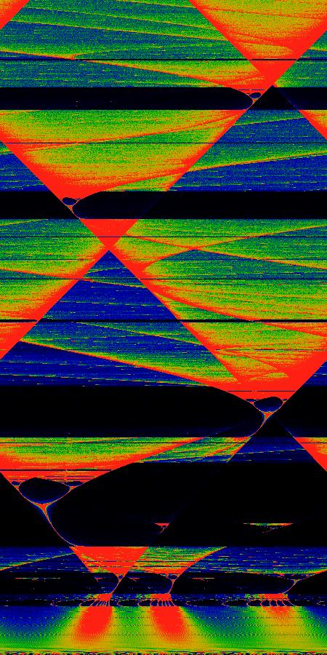

***Theoretical Universal Scaling for Dynamics of Yukawa One-Component Plasmas***