Quantum Natural Language Processing (QNLP) represents a fascinating convergence between quantum computing and computational linguistics, aimed at enhancing natural language processing (NLP) tasks. The integration of lambeq and PennyLane libraries stands at the forefront of this field, enabling the automatic differentiation and training of NLP models utilizing quantum computing frameworks.

The open-source lambeq library, developed by Quantinuum, allows quantum software engineers, NLP specialists, and enthusiasts to construct and train QNLP pipelines comprehensively. This library uses the grammatical structure of input sentences to create quantum circuits for NLP tasks, beginning with parsing sentences using the bobcat parser, among others. This parser transforms sentences into syntax trees, which are then encoded into string diagrams representing word relationships based on a chosen compositional model.

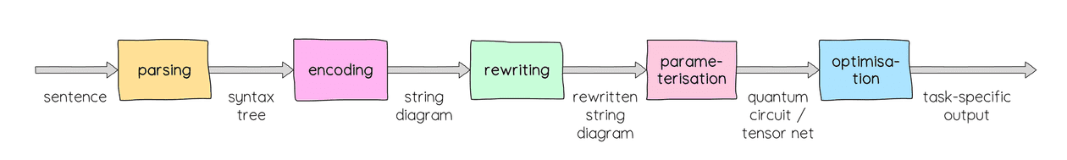

These string diagrams, grounded in category theory, can be simplified through rewriting rules to eliminate redundant word interactions or to make the computation more suitable for quantum processing units (QPUs). Subsequently, the lambeq library translates these diagrams into quantum circuits, ready for training.

For practical illustration, the post describes training a hybrid model with PennyLane, aimed at distinguishing topics between pairs of sentences. This involves the transformation of string diagrams into quantum circuits using an IQPAnsatz, which are then employed in a model to determine topic similarity or divergence.

The setup for the hybrid QNLP model involves defining training hyperparameters and preparing the dataset, which includes sentence pairs labeled according to their topical relevance. These sentences are parsed and converted into string diagrams, simplified, and then reassociated into paired datasets for the training process.

The model, named XORSentenceModel, combines quantum circuit outputs with a classical neural network, trained to perform XOR operations on the outputs to discern if the sentences share the same topic. The implementation leverages PennyLane for the seamless integration of quantum circuits into a PyTorch-based learning framework.

The training process adopts a standard PyTorch workflow, utilizing binary cross-entropy loss for binary classification tasks. The authors highlight the importance of transforming circuit probability outputs for effective neural network training, preventing issues like dying ReLUs and facilitating better learning dynamics.

Upon training, the model demonstrates a clear capacity to differentiate between topics, achieving perfect accuracy on the development set and showcasing effective internal representation separation within the quantum circuits. The final analysis provides insights into how the trained model and its quantum components contribute to NLP task resolution, with examples showcasing the distinct processing of different topics.

In summary, the integration between lambeq and PennyLane represents a significant stride in QNLP, offering a structured approach to employing quantum computing in language processing tasks. This framework not only extends the capabilities of quantum models to NLP but also opens new avenues for research and development in quantum-enhanced computational linguistics. The integration encourages experimentation and further exploration, supported by comprehensive documentation and a community-oriented development approach, inviting feedback and contributions.