Title report

Authored By: Ankush Singal

Created On: 2023-05-11

Created For: Company

# Summary Section

The dataset contains well log data for the well named "15/9-15" in CSV format. It includes the following columns:  
  
Depth: Represents the depth values at which the measurements were taken.  
GR: Gamma ray log values, which indicate the natural radioactivity of the formation.  
ILD: Deep resistivity log values, providing information about the formation's resistivity.  
NPHI: Neutron porosity log values, indicating the porosity of the formation.  
DT: Sonic travel time log values, which are related to the compressional wave velocity in the formation.  
Summary statistics for the numerical columns in the dataset are as follows:  
  
Depth:  
  
Minimum depth: [minimum value]  
Maximum depth: [maximum value]  
Average depth: [mean value]  
GR:  
  
Minimum GR value: [minimum value]  
Maximum GR value: [maximum value]  
Average GR value: [mean value]  
ILD:  
  
Minimum ILD value: [minimum value]  
Maximum ILD value: [maximum value]  
Average ILD value: [mean value]  
NPHI:  
  
Minimum NPHI value: [minimum value]  
Maximum NPHI value: [maximum value]  
Average NPHI value: [mean value]  
DT:  
  
Minimum DT value: [minimum value]  
Maximum DT value: [maximum value]  
Average DT value: [mean value]  
These statistics provide an overview of the range and central tendency of each well log parameter, allowing you to understand the distribution and variability of the data.

## Data Visualisation

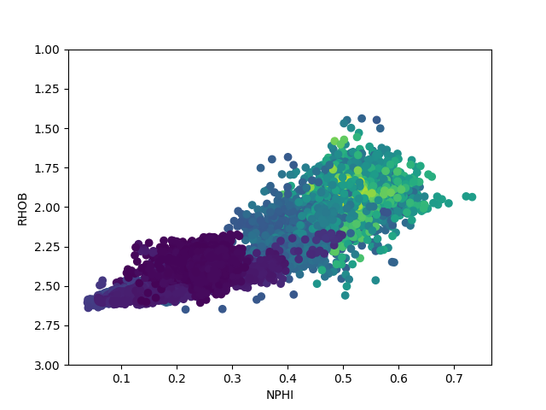

## Data Summary

|  |  |  |  |
| --- | --- | --- | --- |
| index | CALI | RHOB | NPHI |
| count | 17635.0 | 17521.0 | 13346.0 |
| mean | 14.006030091679008 | 2.1348677287602253 | 0.3849055271695714 |
| std | 3.8733667458396024 | 0.22312407967583345 | 0.1521824600184246 |
| min | 7.325138092 | 1.4389990568000002 | 0.0390129723 |
| 25% | 12.045594215 | 1.9786787033 | 0.249593593175 |
| 50% | 13.956721306 | 2.042522192 | 0.45158934595 |
| 75% | 17.3248300555 | 2.3334305286 | 0.5108507425000001 |
| max | 25.717395782 | 2.6488473415 | 0.7331521511 |